GitHub Repo URL: <https://github.com/Gaurav2119/Cucumber_BDD_framework.git>

**Jenkins Setup**

This repository contains the configuration and pipeline setup for the Jenkins CI/CD server.

**Prerequisites**

Before you begin, ensure that you have the following installed:

- Jenkins

- Git

- Java

**Configuration**

1. **Install Required Plugins**

- Navigate to `Manage Jenkins` > `Plugins` > `Available` tab.

- Install the necessary following plugins:

- Git

- Maven

- Any other plugins required for your specific needs

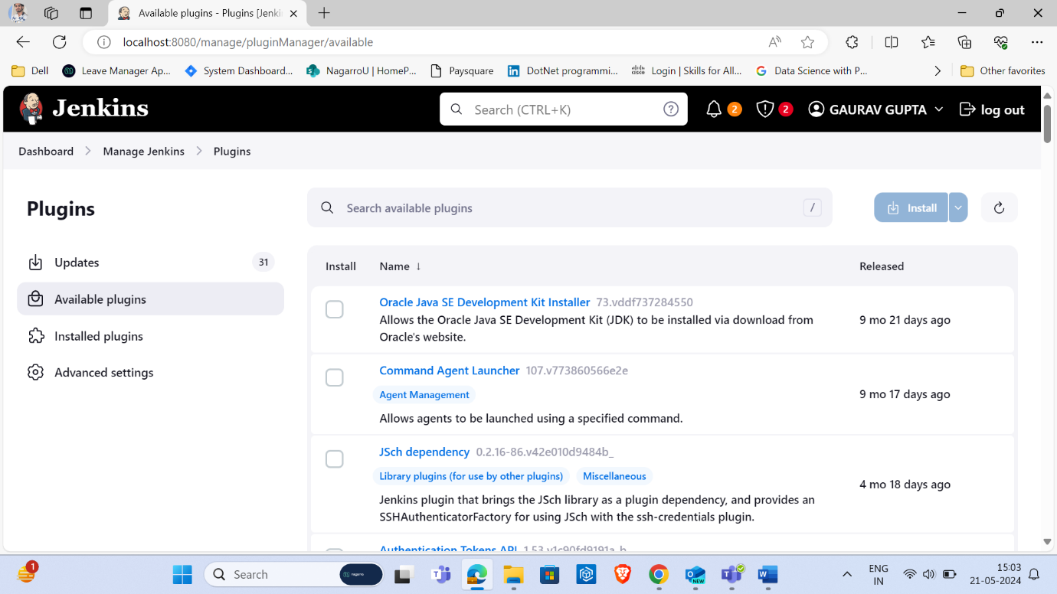

2. **Configure Git**

- Navigate to `Manage Jenkins` > `Configure System`.

- Under the `Git` section, add the path to your Git executable.

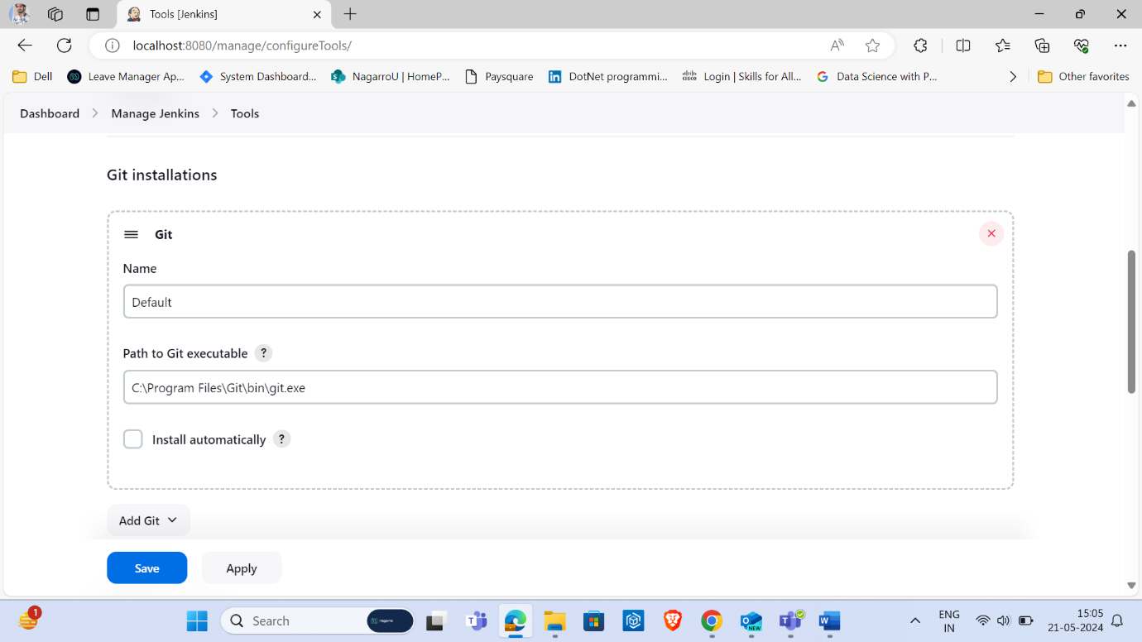

3. **Configure Maven**

- Navigate to `Manage Jenkins` > `Configure System`.

- Under the `Maven` section, add the path to your Maven executable or Install from Apache.

4. **Configure Credentials**

- Navigate to `Manage Jenkins` > `Manage Credentials`.

- Add your Git credentials (username and password/access token) or SSH keys, depending on your repository setup.

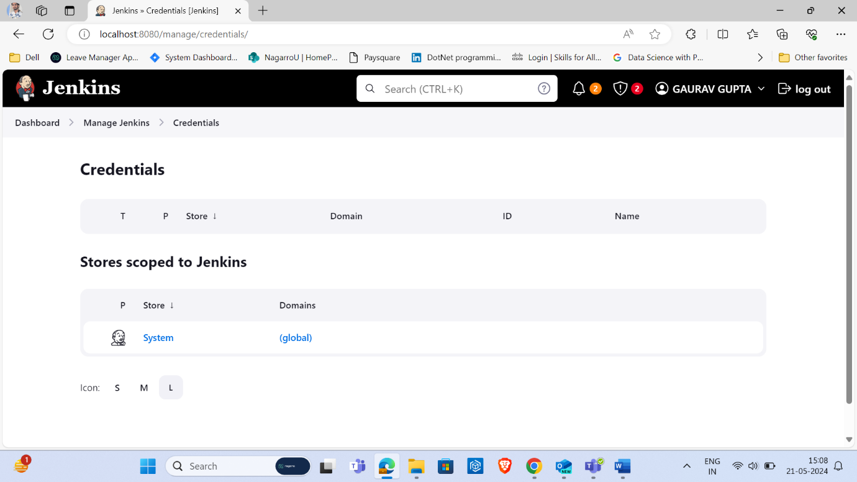

## Pipeline Setup

The `Jenkinsfile` in this repository defines the pipeline for building, testing, and deploying your application. Here's an overview of the stages:

1. **Checkout**: Checks out the code from the specified Git repository.

2. **Build**: Builds the application using the specified build tool (e.g., Maven, Gradle).

3. **Test**: Runs the test suite for the application.

4. **Deploy**: Deploys the application to the specified environment (e.g., staging, production).

4. **Create a Jenkins Job**

- In the Jenkins dashboard, click `New Item`.

- Enter a name for your job and select `Pipeline`.

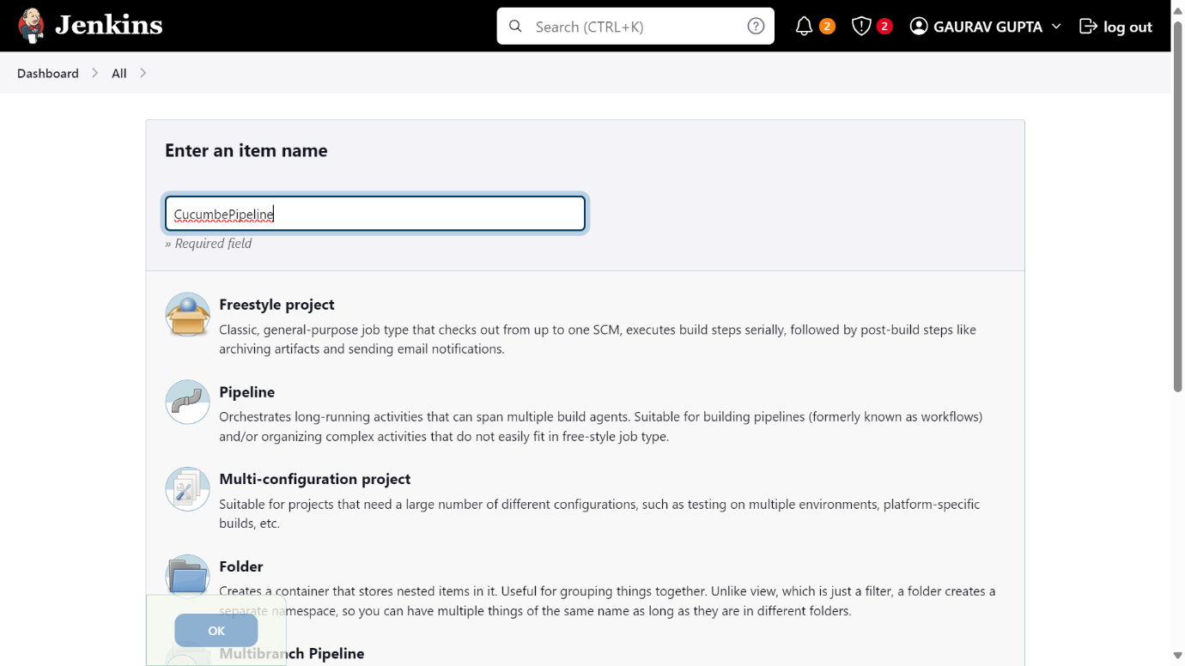

- In the Pipeline configuration, choose `Pipeline script from SCM`.

- In the SCM section, select `Git`.

- Enter the repository URL containing your Jenkinsfile.

- If required, specify the credentials to access the repository.

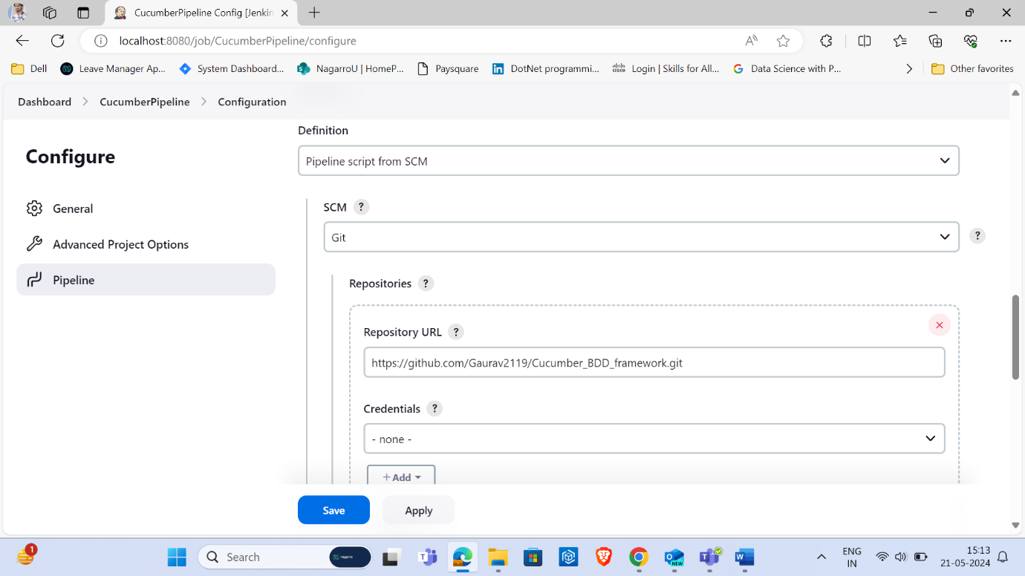

***Specify branches to build a section under Repositories***

1. Branch Specifier – */master (This is my main branch)
2. ScriptPath – Jenkinsfile

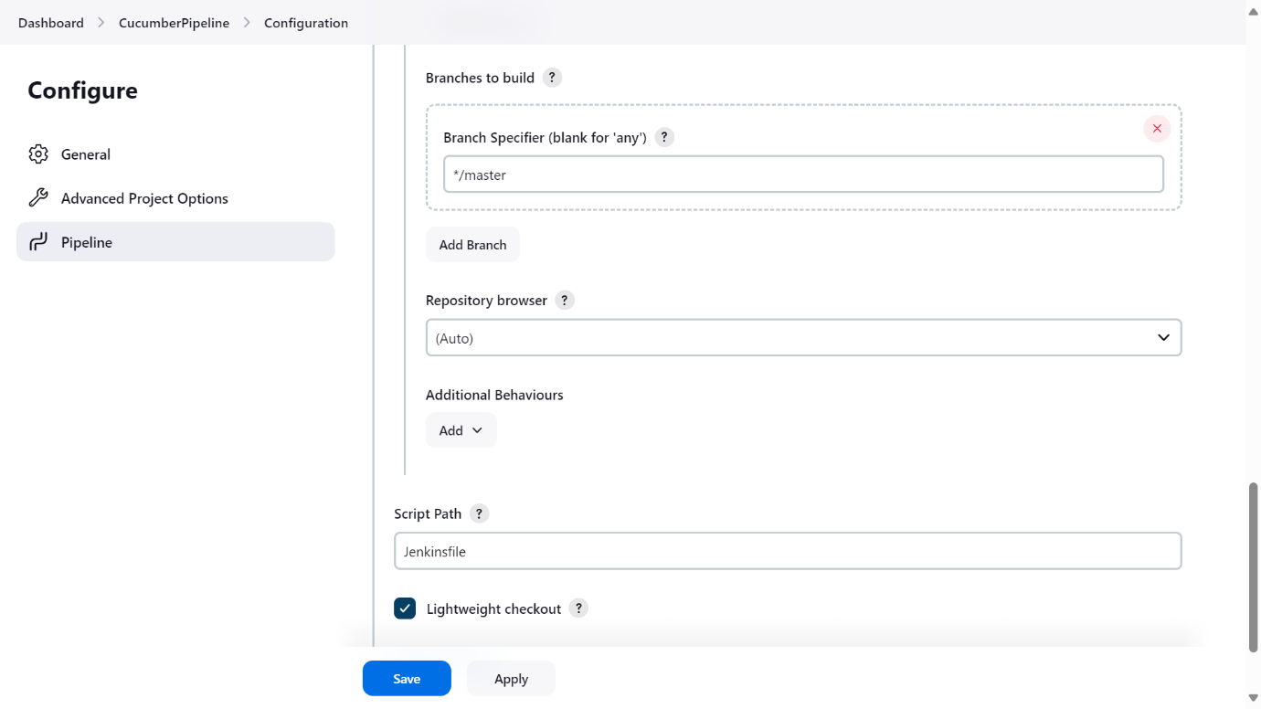

**Poll SCM**

Under Build trigger select poll SCM and provide the schedule as needed to build the pipeline periodically.

Every fifteen minutes (perhaps at :07, :22, :37, :52): H/15 * * * *

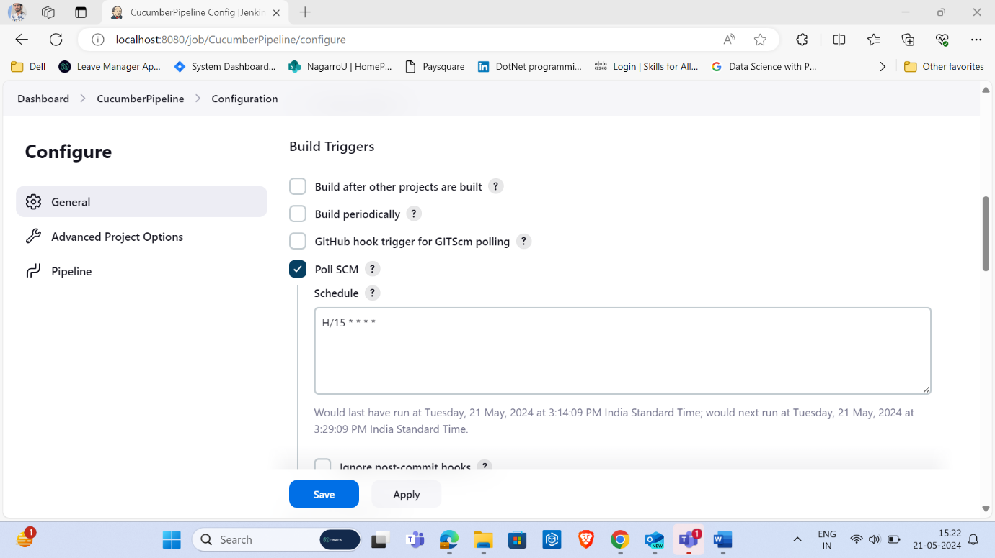

Click on the ***Apply***and ***Save***buttons

***Execute the tests***

Execute by clicking on the “***Build Now***” button.

Once the execution is completed, and we want to see the Pipeline Steps, click on the Pipeline Steps mentioned on the left side of the page.

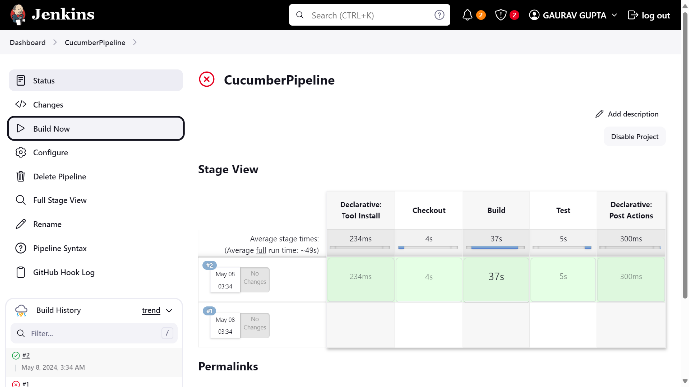

You can customize the `Jenkinsfile` according to your project's specific requirements.