

| **1st Set COURSEWORK 2 – QUESTION PAPER** | **Year Long 2023/2024** |
| --- | --- |

| **Module Code:** | **CU5007NI** |
| --- | --- |
| **Module Title:** | **Modeling and Texturing** |
| **Module Leader:** | **Ranjan Shrestha** (Islington College) |

| **Coursework Type:** | **Individual - Production 2:**  **UVs and texture maps on complete rendered 3D character + In-Class work presentation** |
| --- | --- |
| **Coursework Weight:** | This coursework accounts for **60%** of your total module grades but will be graded out of 100. |
| **Submission Date:** | **Week28** |
| **When Coursework is given out:** |  |
| **Submission Instructions:** | Submit the following to Islington College RTE department before the due date:   * **Production Process Documentation** * **Project Files send via Collage id Google Drive.** * **Presentation Slides** * **Final Render Video.** |
| **Warning:** | London Metropolitan University and Islington College takes Plagiarism seriously. Offenders will be dealt with sternly. |

# Coursework 2 - Production 2: UVs and texture maps on complete rendered 3D character _ In-Class work presentation

## **On completing the module, the student will be able to:**

## **LO4:** demonstrate competency, confidence and an advanced level of creativity and skill by implementing a believable 3D character’s (and/or game asset) model and texturing.

## **LO5:** integrate diverse tools and techniques to realize creative ideas in terms of model realism, materials/textures, target audience and purpose.

## **LO6:** Effective oral, visual and written communication skills via presentations, reports and demonstrations.

## Coursework Introduction

This coursework enables you to develop your skills in proper use of UVs and texture maps.

In your 2nd coursework, you are to add in proper UV Maps and texture maps on a properly rendered 3D character and make in in-class presentation to a module teaching team about it.

## Instructions

You are to make a proper UV layout and texture for your models along with the use of bump map.

After all the process is complete, you are to make a proper turntable video as your show reel with proper break down of the texturing process.

The video should be 60 seconds long excluding title/credits.

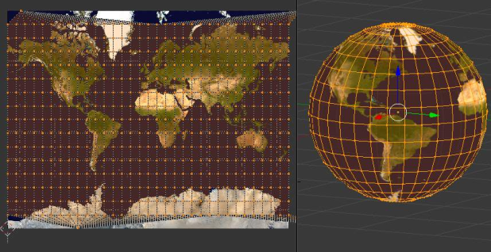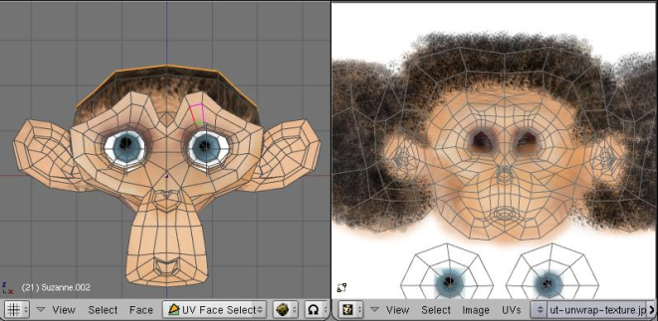

You do not need to rig the character for this module and just focus on the modelling process. However, you are to render the images properly with the use of proper lighting, texturing and use of relevant materials.

## Deliverables

## Deliverables

* Maya project files with all sources for textures.
* Project progress documentation with all the details of how the project was carried out.
* Final video is to be provided in MP4 format with H.264 codec with a minimum of 640 by 480 (480p) resolution. or upload your video in Google Drive / YouTube with unlisted.

**Note:** Marks will not be impacted based on the resolution of the video

## Google Drive Contents Structure

| **Contents** |  |
| --- | --- |
| **Folder Structure:**  **Documentation**  **Photoshop Files**  **Maya Files**  **Rendered Images**  **Presentation Slides**   * **Readme.txt** * **References.txt** | Documentation – This folder should contain the soft copy of the documentation submitted.  Photoshop Files – Should contain the Photoshop source files used for the model.  Maya Files – Should contain the Autodesk Maya ASCII Files. Proper folder structure is expected.  Rendered Images – Should contain the rendered images Maya in .jpg format.  Presentation Slides – Should contain the presentation slides and visual assets used for in-class presentation.  Readme.txt – Should contain student name, student ID, and course of study, lecturer name and folder and file structure of location information.  References.txt – Should contain the proper links of any external sources used in the project. |

**Note: Harvard style referencing must be used for referencing.**

**MARKING SCHEME**

| **CRITERIA** | **MARKS** |
| --- | --- |
| 8 Props UV Layout and Texture | 20 |
| Character UV Layout | 15 |
| Character Texture Mapping | 15 |
| Lighting and Sequence /Image Render | 10 |
| Character Pose and Turntable Video | 15 |
| In-Class Presentation | 15 |
| Documentation | 10 |