IoT in Agriculture- Smart Farming
Ankit Tripathi, Manpreet Singh, Gaurav Taneja, Gaurav Chajjed
axt0604@mavs.uta.edu / mxs3982@mavs.uta.edu / gxt5801@mavs.uta.edu / gxm1652@mavs.uta.edu
Abstract— Over time technology has come a long way and
many innovations have been carried out over the time. The
IoT, which is one of the most revolutionary technologies, is the
future
of
communication
and
computing.
Nowadays,
the
applications and usage of IoT are seen in every field like smart
homes, smart schools, smart cities etc. The administration of
IoT is very vast and can be easily deployed into every field.
Thus,
this
paper
is
about
deploying
IoT
technologies
in
agriculture. IoT technologies enhance crop management, cost
efficiency,
resource
management,
field
monitoring,
disease
detection and crop monitoring. A rigorous discussion on the
basic architecture of IoT in agriculture, sensors used to fetch
the real time data, connectivity through LPWAN, challenges
faced in current farming practices and measures to increase
the
farm
produce
by
implementing
models
that
increase
efficiency and monitor the life cycle of crop growth.
Keywords— IOT: Internet of Things, agriculture, sensors,
protocols, communication, end-user, LPWAN: Low Power Wide
Area Network)
I.
INTRODUCTION
With the increasing population, it would be difficult to
feed the world population after a certain period and with
increase
in
population
there
will
be
a
decrease
in
the
agricultural land due to various reasons like construction of
residential
buildings,
commercial
markets,
and
other
industries. To overcome this and to save the world from the
scarcity of the food, implementation of smart farming is
necessary. Smart Farming will not only enhance the crop
growth but also will increase its quality as well.
The Internet of things helps various devices and
sensors to communicate with each other and send real time
data over the internet. This real time data can be used by the
computer
systems
to
analyses
data
and
make
predictive
analysis on it to improve the efficiency. With the help of IoT
technologies a model can be created in a closed environment
to monitor over all the environmental conditions of the farm.
In the current practices, the farmers are not satisfied with
their crop yield and that is due to various reasons like spread
of diseases on the plants, attacks by insects and not having
proper knowledge about the practices that involve in the
production of the crop. All these reasons can highly impact
the production of the crop yield and to solve this problem the
proposed model is Smart Farming which will typically use
technology
to
solve
the
problems
faced
by
farmers
to
increase the efficiency and quality of the crop
Smart Farming uses technologies like the Internet, IoT
devices,
sensors,
and
concurrent
assessment
of
various
factors that determine the best conditions required by the
plant like nutrients, soil quality, water quality, etc. Smart
farming not only makes farming easy but also economical by
reducing the labor cost involved and hence improving the
crop yield and quality.
________________________________________________
II.
OVERVIEW
IoT in Agriculture (Smart Farming):
Deployment
of
IoT
technologies
enables
the
moderator to access the real-time data of that environment.
IoT uses the access of the Internet for the exchange of data
from sensors to the end-system destination. Implementation
of IoT Technologies in the agricultural environment is a
vigorous task but is achievable. With the implementation of
IoT in agriculture we can achieve various advantages that
tend to enhance the productivity and quality of the crop and
increase the net profit of the farmer. Smart Farming has
various applications which can be used to improve and
enhance the way of farming. The major responsibilities that
are to be carried out by Smart Farms are Crop monitoring,
Disease detection, Monitoring environmental factors like
pressure,
gas,
soil,
water,
and
air.
To
implement
these
responsibilities, a proper architecture must be created which
connects all the nodes and provides us with the reliable
transfer of data.
Smart
Farming
systems
make
use
of
sensors
to
monitor the conditions that can influence the growth of the
crop. This real-time data is continuously monitored by an
intelligent system that already has a predefined model to
detect changes that can potentially lead to the deterioration
of the crop. With this predictive analyzer, we can monitor
various components of a plant that can lead to any problem
in the life cycle of its growth. The Intelligent system uses
technologies
like
machine
learning,
deep
learning,
and
computer vision to make an appropriate decision on the
input given to it. In the current practice with the help of
computer vision, we can detect the potential of infection on
the plant by just scanning the plant leaf and deciding the
percentage
of
potential
infection
by
deep
learning
algorithms.
The
main
obstruction
that
comes
forward
in
the
deployment of IoT technologies in agriculture is the initial
capital
investment.
While
the
IoT
provides
us
various
advantages by using different technologies, all of that comes
with huge capital investment and not all farmers can afford
to
build
that
infrastructure.
Second
to
that
comes
communication, while all the farms are in remote locations,
it is difficult to provide high-speed internet connectivity in
that area. In the coming times, 5G technology can overcome
this as well but at the present time, it is difficult to provide
high-speed
internet
connectivity.
Thirdly,
the
biggest
challenge
is
illiteracy,
using
advanced
technology
and
analyzing data is not possible for everyone. And teaching
the farmer this high-level technology is another big task.
There are various advantages of turning traditional
farming into smart farming, not only it will save a lot of
labor work but also will be cost-efficient and beneficial. The
main advantages of implementing IoT in agriculture are
disease monitoring: the system monitors the condition of the
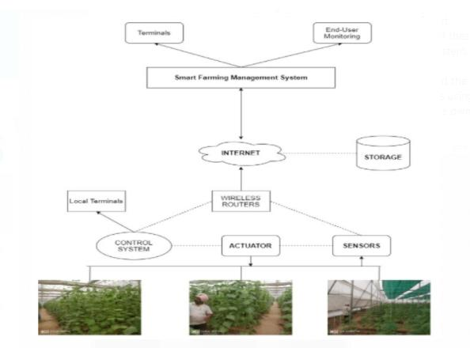
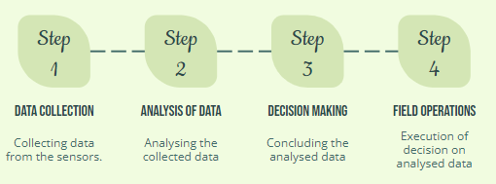
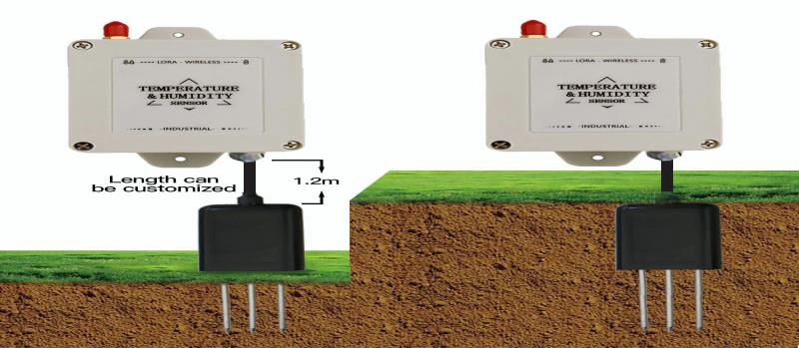
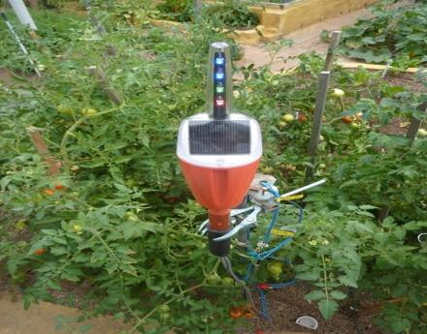
plant components in real-time and then accordingly analyses
and makes a decision, the other benefit is to improve the
production quality and take countermeasures to increase the
production quantity as well. It also saves money by reducing
the labor cost and increases efficiency by monitoring the
crop life cycle and providing the end-user with visualized
infrastructure.
Architecture:
The
architecture
of
an
IoT
system
incorporates
many
devices
like
actuators,
sensors,
cloud
services,
wireless routers, control systems, intelligent management
systems and end-user monitors. Every IoT system has a
different architecture according to the components in that
system.
The
IoT
in
agriculture
typically
has
3
main
components, the applications that run on the end-user level
and are used for the visualization and analyzation of data,
the IoT devices that transmit real-time data and the cloud
services storage that stores the raw data transmitted by the
IoT dev ices, connected over the internet.
The
architecture
of
the
Smart
farming
system
consists
of
various
components
like
Actuators,
Sensors,
Storage (Cloud Services), Wireless routers, Smart farming
management systems and end-user monitoring systems. All
these components are incorporated together to form a smart
farming IoT system, which is connected with each other
with the help of the Internet. The rudimentary workflow of
the system starts from the sensors which send the data to the
smart farming management system via the wireless routers
using the internet. The Smart Farming Management System
then performs its own operations like predictive analysis and
visualization algorithms for the understanding of the end-
user.
Sensors:
The sensors play an important role in every IoT
system, as these are the building blocks of IoT technologies.
The main role of the sensors is to capture the real-time data
and send it to the control system. The control system then
monitors the data and sends it to the intelligent system for
its analyzation. There are several sensors involved in IoT in
agriculture like pressure, gas, imaging, thermal, soil, water,
temperature and humidity.
Temperature and Humidity
Soil Moisture Sensor
Actuators:
An actuator is a system that moves or controls the
system on the call from above or the control system. The
actuator basically takes an electrical signal as input and
turns that into an appropriate physical action associated
with it. There are several types of actuators: Linear actuator,
Hydraulic actuator, Electric actuator, Mechanical actuator
and Thermal actuator.
Storage:
The storage or the database is used to store the data
transmitted by the sensors and is used for manipulation or
predictive analysis by the intelligent system. This time-
series
data
must
be
accurate
for
Internet
of
Things
applications.
If the order of data is not completely aligned and
accurate, then it points to potentially different results when
analyzed. Time-series data can be created as events take
place around the device and then sent. There are several
services provided for storage of the IoT devices like Google
cloud
platform,
Microsoft
Azure
and
Amazon
Web
Services.
Smart Farming Management System: The Smart
Farming Management System (SFMS) is the brain of the
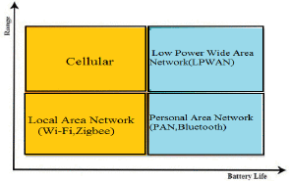
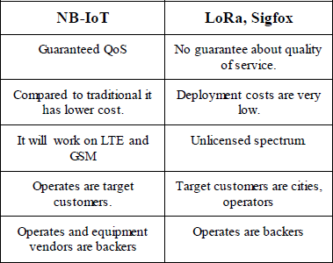
architecture as all the mathematical computation, predictive
analysis and visualization of data happen here. It takes the
real-time raw data from the sensors which are stored in the
cloud storage, then sorts and segregates the data and cleans
the data for the analysis. After the data has been fragmented
and segregated, it focuses on feature extraction and hence it
analyses the data and combines data to extract important
features from the sorted data. After everything, it trains the
data and applies appropriate algorithms on the data which
gives us the desired results. Once the results have been
generated it creates a user friendly, visualized version of the
data which is easily understood by the end-user of the
monitoring. On the backend it monitors the environmental
conditions, associates trigger with every condition and once
that trigger is generated it informs the end-user about the
scenario.
Connectivity:
There are many methods used in connectivity. But
the major issue is farming mostly happens in remote area
where there are certain constraints. The LPWAN is the
efficient approach in which it utilizes less power and works
in
wide
range.
This
method
also
maintains
good
connectivity,
main
methods
used
are
NBIoT
and
LORAWAN.
The LORAWAN is Long Range technology, they are
less secure that NBIot.The latency is more. The NBIoT is a
radio added LTE platform used for low end of the market.
They are basically used in low power sensors. This method
provides wide coverage with indoor penetration. It uses
license protocol that gives better experience to customer.
They
are
more
secure
network
than
LORAWAN.
Low
latency. Both support geolocation to same level. The cost of
LORAWAN is less than that of NBIoT because it uses
unlicensed spectrum. The LORAWAN has more mature
chipsets, cloud service and gateway can be used well in
agriculture. The connectivity is at regional or global level
they are used in organization but can be used in green house
farming. LORAWAN devices register with network sever
not with the gateways so it can move easily between the
gateways. But there is possibility that they might go in a
bind spot when mobile. NBIoT are stagnant they cannot be
register or setup again without consumption of more power.
Our is to use LORAWAN for agriculture and monitor of the
other sections like delivery where mobility is key and accept
some loss of data. But using NBIoT for faming will be best
option where it more secure and reliable.
The major task in implementing the IoT technology in
any
infrastructure
is
the
establishment
of
a
connection
between the intermediary nodes. The challenge is to provide
low powered and long-range connectivity over the network
without any delay or congestion. The reliability of data
matters a lot as data is the building block of the IoT systems
and hence providing a service that offers this has to be
implemented.
There
are
several
technologies
that
offer
connectivity
and
have
their
own
advantages
and
disadvantages. In IoT in agriculture, the main focus is on
providing a connectivity service that has long-lasting battery
life, low cost and provides fast transmission of data over a
long-range.
The
technologies
that
are
currently
used
in
connectivity are Cellular Networks(5G, 4G), Local Area
Network(Wi-fi,
Zigbee),
Low
Power
Wide
Area
Network(LPWAN), Personal Area Network(Bluetooth).
In Smart Farming infrastructure, there are three main
areas that have to be considered in choosing a connectivity
technology, namely long-range, low power and low cost.
The closest to this type of technology is the LPWAN, which
provides all the services that are required in long-range
areas like agricultural fields. There are several services that
LPWAN provides, which are Long range, Low cost, Low
Power, Quality of Service, Security and scalability. There
are mainly three types of LPWAN: SigFox, NB-IoT and
LoRaWAN.
NarrowBand-Internet
of
Things
(NB-IoT)
is
a
standards-based low power wide area (LPWA) technology
developed to enable a wide range of new IoT devices and
services.
NB-IoT
significantly
improves
the
power
consumption of user devices, system capacity and spectrum
efficiency, especially in deep coverage. Battery life of more
than 10 years can be supported for a wide range of use
cases. The initial cost of the NB-IoT modules is expected to
be comparable to GSM/GPRS.
Sigfox
is
a
long-range
cellular
wireless
communication that offers custom solutions primarily for
low-throughput
Internet
of
Things
(IoT).
Low
power
consumption ensures that remote devices run for long with
minimal battery charging or maintenance. Sigfox enables
IoT communication over long distances making it possible
to transmit with minimal base stations.
LoRaWAN is the radio modulation technology that is
used for the transmission of data over a long-range. It is
another category of LPWAN technology that is proprietary
and works on RF technology. It works on the unlicensed
spectrum hence because of that it does not have a high
deployment cost.
Messaging:
Iot
devices
basically
communicate
through
telemetry messages with the messaging hub. There should
be some protocols used by each and every node. The basic
protocol is TCP.
The nodes are connected to the each other using
methods like WIFI, Bluetooth, ZigBee, Lora WAN etc.
There is some type of the protocols:
1. Message queue Telemetry Transport (MQTT)
2. Advanced Message Queue Protocol (AMQP)
3. Data Distributed Service (DDS)
4. Extensible Message and Presence Protocol (XMPP)
5. Constrained Application Protocol. (CoAP)
They have their own benefits and each protocol can be
used according to the requirement of the system. Below is
the comparison between the benefits of each protocols.
MQTT
AMQP
DDS
XMPP
CoAP
Lightweight
protocol
because
push method
is used
Transfer
data
through
TCP and
UDP
Scalable and
effective
Easy to
identify or
locate
device on
network
Quick setup
Support low
power usage
End to end
encryption
Efficient
utilization of
bandwidth
No
Encryption
Small
Packet size.
Small Data
packets
Application
layer
protocol is
binary
Reliable data
transfer
Quality of
Service
not
available.
No
broadcasting
Quick
Results
Heavyweight
protocol
difficult to
incorporate
with
embedded
system
Lack of
Encryption
Can’t use
with web
pages
Works over
TCP so
high-power
consumption
Uses large
amount of
power and
memory
More
bandwidth
usage than
MQTT
After reviewing the benefits MQTT and AMQP are best fit.
MQTT is utilized in most of the present system, as AMQP
is new in market and less famous implementation AMQP
with agriculture is not them according to our research.
________________________________________________
III.
LITERATURE
SURVEY
Smart Farming – IoT in Agriculture:
Sunil
Kumar
Khatri
et
al,
has
stated
that
the
main
objective
is
to
design
an
efficient
smart
farm
for
crop
management and monitoring, better resources management
and improved quality and quantity of crops. This is done
using the different sensors such as air sensor, soil pH sensor,
soil humidity sensor etc. In this survey the proposed model
is a simple Iot architecture which collects information and
send it over the Wi-Fi network to the server. Depending on
the information the server can act.
________________________________________________
Cloud
Service
Oriented
Architecture
(CSoA)
for
agriculture through Internet of Things (IoT) and Big
Data:
R Venkat et al, has stated that the producers are not gaining
profit due to the obstacles that come up in the process of
farming.
So,
the
proposed
work
makes
use
of
various
technologies
such
as
IoT,
cloud
computing
etc.,
which
makes agriculture profitable and enhances the GDP.
________________________________________________
A Survey on the Role of IoT in Agriculture for the
Implementation of Smart Farming:
Muhammad Shoaib Farooq et al, presented this survey
paper by keeping in mind the basic architecture of the
agriculture farming to reduce dependency on manpower.
They
focused
on
the
network
architectures,
layers,
topologies, and protocols. And use of modern technologies
such as cloud computing, big data and Analytics. They
shared about the security breaches that occur while using
smart
farming.
The
involvement
of
government
in
promoting smart farming.
________________________________________________
IoT in Agriculture: Designing a Europe-Wide Large-
Scale Pilot:
Christopher
Brewster
et
al,
has
stated
that
the
implementation
of
IoT
can
transform
the
agriculture
sector. The aim is to gain good yield of crop, security, and
privacy to monitor the data and to control the cultivation of
crop from the collected data using different sensors and
IoT
technologies
such
as
image
sensor,
water
sensor,
fertility sensor etc.
________________________________________________
A Survey of LPWAN Technology in Agricultural Field
Liya M L et al, has created this survey paper to help spread
smart farming in the remote area. They have highlighted the
basic issue faced in deploying smart farming in rural areas.
They
face
poor
connectivity
and
power.
LPWAN
technology
has
suffice
all
the
drawbacks.
LPWAN
technology provide devices with low power and long range.
Some of the technologies are LoRa, Sigfox, NB-IoT and
LTE-M. They concluded that LORA and NB-IoT suffice
most of the requirement generated to deploy in rural areas.
________________________________________________
Investigating Messaging Protocols for the Internet of
Things (IoT)
Eyhab
Al-Masri
et
al,
there
is
large
amount
of
data
generated
and
to
transfer
this
data
from
source
to
a
destination where a data can be used for future predictions.
This generates certain constraint of reliable data transfer,
lightweight, scalable, and secure. So, certain protocols are
needed. They have examined six protocols HTTP, CoAP,
MQTT,
AMQP,
DDS
and
XMPP
and
investigate
the
distinctive approach of each.
________________________________________________
Security and Privacy in Smart Farming: Challenges and
Opportunities
M. Mittal et al, believe that IOT devices play an important
role in Smart Farming from knowing the status of crops and
soil moisture content to deploying different sensors such as
drones to monitor crops or spray pesticides. However, such
an exposure also paves path for lot of cybersecurity threats
and vulnerabilities. As a solution to this problem authors
suggested a lightweight device authentication solution in
which session keys and public keys are combined to carry
out the encryption/decryption tasks.
________________________________________________
A Feasible IoT-Based System for Precision Agriculture
Vesna Maraš et al, has specified about low cost IoT based
monitoring system for precision agriculture. A field data is
collected by self-powered station and is then transferred to
remote controllers such as home or office via the Wi-Fi or
open IoT servers for visualization, analysis and react back.
By using this process people who have mobile, or gadget
can monitor the data.
________________________________________________
A
Demo
of
the
PEACH
IoT-based
Frost
Event
Prediction System for Precision Agriculture
Ana Laura et al, has stated that farmers loose lot of crop
production due to frost and to overcome that the PEACH
project was started. With the use of sensors to detect the
temperature and weather the frost density was predicted
ahead than it could also take place. With the collected data
from the sensors the farmers can control the damage on the
crops and the production can be increased.
________________________________________________
IoT
Agriculture
to
improve
Food
and
Farming
Technology
Gunaseelan.K et al, has stated that with the use of propel in
agriculture we can keep track of the farm and its cultivation.
It gives information which can be shared on the cloud
storage which will be useful for the IT to maintain the data
and its production growth. With the help of this technique,
we can maintain the information about the grown of the crop
in means of snapshot and using the sensors we can calculate
the soil texture, pH value, fertility etc.
________________________________________________
FarmBeats:
An
IoT
Platform
for
Data-Driven
Agriculture
Vashisth et al, proposed that data driven techniques help to
get more agricultural yields, reduces loss, and cuts down
cost of inputs. But are limited due to factors such as limited
power connectivity, data connectivity, and sensor outputs.
Here
authors
have
suggested
systems
to
generate
and
conserve power by using solar power and duty cycling the
components, for data connectivity using TV White Spaces
(TVWS) and for drone sensors to leverage Assisted Yaw
Control using wind to increase flight duration.
________________________________________________
An
Overview
of
Internet
of
Things
(IoT)
and
Data
Analytics in Agriculture: Benefits and Challenges
Nour Hindia et al, Member, IEEE has concerns regarding
the depletion of natural resources so to produce abundantly
and efficiently is the main goal. The two factors’ analytics
and IoT help in achieving these two goals. In this paper they
have review various challenges and benefits of IoT and
suggests
future
trends.
There
are
many
benefits
by
incorporating Iot in agriculture, but the only issues are the
cost of deployment. The research on LPWA technology and
NBIOT is stand out from the LPWA type according to this
paper.
________________________________________________
Smart farm and monitoring system for measuring the
Environmental condition using wireless sensor network -
IOT Technology in farming
Tharindu Madushan et al, has cited that as the amount of
IoT devices continue to grow, the amount of data being
generated continues to increase rapidly. IoT systems depend
mainly on using messaging protocols for exchanging IoT
data and there are several protocols or frameworks that
support different types of messaging patterns. Since IoT
devices generally have limited computational resources and
processing power, choosing a lightweight, reliable, scalable,
interoperable,
extensible,
and
secure
messaging
protocol
becomes a difficult task.
Interoperability among existing messaging protocols
will play an important role in simplifying the development
and
deployment
of
IoT
systems.
Hypertext
Transfer
Protocol (HTTP), Message Queuing Telemetry Transport
(MQTT), Advanced Message Queuing Protocol (AMQP),
Constrained
Application
Protocol
(CoAP),
Extensible
Messaging
and
Presence
Protocol
(XMPP),
and
Data
Distribution
Service
(DDS)
are
commonly
used
communication
protocols
in
IoT
devices.
IoT
devices
produce data at a high velocity and require lightweight
communication protocols. It would be desirable in this case
to use a lightweight messaging protocol such as Message
Queuing Telemetry Transport (MQTT). MQTT is good for
cloud based IoT applications (D2C), a lightweight protocol
and
works
well
over
constrained
networks, provides
an
adequate level of QoS support.
________________________________________________
Smart Greenhouse Management System based
on NB-IoT and Smartphone
Tao Zheng et al, they are using cloud for storage and UI
based application for end user for real time monitoring the
environment and many other factors. They have conducted
test on the packet transmission. And observed the success
rate. They achieved their aim of intelligent management of
greenhouse. The sensor node integrates the NB-IoT module,
which implements data upload and down through the NB-
IoT network, and effectively reduces communication power
consumption. They concluded that data packet successfully
transmitted rate from the node to the cloud server and the
smartphone APP is 99.9008% and 99.7044%, respectively.
The use of system application is also convenient.
________________________________________________
IV.
COCLUSION
The IoT in agriculture is one of the most recent
topics under which several researches are being carried out
in order to make farming smarter and provide maximum
yield
with
minimum
resources
for
the
farmers.
Several
findings in this area have provided farmers or end users with
improved yields by incorporating smart sensors, low cost,
unlimited power options, better connectivity on farms etc.
Along with these factors several messaging protocols like
MQTT have been studied and better ones were suggested
like
AMQP.
Major
challenges
in
smart
agriculture
like
power has been dealt with duty cycling of components and
using solar power backed devices which include weather
aware
base
stations.
For
Security
and
privacy
issues
lightweight multi-factor authentication protocols is required.
Low
power
devices,
with
limited
power,
memory
and
storage cannot be considered as feasible solution.
________________________________________________
V.
REFERENCES
[1]
A. Khanna and S. Kaur, "Evolution of internet of
things (IoT) and its significant impact in the field
of precision agriculture", Comput. Electron. Agr.,
vol. 157, pp. 218-231, Feb. 2019.
[2]
Jaiganesh.S,
Gunaseelan.K,
V.Ellappan,
”IOT
Agriculture
to
improve
Food
and
Farming
Technology
3-4
March
2017,
Mahendra
Engineering College, Tamilnadu, India.
[3]
Christopher
Brewster,
Ioanna
Roussaki,
Nikos
Kalatzis,
Kevin
Doolin,
and
Keith
Ellis,
“IoT
in
Agriculture:
Designing
a
Europe-Wide
Large-
Scale Pilot”, IEEE Communications Magazine •
September 2017
[4]
Rahul Dagar, Subhranil Som, Sunil Kumar Khatri,
“Smart
Farming
–
IoT
in
Agriculture”,
International Conference on Inventive Research
in Computing Applications (ICIRCA 2018)
[5]
Keoma Brun-Laguna, Ana Laura Diedrichs , Javier
Emilio
Chaar,
Diego
Dujovne,
Juan
Carlos
Taffernaberry,
Gustavo
Mercado,
Thomas
Watteyne, “A Demo of the PEACH IoT-based Frost
Event Prediction System for Precision Agriculture”
, ©2016 IEEE
[6]
X. J. Shi, X. S. An, Q. X. Zhao, H. M. Liu, L. M.
Xia, X. Sun, et al., "State-of-the-art internet of
things in protected agriculture", Sensors, vol. 19,
no. 8, pp. 1833, Apr. 2019.
[7]
O. Elijah, T. A. Rahman, I. Orikumhi, C. Y. Leow
and M. N. Hindia, "An overview of internet of
things
(IoT)
and
data
analytics
in
agriculture:
Benefits and challenges", IEEE Int. Things J., vol.
5, no. 5, pp. 3758-3773, Oct. 2018.
[8]
Xuefen
Wan,
Fan
Zhang,
“Smart
Greenhouse
Management
System
based
on
NB-IoT
and
Smartphone”, IEEE, vol 34, no. 9, pp. 1986, Apr.
2020.
[9]
Eyhab Al-Masri; Karan Raj Kalyanam; John Batts;
Jonathan
Kim;
Sharanjit
Singh,
“Investigating
Messaging
Protocols
for
the
Internet
of
Things
(IoT)” , IEEE Access ( Volume: 8) 08 May 2020.
[10]
M.L.
Liya;
D.
Arjun,
“A
Survey
of
LPWAN
Technology
in
Agricultural Field”,
2020
Fourth
International
Conference
on
I-SMAC
(IoT
in
Social, Mobile, Analytics and Cloud) (I-SMAC),
10 November 2020.
[11]
Mansoor
RAZA,
Tharindu
Madushan,
Bandara
Wanninayaka
Mudiyanselage,
“Smart
farm
and
monitoring
system
for
measuring
the
Environmental
condition
using
wireless
sensor
network
-
IOT
Technology
in
farming”,
IEEE-
2020 5th International Conference on Innovative
Technologies in Intelligent Systems and Industrial
Applications (CITISIA), 20 Aug 2018.
[12]
Deepak
Vasisht,
Zerina
Kapetanovic,
Jongho
Won,
Xinxin
Jin,,
Ranveer
Chandra,
Ashish
Kapoor,
Sudipta
N.
Sinha,
and
Madhusudhan
Sudarshan,
“
FarmBeats:
An
IoT
Platform
for
Data-Driven Agriculture”, March 27–29, 2017
[13]
Maanak
Gupta,
Mahmoud
Abdelsalam,
Sajad
Khorsandroo,
And
Sudip
Mittal,
“Security
and
Privacy
in
Smart
Farming:
Challenges
and
Opportunities” IEEE, February 19, 2020
[14]
S. Imane, M. Tomader and H. Nabil, "Comparison
between CoAP and MQTT in smart healthcare and
some
threats",
Proc.
Int.
Symp.
Adv.
Electr.
Commun. Technol. (ISAECT), pp. 1-4, Nov. 2018.
[15]
Constrained
Application
Protocol
(CoAP)
Standard.,
Apr.
2020,
[online]
Available:
https://tools.ietf.org/html/rfc7252.
[16]
N.
Wang,
N.
Zhang
and
M.
Wang,
"Wireless
sensors in agriculture and food industry—Recent
development
and
future
perspective",
Comput.
Electron. Agricult., vol. 50, no. 1, pp. 1-14, 2006.
[17]
G. Premsankar, M. D. Francesco and T. Taleb,
"Edge computing for the Internet of Things: A case
study", IEEE Internet Things J., vol. 5, no. 2, pp.
1275-1284, Apr. 2018.
[18]
J. Chen, K. Hu, Q. Wang, Y. Sun, Z. Shi, and S.
He,
"Narrowband
internet
of
things:
Implementations and applications," IEEE Internet
of Things Journal, Vol. 4, No. 6, pp. 2306-2314,
2017.
[19]
Prof. K. A. Patil, Prof. N. R. Kale, “A Model for
Smart Agriculture Using IoT”, 2016 International
Conference on Global Trends in Signal Processing,
Information Computing and Communication
[20]
Ibrahim Mat, Mohamed Rawidean Mohd Kassim,
Ahmad Nizar Harun, Ismail Mat Yusoff , “IoT in
Precision Agriculture Applications Using Wireless
Moisture Sensor Network”, 2016 IEEE Conference
on Open Systems (ICOS), October 10-12, 2016,
Langkawi, Malaysia.

