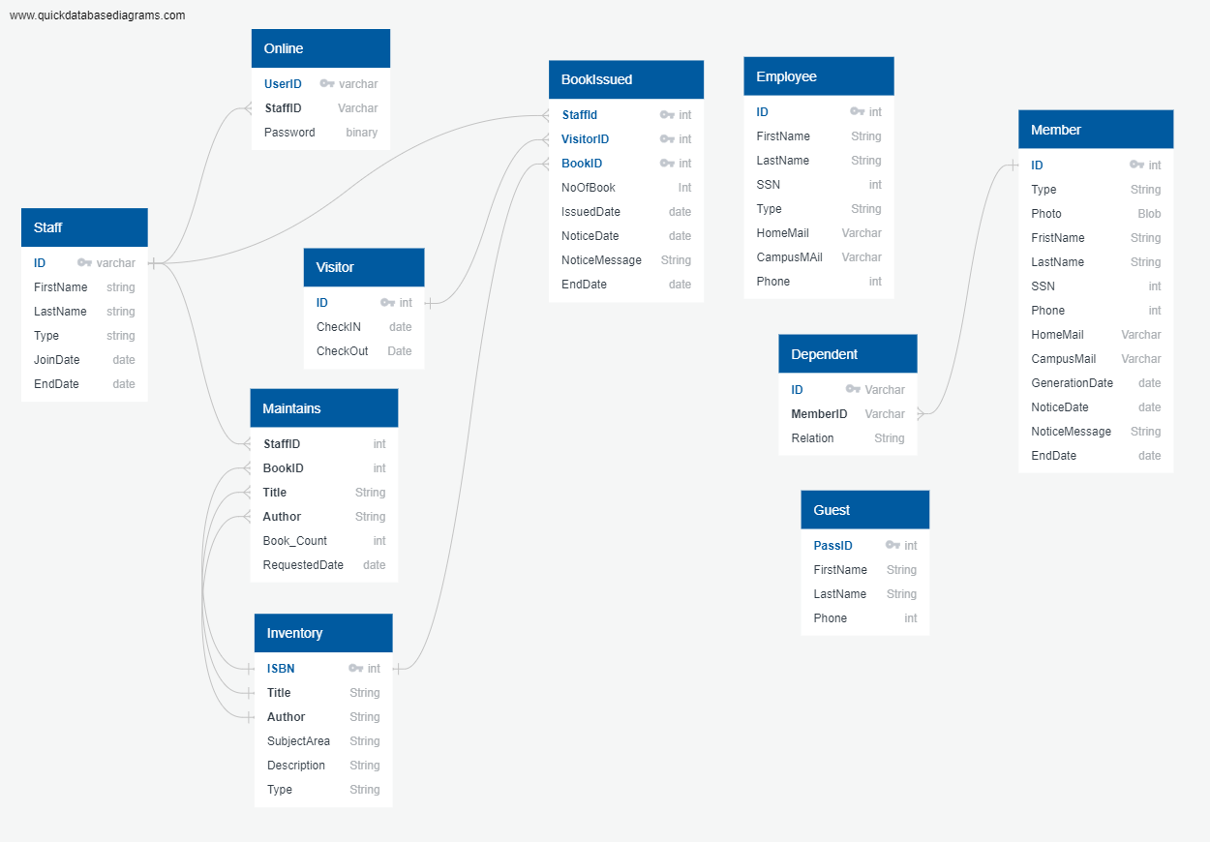

## Online

| Field | Description | Type | Default | Other |
| --- | --- | --- | --- | --- |
| UserID |  | varchar |  | PK |
| StaffID |  | Varchar |  | FK |
| Password |  | binary |  |  |

## Staff

| Field | Description | Type | Default | Other |
| --- | --- | --- | --- | --- |
| ID |  | varchar |  | PK |
| FirstName |  | string |  |  |
| LastName |  | string |  |  |
| Type |  | string |  |  |
| JoinDate |  | date |  |  |
| EndDate |  | date |  |  |

## Inventory

| Field | Description | Type | Default | Other |
| --- | --- | --- | --- | --- |
| ISBN |  |  |  | PK |
| Title |  | String |  | FK |
| Author |  | String |  | FK |
| SubjectArea |  | String |  |  |
| Description |  | String |  |  |
| Type |  | String |  |  |

## Maintains

| Field | Description | Type | Default | Other |
| --- | --- | --- | --- | --- |
| StaffID |  |  |  | FK |
| BookID |  |  |  | FK |
| Title |  | String |  | FK |
| Author |  | String |  | FK |
| Book_Count |  | int |  |  |
| RequestedDate |  | date |  |  |

## Employee

| Field | Description | Type | Default | Other |
| --- | --- | --- | --- | --- |
| ID |  | int |  | PK |
| FirstName |  | String |  |  |
| LastName |  | String |  |  |
| SSN |  | int |  |  |
| Type |  | String |  |  |
| HomeMail |  | Varchar |  |  |
| CampusMAil |  | Varchar |  |  |
| Phone |  | int |  |  |

## Member

| Field | Description | Type | Default | Other |
| --- | --- | --- | --- | --- |
| ID | M + ID generate Member ID |  |  | PK |
| Type |  | String |  |  |
| Photo |  | Blob |  |  |
| FristName |  | String |  |  |
| LastName |  | String |  |  |
| SSN |  | int |  |  |
| Phone |  | int |  |  |
| HomeMail |  | Varchar |  |  |
| CampusMail |  | Varchar |  |  |
| GenerationDate |  | date |  |  |
| NoticeDate |  | date |  |  |
| NoticeMessage |  | String |  |  |
| EndDate |  | date |  |  |

## Dependent

| Field | Description | Type | Default | Other |
| --- | --- | --- | --- | --- |
| ID | D + ID generated | Varchar |  | PK |
| MemberID |  | Varchar |  | FK |
| Relation |  | String |  |  |

## Guest

| Field | Description | Type | Default | Other |
| --- | --- | --- | --- | --- |
| PassID | G + ID |  |  | PK |
| FirstName |  | String |  |  |
| LastName |  | String |  |  |
| Phone |  | int |  |  |

## Visitor

Table is updated when member Relative or guest visit

| Field | Description | Type | Default | Other |
| --- | --- | --- | --- | --- |
| ID | ID updated with Guest PassID or Member ID |  |  | PK |
| CheckIN |  | date |  |  |
| CheckOut |  | Date |  |  |

## 

## BookIssued

| Field | Description | Type | Default | Other |
| --- | --- | --- | --- | --- |
| StaffId |  |  |  | PK, FK |
| VisitorID |  |  |  | PK, FK |
| BookID |  |  |  | PK, FK |
| NoOfBook |  | Int |  |  |
| IssuedDate |  | date |  |  |
| NoticeDate |  | date |  |  |
| NoticeMessage |  | String |  |  |
| EndDate |  | date |  |  |