**CSE 3302: Programming Languages**

**Spring 2022**

**Name: Gaurav Taneja**

**1000 number: 1001955801**

**Date: 7/7/2022**

**INSTRUCTIONS**

1. **Do NOT plagiarize.**
2. **No group-work. All work should be your own.**
3. **Do not discuss your work with other students in the class.**
4. **Cite sources where necessary.**
5. **Do not email your documents.**
6. **Name your document as netid.docx where *netid* is your UTA NetID. If you do not know your NetID, check what it is using NetID Self Service. Your 1000 number is NOT your NetID.**
7. **Try to answer each question within 5-7 lines.**

**Questions:**

**1.** Describe the Difference engine. **[7 points]**

**=>** Difference engine was first developed in 1822 by Charles Babbage. It was the first mechanical calculator designed to work with polynomial. The primary function of difference engine was calculation. Difference engine uses finite differences method. This method only utilize addition and eliminate the need for multiplication and division. The invention was not completed by Charles Babbage because of insufficient funding. This machine was developed in 1991.

**2.** From the following list, which can be considered as a “general purpose computer”? **[3 points]**

a. Step Reckoner

b. Difference Engine

c. Analytical Engine

=>Only option c- Analytical Engine can be considered as a general purpose computer for the following reasons: -

* It has memory to store data.
* It can schedule multiple operations in a queue.

**3.** What were the limitations of Harvard Mark 1? How does current technology deal with those problem? **[7 points]**

**=>** The limitation are:

1. Harvard University Mark is a slower machine than electronic machines, thus calculations take longer.

2.Because the machines are fairly large, they demand additional room. They even generate quite a bit of noise.  
3. Mark 1 does not save programs. Because programs are kept on tapes, it is impossible to relocate a specific segment of reused code. To execute the software, several actions must be taken.  
Modern computing is electrical computing rather than mechanical computing like HM1, which reduces time complexity through quicker circuit switching and makes it minimal maintenance due to the lack of movement-based mechanical aspects.

**4.** Why is Silicon Valley so called? **[3 points]**

**=>** The phrase Silicon Valley refers to an area in the southern San Francisco Bay Area. The term "silicon" in the name initially alluded to a significant number of regional innovators and manufacturers specialized in silicon-based transistors and integrated circuit chips.

**5.** Make boolean logic tables for AND, OR, and XOR (A XOR B). **[9 points]**

**=>**

|  |  |  |  |  |
| --- | --- | --- | --- | --- |
| A | B | AND | OR | XOR |
| 0 | 0 | 0 | 0 | 0 |
| 0 | 1 | 0 | 1 | 1 |
| 1 | 0 | 0 | 1 | 1 |
| 1 | 1 | 1 | 1 | 0 |

**6.** Can we implement XOR gate using only NOT, AND, and OR gates? If yes, how? **[6 points]**

**=>**

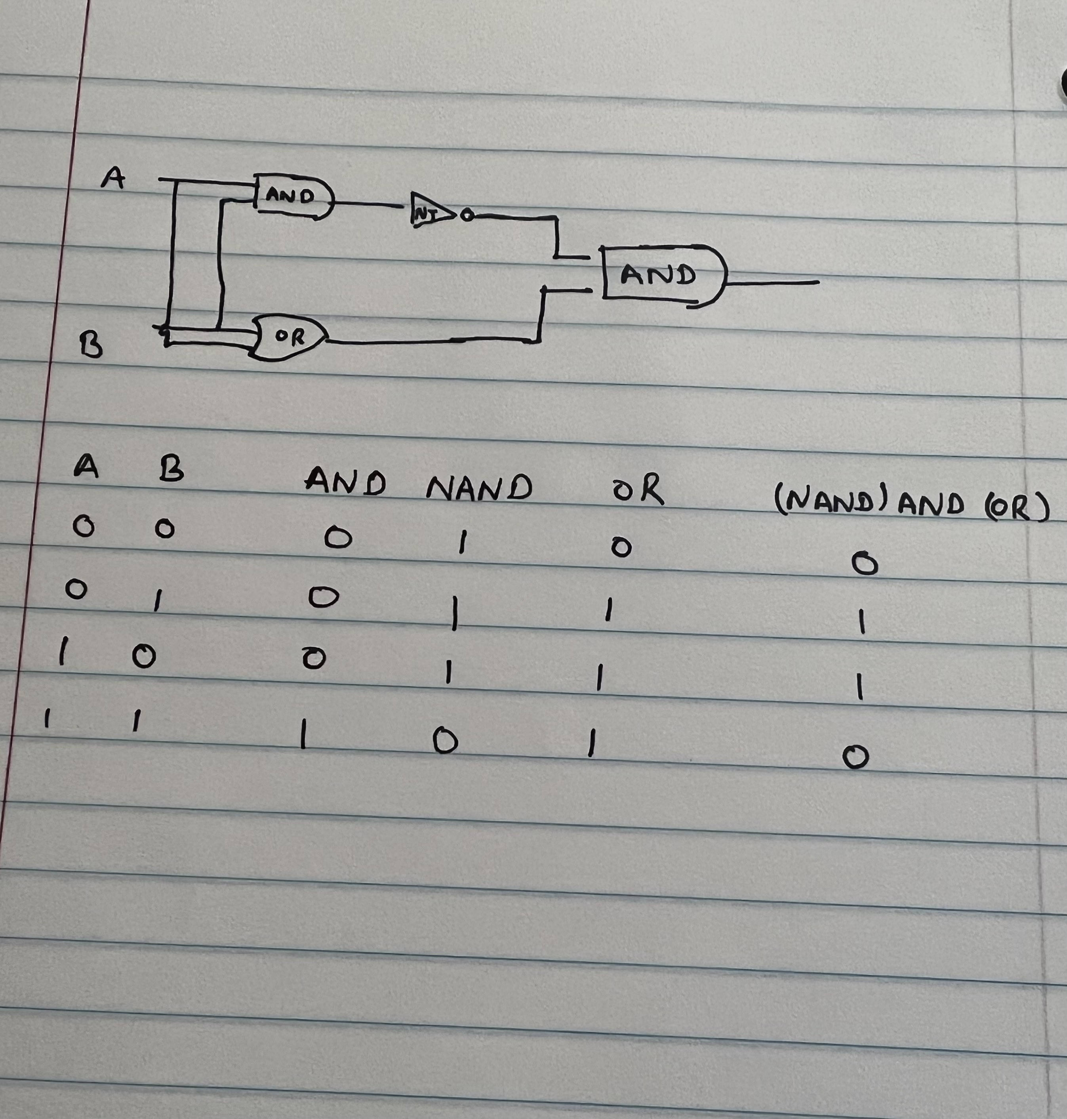

**Reference: https://www.techtarget.com/whatis/definition/logic-gate-AND-OR-XOR-NOT-NAND-NOR-and-XNOR**

**7.** How many bits would you need to represent 2018 in binary? How many bytes is that? **[5 points]**

**=> 201810 = 111111000102 = 11 bits = 1.375 bytes**

**8.** Write CSE using ASCII code. Write CSE using Unicode. **[5 points]**

**=> CSE using ASCII :-**

**C-67 S-83 E-69**

**CSE using Unicode(**UTF-8 **):-**

**C-**U+0043 **S-**U+0053 **E-**U+0045

**9.** What were the shortcomings of Assembly languages? **[7 points]**

**=>**

1. More memory is needed for long programs
2. A code written on one machine can not be used on another machine. The code are not portable or platform independent.
3. The coding is complex and not easy to understand.
4. More effort and time is required to write code.

**10.** What were the advantages and limitations of ALGOL? **[8 points]**

**=> Advantages of ALGOL :-**

• ALGOL 58 introduced the concept of data types as well as compound statements.  
• When ALGOL was first developed, it used a block structure that included data and other instruction statements in the same format as a whole program.  
• As the first language to use nested function declarations with lexical scope, ALGOL.

**Disadvantages of ALGOL :-**

• It lacked standardized input/output, making portability difficult;   
• ALGOL 60 featured features that were too flexible, making it difficult to learn and inefficient to apply.

**11.** What is the difference between parameters and arguments of a procedure? Explain with appropriate examples. **[7 points]**

**=>** The parameter is a variable declared during function. The variable has its scope inside the function.

The argument is the value that is passed when a function is called.

Eg :

function trial(var a, var b)// variable a and b are parameter of function trial

{

let c = a+b;

return c

}

trial(3,5)// this is a function call and 3 and 5 are the arguments for the function.

**12.** Write a recursive factorial function/method in C++ or Java (No limitation on number of lines. **[7 points].**

**=>int factorial(int x){**

if (x==0 || x==1){

return 1;

}

else {

return x*factorial(x-1);

}

}

**13.** Explain Language Syntax and Language Semantics in your own words. **[10 points]**

**=>** The syntax are the rule that should be followed by programmer when writing a code. The syntax defines the structure of the code.

Example: if(a==0){} If should be defined with an expression followed by the code in the parenthesis.

**14.** Explain how Java codes are compiled and then interpreted. **[10 points]**

**=>** The compiler is program that converts the user code(text) into java file with class extension. This file makes the code platform independent.

A Java interpreter is a piece of software that transforms high-level program statements into Assembly Level Language. It's intended to read the input source program before translating it instruction by instruction.

**15.** Explain the following terms: **[6 points]**

a. Syntactic sugar

b. API

**Syntactic sugar-** Shortcuts that a programming language offers to make it simpler to read and write without introducing any new capability are known as syntactic sugar.

For example:-   x=x+10 can also be written as x+=10”

**API**- Application Programming Interface is referred to as API. API is essentially a group of protocols and routes created to allow two pieces of software to communicate with one another.

**Extra credit (bonus question):**

**16.** Do you think that C programming language is a successful programming language even though it’s not the most popular language today? Explain your reasonings. **[10 points]**

**=>** For the following reasons, the C programming language is successful even if it is not widely used today:  
  
Fast - All contemporary CPUs are constructed using C, and the only option to increase speed is to use Assembly Language.  
  
Simplicity - Because C doesn't include constructors, destructors, name manglings, trash collectors, etc., its performance is simpler to estimate and its build times are shorter.  
  
Versatile – C is the greatest language to get to the core because it is used to write the majority of kernels. C is an excellent choice for IOT device programming because it doesn't require large systems.  
  
With Lua, which offers abstractions and flexible programming while running, C may always be linked for dynamic power.

Old - C has been been for a while and is still in use, therefore a lot of programmers have made sure that it is great.  
  
Due to its simplicity and usability, C is the ideal programming language to begin with.