FRONTEND DEVELOPMENT
LAB2: A static website to implement inline css,
Example:
<h1 style="color: red; font-size: 40px;">
Hello World
</h1>
WEBSITE PREVIEW
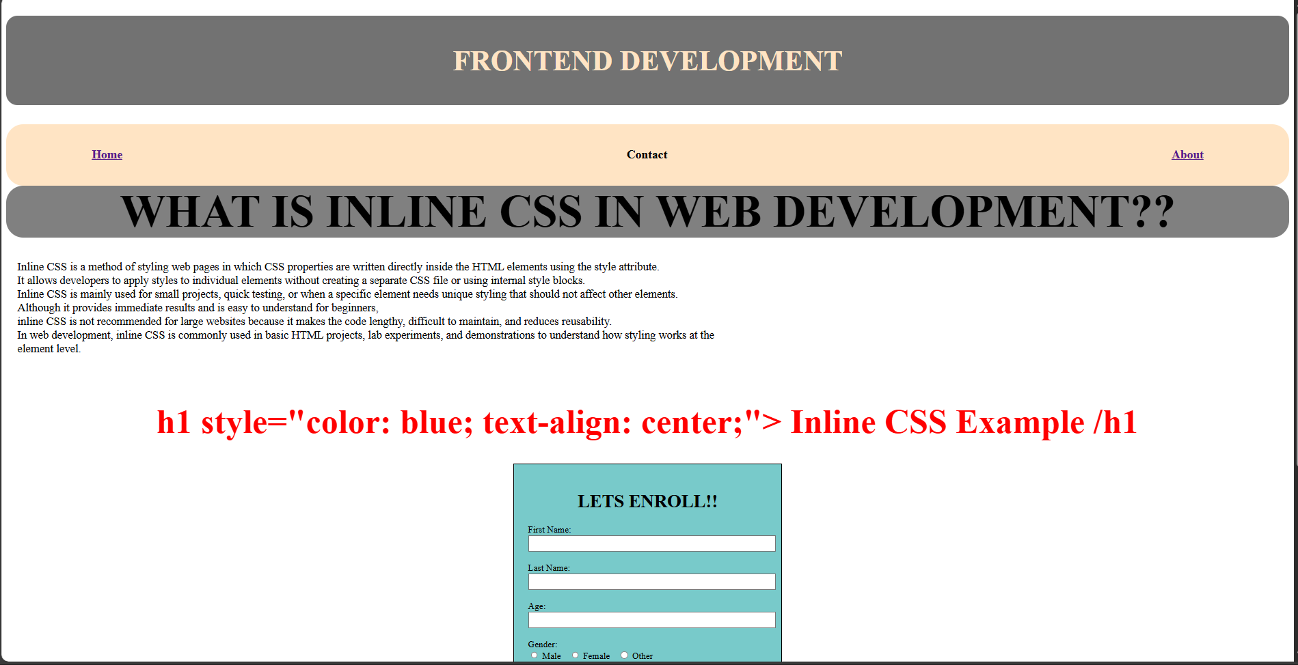
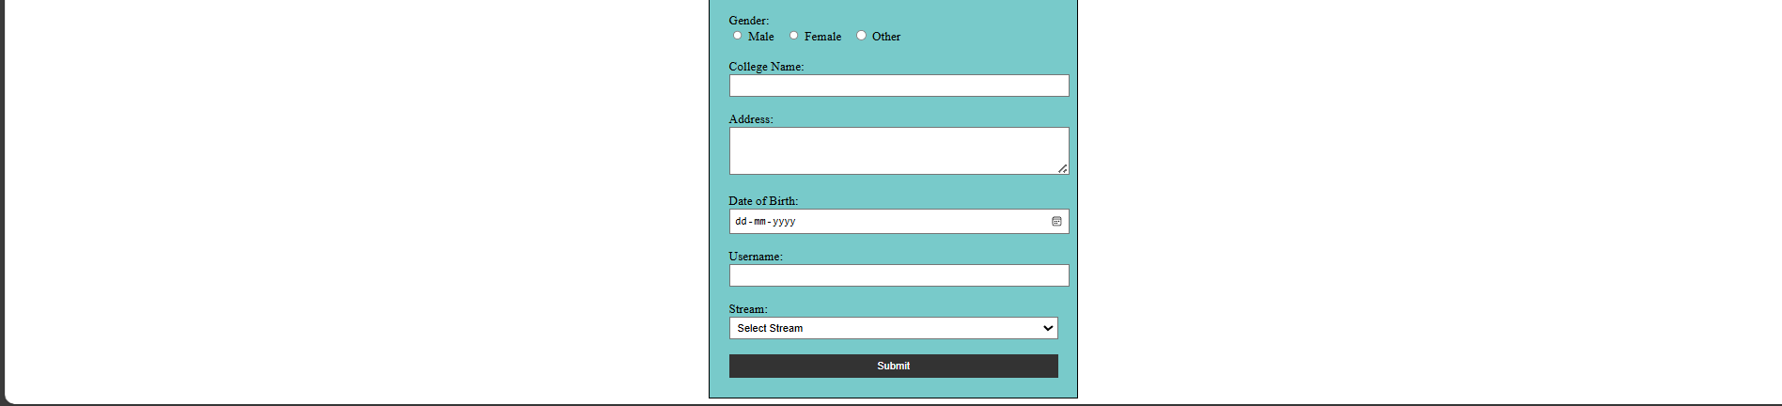

HOME:
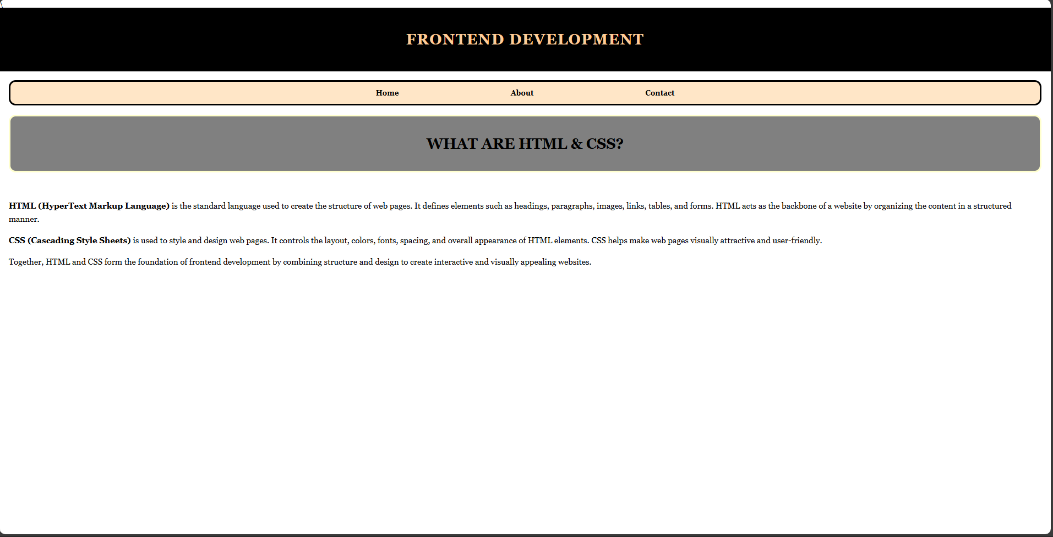

CODE:
<!DOCTYPE html>
<html lang="en">
<head>
<meta charset="UTF-8">
<meta name="viewport" content="width=device-width, initial-scale=1.0">
<title>Document</title>
</head>
<body style="background-color:rgb(255, 255, 255)">

<h1 style="border-radius: 20px;font-size: 50px;text-align: center;background-color: rgb(114, 114, 114);color: bisque;font-family: 'Times New Roman', Times, serif;padding: 50px;text-align: center;">FRONTEND DEVELOPMENT</h1>
<div style="border-radius: 30px; display: flex; font-size: large;color: rgb(0, 0, 0); background-color: bisque; padding: 20px;gap: 30px;text-align: center;justify-content: center;gap: 40%;">
<a href="home.html"><h3 style="text-align: center;">Home</h3></a>
<h3 style="text-align: center;">Contact</h3>
<a href="about.html "><h3 >About</h3></a>
</div>
<h1 style="font-size: 80px; text-align: center; background-color: grey;margin: 0%;border-radius: 30px; ">WHAT IS INLINE CSS IN WEB DEVELOPMENT??</h1>

<p style="display: inline-block; vertical-align: top; padding: 20px; text-align: left; font-size: 20px; width: 55%; color: rgb(0, 0, 0) ; ">
Inline CSS is a method of styling web pages in which CSS properties are written directly inside the HTML elements using the style attribute.
<br>It allows developers to apply styles to individual elements without creating a separate CSS file or using internal style blocks.
<br>Inline CSS is mainly used for small projects, quick testing, or when a specific element needs unique styling that should not affect other elements.
<br>Although it provides immediate results and is easy to understand for beginners,
<br>inline CSS is not recommended for large websites because it makes the code lengthy, difficult to maintain, and reduces reusability.
<br>In web development, inline CSS is commonly used in basic HTML projects, lab experiments, and demonstrations to understand how styling works at the element level.
</p>

<h1 style="text-align: center; color: red;font-size: 60px;"> h1 style="color: blue; text-align: center;">
Inline CSS Example
/h1
</h1>

<form style="width: 420px;background-color:rgb(120, 202, 202);padding: 25px;border: 2px solid rgb(0,0, 0);color: rgb(0, 0, 0);margin: auto;">

<h1 style="text-align: center;">LETS ENROLL!!</h1>
<label>First Name:</label><br>
<input type="text" style="width:100%; padding:6px;"><br><br>

<label>Last Name:</label><br>
<input type="text" style="width:100%; padding:6px;"><br><br>

<label>Age:</label><br>
<input type="number" style="width:100%; padding:6px;"><br><br>

<label>Gender:</label><br>
<input type="radio" name="gender"> Male
<input type="radio" name="gender" style="margin-left:15px;"> Female
<input type="radio" name="gender" style="margin-left:15px;"> Other
<br><br>

<label>College Name:</label><br>
<input type="text" style="width:100%; padding:6px;"><br><br>

<label>Address:</label><br>
<textarea rows="3" style="width:100%; padding:6px;"></textarea><br><br>

<label>Date of Birth:</label><br>
<input type="date" style="width:100%; padding:6px;"><br><br>

<label>Username:</label><br>
<input type="text" style="width:100%; padding:6px;"><br><br>

<label>Stream:</label><br>
<select style="width:100%; padding:6px;">
<option>Select Stream</option>
<option>Computer Science</option>
<option>Information Technology</option>
<option>Electronics</option>
<option>Mechanical</option>
<option>Civil</option>
</select><br><br>

<button style="width:100%; padding:8px;background-color:#333;color:white; border:none;">
Submit
</button>

</form>

</body>
</html>

HOME PAGE CODE:
\<!DOCTYPE html>
<html>
<head>
<title>Frontend Development - Home</title>
</head>

<body style="margin:0; background-color:#ffffff; font-family: Georgia, serif;">

<div style="background-color:black; padding:30px;">
<h1 style="color:#ffcc99; text-align:center; letter-spacing:2px;">
FRONTEND DEVELOPMENT
</h1>
</div>

<div style="background-color:#ffe6c7; margin:20px; padding:15px; border:4px solid black; border-radius:15px;text-align:center;" >
<a href="home.html" style="margin:0 120px; text-decoration:none; color:black; font-weight:bold;">Home</a>
<a href="about.html" style="margin:0 120px; text-decoration:none; color:black; font-weight:bold;">About</a>
<a href="#" style="margin:0 120px; text-decoration:none; color:black; font-weight:bold;">Contact</a>
</div>

<div style="background-color:gray;margin:20px;padding:15px;border-radius:15px;border:4px solid #ffffcc ">
<h2 style="text-align:center; font-size:32px;">
WHAT ARE HTML & CSS?
</h2>
</div>

<div style="padding:20px; font-size:18px; line-height:1.6;">

<p>
<b>HTML (HyperText Markup Language)</b> is the standard language used to create the
structure of web pages. It defines elements such as headings, paragraphs, images,
links, tables, and forms. HTML acts as the backbone of a website by organizing
the content in a structured manner.
</p>

<p>
<b>CSS (Cascading Style Sheets)</b> is used to style and design web pages.
It controls the layout, colors, fonts, spacing, and overall appearance of HTML
elements. CSS helps make web pages visually attractive and user-friendly.
</p>

<p>
Together, HTML and CSS form the foundation of frontend development by combining
structure and design to create interactive and visually appealing websites.
</p>

</div>

</body>
</html>

