- Increase the font size of SEVANA NATURALS. Naturals is not visible
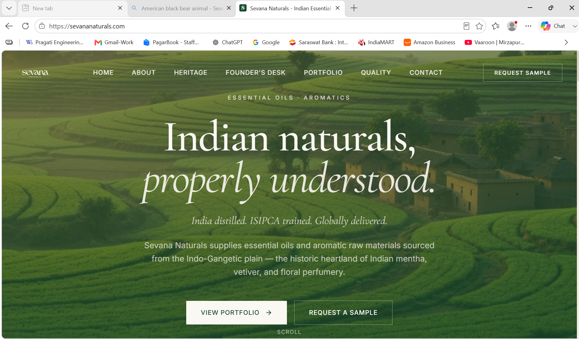
- The alignment of the picture I,e the rectangle of lush green fields needs to be corrected and realigned with with the other 2 images on the right.
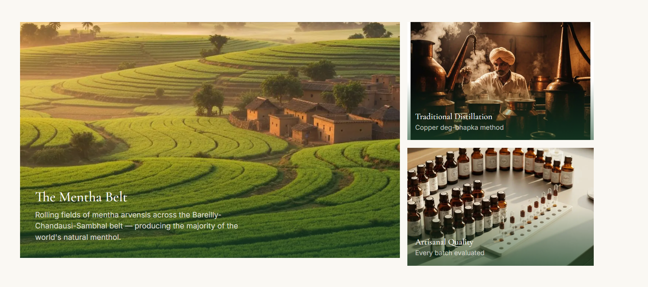

- The Sevana Naturals logo at the bottom left of the screenshot is very small. Make it larger.
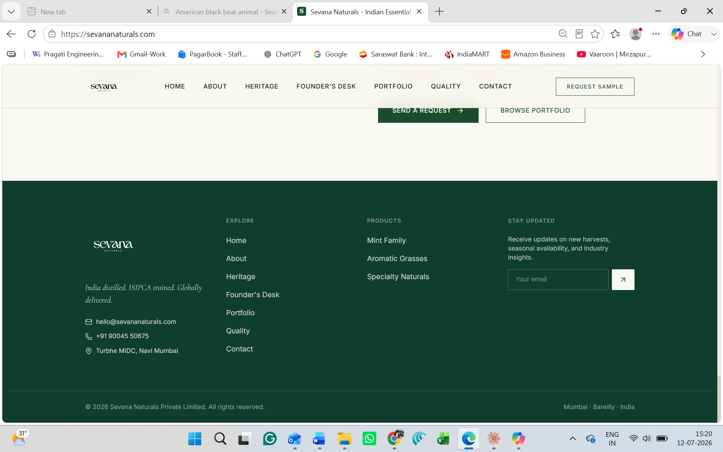

- Add Sheetal’s picture in the left side area. Photo attaching along with the document.
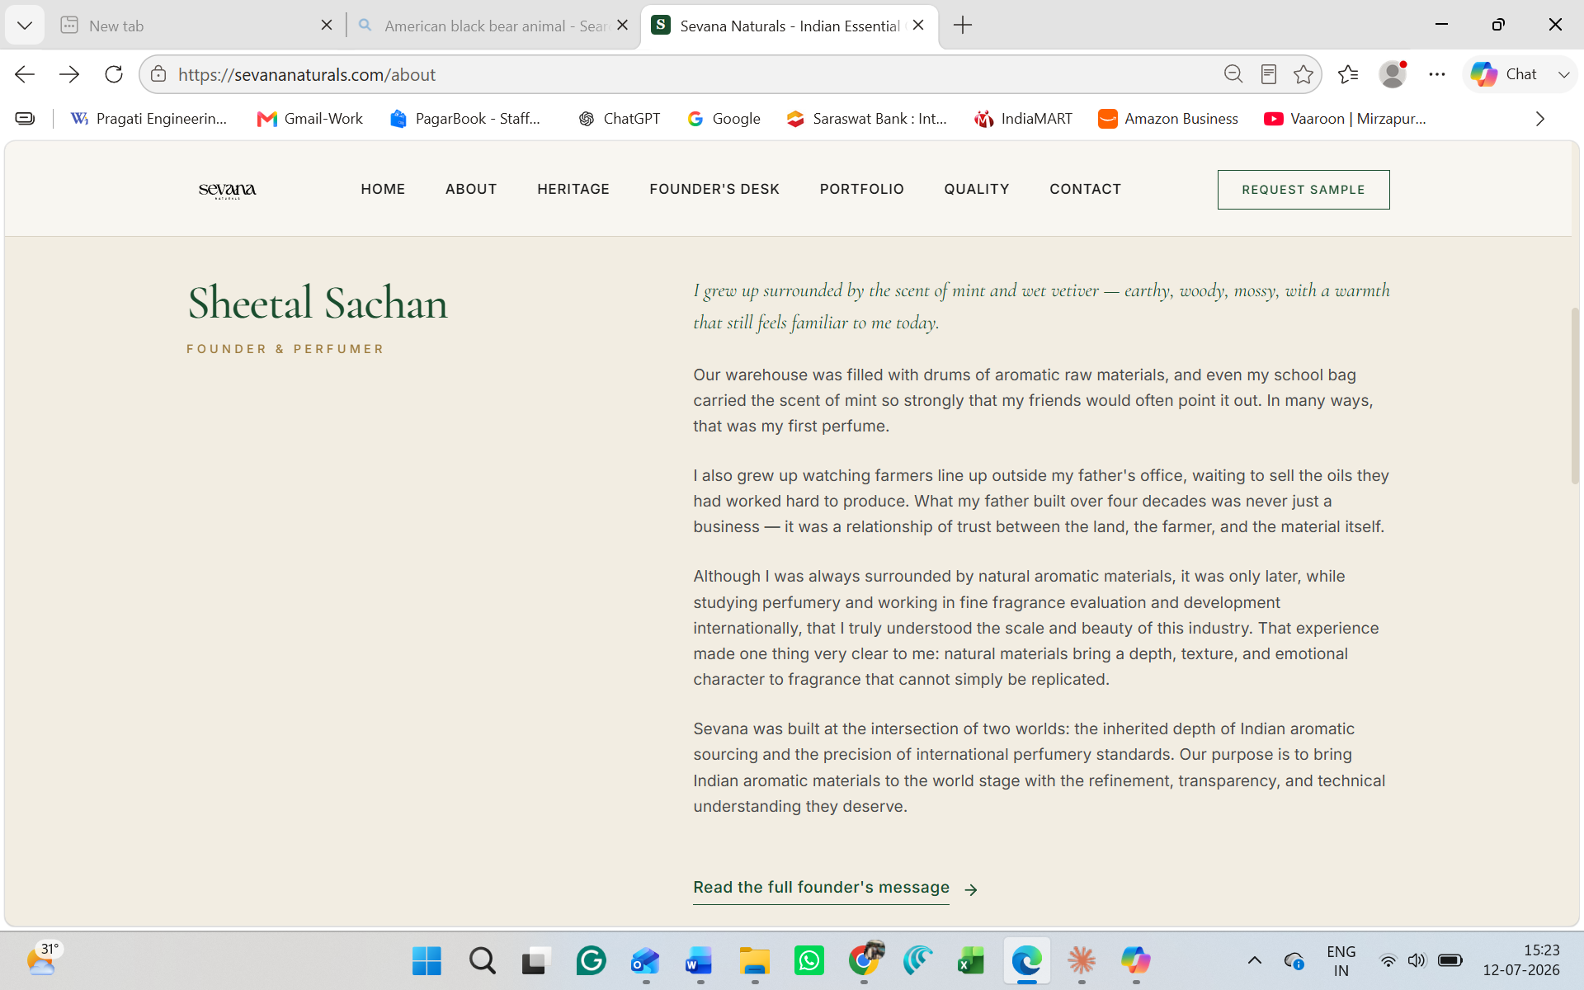

- The inheritance message is common in founder’s desk and heritage. You can change the message in heritage, keep the same in founder’s desk full story.
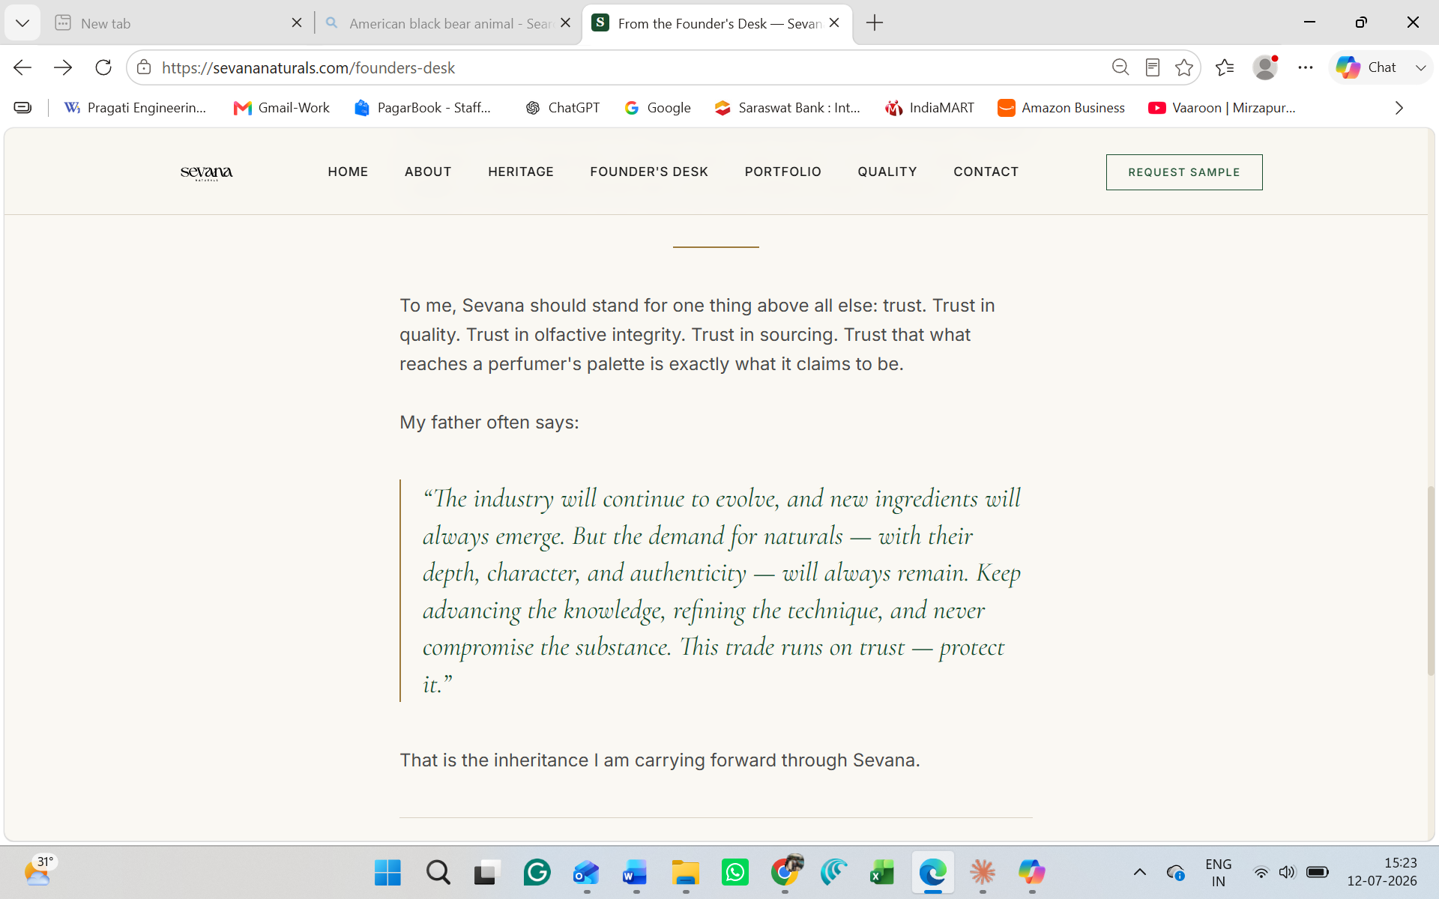
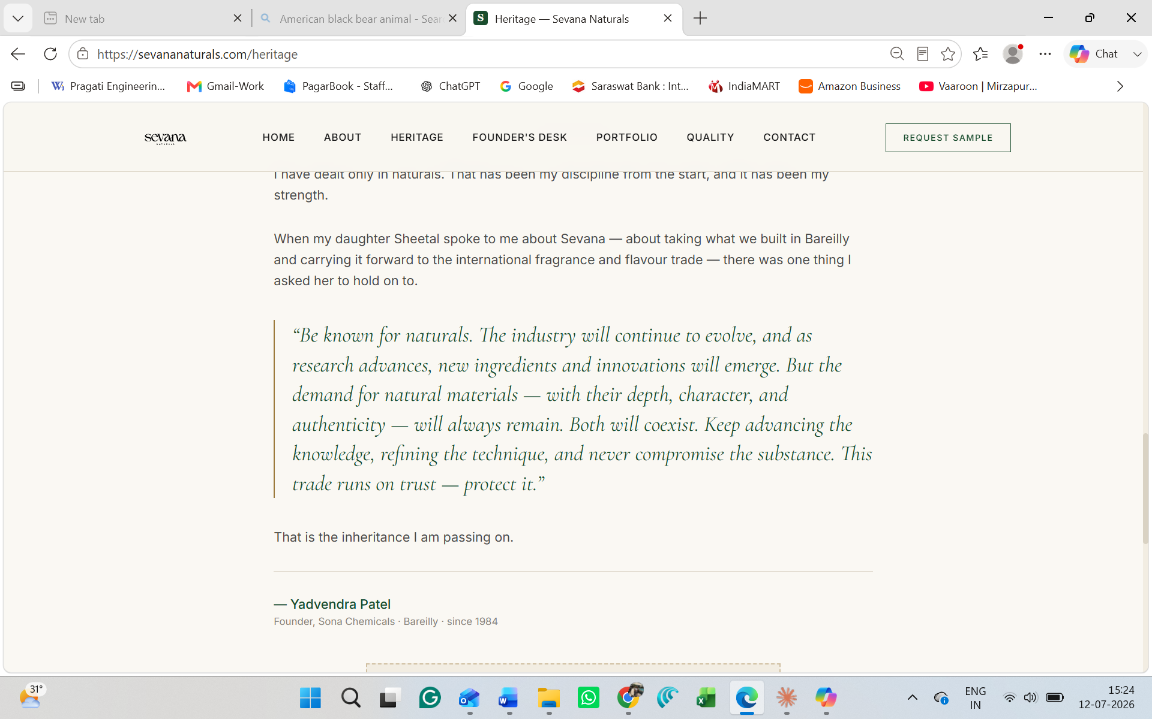
- In video coming soon can you upload the video?
