Section-Roll: A-33

Name: Gaurav Patil

Problems:

1. Find the roots of the polynomial using Numpy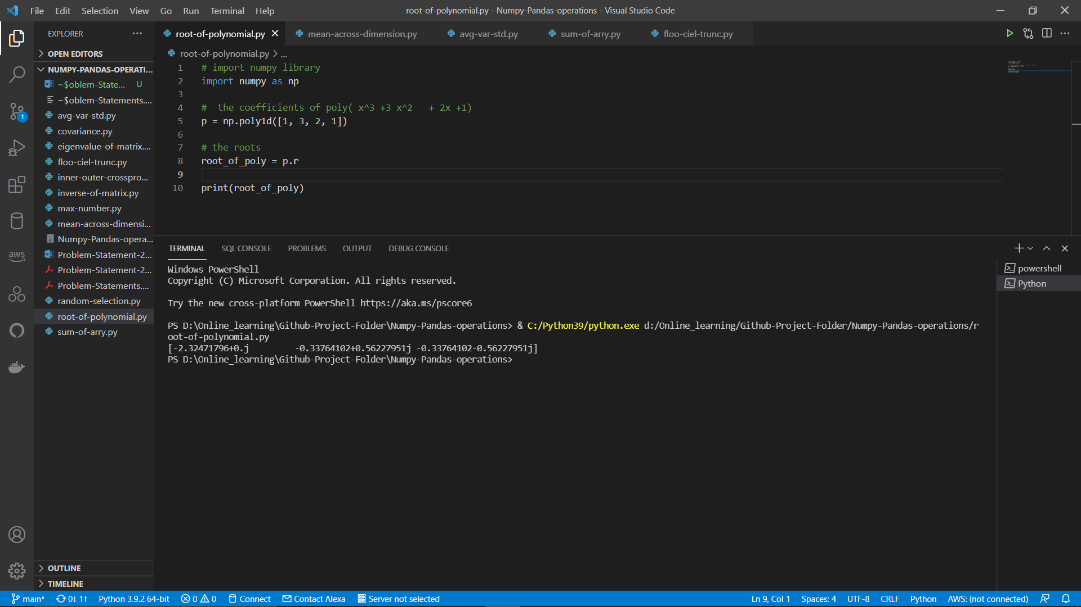
2. Calculate the mean across the dimension in a 2D matrix.

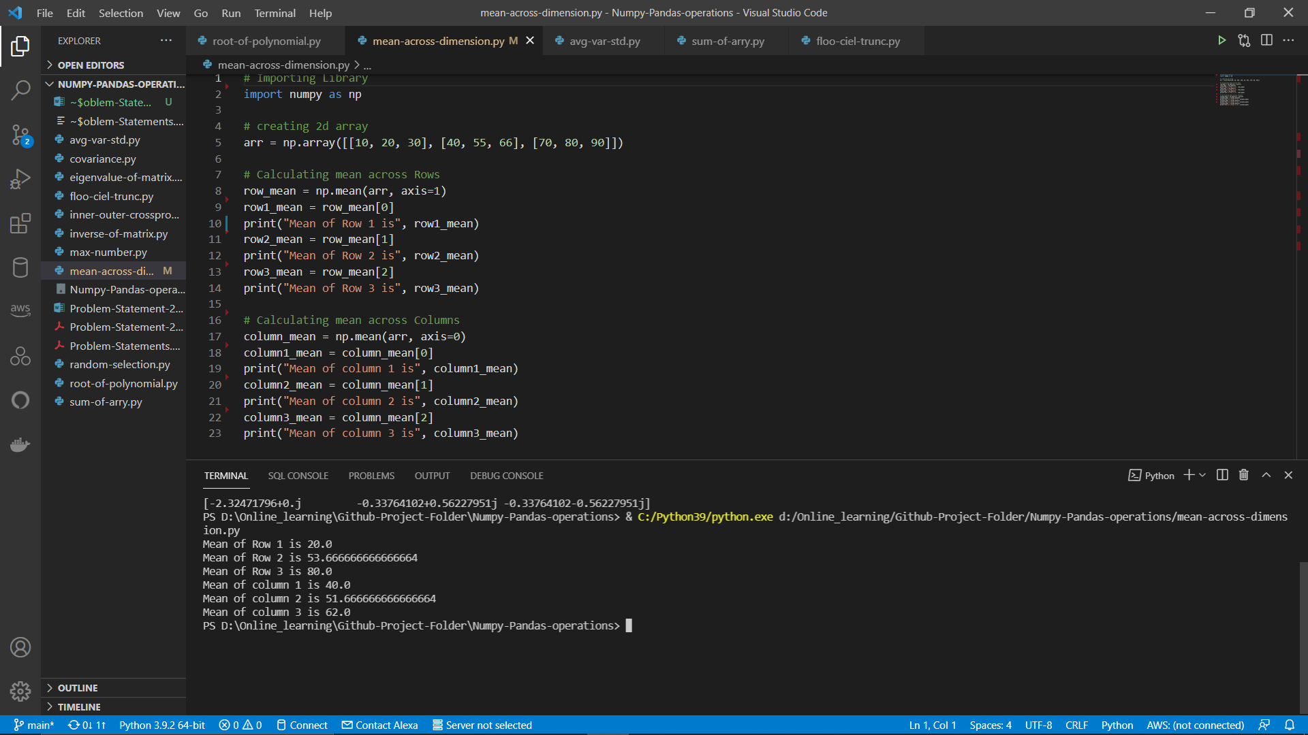

1. Calculate average , variance and standard deviation in python using numpy. 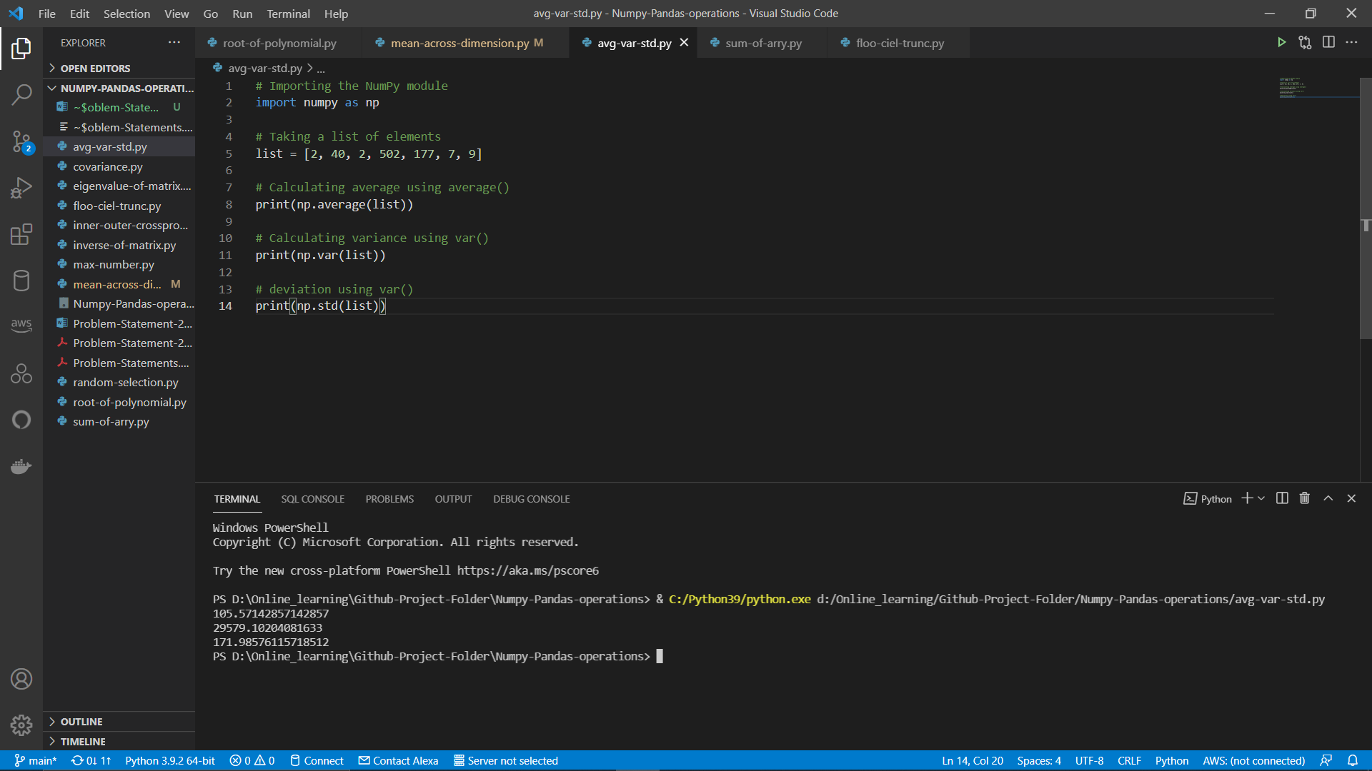
2. Calculate sum of all the columns in a 2 D array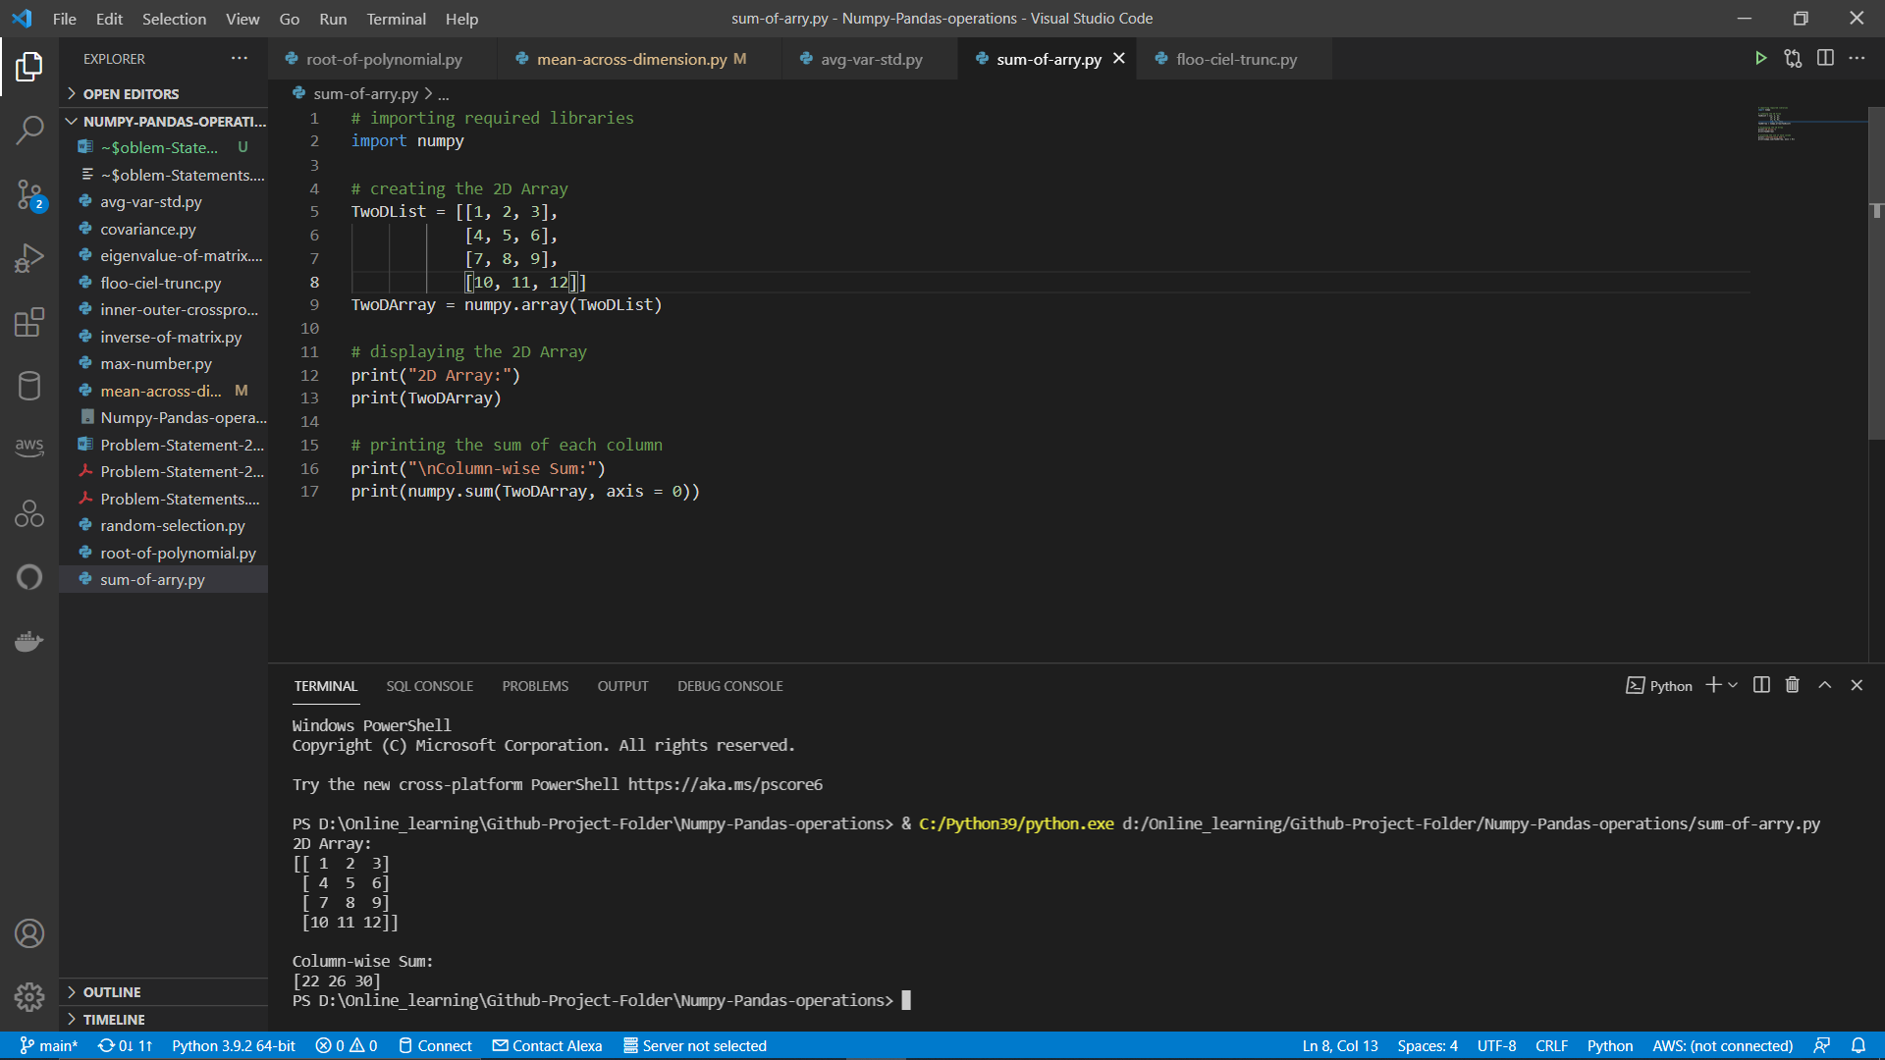
3. How to get the floor , ceiling and truncated values of the elements of a numpy array. 