**AIRPORT Flight Control Simulator**

**System Architecture**

Team- ARMOUR DATE-4/11/22

**Team Members:**

* Nimish Suri
* Sree Vagdevi Kandukuri
* Pardarshee Priya
* Abhay Ojha
* Akarsh Roy
* Kumar Gaurav
* It is a web application made with the help of HTML, CSS and JavaScript.
* **Bootstrap framework** is used to make interactive User Interfaces.
* **Github** is used for version control.
* Sessions are used to store data for different users simultaneously.
* A simulate() function is called at a certain interval of time to show updated details of each plane regularly.

**Data Structure used:**

* Array of objects: To store plane details.

**Home Page:**

1. Hyperlink to Automatic simulation page

* connects main page to automatic simulation page

1. Hyperlink to Manual simulation page

* connects main page to manual simulation page

**Common Scenarios:**

* Plane **BOE114** has some serious faults and needs an emergency landing andholding pattern is full but **BOE22** is waiting for its turn at the last holding pattern.

In the above case is_hold() function is called which returns true since the holding pattern is at max of its capacity. Since it's an emergency case and we have a single runway system, a free() function is called which moves the plane at the end of the queue out of the holding pattern. Hence, giving entry to the emergency plane.

* Plane **BOE114** is at the top of the queue at the holding pattern, still it is not allowed to land immediately.

Since Plane BOE114 is at the top, runway() function is called which returns false as runway is not free so wait() is called which holds the plane at its current position.

**Swimlane Diagram:**

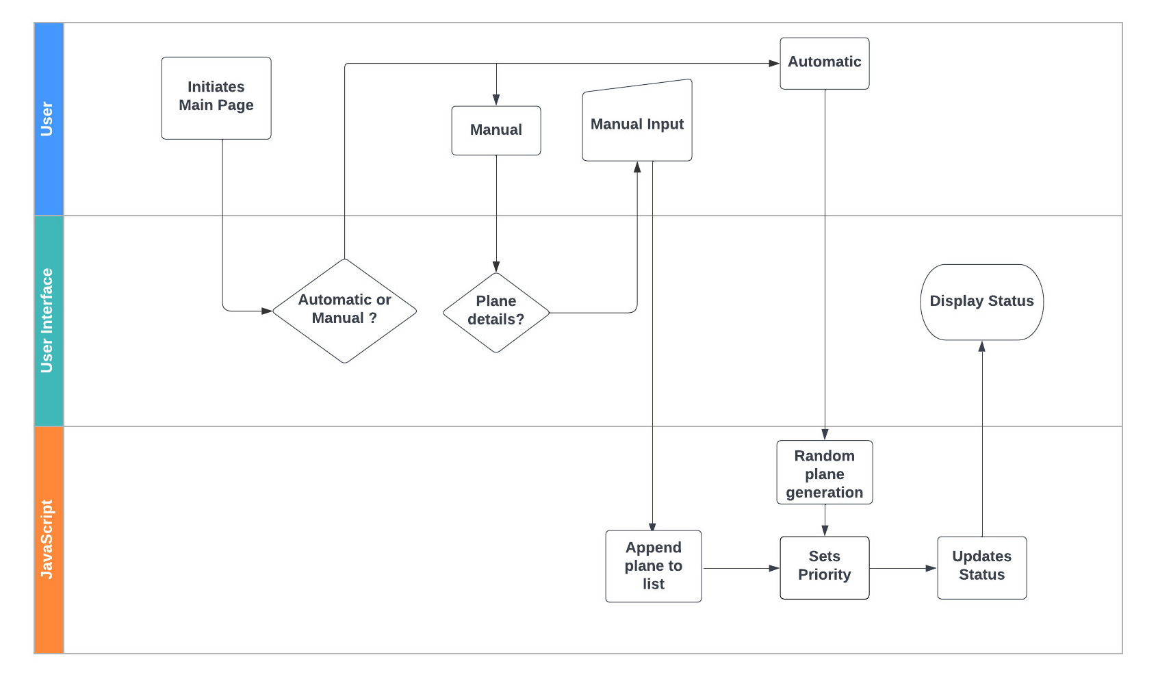

**Working of system when plane is not in emergency:**

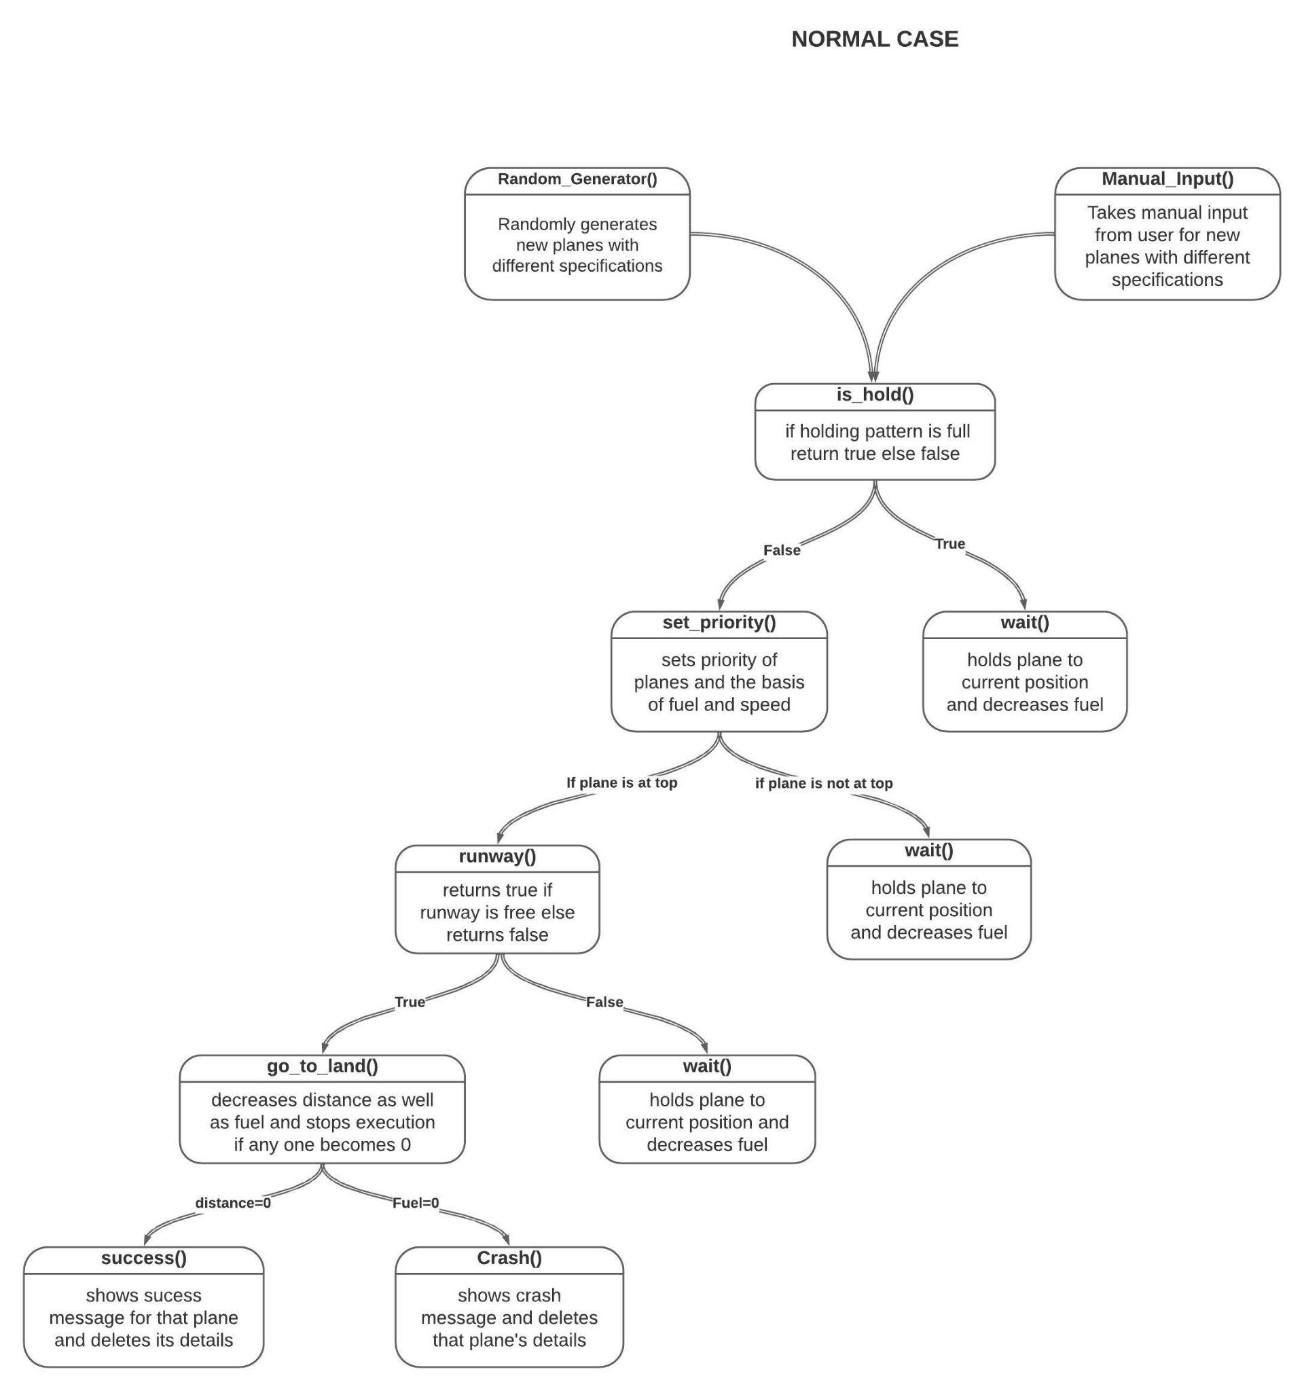

**Working of system when plane is in emergency:**

