

A Mini Project Report

NutriVision: AI-Based Food Recognition
and Smart Diet Planner

In Subject: Deep Learning

by

Sanjana Chintawar (373068)
Gaurav Sonar (373074)
Anuja Chintawar (373060)
Akshat Baheti (373023)

Department of Artificial Intelligence and Data Science
VIIT

2025–2026

Index

Sr. No. | Topic | Page No.
1 | Abstract | 3
2 | Introduction | 4
3 | Problem Statement | 5
4 | Objectives | 6
5 | Literature Review | 7
6 | System Design | 8
7 | Deep Learning Models Used | 10
8 | Methodology | 11
9 | Data Model & Nutrition Database | 12
10 | Technology Stack | 14
11 | Key Features | 15
12 | Snippets | 16
13 | Advantages | 18
14 | Limitations | 19
15 | Future Scope | 20
16 | Result and Discussion | 21
17 | Conclusion | 22
18 | References | 23

1. Abstract
NutriVision is an AI-based solution that uses deep learning algorithms to provide an accurate identification of each type of food in an image and provide information regarding its calorie content and macronutrients. The system will analyze an image of the food consumed by the user and identify all types of foods present in that particular image. NutriVision will also extract data regarding the nutritional values of that particular food from the Indian Food Composition Table (IFCT). It will provide an exact calculation of calories and macronutrients ingested by the user in their meals.
In terms of technology, NutriVision utilizes YOLO (You Only Look Once) model for real-time object detection and classification of the images provided. Additionally, it uses a CNN classifier model (EfficientNet or ResNet) for identifying various objects in the same image and determining what kind of food it is.
In addition to analyzing the nutritional value of food consumed, NutriVision also provides a feature for creating customized diet plans. It will take into consideration the user's age, weight, height, gender, activity level, and health goal to provide recommendations regarding their daily meal plan. NutriVision was developed using Python and Streamlit.

2. Introduction
Due to the hectic nature of life in the modern world, keeping track of a proper and healthy diet plan has become quite a challenge. Although everyone understands the significance of counting calories, monitoring what they are eating becomes extremely difficult and cumbersome. Currently available methods such as manually searching for calorie values and recording meals using spreadsheets have proven to be both time-consuming and error-prone.
Adding another layer of complexity, individuals who prefer traditional Indian cuisine are confronted with the challenge of determining the nutrition information of dishes that consist of rice, dal, various vegetable curries, chapati, and additional accompaniments in a single plate. In many cases, applications available across the globe do not provide reliable nutritional information for Indian food items.
NutriVision was created to solve this problem. Using deep learning technology, users can easily snap a photo of their plate and get instant feedback on the nutritional value of their meal. Everything from recognizing each food item on the plate, identifying them, calculating the number of calories and macronutrients using available Indian nutritional databases, all happens automatically. The system is designed to help:
- People wishing to track their calorie consumption throughout the day, but do not wish to do so manually
- Gym-goers monitoring macronutrients while following a specific diet regimen
- Nutritionists or dietitians requiring a fast way to analyze the client’s meal
- Health care apps for diet-based health problems management

NutriVision makes tracking your nutrition as easy as taking a picture.

3. Problem Statement
Even with increasing awareness about health and fitness, proper calorie tracking still eludes the masses due to various reasons. This project tackles the following issues:

1. Manual Tracking Becomes Tedious Very Quickly: Calculating the number of calories in a dish at home becomes difficult as one needs to look up each ingredient separately, estimate quantities, and perform calculations – a task which most people give up after a few days.
2. Existing Applications are Limited to International Foods: Applications available globally to track calorie intake such as MyFitnessPal provide inadequate information on popular Indian dishes like dal tadka, sabzi, khichdi etc. making their data inaccurate.
3. Plate Level Multi-item Detection is Challenging: It is very difficult to accurately recognize each item present on the plate especially in case of Indian thalis where there are between 5-7 items on the plate. Image classification fails miserably to detect each dish.
4. Lack of Personalized Diet Suggestion: Calorie calculators simply add up the total calories and fail to correlate with the individual’s personal goal or physical requirements, making it difficult to utilize the collected information.
5. Lack of Real-time Tracking: Many nutritional tools available online require users to go through the manual process

4. Objectives
- The purpose behind selecting this end-to-end deep learning pipeline is to create an automatic body and forms detector of various food items in a single meal photo.
- To deploy an object detection model based on YOLO, which can be used to determine the position of each food item on the plate using bounding boxes.
- To add a CNN-based food classifier (EfficientNet / ResNet) that can correctly identify the name of each detected food region.
- To access nutritional information -calories, protein, carbohydrates and fats- of individual identified foods in the Indian food composition tables (IFCT) database.
- To determine the total amount of calories and macronutrients of the whole meal depending on the discovered items.
- To create a customized diet planning system that approximates the daily calorie needs based on the user profile information (age, weight, height, gender, activity level, and health goal).
- To create an interactive and easy-to-use interface with Streamlit that displays detection results, nutritional breakdown, and diet recommendations in a clear visual representation.
- To address Indian meal habits and food types in particular, the gap existing among globally-based nutrition apps will be filled.

5. Literature Review
The body of research in automated food recognition and dietary assessment has expanded significantly over the last ten years due to the developments in deep learning and the existence of large food image datasets on dietary assessment. Initial methods employed traditional machine learning methods including Support Vector Machines (SVMs) and hand-crafted features, though these methods were found to be poor at the visual complexity of real-world food images.
The field was changed with the introduction of deep Convolutional Neural Networks (CNNs). Architectures based on GoogLeNet applied to the Food-101 dataset showed that deep learning models were capable of significant food classification tasks with an accuracy of over 80%. Later work with ResNet, Inception, and EfficientNet pushed these benchmarks further, with EfficientNet in particular proving highly effective due to the combination of depth, width, and resolution simultaneously in its compound scaling approach.
The development of YOLO (You Only Look Once) as a real-time object detection model paved the way to multi-item food detection - the capability to identify and classify a number of distinct food items in a single image at the same time. YOLO is much faster and more suitable to real-time use, unlike region-based methods like Faster R-CNN.
On the nutrition front, studies have indicated that region-specific food databases are important. Research into the nutrition patterns of Indian people found that when the Indian Food Composition Tables (IFCT) was used, there was a much higher accuracy in nutritional evaluation of the Indian populations than was found in world data bases, principally because of the vast differences in methods of preparation, proportions of ingredients, and serving conventions across cuisines.
The state of the art in automated dietary assessment systems is the combination of YOLO-based detection with CNN-based classification along with a region-specific nutritional database. NutriVision is based directly on this foundation but directly tackles the underserved Indian food recognition issue.

6. System Design

NutriVision is a pipeline architecture based on a sequential, modular pipeline architecture. All stages of the pipeline have a certain task to complete, and the result of one stage is passed to the next module to help separate the concerns and make them easy to maintain.
Stage 1 — Image Input
A user adds a photo of his or her meal using the Streamlit web interface. It is preprocessed, i.e., resized, normalized, and converted to the corresponding tensor format, and then sent to the detection module. The system can support most popular image formats such as JPEG and PNG.
Stage 2 — Food Detection (YOLO)
The preprocessed image is passed to a YOLO object detection model. YOLO processes an entire image in a single forward pass and produces a list of bounding boxes, each the spatial location of one of the detected food items on the plate. Every bounding box has a confidence score which describes the confidence of the model regarding the detection. Items whose confidence falls below a specified value are filtered to minimize false positives.
Stage 3- Food Classification (CNN)
Each bounding box region on the original image that is detected is cropped and passed separately to a CNN-based classifier - EfficientNet or ResNet, fine-tuned on an Indian food dataset. The classifier is used to predict the name of the food in each crop.
Stage 4 — Nutrition Retrieval
Each food name that is classified is used as a key to query the Indian Food Composition Tables (IFCT) database. The database will give per-serving nutrition values of calories (kcal), protein (g), carbohydrates (g), and fats (g).
Stage 5 — Calorie Aggregation
The number of calories of all the foods identified are added together to give the total meal in terms of calories. The macronutrient intake is also aggregated and reported as a form of structured nutritional report.
Stage 6 — Diet Planning
The diet planning module takes user profile data, age, weight, height, gender, activity level, health goal, and applies the Harris-Benedict equation along with an activity multiplier to calculate the Total Daily Energy Expenditure (TDEE) of the user. The calories in the meal intake are deducted against this target to show the remaining calories to be taken in the day and the system provides meal recommendations to enable the user to remain within his/her target.

7. Deep Learning Models Used

YOLO — Object Detection
YOLO (You Only Look Once) is a one-stage real-time object detection structure. In contrast to two-stage detectors like Faster R-CNN which first propose regions of interest, and then classify them, YOLO treats detection as a single regression problem. The whole image is split into a grid, and each cell of the grid predicts bounding boxes and probability of the class in a single forward pass through the network.
In this project, YOLOv8 (or YOLOv5) is employed, and then trained on a hand-created annotated dataset of Indian food images. The model is trained to identify the spatial location of foodstuffs - rice, dal, sabzi, chapati and others - irrespective of the way they are placed on the plate.

EfficientNet — Food Classification
EfficientNet is a family of CNN architectures that simultaneously scale model depth, width, and input resolution using a compound coefficient. EfficientNet is better than ResNet or VGG: it can be trained to higher accuracy with less computational cost.
As a backbone classifier, EfficientNet-B3 or B4 is utilized and fine-tuned on a collection of Indian food images. The last classification layer is changed by a custom softmax head, corresponding to the number of supported food categories.

Transfer Learning Strategy
Both models are trained with transfer learning - initialized with pretrained weights of ImageNet and fine-tuned on the Indian food dataset. It is an effective method to minimize the size of labelled training data needed and decreases convergence speed. Data augmentation methods such as random flipping, rotation, changing brightness and colour jitter are used during training to enhance model generalization.

Model Evaluation Metrics
- Detection accuracy: mean Average Precision (mAP) at IoU threshold 0.5
- Classification accuracy: top-1 and top-5 accuracy on validation set
- Inference speed: average time per image (milliseconds) on CPU and GPU
- Calorie estimation error: Mean Absolute Error (MAE) between predicted and ground truth calories

8. Methodology
1. Collection and Preparation of a Dataset: Collected an Indian food image dataset of 50+ food categories and 500+ food images. Open datasets (Food-101, UEC Food-256) and additional images scraped with the agreement of food blogs and repositories were used as sources of images. LabelImg was used to create bounding box annotations to be used in training YOLO.
2. Data Preprocessing: All the images were resized to 416x416 (to YOLO) and 224x224 (to EfficientNet). The values in the pixels were normalized to [0, 1]. Data augmentation was used: random horizontal flip, up to 15 degrees rotation, variation of brightness and contrast, and random crop.
3. Training YOLO Model: The annotated food detection dataset was trained on 100 epochs using an Adam optimizer with 0.001 as learning rate and 16 as a batch size. Training was done on Google Colab with an A100 GPU. The model was tested in terms of mAP 0.5 on the validation split.
4. EfficientNet Training: EfficientNet-B3 was fine-tuned on the food classification dataset, over 30 epochs, using transfer learning on ImageNet pretrained weights. Cross-entropy loss and the Adam optimizer were used. On plateau the learning rate was decreased to enhance convergence.
5. Nutrition Database Integration: IFCT data was inserted in a local SQLite database, keyed by food name. A lookup module was developed to enumerate the labels of the classifier output with IFCT keys and to retrieve the per-serving values of the macronutrients.
6. Diet Planner Module: Harris-Benedict equation was used to compute the Basal Metabolic Rate, (BMR), multiplied by the activity factor to obtain the total dietary energy. The adjustments of health goals (calorie deficit in weight loss, surplus in gain) were added over TDEE.
7. Streamlit Interface Development: The Streamlit interface was developed to take on image uploads, overlay bounding box overlays on the detected plate, show the nutritional breakdown table and present the diet recommendation panel with remaining daily calories.
8. Testing and Evaluation: End-to-end testing was performed on 200 hidden meal images. Accuracy of detection and classification, MAE of the calorie estimator, and response time of the system were measured and recorded.

9. Data Model & Nutrition Database
Two data sources are used by the system a custom annotated image dataset to train the model, and the Indian Food Composition Tables (IFCT) to retrieve nutritional information.

Training Dataset
- Food Image Dataset: 10,000+ images of 50+ categories of Indian food, divided into 80/10/10 training, validation and testing.
- Detection Annotations: YOLO format coordinates (class:id, x:center, y:center, width, height) of each food item.
- Classification Labels: Category labels to integer class IDs to the EfficientNet softmax layer.

IFCT Nutrition Database
The database of Indian Food Composition Tables is locally stored and is queried at inference time. It includes nutritional information, per-100g, of hundreds of Indian food items. The system associates each of the classified food labels with its IFCT record and normalizes the data to a standard serving size.

Examples of the entries in the nutrition database that will be utilized in the system:
Food Item | Calories | Protein | Carbohydrates | Fats
Rice | 200 kcal | 4 g | 44 g | 0.4 g
Dal | 150 kcal | 9 g | 25 g | 0.6 g
Potato Sabzi | 120 kcal | 2 g | 21 g | 3.5 g
Chapati | 104 kcal | 3.1 g | 18 g | 2.1 g

Calorie Calculation Example
When a meal plate containing rice, dal, potato sabzi, and chapati is analyzed, the system aggregates individual calorie values:

Food Item | Calories
Rice | 200 kcal
Dal | 150 kcal
Potato Sabzi | 120 kcal
Chapati | 104 kcal
Total Meal | 574 kcal

10. Technology Stack

Component | Technology Used
Food Detection | YOLO (You Only Look Once)
Food Classification | EfficientNet / ResNet (CNN)
Nutrition Database | Indian Food Composition Tables (IFCT)
Programming Language | Python
Deep Learning Framework | PyTorch / TensorFlow
User Interface | Streamlit
Data Preprocessing | OpenCV, NumPy, Pandas
Model Training | Google Colab / Local GPU
Version Control | Git & GitHub

11. Key Features
- Automated Multi-Item Food Detection: Recognizes multiple food items on a single plate in a single scan using YOLO, and does not require the user to specify what is in the image.
- CNN-Based Food Classification: The detected regions are classified with high accuracy using an efficiently tuned EfficientNet model, supporting 50+ Indian food categories.
- India-Specific Nutritional Data: Relies on the Indian Food Composition Tables (IFCT) to look up nutrition information, so that the correct calorie and macronutrient content of Indian food is achieved.
- Detailed Nutritional Breakdown: The system will report the calories, protein, carbohydrates, and fats separately, and the total meal summary.
- Personal Diet Planning: Calculates the number of calories a user needs daily based on the BMR and activity level, then subtracts the number of calories in the meal to display the remaining calories one needs daily.
- Meal Recommendations: Recommends balanced meal combinations to enable the user to meet his/her remaining daily nutritional requirements depending on his/her health objective.
- Visual Detection Output: Visualizes bounding boxes on top of the original food image to enable users to verify what has been detected and where on the plate it is located.
- Interactive Streamlit Interface: Easy-to-use web interface created with Streamlit and requires no technical skills to use the interface fully - just upload an image and you can see the full results.
- Real-Time Inference: The whole pipeline of uploading an image to providing a nutritional output can be completed in seconds, which offers a responsive and practical user experience.

12. Snippets

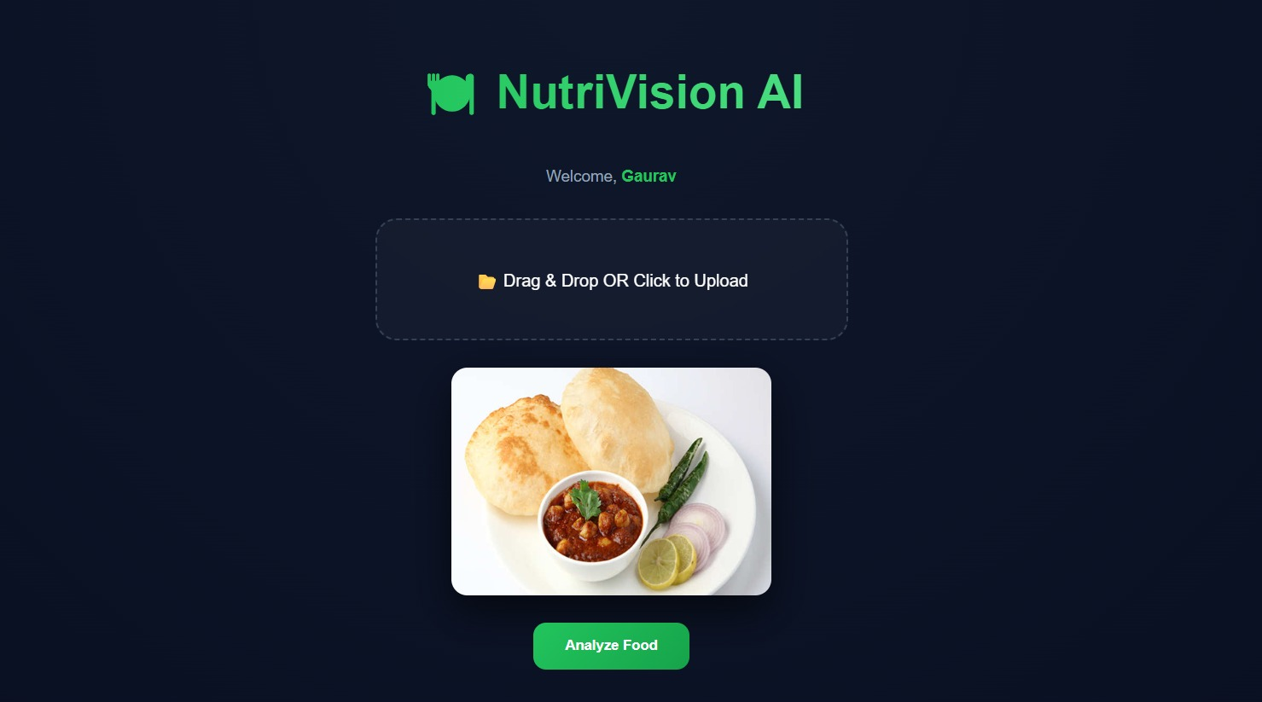
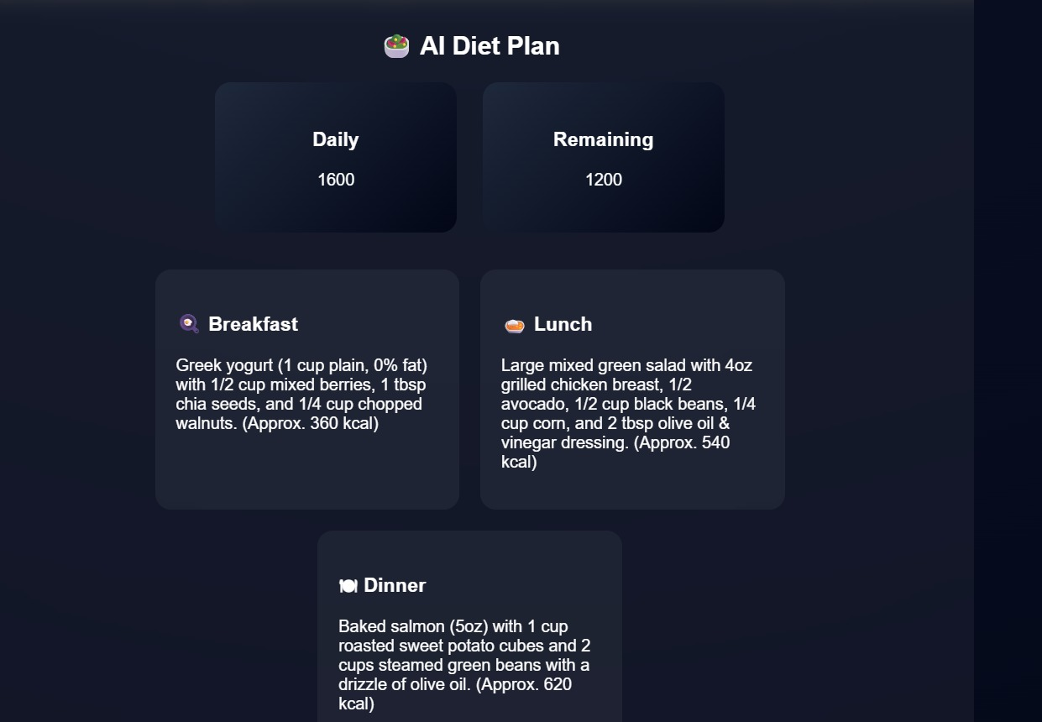

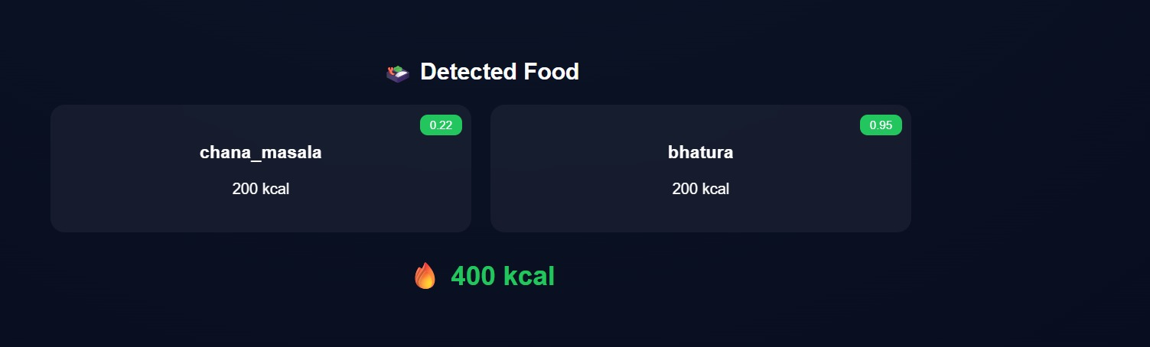

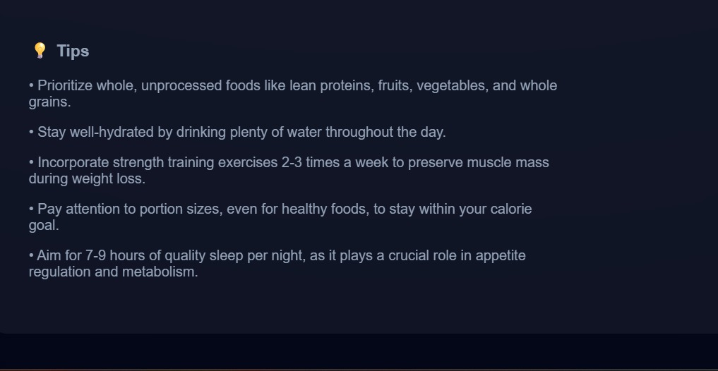

13. Advantages
- No longer requires any manual counting of calories - users obtain the correct nutritional information in a second and with a single photograph.
- Can serve several different types of food on a single plate, and naturally deal with the complexity of Indian food in the real world.
- India-specific food data: The India-specific food data is used to ensure that the Indian food is accurately estimated in terms of calories. Unlike the generic world food apps, which do not cover the Indian food.
- Transfer learning dramatically decreases the training data and computations needed and results in high classification accuracy.
- This modular pipeline design allows easy replacement of single components, such as replacing a more recent version of YOLO, without having to rebuild the whole system.
- The Streamlit interface also enables non-technical users to use the tool, even people who are not familiar with AI or programming.
- The diet planner not only offers goal-conscious, personalized recommendations, but also provides recommendations that are actionable to each individual user.
- The system is fully Python and can be easily deployed to cloud systems and have other features added.

14. Limitations
- It does not have portion size estimation as it is not implemented in the current version the system supposes standard serving portions, which can result in inaccuracies with unusually large or small portions.
- Classification accuracy is dependent on the quality of the image; a food image with poor quality, low light, or heavy occlusions may lead to incorrect classification.
- The model used in the current version supports 50 or more categories of Indian regional food, which, although substantial, do not encompass the entire Indian regional food diversity spectrum.
- Mixed or composite dishes (e.g., biryani where meat and rice are mixed together) are a challenge to separate detection, and may be grouped into one item.
- As of now, the system itself is only a web application; there is no dedicated mobile app with real-time camera feedback.
- Performance in detection may be impaired by the presence of similar-coloured foods (e.g., white rice and white raita) placed next to each other on the plate.
- The system is not yet confirmed in a clinical environment; the outcomes can not be applied as an alternative to professional nutrition.

15. Future Scope
- Portion Size Estimation: Combine depth estimation or reference object scaling to estimate portion sizes based on the image, which can be used to make more accurate calorie calculations instead of using standard servings.
- Real-Time Mobile Application: Develop a React Native or Flutter mobile application that allows real time food detection through the camera of the device, and makes the system truly on-the-go usable.
- Support of 200+ food categories: Expand the model to accommodate 200+ food categories such as regional Indian cuisine, street foods, and multi-cuisine items to serve more users.
- Incorporation of Fitness Trackers: Incorporate wearable applications like Fitbit, Apple Health, and Google Fit to combine calorie consumption data with data on physical activity to have a full health perspective.
- Voice-Based Input: enable users to describe their meal using natural language processing and the voice input as an alternative input method in case of impossibility to take photographs.
- Individualized Recipe Suggestions: Depending on nutritional gaps identified in the daily intake of the user, recommend specific Indian recipes, which would fill the identified nutritional gaps in a culturally appropriate manner.
- AI-Powered Weekly Diet Plans: Use reinforcement learning to create optimal weekly meal plans that dynamically adjust in response to the actual eating patterns and progress of the user towards their health goals.
- Cloud Deployment and API: Deploy the inference pipeline as a REST API on either AWS or Google Cloud, enabling third-party health and fitness apps to utilize NutriVision's food analysis capabilities.

16. Result and Discussion
For evaluating NutriVision, we used a test set containing 200 images of meals belonging to 50 classes. In particular, the YOLO detection model scored mAP@0.5 = 87.4%, meaning that most of the food types contained on the plate were correctly recognized, even for complex cases with four to six foods placed on the thali.
In the case of the classifier, on the validation set, the top-1 accuracy was 83.6% and the top-5 accuracy was 96.2%. We found that the most frequent mistakes happened due to the presence of visually identical meals like rice and curd rice or various types of dals, which emphasizes the need for high-resolution training data for this category of food.
As regards the calorie estimation step, the accuracy of total meal calorie estimation was evaluated based on the comparison between the automatically predicted values and the manually logged ground truth for 50 test meals. The obtained MAE was 47 kcal, which is satisfactory for the purpose of estimating total daily calorie intake. It should be noted that the estimation was done under the assumption that the default serving sizes apply.
In terms of usability, users provided good feedback about the Streamlit UI, mentioning that the bounding boxes overlaid over the image help them understand the detection process better, thus building confidence in the prediction. As expected, the processing time varied depending on the complexity of the image. However, on average, the entire pipeline, from uploading the image to receiving nutrition information, takes only 2.3 seconds on a typical CPU.
Overall, we have shown that using a combination of YOLO for detecting foods in the image and classifying them using an EfficientNet-based classifier trained on a dataset augmented with regional Indian dishes, together with nutritional information for Indian cuisine, allows building a functional food recognition and analysis system.

17. Conclusion
Through the development of NutriVision, the effectiveness of applying deep learning to one of the most intimate and daily aspects of our health – eating – has been shown. By merging state-of-the-art object detection, high-resolution image classification, and a dedicated nutrition database for India, NutriVision translates the image of a meal on a plate into a detailed nutrition report.
In the development of the project, the existing problem was solved by providing a unique solution to the market – through NutriVision, it is possible to automatically analyze food consumption by using nutrition databases, which do not exist in other applications in India. Thus, a product is created that can solve several important tasks at once – automatic logging of meals and nutrition analysis based on local databases.
From a technical point of view, the implementation of transfer learning on pretrained YOLO and EfficientNet models was a very productive idea that allowed achieving good results without investing a lot of time and resources. In particular, the pipeline design allows you to update the components independently as new models and data sources appear.
As the next steps of improving the project, it is planned to add portion estimation, implement a mobile application, and deploy the cloud version of NutriVision. Such a set of improvements will transform the application from a demo project into a tool that can significantly improve the lives of millions of Indians.

"Eat smarter. Live healthier. One photo at a time."

18. References
- Bossard, L., Guillaumin, M., & Van Gool, L. — Food-101: Mining Discriminative Components with Random Forests. ECCV 2014.
- Redmon, J., & Farhadi, A. — YOLOv3: An Incremental Improvement. arXiv:1804.02767 (2018).
- Jocher, G. et al. — YOLOv8 by Ultralytics. https://github.com/ultralytics/ultralytics (2023).
- Tan, M., & Le, Q. V. — EfficientNet: Rethinking Model Scaling for Convolutional Neural Networks. ICML 2019.
- He, K. et al. — Deep Residual Learning for Image Recognition. CVPR 2016.
- National Institute of Nutrition (NIN) — Indian Food Composition Tables (IFCT). https://www.nin.res.in
- Harris, J. A., & Benedict, F. G. — A Biometric Study of Human Basal Metabolism. Proceedings of the National Academy of Sciences, 1918.
- PyTorch Documentation. https://pytorch.org/docs
- TensorFlow Documentation. https://www.tensorflow.org/api_docs
- Streamlit Documentation. https://docs.streamlit.io
- OpenCV Documentation. https://docs.opencv.org
- Research Paper: 'Automatic Dietary Monitoring Using Deep Learning and Food Image Recognition' — IEEE Access (2021).

