5768-3-4KTQ AID:258164 | 15/10/2020

**Question :**

A quick way to show the About Windows NT message box that contain version and licensing information , the amount of memory available , and the service pack level is to run the program _______________ .

**Solution:**

WINVER is run the program.

After completing the installation of service pack, running the WINVER program then show Windows NT message box.

**For Examples:**

Following show the use of WINVER in window 10:

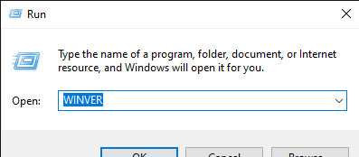

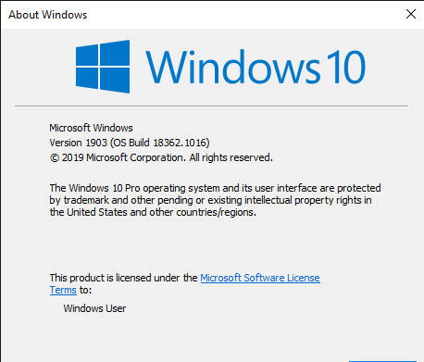

|  |
| --- |
| **WINVER .** |

Therefore , the appropriate word to fill in the blank is