5768-3-8KTQ AID:258164 | 15/10/2020

**Question :**

To perform a/an _________, you begin with a computer with an empty hard disk or repartition the hard disk during the installation of the OS.

**Solution:**

Disk can management by using the computer administrative tools. This is an windows built in tool and can be used for hard disk partitioning.

OS successfully loaded at that time Disk Management can only be used.

**For Example:**

This can show below:

1. At the time of installation disk is unallocated space mean free.

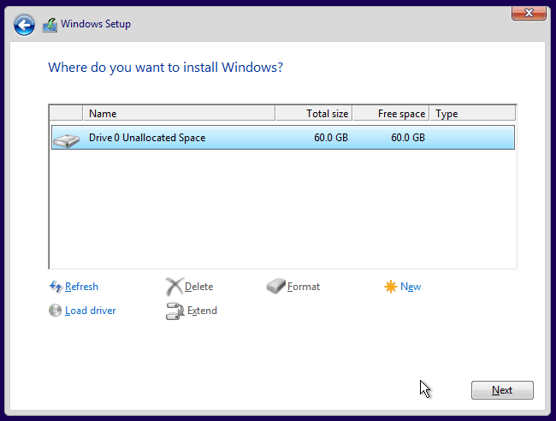

2. Then click on” Drive 0 Unallocated Space” and show the disk drive.

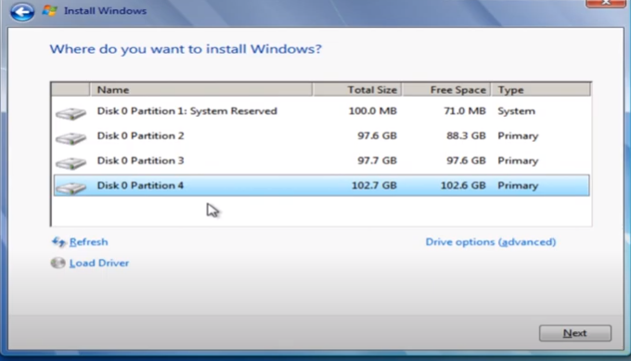

3. Then click on” Disk 0 partition 2” and open the tools for that disk to what want to do like delete , format ,add new disk drive .

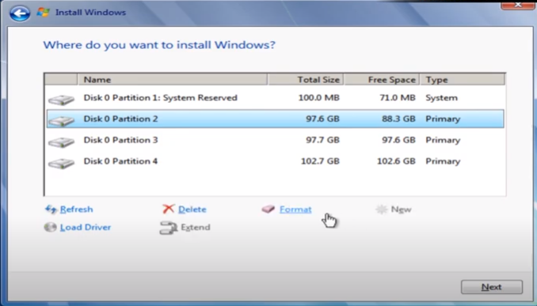

4. Allocating the space for the disk drive click on “format ” and generate message box.

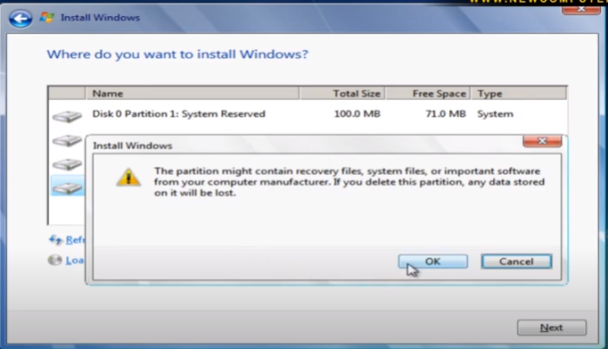

5. and finally after message box set the size of disk 2,simalaraly partition other disk.

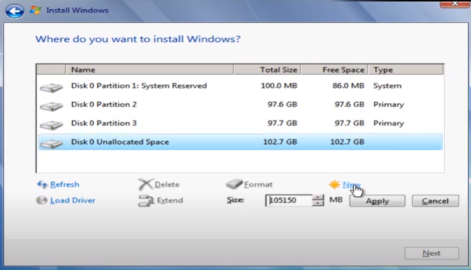

Disk administrator can perform the begin with a computer with an empty hard disk or repartition the hard disk during the installation of OS.

|  |
| --- |
| **Disk Administrator** |

Therefore , the appropriate word to fill in the blank is