14043-11-14E AID: 25816 | 29/09/2020

**Depreciation:**

MVC stands for model-view-controller. MVC is an architecture for developing a web application that separates the data(model) from the user interface(view) and processing(controller). MVC is typically associated with a web application framework. Strut is a framework based on MVC. It separates the software architecture into 3 distinct – model(M), view( V), and controller(C).

**Explanation of structure depreciation :**

|  |
| --- |
| 1. model |

|  |
| --- |
| 2. view |

|  |
| --- |
| 3. controller |

1.Model:

* It is to maintain data.
* It manages and stores manipulated data in some representation such as a hash table, database table, a list, etc.
* It is represented by EJB.

2. View :

* It is displaying data.
* It represents the output of the application. It obtains data from the model and represents it to the user. The view has free access to the model, but it cannot change the state of the model. It is just a read-only representation of the model.
* It is represented by JSP.

3.Controller:

* It is for processing and event handling.
* It receives input from the user and accordingly updates the models. It is also responsible for telling the vies what to display in response to user gestures.
* It is represented by servlet, the servlet communicates with the model(EJB) and response to view(JSP).

**Working of MVC:**

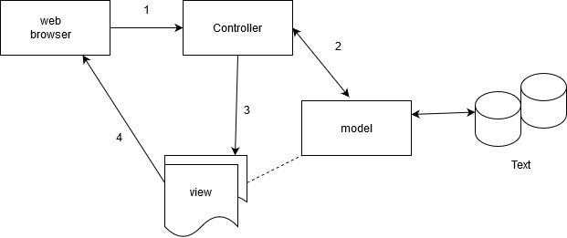

**Fig. working of MVC**

* Browser sends the request.
* Controller receives the input from user, interact with model and accordingly update the model.
* The controller invoke view.
* View obtains data from the model and render it to user browser.

**Types of depreciation:**

1. MVC1(page centric architecture)
2. MVC2(servlet centric architecture)