303626-2-2E AID:258164 | 22/08/2020

**Depreciation:**

**Data abstraction :** Abstraction mean hide some data .It refers to act of showing the essential features or data without involving there main background details or explanation. Class uses list of abstract attributes. Abstraction is eliminate the unwanted irrelevant of the essentials.

It hide implementation details while just presenting the features to the outside world. The main advantage is reduce code complexity , hiding details and exposing the essential parts.

It focus on what the object does ,outer layout used in terms of design. Hide information about the data from actors that don’t need it. This isn’t necessarily a matter of security in order for object to do its job in best way to make use flexibly.

Abstraction separates code into interface and implementation. So while design the component, you must keep interface independent of the implementation so that if changes are underlying implementation then interface would remain intact.

In this case whatever programs are using these interfaces, they would not be impacted and would just need a recompilation with the latest implementation. An important general principle of design here is modularity. Different elements of our software should have clearly defined responsibilities, and the interactions among those elements need to be clearly specified. The start of a class definition is the definition of an abstract data type or ADT, which is a list and specification of the desired operations for the objects.

For example ,in database system , hide the details of how data is to stored and create and maintained.

**Following show another example of above Depreciation:**

Honda4.java

abstract class Bullet{

abstract void run();

}

class Honda4 extends Bulet{

void run(){System.out.println("running safely..");}

public static void main(String args[]){

Bullet obj = new Honda4();

obj.run();

}

}

**The output of above example code:**

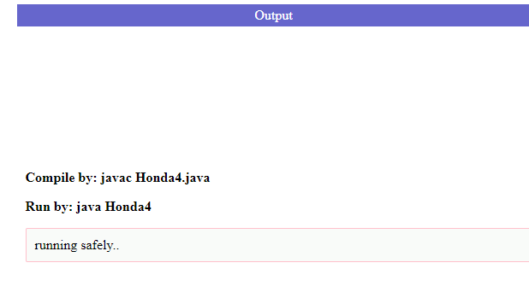

In this example, Bullet is an abstract class that contains only one abstract method run. Its implementation is provided by the Honda class.