514870 -10-14E AID:258164 | 01/07/2020

Program Plan:

The following plan is design for dica problem:

* Open notepad /or any text editor
* Write all HTML opening tags <html> <head>and <body> <script>
* Link java script with html file using below link

<script src = “Index.js”></script>

* In JavaScript file, create a function to which can calculating how many times the dice numbers came.
* The dice can roll randomly by

function roll_d()

* Calculating how many time dice number came

function rolling()

* Close all HTML closing tags </head> </body> and </html>
* Save notepad with file name as “Index.html” and save as type “All files”
* Run the “Index.html” in web browser (Mozilla or chrome)

Program:

Index.html

< ! Doctype html>

<html>

<head>

<meta charset="UTF-8">

<title>Throw_Dice</title>

</head>

<body onload="rolling()">

<h1> ThrowDice1</h1>

<form name = "multiply" action = "">

<table>

<caption> $Throw_Dice_ Program$ </caption>

<div id = "div1"> </div>

<div id = "div2"></div>

</table>

</form>

<script src='http://cdnjs.cloudflare.com/ajax/libs/jquery/2.1.3/jquery.min.js'></script>

<!--to divide the images to small part -->

<script src="js/Index.js"></script>

</body>

</html>

Index.js

var d1, d2 , result , n2;

var n1 , i;

function roll_d()

{

var random_d1=Math.floor(Math.random()*6);

return random_d1+1;

}/*rolling dice function */

function rolling() /*rolling dice results fuction */

{

var combination=new Array();

result=" ";

var display;

display=" ";

n2=window.prompt("Enter how many times you want to throw the dice");

for (i=0 ; i<12 ; i++)

{

combination[i]=0;

}

For (i=0 ; i<parseInt( n2) ; i++)

{

d1 = roll_d();

d2 = roll_d();

result = parseInt(d1)+ parseInt(d2);

combination[ result-2]+=1;

n1=i+1;

display += "Roll #"+ n1 + ": " + d1 + " " + d2 + "<br>";

}

div1.innerHTML=display;

var result1="";

for (i=0 ; i<11 ; i++)

{

n1=i+2;

result1 += "The Sum of "+ n1 +" occurred :" + combination[i] +" Times<br>"

}

div2.innerHTML= result1;

}

</script>

Program Screenshots:

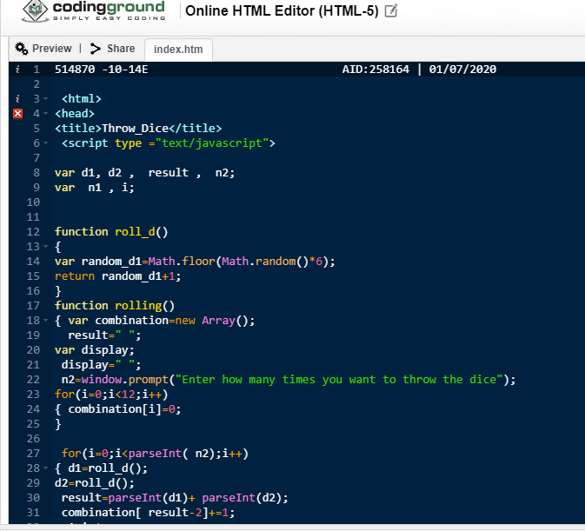

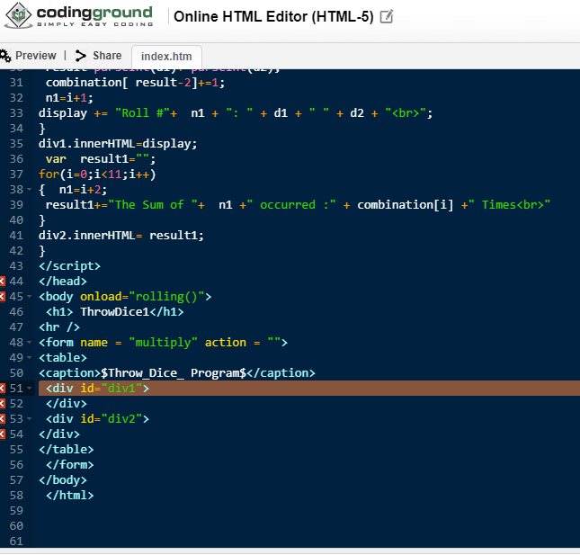

Screenshot Result:

