514870 -10-16E AID:258164 | 01/07/2020

Program Plan:

The following plan is design for prime number problem:

* Open notepad /or any text editor
* Import packages<iostream> and <iomanip>
* Create for loop and calculate total number of prime numbers
* Save notepad with file name as “Main.cpp”
* Run the “Main.cpp” in compiler

Program:

Main.cpp

#include <iostream>

#include<iomanip>

using namespace std;

int main()

{

const int N = 1000;

int array[N];

int c = 0;

for(int k = 0; k < N; k++)

array[k] = 1;

for (int i = 1; i < N; i++)

{

if (array[i] == 1 && i != 1)

{

for (int j = i; j < N; j++)

{

if (j % i == 0 && j != i)

array[j] = 0;

}

}

}

for(int a = 2; a < N; a++)

{

if(array[a] == 1)

{

cout << setw(3) << a << " is a prime number\n";

}

}

cout << "A total of " << c << " prime numbers were found.\n";

}

Program Screenshots:

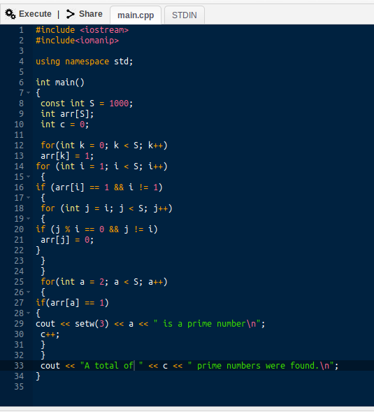

Result:

