519797-14-10E AID: 258164 | 07/07/2020

The details of SOFTWARE EXPERT inquiry show in below:

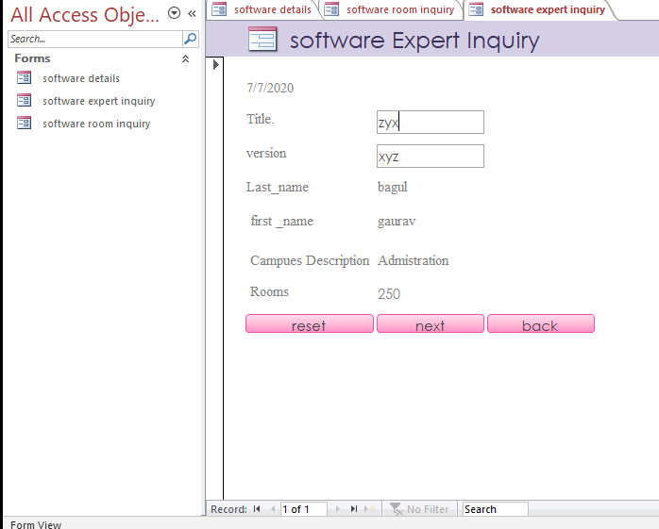

And Inquiry type : Type 1,

V >= (E, A)