519797-14-4E AID: 258164 | 07/07/2020

The following hierarchy chart representing the Update Hardware menu. This contain

CHANGE COMPUTER, DELETE COMPUTER RECORD ,UPDATE INSTALLED COMPUTER :

HIERARCHY CHART:

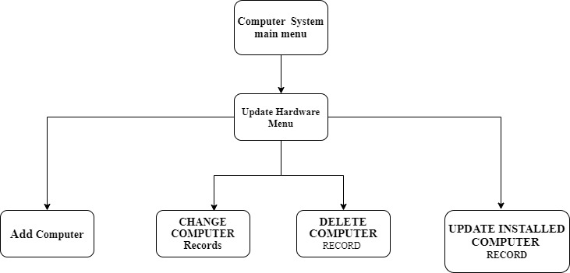

The hierarchy chart can explain as follows:

The main menu of computer system can conclude all hardware and software queries like update, create etc. In this hierarchy we take update hardware menu. And then it contains

CHANGE COMPUTER, DELETE COMPUTER RECORD ,UPDATE INSTALLED COMPUTER records.