519797-14-5E AID: 258164 | 07/07/2020

The following hierarchy chart representing the Update Software menu. This contain

ADD SOFTWARE PACKAGE , CHANGE SOFTWARE RECORD , DELETE SOFTWARE RECORD , UPGRADE SOFTWARE PACKAGE:

HIERARCHY CHART:

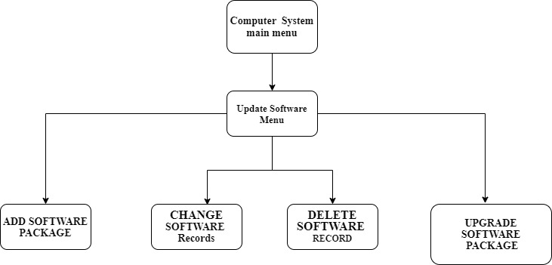

The hierarchy chart answers can also check on link:

“

https://app.diagrams.net/?lightbox=1&highlight=0000ff&edit=_blank&layers=1&nav=1&title=the%20Update%20Hardware%20menu.drawio#R7VpZd6IwFP41PjqHvfTRol1ON4%2B20%2Bm8RYnCHCBMCBXm108CiSyKS9VR5%2FRFyZfl3uT77vUCtlTLT24wCJ1HZEOvpUh20lK7LUUxDZN%2BMiDNAU1Vc2CKXTuH5AIYun8gByWOxq4No8pAgpBH3LAKjlEQwDGpYABjNKsOmyCvajUEU7gADMfAW0TfXJs4fFu6VOC30J06wrIs8R4fiMEciBxgo1kJUnst1cIIkfzKTyzosbMT55LPu27onTuGYUA2mZD%2BRPJVhO9QG96b3632nSmZbYP7RlKxYWjT%2FfMmwsRBUxQAr1egVxjFgQ3ZqhJtFWMeEAopKFPwFyQk5WSCmCAKOcT3eO8EBeQa%2BK7HNPHi%2BpRfRXqCM%2Fo5QD4I6JDcLeZL4245FKEYj%2BGKLarzs6YahciHBKd0HoYeIO5HdX3A1TKdj5tP7SOXWlakROiY08p1LRtSdQkC8BQSPqughV6U3CigjKwtiONR9AG8mG%2BhpRge4adbodT4HSPR0Y4yUjp0gKyFSdFJr6b8O1tlJAAL%2BWFMIKZt4FN%2Br4JRFGYDpWEaEehnWncD9gWDWMynmxrV16RY7pyAa9IrhMVUMnNcAochyMid0eTySRF9QExgslpGi%2FLgE9SLKs0ab86KXCCLAHdKeeBCahZURQrb8i4rJxqxbAifL6v7jWCd5%2F0solaMM3eM9N2IUY9BDD1LnP5g878Z8oUA3jNAKoBuwk3krbTc6kNMCWURnoPnwfXlUbnWjsy1XmF6DcufIBQmLilZoq134QS9LuywhjBzBBHI0lFVoB9ZBVpFBu3%2FPOLlhl%2Fqf0O23lhvjTYqttRlxdZraAMCWSWFJmRGz45ePjYWUQeulpZTvNfqaV4kryuf6sX03mg0d6RxZc0chSBoXmXCj5%2BtMy%2BmW4qqavSbcEqCjBKcUVIfk82zmAEavxPWyjBKD2m7VAqME7a4Zi5zstPtMqE9X7%2B8dQa9ksJyr2vVPz7ZfZzFYfc71n3nZt0pn3t416JblY8d3ZeN0d2oFs8NYFs4l4U4%2B1nX54QfRk1r77o3U3kpMRlMhtuJ1LrtPK3V6KpMsJv5rbeobW%2BjlO5qDy9WbnpPj1CwQAZwjLAdLXY0PhlZ%2BRCl6vL55Y3TSxzCga%2FMsVFYdXsPvZczyhyfsLEucyyN4WXHsLGTesNWD5K4lGXGBj3redDdR07aIbOfTFhtdu7nl301%2FeSyr9yYfff8MuMsbh5e%2BzeDTvfrFu2wTtbvhCsJvRL7tZu5jTP%2FKbwCO0D%2BMLQN8oexJH%2BY2%2BcP2ixekOevTot%2FGai9vw%3D%3D

“