527326-12-2E AID: 258164| 31/08/2020

1. **Formula to find number of sector per track of disk :**

|  |
| --- |
| Number of sector per track of disk = capacity * 1024 * 1024 * 2 |

**Following shows the calculation:**

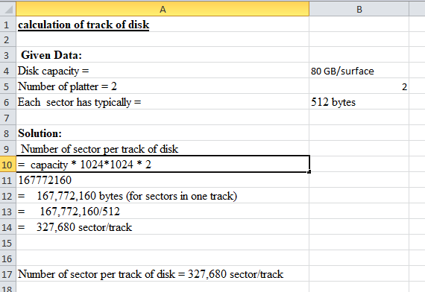

Number of sector per track of disk =

|  |
| --- |
| 327,680 sector/track |

**B) Formula to find number of track on per surface:**

|  |
| --- |
| Number of tracks on disk = capacity _bytes / bytes_track |

|  |
| --- |
| Number of tracks per surface = track on disk / number of surface |

**Following shows the calculation of track of disk:**

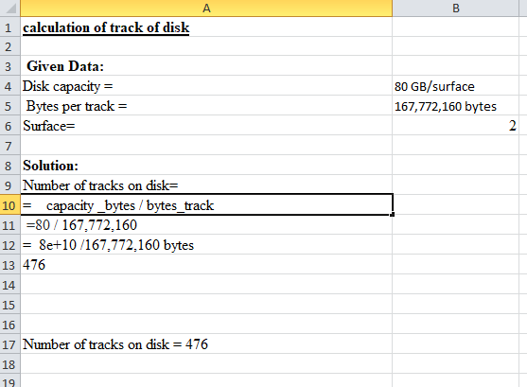

Number of tracks on disk= 476

Following shows the calculation of track per surface:

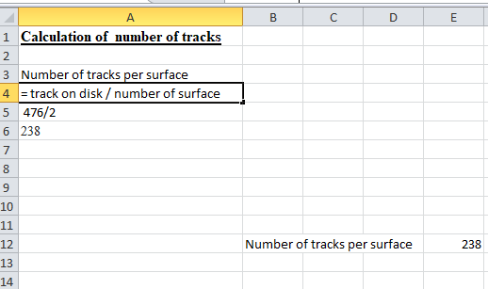

Number of tracks per surface = track on disk / number of surface =

|  |
| --- |
| 238 |

**C) Following shows the calculation of distance from one track to next track:**

Diameter = 6.3 cm r = 3.15 cm

**Solution:**

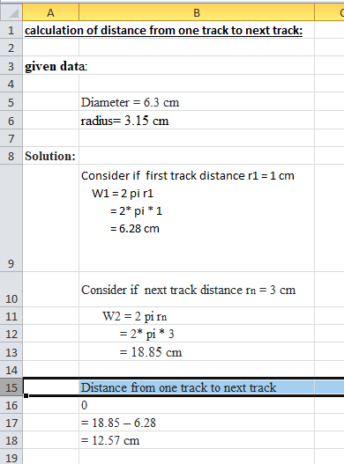

|  |
| --- |
| 12.57 cm |

Distance from one track to next track =