527326-12-4E AID: 258164| 31/08/2020

**500 read requests ,to a randomly chosen sector disk head on outside track ;CSCAN**

**The formulae:**

|  |
| --- |
| **S**eek time = estimate track + interpolation with average seek time |

|  |
| --- |
| total time of block = block * total time |

________________________________________________________________________

**Calculation as follows:**

Step 1:

seek time:

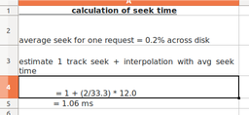

________________________________________________________________________

Step 2:

Rotation time:

We don’t know head position when seek ends ;

random reads

= 4.15 ms (half rotation)

________________________________________________________________________

Step 3:

Transfer time:

Just as before ,at least 9.5 microsecond

________________________________________________________________________

Step 4:

Total time :

= 5.22 ms per block

________________________________________________________________________

Step 5:

For 1000 blocks:

= 1000 * 5.22 ms

=2.16 s

Total block time = 2.16 s