534575-5-31KE AID:258164 | 09/07/2020

a)Step 1 of 3:

Direct hashing function : using direct hashing if the keys are unique we can store 1000 bytes of each object in hash table using direct hashing. There are some constraints for the key in direct hashing function. The address is key itself hash(key) = key. Direct hashing is limited but it can be very powerful because it guarantee that there are no synonyms and therefore collision.

Step 2 of 3:

Given data:

Nodes = 1500 , Information byte = 1000 , Key-field =5 digit let us consider 12345

|  |
| --- |
| ip = k % number of elements in the array |

Formulae :

Step 3of 3:

Calculation of how many elements in primary storage area:

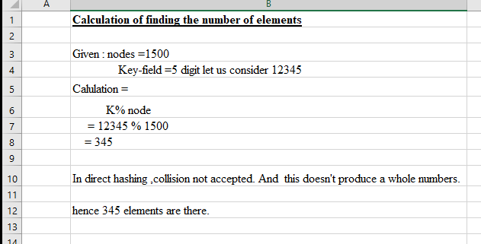

b) step 1 of 3:

Division hashing function : using division hashing if the keys are unique we can store 1000 bytes of each object in hash table using division hashing. There are some constraints for the key in division hashing function. This also known as division remainder method.This algorithm works with list size but if list size is prime number then it produce collision .The address formula = key modulo listsize+1,where list size is number of elements in array.

Step 2 of 3 :

General guideline N= 1.33n max Where , N= next highest 4K+3 prime 33% above max number of nodes that will exist in structure at any given time n max.

Given data:

Nodes = 1500 , Information byte = 1000 , Key-field =5 digit

|  |
| --- |
| ip = k mod N |

Formulae :

Step 3 of 3:

Calculation of how many elements in primary storage area:

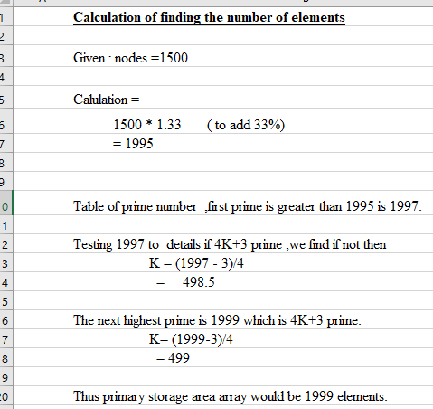

Thus primary storage area array would be 1999 elements.