534575-5-33KE AID:258164 | 09/07/2020

Step 1 of 2 :

General guideline N = 1.33n max Where , N= next highest 4K+3 prime 33% above max number of nodes that will exist in structure at any given time n max.

Given data:

Nodes = 300

|  |
| --- |
| ip = k mod N |

Formulae :

Step 2 of 2:

Calculation of how many elements in primary storage area:

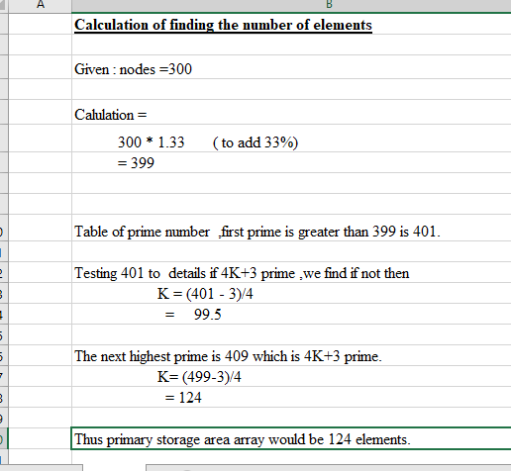

Thus size of primary storage area array would be 124 elements.