534575-5-34KE AID:258164 | 09/07/2020

Array index of the following keys are as follow:

Step 1 of 6:

Given : Pk = a. 4618 , b. 391 , c. 6941 , d. 547

Ip = 5 , Pm 4K+3 =23 and N = 19

Step 2 of 6: Calculation is as follows:

For case a) Pk = 4618

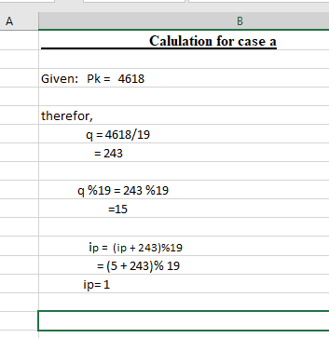

And this calculation is same for next ip.

Step 3 of 6:

For case b) Pk = 391

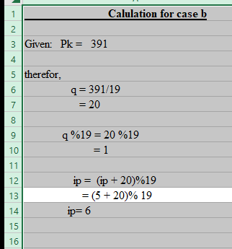

And this calculation is same for next ip.

Step 4 of 6:

For case c) Pk = 6941

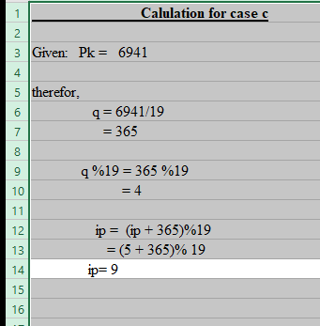

And this calculation is same for next ip.

Step 5 of 6:

For case d) Pk = 547

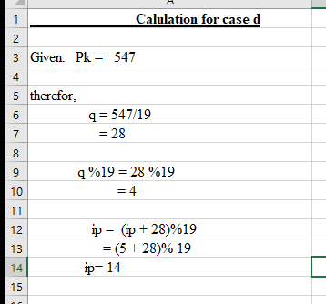

And this calculation is same for next ip.

Step 6 of 6:

And next ip are:

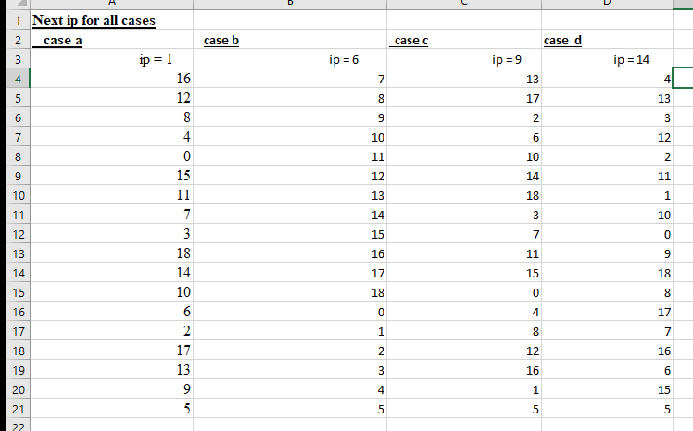

From the above table we conclude that the array index should be 19 after 19 it should be repeated.