Mutual Fund Analytics & Investor Insights

Bluestock Fintech Capstone Project

Submitted By
Name: Gaurav Kumar

Project Duration
Day 1 – Day 7

Technologies Used
- Python
- Pandas
- NumPy
- Matplotlib
- SQLite
- Power BI
- Git & GitHub
- VS Code
- Jupyter Notebook

Submitted To
Bluestock Fintech

Date
June 2026

Executive Summary
The Mutual Fund Analytics & Investor Insights project was developed as part of the Bluestock Fintech Capstone Program. The objective of this project was to build an end-to-end analytics solution for the Indian mutual fund industry using Python, SQL, Power BI, and GitHub.
The project began with collecting and organizing multiple datasets containing mutual fund schemes, historical NAV values, investor transactions, portfolio holdings, benchmark indices, industry statistics, and fund performance metrics. An ETL pipeline was implemented to clean, validate, and transform the raw data into structured datasets suitable for analysis.
Exploratory Data Analysis (EDA) was performed to understand industry trends, investor behavior, fund categories, sector allocation, assets under management (AUM), folio growth, and transaction patterns. More than fifteen visualizations were created to identify important trends and relationships within the data.
Performance analytics were carried out by calculating financial metrics such as daily returns, Compound Annual Growth Rate (CAGR), Sharpe Ratio, Sortino Ratio, Alpha, Beta, Maximum Drawdown, and a composite Fund Scorecard. Advanced analytics included Value at Risk (VaR), Conditional Value at Risk (CVaR), Rolling Sharpe Ratio, Investor Cohort Analysis, SIP Continuity Analysis, Portfolio Concentration (HHI), and a rule-based mutual fund recommender system.
A four-page interactive Power BI dashboard was designed to present industry statistics, fund performance, investor analytics, and market trends. The dashboard provides interactive filters, charts, KPIs, and visual insights that support investment analysis and decision-making.
Overall, this project demonstrates practical skills in data engineering, financial analytics, data visualization, dashboard development, and software project management. It highlights how data-driven techniques can help investors and financial organizations evaluate mutual fund performance and understand investor behavior more effectively.

Project Objective & Data Sources

Project Objective
The primary objective of this project is to develop a comprehensive Mutual Fund Analytics and Investor Insights platform that enables effective analysis of mutual fund performance, investor behavior, and market trends. The project integrates data engineering, financial analytics, and business intelligence to provide meaningful insights for investors and financial professionals.
The major objectives of this project are:
- Develop an automated ETL pipeline to collect, clean, and organize mutual fund datasets.
- Analyze historical NAV data to evaluate fund performance over different time periods.
- Perform Exploratory Data Analysis (EDA) to identify trends in Assets Under Management (AUM), SIP inflows, folios, and investor transactions.
- Calculate key financial performance metrics such as CAGR, Sharpe Ratio, Sortino Ratio, Alpha, Beta, Maximum Drawdown, VaR, and CVaR.
- Build an interactive Power BI dashboard for visualization and decision-making.
- Develop a simple fund recommendation system based on risk appetite and Sharpe Ratio.
- Generate professional reports and visualizations to support investment analysis.

Data Sources
The project uses multiple datasets related to the Indian mutual fund industry. These datasets provide information about fund schemes, NAV history, investor transactions, portfolio holdings, benchmark indices, and industry statistics.
Dataset | Description
Fund Master | Contains AMFI codes, scheme names, fund houses, categories, and plan information.
NAV History | Historical Net Asset Value (NAV) of mutual fund schemes used for return calculations.
Scheme Performance | Annual returns, Sharpe Ratio, Sortino Ratio, Alpha, Beta, expense ratio, AUM, and risk grades.
Investor Transactions | Records of SIP, lump sum, and redemption transactions for investor analysis.
Portfolio Holdings | Details of stocks held by each mutual fund including sector allocation and portfolio weights.
Benchmark Indices | Historical values of NIFTY 50, NIFTY 100, and other benchmark indices.
Industry Statistics | Monthly industry-level data such as total AUM, SIP inflows, and folio counts.
These datasets were cleaned, validated, and transformed using Python before being loaded into SQLite and Power BI for analysis and visualization.

ETL Design & Workflow

ETL (Extract, Transform, Load) Process
The project follows a structured ETL (Extract, Transform, Load) pipeline to prepare the mutual fund datasets for analysis and visualization. This process ensures that the data is accurate, consistent, and ready for analytics.

1. Extract
The raw datasets were collected in CSV format and included information related to mutual fund schemes, NAV history, investor transactions, benchmark indices, portfolio holdings, and industry statistics.

2. Transform
The raw data was cleaned and processed using Python. The transformation process included:
- Handling missing and duplicate values.
- Converting date columns into a standard datetime format.
- Standardizing column names and data types.
- Calculating daily returns from NAV values.
- Creating derived metrics such as CAGR, Sharpe Ratio, Sortino Ratio, Alpha, Beta, Maximum Drawdown, VaR, CVaR, and HHI.
- Preparing cleaned datasets for SQLite and Power BI.

3. Load
After transformation, the cleaned datasets were loaded into a SQLite database and imported into Power BI. Relationships between tables were created using common fields such as amfi_code and date, enabling interactive dashboards and advanced analysis.

ETL Workflow
Raw CSV Files
↓
Data Cleaning (Python – Pandas & NumPy)
↓
Feature Engineering & Financial Calculations
↓
SQLite Database
↓
Power BI Dashboard
↓
Reports & Insights

Technologies Used in ETL
- Python
- Pandas
- NumPy
- SQLite
- Jupyter Notebook
- VS Code
- Git & GitHub
- Power BI
The ETL pipeline automated the process of preparing raw mutual fund data for analytics, ensuring data quality and improving the efficiency of reporting and dashboard development.

Dataset Description

Overview
This project uses multiple datasets related to the Indian mutual fund industry. Each dataset provides specific information required for data engineering, financial analysis, investor analytics, and dashboard visualization.

Dataset Details
Dataset Name | Description | Key Columns
Fund Master | Contains master information about mutual fund schemes. | amfi_code, scheme_name, fund_house, category, plan
NAV History | Historical Net Asset Value (NAV) data for all schemes. | amfi_code, date, nav
Scheme Performance | Performance metrics for each mutual fund. | return_1yr_pct, return_3yr_pct, return_5yr_pct, sharpe_ratio, sortino_ratio, alpha, beta, max_drawdown_pct
Investor Transactions | Investor purchase, SIP, redemption, and transaction records. | investor_id, transaction_date, amount_inr, transaction_type
Portfolio Holdings | Portfolio allocation across stocks and sectors. | stock_symbol, stock_name, sector, weight_pct
Benchmark Indices | Historical benchmark index values used for comparison. | date, index_name, close_value
Industry Statistics | Monthly industry data such as AUM, SIP inflows, and folios. | month, total_aum, sip_inflow, folios

Dataset Relationships
The datasets are connected using common fields:
- amfi_code → Used to connect Fund Master, NAV History, Scheme Performance, and Portfolio Holdings.
- date → Used for time-series analysis and benchmark comparison.
- investor_id → Used for investor behavior, cohort analysis, and SIP continuity analysis.

Data Quality & Preprocessing
Before analysis, the following preprocessing steps were performed:
- Removed duplicate records.
- Handled missing values where applicable.
- Converted date columns into datetime format.
- Standardized numerical columns.
- Validated relationships between datasets.
- Created derived features such as daily returns and rolling performance metrics.
These preprocessing steps ensured the datasets were clean, consistent, and ready for advanced analytics and dashboard development.

Exploratory Data Analysis (EDA) – Part 1

Introduction
Exploratory Data Analysis (EDA) was performed to understand the characteristics of the mutual fund industry, identify trends, and uncover meaningful insights from the datasets. Various visualizations were created using Python libraries such as Matplotlib to analyze investor demographics, industry growth, and investment patterns.

Key Observations

1. Assets Under Management (AUM) Growth
The AUM growth chart shows a steady increase in the total assets managed by the mutual fund industry over the analysis period. This indicates growing investor confidence and increasing participation in mutual fund investments.

2. Folio Growth
The number of mutual fund folios has consistently increased, reflecting a growing investor base and wider adoption of mutual fund products across different regions.

3. Gender Distribution
The investor dataset indicates the distribution of male and female investors. This visualization helps understand participation across different demographic groups.

4. Age Group Distribution
The age group analysis shows that the majority of investments are made by working-age individuals, highlighting that salaried professionals form a significant portion of mutual fund investors.

Summary
The EDA results provide valuable insights into industry growth, investor demographics, and participation trends. These findings form the foundation for the performance analytics and advanced analytics performed in the later stages of the project.

Exploratory Data Analysis (EDA) – Part 2

Additional Analysis
To gain deeper insights into investor behavior and mutual fund portfolio composition, additional visualizations were created. These charts highlight regional investment trends, sector allocation, category relationships, and investor distribution across different city classifications.

1. State-wise Investment Analysis
The state-wise investment chart illustrates the total investment amount across different states. It helps identify regions with higher investor participation and larger investment volumes.

2. Sector Allocation
The sector allocation donut chart presents the distribution of investments across different industry sectors. It provides an overview of portfolio diversification and the sectors receiving the highest allocation.

3. Category Correlation Heatmap
The heatmap highlights relationships among different mutual fund categories and investment variables. It assists in identifying patterns and similarities within the dataset.

4. T30 vs B30 Distribution
The T30 and B30 distribution chart compares investments originating from the top 30 cities (T30) with those from beyond the top 30 cities (B30). This analysis demonstrates the increasing participation of investors from smaller cities and towns.

Summary
The second phase of EDA provides a broader understanding of investment distribution, portfolio diversification, and geographical participation. These insights support more advanced financial analysis and strategic decision-making.

Performance Analytics – Part 1

Introduction
Performance analytics were performed to evaluate the historical returns and risk-adjusted performance of mutual fund schemes. Various financial metrics were calculated using Python to compare the performance of different funds and identify the best-performing schemes.

Performance Metrics

1. Daily Returns
Daily returns were calculated using historical NAV values to measure the day-to-day percentage change in fund prices. These returns formed the basis for further risk and performance analysis.

2. Compound Annual Growth Rate (CAGR)
The Compound Annual Growth Rate (CAGR) was calculated for 1-year, 3-year, and 5-year periods to measure the average annual growth of each mutual fund. CAGR provides a standardized measure of long-term investment performance.

3. Sharpe Ratio
The Sharpe Ratio was calculated to evaluate risk-adjusted returns. Funds with higher Sharpe Ratios generated better returns relative to the level of risk taken, making them more attractive to investors.

4. Sortino Ratio
The Sortino Ratio focuses only on downside volatility instead of total volatility. It provides a better assessment of investment performance by penalizing only harmful risk.

Summary
The calculated performance metrics enabled comparison across all mutual fund schemes and helped identify funds delivering strong returns with controlled levels of investment risk.

Performance Analytics – Part 2

Advanced Performance Metrics
In addition to basic return calculations, several advanced financial metrics were computed to evaluate the performance and risk characteristics of mutual fund schemes.

1. Alpha
Alpha measures the excess return generated by a mutual fund compared to its benchmark after adjusting for market risk. A positive alpha indicates that the fund outperformed its benchmark.

2. Beta
Beta measures the sensitivity of a mutual fund's returns relative to the market. A beta greater than 1 indicates higher volatility than the benchmark, while a beta less than 1 indicates lower volatility.

3. Maximum Drawdown
Maximum Drawdown represents the largest decline in a fund's value from its peak to its lowest point during the analysis period. It is an important measure of downside risk.

4. Benchmark Comparison
The performance of mutual funds was compared against benchmark indices such as NIFTY 50 and NIFTY 100 to evaluate whether the funds consistently outperformed the market.

5. Rolling Sharpe Ratio
A 90-day Rolling Sharpe Ratio was calculated to observe changes in risk-adjusted performance over time. This metric helped identify periods where funds delivered stronger or weaker performance relative to their risk.

Summary
These advanced metrics provided a comprehensive assessment of fund performance by combining return, volatility, downside risk, and benchmark comparison. Together, they offer a more complete understanding of investment quality than return analysis alone.

Advanced Analytics

Introduction
Advanced analytics techniques were applied to gain deeper insights into mutual fund performance, portfolio risk, and investor behavior. These analyses extend beyond traditional return calculations and provide valuable information for investment decision-making.

1. Value at Risk (VaR) and Conditional Value at Risk (CVaR)
Historical Value at Risk (VaR) at the 95% confidence level was calculated to estimate the maximum expected loss under normal market conditions. Conditional Value at Risk (CVaR) measures the average loss beyond the VaR threshold, providing a better understanding of extreme downside risk.

2. Investor Cohort Analysis
Investor cohorts were created based on the year of their first investment. This analysis helped identify investment patterns, average SIP amounts, total investments, and preferred mutual fund categories across different investor groups.

3. SIP Continuity Analysis
The average gap between SIP transactions was calculated for investors with at least six SIP transactions. Investors with an average gap greater than 35 days were identified as "At Risk", enabling early identification of possible SIP discontinuation.

4. Portfolio Concentration (HHI)
The Herfindahl-Hirschman Index (HHI) was calculated using portfolio holding weights to measure concentration risk. Funds with higher HHI values were more concentrated in fewer securities, while lower HHI values indicated better portfolio diversification.

5. Mutual Fund Recommendation System
A simple rule-based recommendation system was developed using the calculated Sharpe Ratio and risk grade. Based on an investor's selected risk appetite (Low, Moderate, or High), the system recommends the top-performing mutual funds that best match the selected risk profile.

Summary
The advanced analytics module enhanced the project by incorporating modern financial risk measures, investor behavior analysis, portfolio concentration analysis, and a practical recommendation system. These techniques provide investors with deeper insights for making informed investment decisions.

Power BI Dashboard – Industry Overview & Fund Performance

Dashboard Overview
An interactive Power BI dashboard was developed to visualize mutual fund industry statistics, fund performance, investor behavior, and market trends. The dashboard enables users to analyze large volumes of financial data through interactive charts, KPI cards, filters, and drill-through functionality.

Dashboard Page 1 – Industry Overview
The first dashboard page provides an overview of the Indian mutual fund industry. It includes key performance indicators (KPIs) such as:
- Total Assets Under Management (AUM)
- Monthly SIP Inflows
- Total Investor Folios
- Total Mutual Fund Schemes
The page also includes:
- Industry AUM Trend (2022–2025)
- AUM by Asset Management Company (AMC)
These visualizations help users understand the growth of the mutual fund industry and compare the market share of different fund houses.
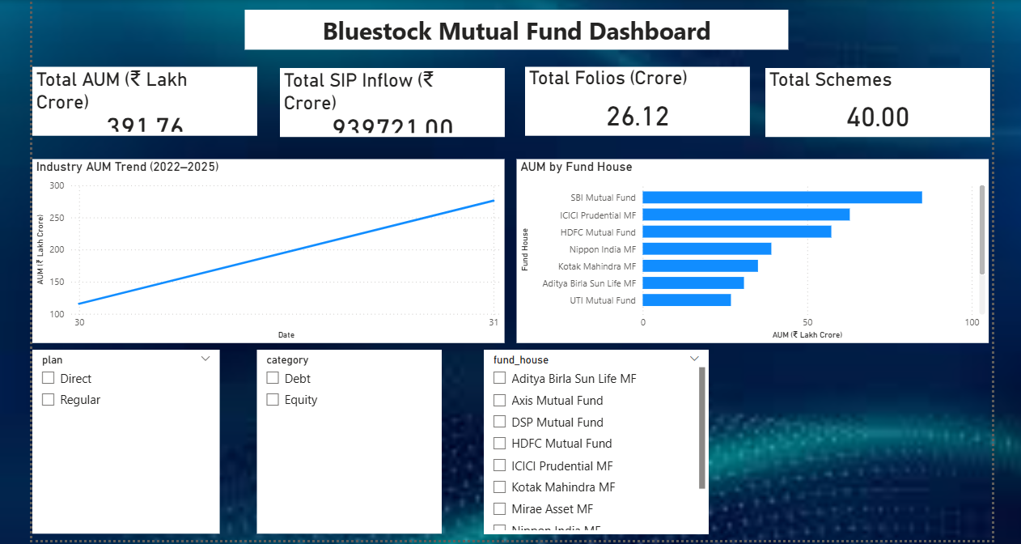

Dashboard Page 2 – Fund Performance
The second dashboard page focuses on mutual fund performance analysis.
Key visualizations include:
- Risk vs Return Scatter Plot
- Fund Scorecard
- NAV vs Benchmark Comparison
- Interactive Filters (Fund House, Category, and Plan)
This page enables investors to compare mutual funds based on historical returns, risk-adjusted performance, and benchmark comparison, helping them identify suitable investment options.
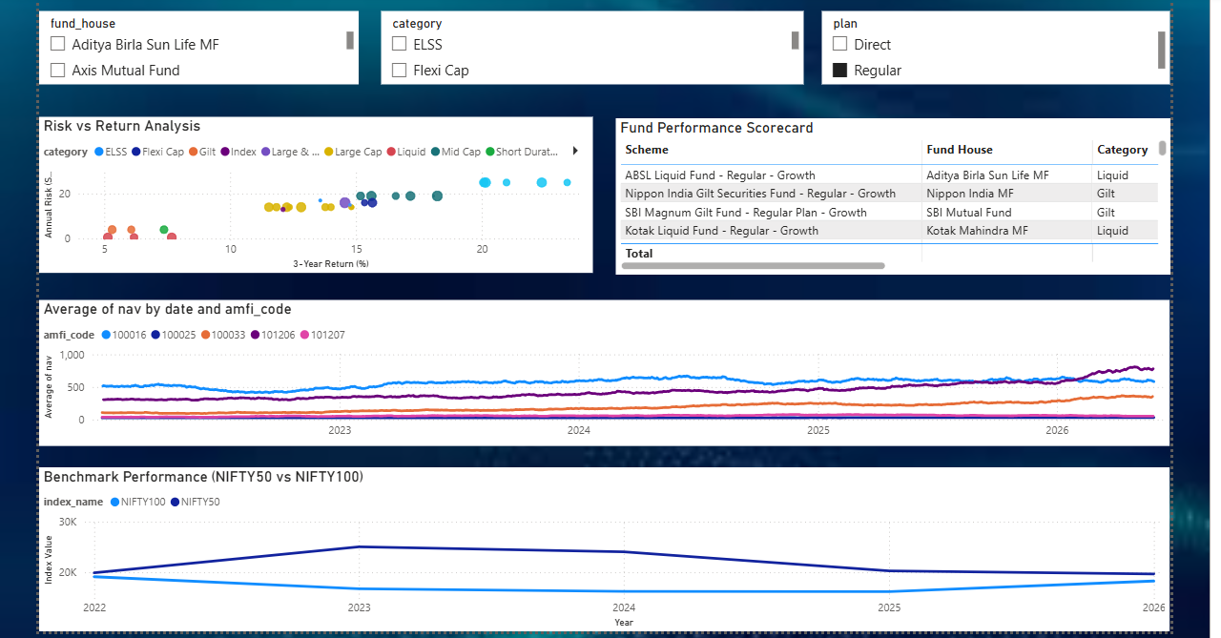

Summary
The first two dashboard pages provide a comprehensive overview of the mutual fund industry and fund performance. Interactive filters and visualizations allow users to explore the data dynamically and gain meaningful insights for investment analysis.

Power BI Dashboard – Investor Analytics & SIP & Market Trends

Dashboard Page 3 – Investor Analytics
The third dashboard page focuses on investor behavior and transaction analysis. It provides insights into investment patterns across different states, age groups, and transaction types.
The major visualizations included are:
- State-wise Investment Analysis
- SIP, Lumpsum, and Redemption Distribution
- Average SIP Amount by Age Group
- Monthly Transaction Volume
Interactive slicers such as State, Age Group, and City Tier allow users to filter and explore investor data efficiently. These visualizations help identify investor demographics and regional investment trends.
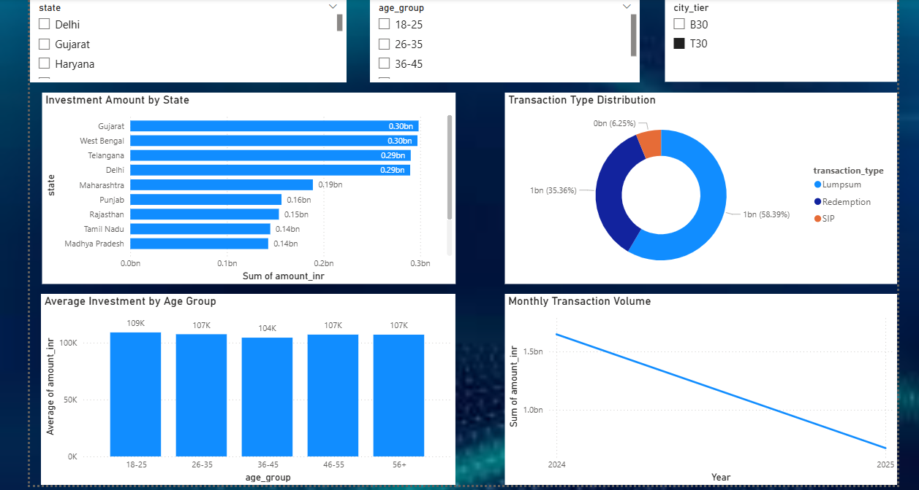

Dashboard Page 4 – SIP & Market Trends
The fourth dashboard page compares SIP inflows with market performance and category-wise investment trends.
The major visualizations include:
- SIP Inflow vs NIFTY 50 Trend
- Category-wise Inflow Heatmap
- Top 5 Categories by Net Inflow
- Interactive Filters and Tooltips
This dashboard enables users to understand how market movements influence investor participation and SIP investments over time.
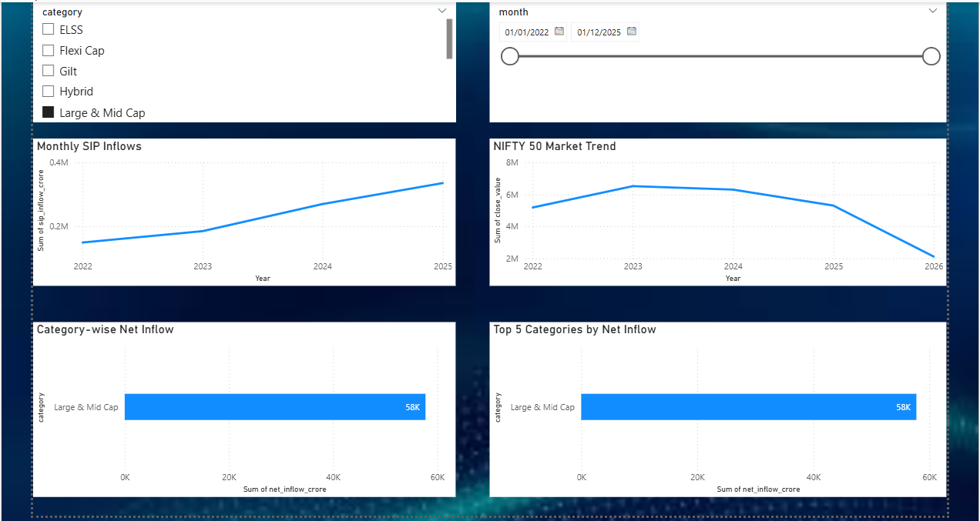

Dashboard Features
The Power BI dashboard includes several interactive features:
- KPI Cards
- Interactive Slicers
- Drill-through Navigation
- Dynamic Tooltips
- Cross-filtering Between Visuals
- Responsive Dashboard Layout
These features improve user experience and enable effective data exploration.

Summary
The Power BI dashboard transforms raw mutual fund data into meaningful visual insights. It allows investors and analysts to evaluate industry growth, compare fund performance, analyze investor behavior, and monitor market trends through an intuitive and interactive interface.

Key Findings
The analysis of the mutual fund datasets resulted in several important insights regarding fund performance, investor behavior, and market trends.

Major Findings
- The mutual fund industry has shown consistent growth in Assets Under Management (AUM) over the study period.
- SIP inflows have increased steadily, indicating growing investor confidence in systematic investment plans.
- Risk-adjusted performance metrics such as the Sharpe Ratio and Sortino Ratio helped identify funds that delivered superior returns relative to risk.
- Historical VaR and CVaR analysis highlighted funds with higher downside risk during volatile market conditions.
- Investor Cohort Analysis showed that recent investor groups contributed higher investment amounts and larger SIP values.
- SIP Continuity Analysis identified investors with irregular investment patterns, allowing early detection of potentially inactive investors.
- Portfolio concentration measured using the Herfindahl-Hirschman Index (HHI) revealed differences in diversification among equity mutual funds.
- The rule-based recommendation system successfully suggested suitable mutual funds based on investor risk appetite and historical fund performance.
- The interactive Power BI dashboard enabled efficient exploration of industry statistics, fund performance, and investor analytics.
- The combination of Python, SQLite, and Power BI created a complete end-to-end analytics solution for mutual fund analysis.

Overall Observation
The project demonstrates how data analytics and business intelligence tools can be integrated to support investment decisions, improve financial reporting, and provide valuable insights into mutual fund performance and investor behavior.

Limitations & Recommendations

Project Limitations
Although the project successfully demonstrates mutual fund analytics and investor insights, there are certain limitations:
- The analysis is based on the available historical datasets and may not reflect future market conditions.
- Some datasets contain simulated or sample data rather than complete real-world records.
- The recommendation system is rule-based and does not use machine learning algorithms.
- Market news, economic events, and macroeconomic indicators were not included in the analysis.
- Real-time NAV updates and live market integration were outside the scope of this project.

Recommendations
The following improvements can be implemented in future versions of the project:
- Integrate live mutual fund and stock market data using financial APIs.
- Develop a machine learning-based recommendation system for personalized fund suggestions.
- Add predictive analytics to forecast NAV trends and fund performance.
- Include sentiment analysis using financial news and social media data.
- Deploy the application as a web-based dashboard using Streamlit or Flask.
- Automate the ETL pipeline with scheduled updates for real-time reporting.
- Expand the dashboard with additional investor analytics and portfolio optimization features.

Future Scope
This project provides a strong foundation for developing a complete mutual fund analytics platform. Future enhancements can transform it into a real-time investment decision support system capable of assisting investors, financial advisors, and asset management companies with data-driven insights.

Conclusion

Conclusion
The Mutual Fund Analytics & Investor Insights project successfully demonstrates the application of data engineering, financial analytics, and business intelligence in solving real-world investment analysis problems.
Throughout the project, raw mutual fund datasets were extracted, cleaned, transformed, and analyzed using Python. Various financial performance metrics, including CAGR, Sharpe Ratio, Sortino Ratio, Alpha, Beta, Value at Risk (VaR), Conditional Value at Risk (CVaR), and Portfolio Concentration (HHI), were calculated to evaluate fund performance and investment risk.
Exploratory Data Analysis provided valuable insights into industry growth, investor behavior, and portfolio characteristics. Advanced analytical techniques such as Investor Cohort Analysis, SIP Continuity Analysis, and a rule-based Mutual Fund Recommendation System further enhanced the practical value of the project.
An interactive Power BI dashboard was developed to present key performance indicators, industry trends, fund performance, investor analytics, and market insights through intuitive visualizations and interactive filters.
Overall, this project strengthened practical skills in Python programming, data analysis, SQL, Power BI, GitHub, and project documentation while demonstrating the complete lifecycle of a real-world data analytics project.
The project serves as a strong foundation for future enhancements such as real-time data integration, machine learning-based fund recommendations, predictive analytics, and deployment as a web application. It highlights the importance of data-driven decision-making in the financial services industry and showcases the potential of analytics in improving investment strategies.

