

**To,**

**The Principal**

**Vivekanand Education Society Polytechnic**

**INTERNSHIP COMMPLETION LETTER**

Dear Sir

This is to certify that Mr. Gaurav Sanjay Amarnani student of Diploma Computer Engineering studying in semester IV of your esteemed Institute has successfully completed the Internship of Web Development from 5 June 2020 to 05 July 2020 as the syllabus during the period he was assigned and has completed the tasks as mentioned below:

1. Web Designing
2. Web Development

Yours Sincerely,

For **Aerus InfoTech.**

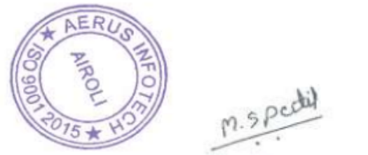

**Received & Accepted**

**Mrs Manjusha Patil**

(Managing Director)

**Authorized Signatory**