**Task 1: Launching your EC2 instance**

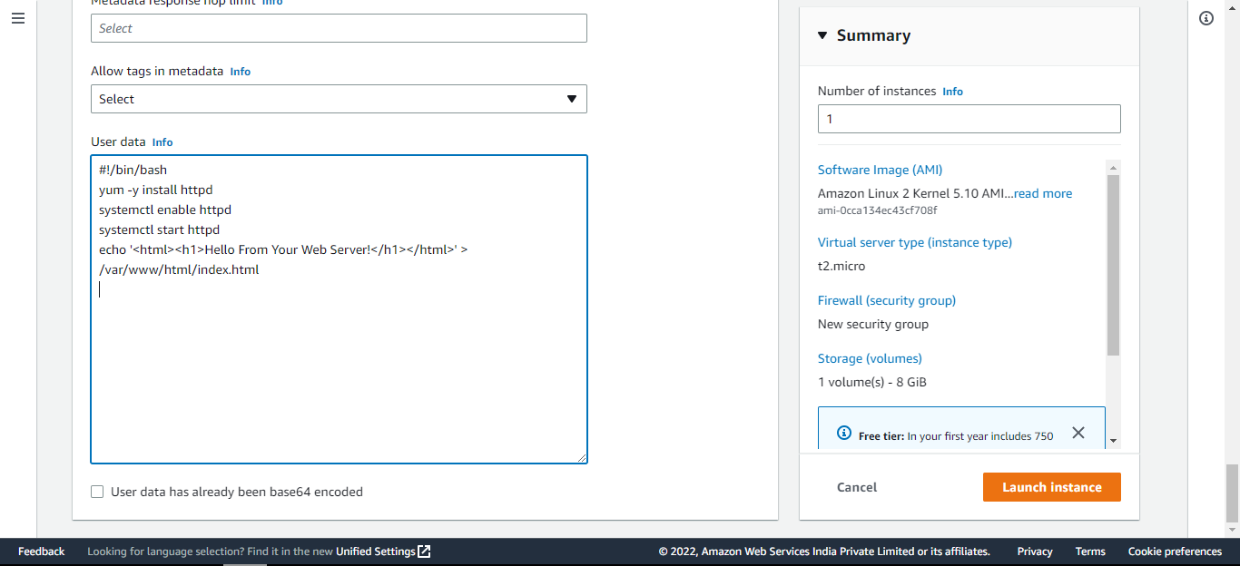

Added the code in user data and previously selected AMI, Instance type etc

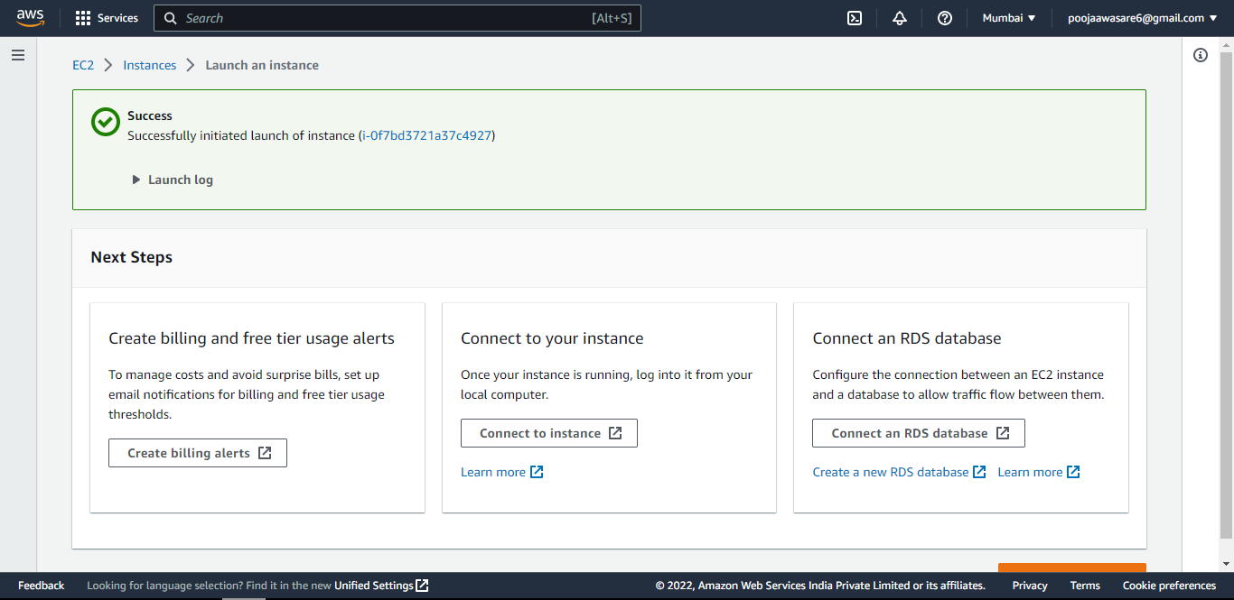

Instance created here

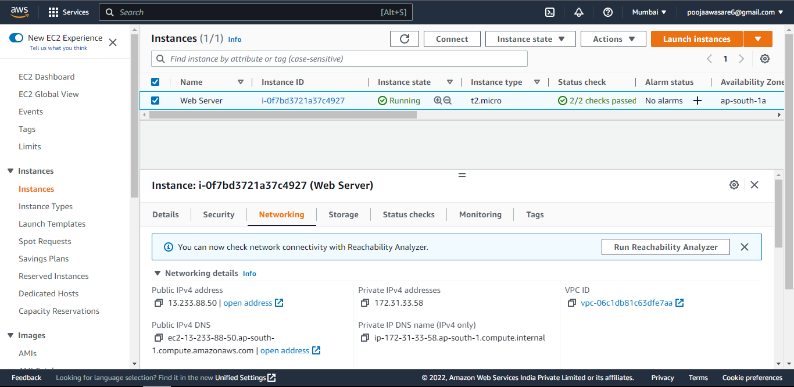

Instance is running in above slides

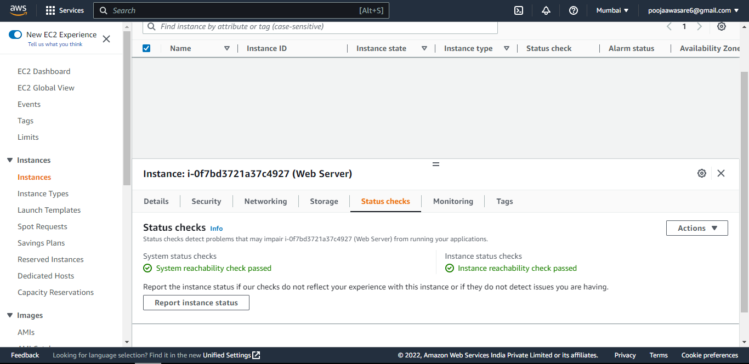

All the two status checks which include System status and Instance Status are checked

**Task 2: Monitor Your Instance**

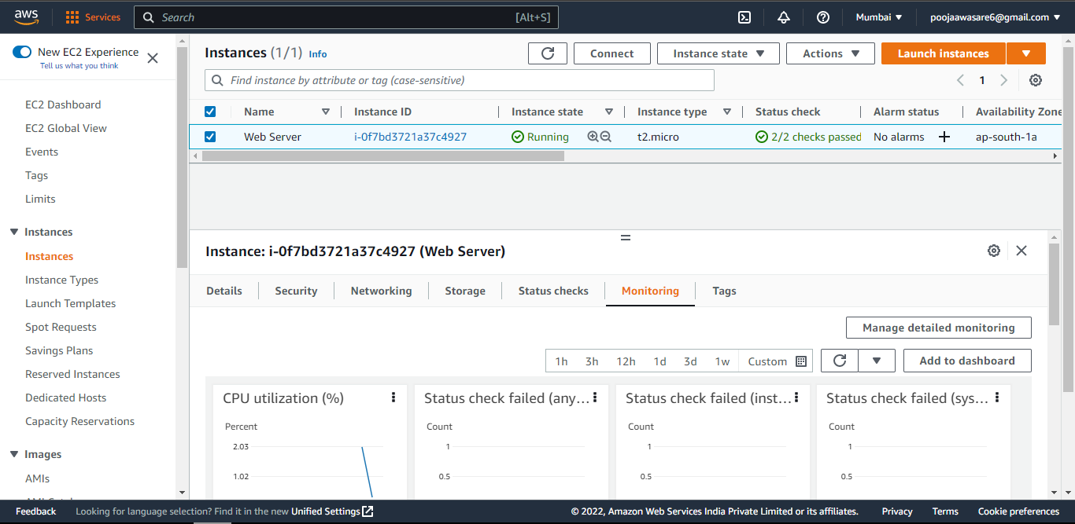

Here we are selecting the Instance we have created and checking the status again in Monitoring tab

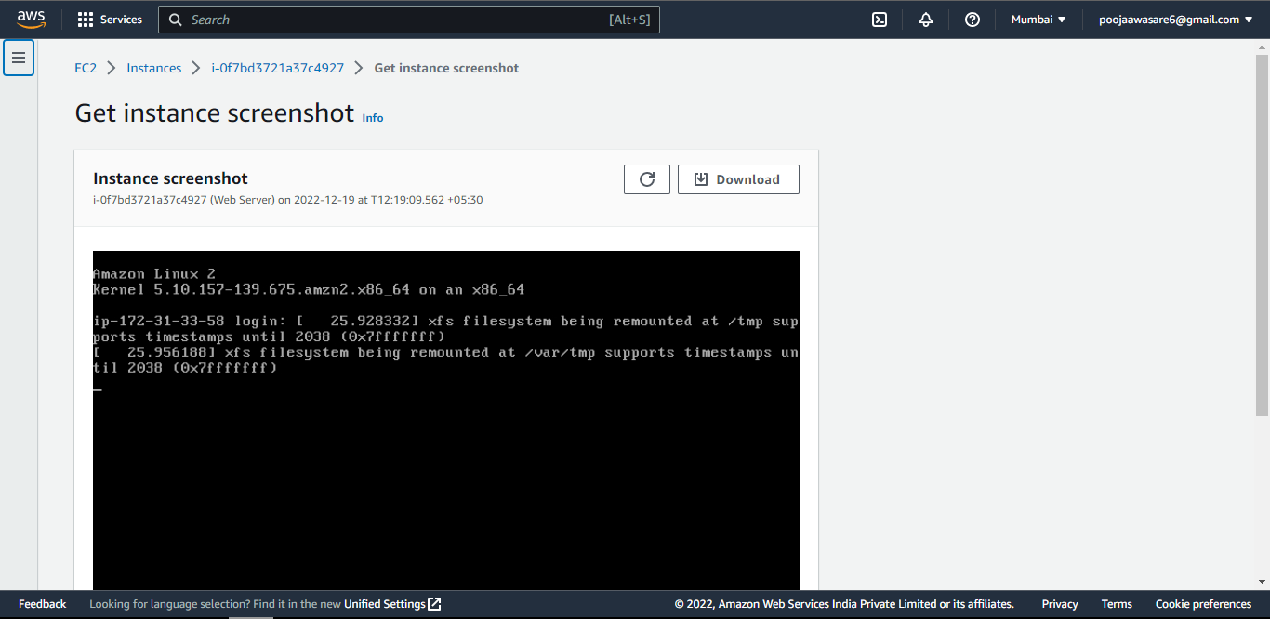

In actions menu we have selected the monitor and troubleshoot instance to monitor our Instance

**Task 3: Update Your Security Group and Access the Web Server**

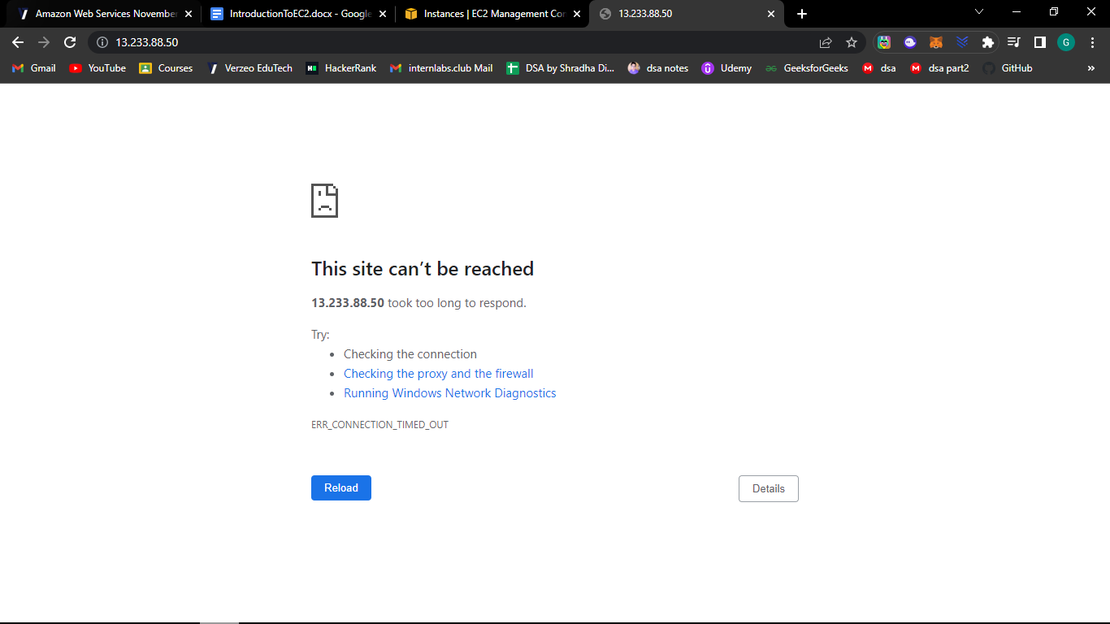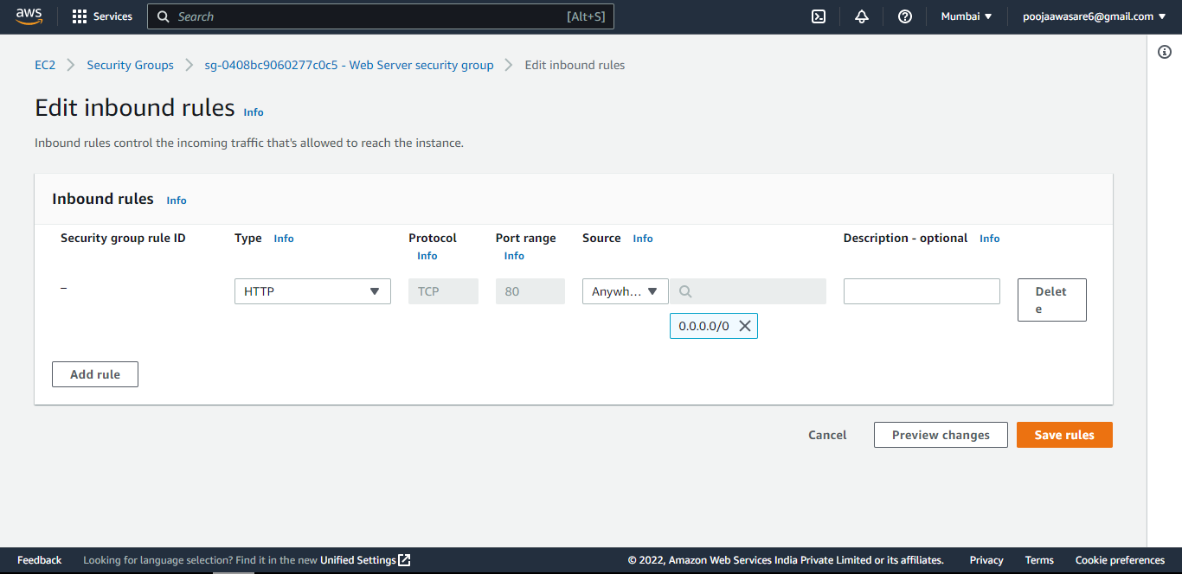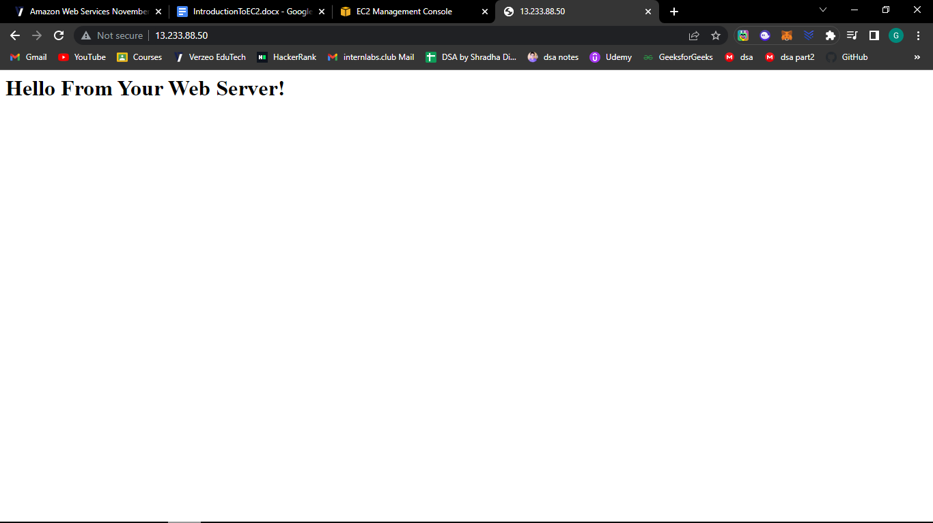

**Task 4: Resize Your Instance: EBS Volume**

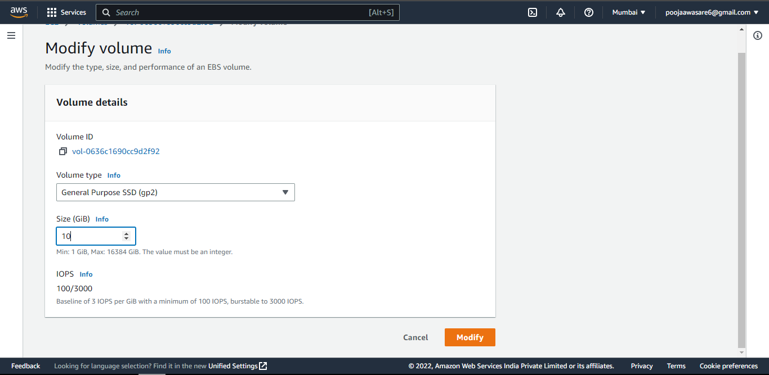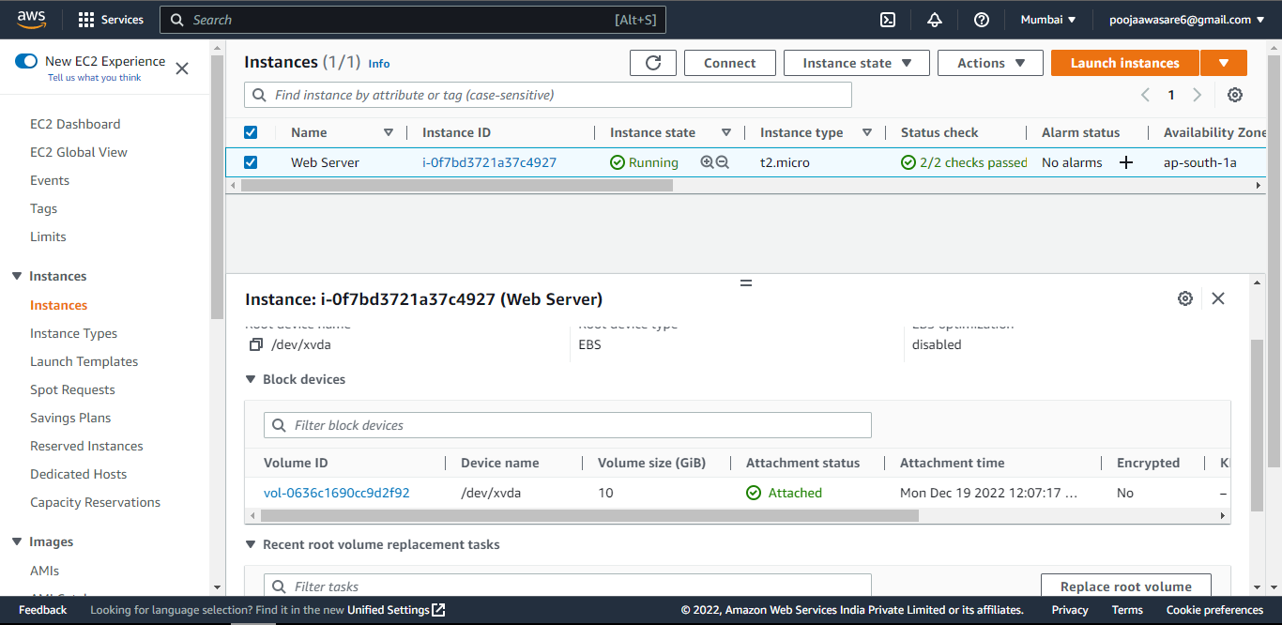

**Task 5: Explore EC2 Limits**

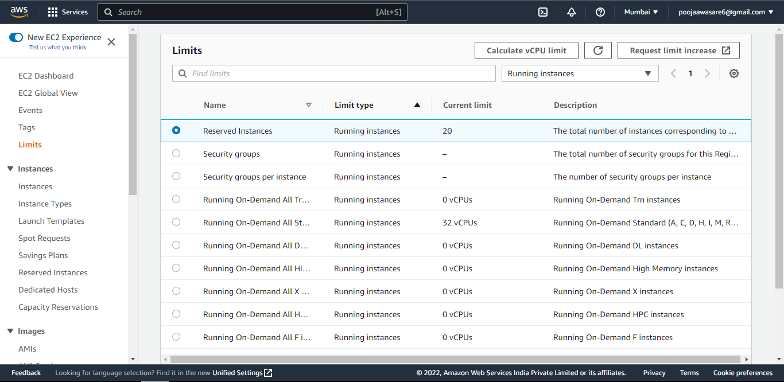

**Task 6: Test Termination Protection**

