Experiment 6
Gaurav Bhagchandani
Roll no. 10
Batch D

Aim: To apply line and edge detection techniques to images

Code:

<!DOCTYPE html>
<html lang="en">
<head>
<meta charset="UTF-8">
<meta name="viewport" content="width=device-width, initial-scale=1.0">
<meta http-equiv="X-UA-Compatible" content="ie=edge">
<title>Document</title>
<style>
.container{
float: right;
width:600px;
}
input[type="text"]{
width:40px;
}
input{
margin:5px;
font-size: 15px;
font-weight: bold;
font-family: sans-serif;
}
.gs{
margin-top: 10px;
}
.thresh{
margin-bottom: 10px;
}
</style>
</head>
<body>
<canvas id="canvas" width="800" height="500"></canvas>
<div class="container">
<div class="thresh">
<input id="threshold" type="range" default=100 min=0 max=255 onchange="updateTextInput(this.value);">
<input type="text" id="textInput" value="100">
<input id="thresholdapply" value="Threshold" type="button">
</div>
<input id="invertbtn" value="Invert" type="button">
<div class="gs">
<div>
<input id="greya" type="range" value=50 min=0 max=255 onchange="updateTextInputGreyA(this.value);">
<input type="text" id="textGreyA" value="50">
</div>
<div>
<input id="greyb" type="range" value=100 min=0 max=255 onchange="updateTextInputGreyB(this.value);">
<input type="text" id="textGreyB" value="100">
</div>
<input id="gsb" value="GS With Background" type="button">
<input id="gswb" value="GS Without Background" type="button">
</div>
<input id="smoothing" value="Smoothing" type="button">
<input id="sharpening" value="Sharpening" type="button">
<br/>
<input id="erosion" value="Erosion" type="button">
<input id="dilation" value="Dilation" type="button">
<br/>
<input id="opening" value="Opening" type="button">
<input id="closing" value="Closing" type="button">
<br/>
<input id="fourier" value="DFT" type="button">
<input id="invfourier" value="IDFT" type="button">
<br/>
<input id="horiz" value="Horizontal Line Detection" type="button">
<input id="vert" value="Vertical Line Detection" type="button">
<input id="ldiag" value="Left Diagonal Line Detection" type="button">
<input id="rdiag" value="Right Diagonal Line Detection" type="button">
<input id="robert" value="Robert's Cross Edge Detection" type="button">
<input id="sobel" value="Sobel Operator Edge Detection" type="button">
<input id="prewitt" value="Prewitt Edge Detection" type="button">
</div>
<script>
var img = new Image();
img.src = 'http://localhost:8000/image.jpg';
img.onload = function() {
draw(this);
};
function updateTextInput(val) {
document.getElementById('textInput').value=val;
}
function updateTextInputGreyA(val) {
document.getElementById('textGreyA').value=val;
}
function updateTextInputGreyB(val) {
document.getElementById('textGreyB').value=val;
}
function addComp(a,b){
let c = {};
c.real = a.real+b.real;
c.imag = a.imag+b.imag;
return c;
}

function subComp(a,b){
let c = {};
c.real = a.real-b.real;
c.imag = a.imag-b.imag;
return c;
}
function magComp(a){
return Math.sqrt(a.real*a.real + a.imag*a.imag);
}
function divComp(a,b){
let c = {},
temp = (b.real*b.real + b.imag*b.imag);
c.real = (a.real*b.real + a.imag*b.imag) / temp;
c.imag = (a.imag*b.real - a.real*b.imag) / temp;
return c;
}
function mulComp(a,b){
let c = {};
c.real = a.real*b.real - a.imag*b.imag;
c.imag = a.real*b.imag + b.real*a.imag;
return c;
}

function doubleuNnk(N,n,k){
let hold = k*n;
hold /= N;
let temp = {},
theta = -2*Math.PI*hold;
temp.real = Math.cos(theta);
temp.imag = Math.sin(theta);
return temp;
}
function arrToComp(arr){
arr.forEach((a,i)=>{
let temp = {};
temp.real = a;
temp.imag = 0;
arr[i] = temp;
});
return arr;
}
function TwoDIDFT(arr){
let temp = [];
console.log(arr);
for(let i = 0; i < arr.length; i++){
temp.push([]);
for(let j = 0; j < arr[i].length; j++){
let t = {real:0,imag:0};
for(let k = 0; k < arr[i].length; k++){
let o = mulComp(doubleuNnk(arr[i].length,-k,j),arr[i][k]);
t = addComp(t,o)
}
temp[i].push(divComp(t,{real:arr[i].length, imag:0}));
}
}
console.log("INVERSE ROW DONE");
let result = [];
for(let i = 0; i < temp.length; i++){
result.push([]);
for(let j = 0; j < temp[i].length; j++){
let t = {real:0,imag:0};
for(let k = 0; k < temp.length; k++){
let o = mulComp(doubleuNnk(temp.length,-k,i),temp[k][j])
t = addComp(t,o)
}
result[i].push(divComp(t,{real:temp.length, imag:0}));
}
}
console.log("INVERSE COLUMN DONE");
for(let i = 0; i < result.length; i++){
for(let j = 0; j < result[i].length; j++){
if((i+j) % 2 === 1){
result[i][j] = mulComp(result[i][j],{real: -1, imag: 0})
}
}
}
return result;
}
function TwoDDFT(arr){
for(let i = 0; i < arr.length;i++){
for(let j = 0; j < arr[i].length; j++){
if((i+j) % 2 === 1){
arr[i][j] = -arr[i][j];
}
}
}
arr.forEach((a)=>{
arrToComp(a);
})
let temp = [];
let max = 0;
for(let i = 0; i < arr.length; i++){
temp.push([]);
for(let j = 0; j < arr[i].length; j++){
let t = {real:0,imag:0};
for(let k = 0; k < arr[i].length; k++){
let o = mulComp(doubleuNnk(arr[i].length,k,j),arr[i][k]);
t = addComp(t,o)
}
temp[i].push(t);
}
}
console.log("ROW DONE");
let result = [];
for(let i = 0; i < temp.length; i++){
result.push([]);
for(let j = 0; j < temp[i].length; j++){
let t = {real:0,imag:0};
for(let k = 0; k < temp.length; k++){
let o = mulComp(doubleuNnk(temp.length,k,i),temp[k][j])
t = addComp(t,o)
}
if(magComp(t) > max){
max = magComp(t);
}
result[i].push(t);
}
}
console.log("COLUMN DONE");
return [result,max];
}
function draw(img) {
var canvas = document.getElementById('canvas');
canvas.height = img.height;
canvas.width = img.width;
var ctx = canvas.getContext('2d');
console.log(img.height, img.width);
ctx.drawImage(img, 0, 0);
img.style.display = 'none';
let dftResult;
var imageData = ctx.getImageData(0, 0, canvas.width, canvas.height);
let height = img.height,
width = img.width;
var data = imageData.data;
var invert = function() {
for (var i = 0; i < data.length; i += 4) {
data[i] = 255 - data[i]; // red
data[i + 1] = 255 - data[i + 1]; // green
data[i + 2] = 255 - data[i + 2]; // blue
}
ctx.putImageData(imageData, 0, 0);
data = imageData.data;
};
var threshold = function(){
let t = parseInt(document.getElementById('threshold').value);
for (var i = 0; i < data.length; i += 4) {
if(data[i] < t){
data[i] = 255; // red
}else{
data[i] = 0;
}
if(data[i+1] < t){
data[i+1] = 255;
}else{
data[i+1] = 0;
}
if(data[i+2] < t){
data[i+2] = 255;
}else{
data[i+2] = 0;
}
}
ctx.putImageData(imageData, 0, 0);
}
var glslicing = function(wb){
let a = parseInt(document.getElementById('greya').value),
b = parseInt(document.getElementById('greyb').value);
if(a > b){
let temp = a;
a = b;
b = temp;
}
for (var i = 0; i < data.length; i += 4) {
if(data[i] < a || data[i] > b){
data[i] = 255;
}else if(wb){
data[i] = 0;
}
if(data[i+1] < a || data[i+1] > b){
data[i+1] = 255;
}else if(wb){
data[i+1] = 0;
}
if(data[i+2] < a || data[i+2] > b){
data[i+2] = 255;
}else if(wb){
data[i+2] = 0;
}
}
ctx.putImageData(imageData, 0, 0);
}
function twotoone(i,j,width){
if(i < 0 || j < 0 || i >= width || j >= height){
return -1;
}
return j*width + i;
}
var smoothingEv = function(){
let dat = [],dat2=[];
for(let i = 0; i < data.length; i+=4){
dat.push(data[i]);
dat2.push(data[i]);
}
let c;
let mask = [[1, 1, 1], [1, 1, 1], [1, 1, 1]]
for(let i = -1; i < width;i++){
for(let j = -1; j < height; j++){
let sum = 0;
for(let k = 0; k < 3; k++){
for(let l = 0; l < 3; l++){
c = mask[k][l];
if(dat[twotoone(i + k, j + l, width)]){
sum += c*dat[twotoone(i + k, j + l, width)];
}else{
if(j === -1 && l === 0){
// console.log(twotoone(i + k, j + l + 1, width),j,l,i)
sum += c*dat[twotoone(i + k, j + l + 1, width)];
}else if(i === -1 && k === 0){
sum += c*dat[twotoone(i + k + 1, j + l, width)];
}else if(j === height && l === 2){
sum += c*dat[twotoone(i + k, j+l-1 , width)];
}
else if(i === width && k === 2){
sum += c*dat[twotoone(i+k-1, j + l, width)];
}
}
}
}
sum /= 9;
sum = Math.round(sum);
dat2[twotoone(i+1,j+1,width)] = sum;
}
}
// console.log(dat2);
for(let i = 0; i < dat2.length;i++){
data[4*i] = dat2[i];
data[4*i+1] = dat2[i];
data[4*i+2] = dat2[i];
}
ctx.putImageData(imageData, 0, 0);
}
var sharpeningEv = function () {
let dat = [], dat2 = [];
for (let i = 0; i < data.length; i += 4) {
dat.push(data[i]);
dat2.push(data[i]);
}
let c;
let mask = [[-1,-1,-1],
[-1,17,-1],
[-1,-1,-1]];
// let mask = [[0, -1, 0],
// [-1, 5, -1],
// [0, -1, 0]]
for (let i = -1; i < width; i++) {
for (let j = -1; j < height; j++) {
let sum = 0;
for (let k = 0; k < 3; k++) {
for (let l = 0; l < 3; l++) {
c = mask[k][l];
if (dat[twotoone(i + k, j + l, width)]) {
sum += c*dat[twotoone(i + k, j + l, width)];
} else {
if (j === -1 && l === 0) {
// console.log(twotoone(i + k, j + l + 1, width),j,l,i)
sum += c*dat[twotoone(i + k, j + l + 1, width)];
} else if (i === -1 && k === 0) {
sum += c*dat[twotoone(i + k + 1, j + l, width)];
} else if (j === height && l === 2) {
sum += c*dat[twotoone(i + k, j + l - 1, width)];
}
else if (i === width && k === 2) {
sum += c*dat[twotoone(i + k - 1, j + l, width)];
}
}
}
}
sum /= 9;
sum = Math.round(sum);
if(sum < 0){
sum = 0;
}
dat2[twotoone(i + 1, j + 1, width)] = sum;
}
}
// console.log(dat2);
for (let i = 0; i < dat2.length; i++) {
data[4 * i] = dat2[i];
data[4 * i + 1] = dat2[i];
data[4 * i + 2] = dat2[i];
}
ctx.putImageData(imageData, 0, 0);
}
var dilationEv = function () {
let dat = [], dat2 = [];
for (let i = 0; i < data.length; i += 4) {
dat.push(data[i]);
dat2.push(data[i]);
}
let c;
let mask = [
[1, 1, 1, 1, 0],
[1, 0, 1, 1, 1],
[1, 1, 1, 1, 1],
[1, 1, 1, 0, 1],
[0, 1, 1, 1, 1]
];
for (let i = 0; i < width; i++) {
for (let j = 0; j < height; j++) {
let max = 0;
for (let k = -1; k < mask.length-1; k++) {
for (let l = -1; l < mask.length-1; l++) {
c = mask[k+1][l+1];
let hold = dat[twotoone(i + k, j + l, width)];
if (hold !== undefined && c === 1 && hold > max) {
max = hold;
}
}
}
dat2[twotoone(i, j, width)] = max;
}
}
for (let i = 0; i < dat2.length; i++) {
data[4 * i] = dat2[i];
data[4 * i + 1] = dat2[i];
data[4 * i + 2] = dat2[i];
}
ctx.putImageData(imageData, 0, 0);
}
var erosionEv = function () {
console.log("In")
let dat = [], dat2 = [];
for (let i = 0; i < data.length; i += 4) {
dat.push(data[i]);
dat2.push(data[i]);
}
let c;
let mask = [
[1, 1, 1, 1, 0],
[1, 0, 1, 1, 1],
[1, 1, 1, 1, 1],
[1, 1, 1, 0, 1],
[0, 1, 1, 1, 1]
];
for (let i = 0; i < width; i++) {
for (let j = 0; j < height; j++) {
let min = 255;
for (let k = -1; k < mask.length-1; k++) {
for (let l = -1; l < mask.length-1; l++) {
c = mask[k+1][l+1];
let hold = dat[twotoone(i + k, j + l, width)];
if (hold !== undefined && c === 1 && hold < min) {
min = hold;
}else if(hold === undefined){
// console.log("Hello",i,j,height,width, dat.length, twotoone(i + k, j + l, width),min)
}
}
}
dat2[twotoone(i, j, width)] = min;
}
}
for (let i = 0; i < dat2.length; i++) {
data[4 * i] = dat2[i];
data[4 * i + 1] = dat2[i];
data[4 * i + 2] = dat2[i];
}
ctx.putImageData(imageData, 0, 0);
}
var closingEv = function () {
erosionEv();
dilationEv();
}
var openingEv = function () {
dilationEv();
erosionEv();
}
var dft = function(){
let dat = [[]], count = 0, count2 = 0;
for (let i = 0; i < data.length; ) {
if(count2 < width){
dat[count].push(data[i]);
count2++;
i += 4
}else{
count++;
count2 = 0;
dat.push([]);
}
}
let result = TwoDDFT(dat);
let max = result[1];
dftResult = result[0];
let c = 255 / Math.log(1 + max);
result = result[0];
for (let i = 0; i < result.length; i++) {
for(let j = 0; j < result[i].length;j++){
data[4 * (i*width+j)] = c*Math.log(1+magComp(result[i][j]));
data[4 * (i*width+j) + 1] = c*Math.log(1+magComp(result[i][j]));
data[4 * (i*width+j) + 2] = c*Math.log(1+magComp(result[i][j]));
// data[4 * (i*width+j)] = magComp(result[i][j]);
// data[4 * (i*width+j) + 1] = magComp(result[i][j]);
// data[4 * (i*width+j) + 2] = magComp(result[i][j]);
}
}
ctx.putImageData(imageData, 0, 0);
}
var idft = function(){
if(dftResult){
let result = TwoDIDFT(dftResult);
for (let i = 0; i < result.length; i++) {
for(let j = 0; j < result[i].length;j++){
data[4 * (i*width+j)] = magComp(result[i][j]);
data[4 * (i*width+j) + 1] = magComp(result[i][j]);
data[4 * (i*width+j) + 2] = magComp(result[i][j]);
}
}
ctx.putImageData(imageData, 0, 0);
}else{
alert("DFT has not been applied");
}

}
var convolve = function(mask){
let dat = [],dat2=[];
for(let i = 0; i < data.length; i+=4){
dat.push(data[i]);
dat2.push(data[i]);
}
let c;
for(let i = -1; i < width;i++){
for(let j = -1; j < height; j++){
let sum = 0;
for(let k = 0; k < 3; k++){
for(let l = 0; l < 3; l++){
c = mask[l][k];
if(dat[twotoone(i + k, j + l, width)]){
sum += c*dat[twotoone(i + k, j + l, width)];
}else{
if(j === -1 && l === 0){
// console.log(twotoone(i + k, j + l + 1, width),j,l,i)
sum += c*dat[twotoone(i + k, j + l + 1, width)];
}else if(i === -1 && k === 0){
sum += c*dat[twotoone(i + k + 1, j + l, width)];
}else if(j === height && l === 2){
sum += c*dat[twotoone(i + k, j+l-1 , width)];
}
else if(i === width && k === 2){
sum += c*dat[twotoone(i+k-1, j + l, width)];
}
}
}
}
sum = Math.round(sum);
dat2[twotoone(i+1,j+1,width)] = sum;
}
}
// console.log(dat2);
for(let i = 0; i < dat2.length;i++){
data[4*i] = dat2[i];
data[4*i+1] = dat2[i];
data[4*i+2] = dat2[i];
}
ctx.putImageData(imageData, 0, 0);
}
var horizontalLineDetection = function(){
convolve([
[-1, -1, -1],
[2, 2, 2],
[-1, -1, -1]
])
}
var verticalLineDetection = function(){
convolve([
[-1, 2, -1],
[-1, 2, -1],
[-1, 2, -1]
])
}
var leftDiagonalLineDetection = function(){
convolve([
[2, -1, -1],
[-1, 2, -1],
[-1, -1, 2]
])
}
var rightDiagonalLineDetection = function(){
convolve([
[-1, -1, 2],
[-1, 2, -1],
[2, -1, -1]
])
}
var sobel = function(){
let dat = [],dat2=[], dat3=[];
for(let i = 0; i < data.length; i+=4){
dat.push(data[i]);
dat2.push(data[i]);
dat3.push(data[i]);
}
let c;
let mask = [
[1, 2, 1],
[0, 0, 0],
[-1, -2, -1]
];
let mask2 = [
[1, 0, -1],
[2, 0, -2],
[1, 0, -1]
];
for(let i = -1; i < width;i++){
for(let j = -1; j < height; j++){
let sum = 0;
for(let k = 0; k < 3; k++){
for(let l = 0; l < 3; l++){
c = mask[l][k];
if(dat[twotoone(i + k, j + l, width)]){
sum += c*dat[twotoone(i + k, j + l, width)];
}else{
if(j === -1 && l === 0){
// console.log(twotoone(i + k, j + l + 1, width),j,l,i)
sum += c*dat[twotoone(i + k, j + l + 1, width)];
}else if(i === -1 && k === 0){
sum += c*dat[twotoone(i + k + 1, j + l, width)];
}else if(j === height && l === 2){
sum += c*dat[twotoone(i + k, j+l-1 , width)];
}
else if(i === width && k === 2){
sum += c*dat[twotoone(i+k-1, j + l, width)];
}
}
}
}
sum = Math.round(sum);
dat2[twotoone(i+1,j+1,width)] = sum;
}
}
for(let i = -1; i < width;i++){
for(let j = -1; j < height; j++){
let sum = 0;
for(let k = 0; k < 3; k++){
for(let l = 0; l < 3; l++){
c = mask2[l][k];
if(dat[twotoone(i + k, j + l, width)]){
sum += c*dat[twotoone(i + k, j + l, width)];
}else{
if(j === -1 && l === 0){
// console.log(twotoone(i + k, j + l + 1, width),j,l,i)
sum += c*dat[twotoone(i + k, j + l + 1, width)];
}else if(i === -1 && k === 0){
sum += c*dat[twotoone(i + k + 1, j + l, width)];
}else if(j === height && l === 2){
sum += c*dat[twotoone(i + k, j+l-1 , width)];
}
else if(i === width && k === 2){
sum += c*dat[twotoone(i+k-1, j + l, width)];
}
}
}
}
sum = Math.round(sum);
dat3[twotoone(i+1,j+1,width)] = sum;
}
}
// console.log(dat2);
for(let i = 0; i < dat2.length;i++){
let temp = Math.sqrt(dat2[i]*dat2[i]+dat3[i]*dat3[i]);
// let temp = dat2[i]+dat3[i];
data[4*i] = temp;
data[4*i+1] = temp;
data[4*i+2] = temp;
}
ctx.putImageData(imageData, 0, 0);
}
var prewitt = function(){
let dat = [],dat2=[], dat3=[];
for(let i = 0; i < data.length; i+=4){
dat.push(data[i]);
dat2.push(data[i]);
dat3.push(data[i]);
}
let c;
let mask = [
[1, 1, 1],
[0, 0, 0],
[-1, -1, -1]
];
let mask2 = [
[1, 0, -1],
[1, 0, -1],
[1, 0, -1]
];
for(let i = -1; i < width;i++){
for(let j = -1; j < height; j++){
let sum = 0;
for(let k = 0; k < 3; k++){
for(let l = 0; l < 3; l++){
c = mask[l][k];
if(dat[twotoone(i + k, j + l, width)]){
sum += c*dat[twotoone(i + k, j + l, width)];
}else{
if(j === -1 && l === 0){
// console.log(twotoone(i + k, j + l + 1, width),j,l,i)
sum += c*dat[twotoone(i + k, j + l + 1, width)];
}else if(i === -1 && k === 0){
sum += c*dat[twotoone(i + k + 1, j + l, width)];
}else if(j === height && l === 2){
sum += c*dat[twotoone(i + k, j+l-1 , width)];
}
else if(i === width && k === 2){
sum += c*dat[twotoone(i+k-1, j + l, width)];
}
}
}
}
sum = Math.round(sum);
dat2[twotoone(i+1,j+1,width)] = sum;
}
}
for(let i = -1; i < width;i++){
for(let j = -1; j < height; j++){
let sum = 0;
for(let k = 0; k < 3; k++){
for(let l = 0; l < 3; l++){
c = mask2[l][k];
if(dat[twotoone(i + k, j + l, width)]){
sum += c*dat[twotoone(i + k, j + l, width)];
}else{
if(j === -1 && l === 0){
// console.log(twotoone(i + k, j + l + 1, width),j,l,i)
sum += c*dat[twotoone(i + k, j + l + 1, width)];
}else if(i === -1 && k === 0){
sum += c*dat[twotoone(i + k + 1, j + l, width)];
}else if(j === height && l === 2){
sum += c*dat[twotoone(i + k, j+l-1 , width)];
}
else if(i === width && k === 2){
sum += c*dat[twotoone(i+k-1, j + l, width)];
}
}
}
}
sum = Math.round(sum);
dat3[twotoone(i+1,j+1,width)] = sum;
}
}
// console.log(dat2);
for(let i = 0; i < dat2.length;i++){
let temp = Math.sqrt(dat2[i]*dat2[i]+dat3[i]*dat3[i]);
// let temp = dat2[i]+dat3[i];
data[4*i] = temp;
data[4*i+1] = temp;
data[4*i+2] = temp;
}
ctx.putImageData(imageData, 0, 0);
}
var roberts = function(){
let dat = [],dat2=[], dat3=[];
for(let i = 0; i < data.length; i+=4){
dat.push(data[i]);
dat2.push(data[i]);
dat3.push(data[i]);
}
let c;
let mask = [
[1, 0],
[0, -1]
];
let mask2 = [
[0, 1],
[-1, 0]
];
for(let i = -1; i < width;i++){
for(let j = -1; j < height; j++){
let sum = 0;
for(let k = 0; k < mask.length; k++){
for(let l = 0; l < mask.length; l++){
c = mask[l][k];
if(dat[twotoone(i + k, j + l, width)]){
sum += c*dat[twotoone(i + k, j + l, width)];
}else{
if(j === -1 && l === 0){
// console.log(twotoone(i + k, j + l + 1, width),j,l,i)
sum += c*dat[twotoone(i + k, j + l + 1, width)];
}else if(i === -1 && k === 0){
sum += c*dat[twotoone(i + k + 1, j + l, width)];
}else if(j === height && l === 2){
sum += c*dat[twotoone(i + k, j+l-1 , width)];
}
else if(i === width && k === 2){
sum += c*dat[twotoone(i+k-1, j + l, width)];
}
}
}
}
sum = Math.round(sum);
dat2[twotoone(i+1,j+1,width)] = sum;
}
}
for(let i = -1; i < width;i++){
for(let j = -1; j < height; j++){
let sum = 0;
for(let k = 0; k < mask.length; k++){
for(let l = 0; l < mask.length; l++){
c = mask2[l][k];
if(dat[twotoone(i + k, j + l, width)]){
sum += c*dat[twotoone(i + k, j + l, width)];
}else{
if(j === -1 && l === 0){
// console.log(twotoone(i + k, j + l + 1, width),j,l,i)
sum += c*dat[twotoone(i + k, j + l + 1, width)];
}else if(i === -1 && k === 0){
sum += c*dat[twotoone(i + k + 1, j + l, width)];
}else if(j === height && l === 2){
sum += c*dat[twotoone(i + k, j+l-1 , width)];
}
else if(i === width && k === 2){
sum += c*dat[twotoone(i+k-1, j + l, width)];
}
}
}
}
sum = Math.round(sum);
dat3[twotoone(i+1,j+1,width)] = sum;
}
}
// console.log(dat2);
for(let i = 0; i < dat2.length;i++){
let temp = Math.sqrt(dat2[i]*dat2[i]+dat3[i]*dat3[i]);
// let temp = dat2[i]+dat3[i];
data[4*i] = temp;
data[4*i+1] = temp;
data[4*i+2] = temp;
}
ctx.putImageData(imageData, 0, 0);
}
var invertbtn = document.getElementById('invertbtn');
invertbtn.addEventListener('click', invert);
var thresholdbtn = document.getElementById('thresholdapply');
thresholdbtn.addEventListener('click', threshold);
var gsb = document.getElementById('gsb');
gsb.addEventListener('click', ()=>{ glslicing(false) });
var gswb = document.getElementById('gswb');
gswb.addEventListener('click', ()=>{ glslicing(true) });
var smoothing = document.getElementById('smoothing');
smoothing.addEventListener('click', ()=>{ smoothingEv() });
var sharpening = document.getElementById('sharpening');
sharpening.addEventListener('click', () => { sharpeningEv() });
var dilation = document.getElementById('dilation');
dilation.addEventListener('click', () => { dilationEv() });
var erosion = document.getElementById('erosion');
erosion.addEventListener('click', () => { erosionEv() });
var closing = document.getElementById('closing');
closing.addEventListener('click', () => { closingEv() });
var opening = document.getElementById('opening');
opening.addEventListener('click', () => { openingEv() });
var fourier = document.getElementById('fourier');
fourier.addEventListener('click',() => { dft() })
var invfourier = document.getElementById('invfourier');
invfourier.addEventListener('click',() => { idft() })
var horizLine = document.getElementById('horiz');
horizLine.addEventListener('click',() => { horizontalLineDetection() })
var vertLine = document.getElementById('vert');
vertLine.addEventListener('click',() => { verticalLineDetection() })
var ldiagLine = document.getElementById('ldiag');
ldiagLine.addEventListener('click',() => { leftDiagonalLineDetection() })
var rdiagLine = document.getElementById('rdiag');
rdiagLine.addEventListener('click',() => { rightDiagonalLineDetection() })
var sobelEdge = document.getElementById('sobel');
sobelEdge.addEventListener('click',() => { sobel() })
var robertEdge = document.getElementById('robert');
robertEdge.addEventListener('click',() => { roberts() })
var prewittEdge = document.getElementById('prewitt');
prewittEdge.addEventListener('click',() => { prewitt() })
}

</script>
</body>
</html>

Output:

Original Image:

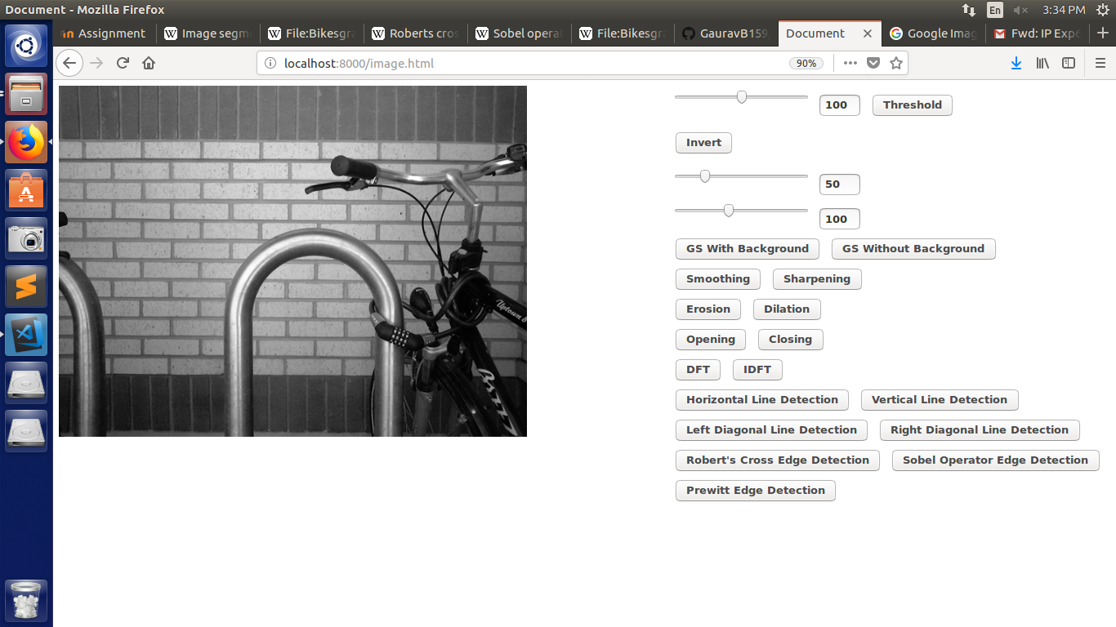
Horizontal Line Detection:

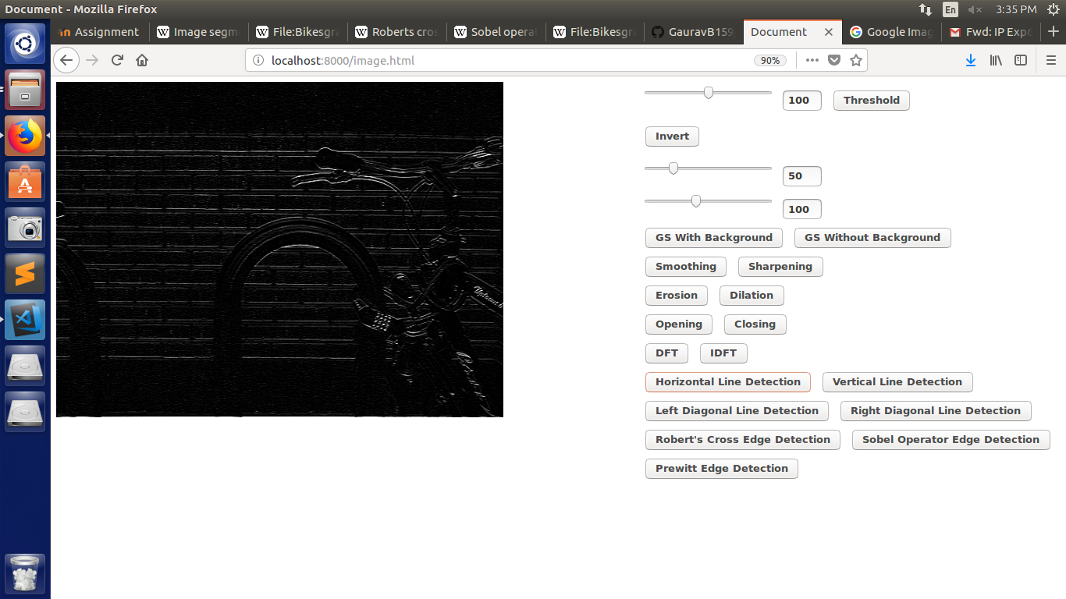

Vertical Line Detection:

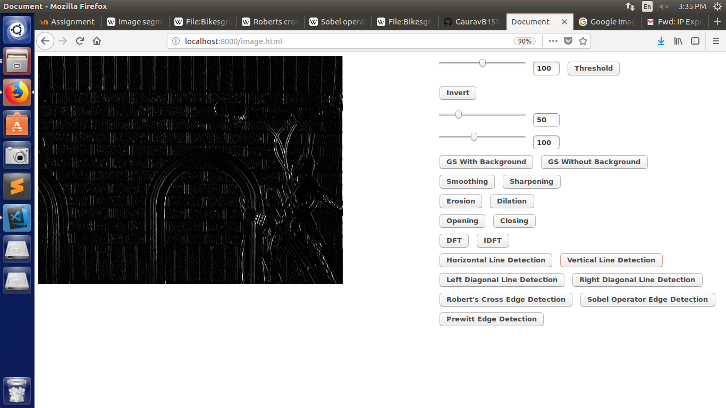
Left Diagonal Line Detection:

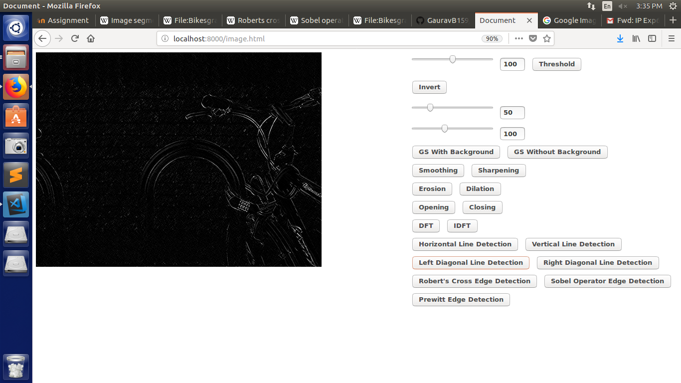

Right Diagonal Line Detection:

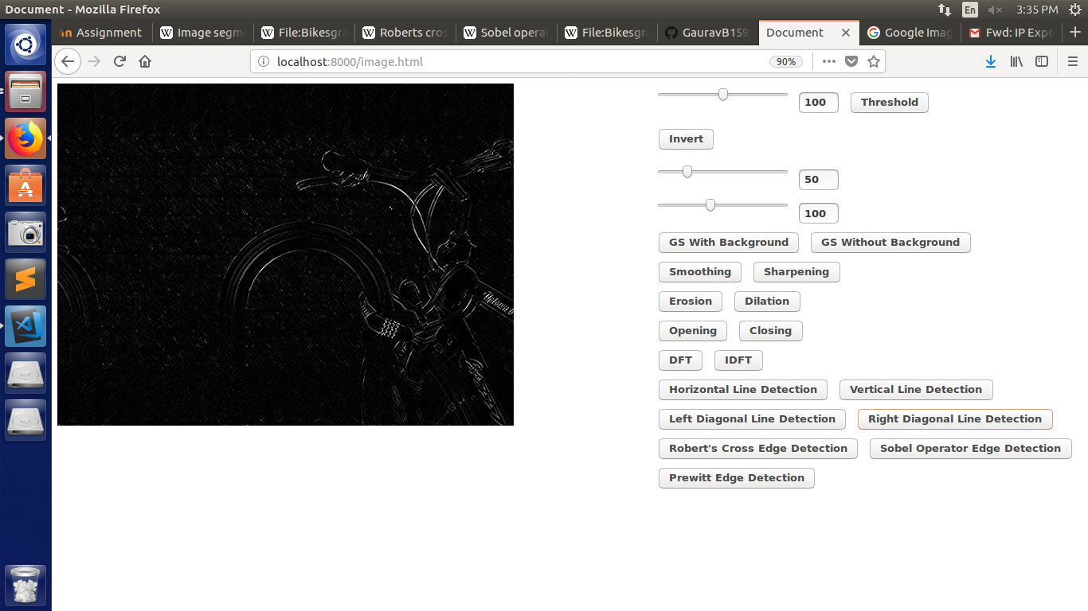
Robert’s Cross Edge Detection:

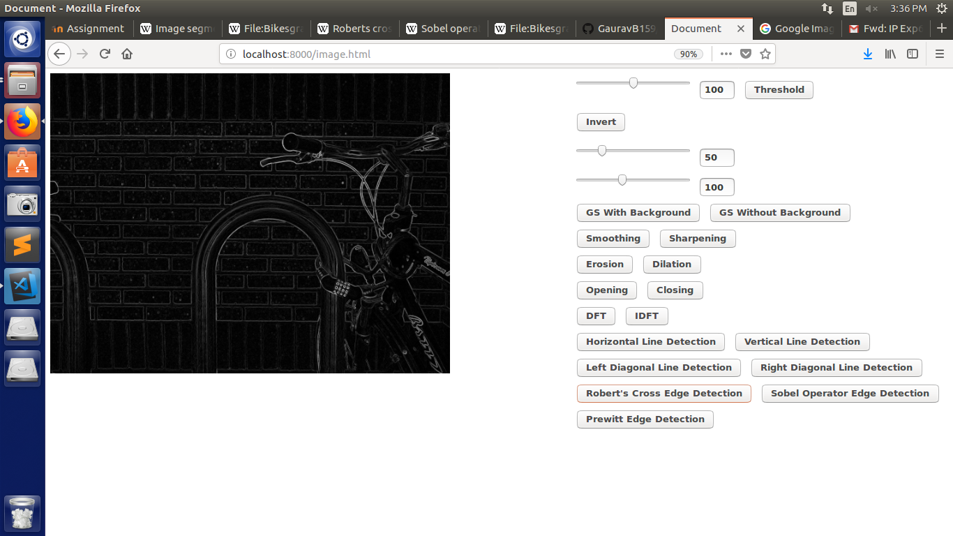

Sobel Operator Edge Detection:

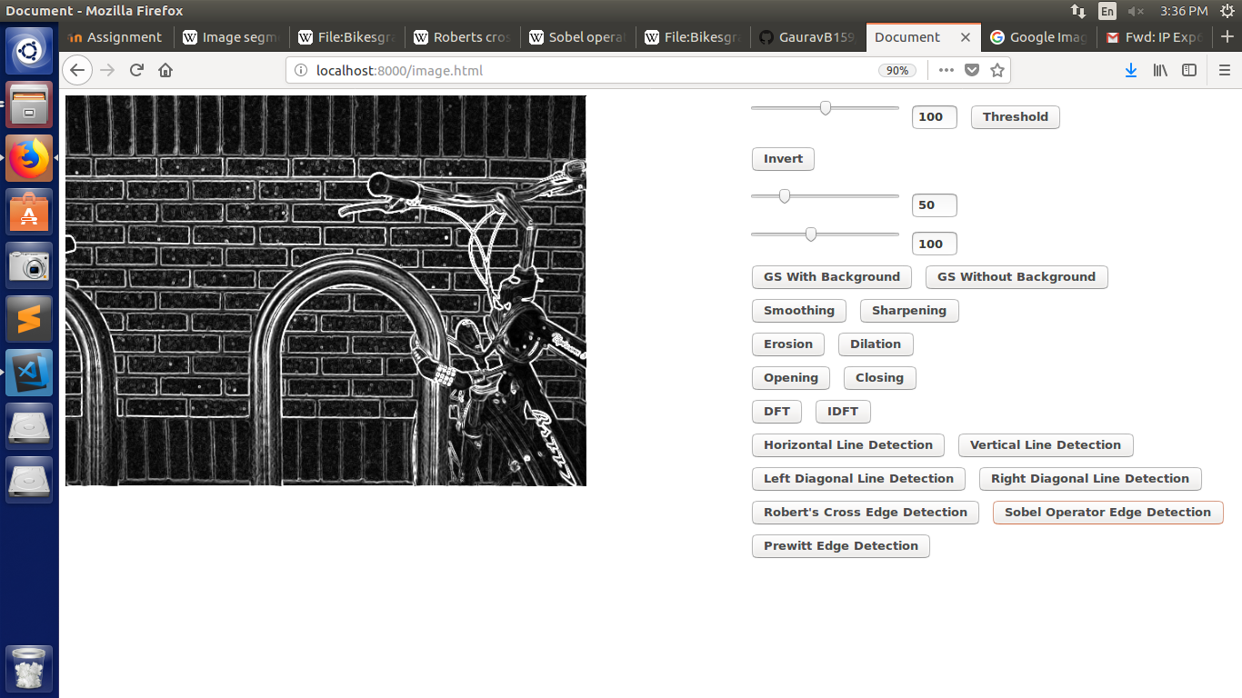
Prewitt Edge Detection:

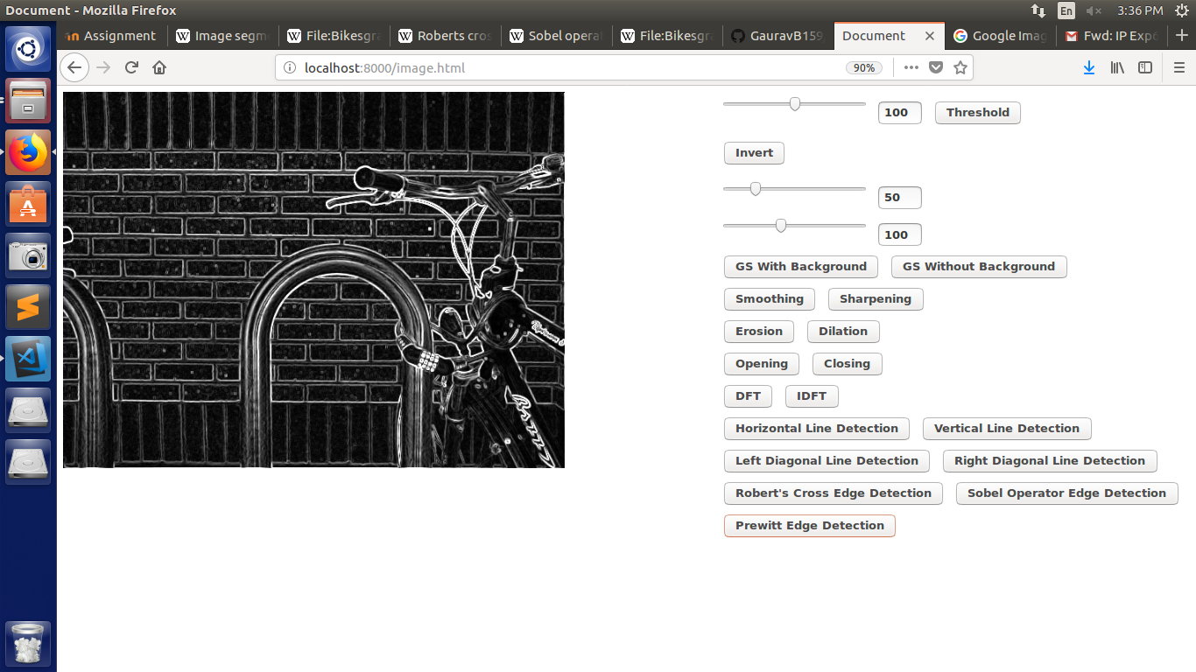
Conclusion: Applied various edge and line detection techniques

