**------------------------------------------------FOOTER**

**About us**

‘Smash The Court’ is a team of sports lovers with a vision to facilitate sports through its online platform. From facility booking to sports event registration, we offer a range of services to players, sports facility owners, as sports Enthusiasts.

Our approach is simple—to design something that we will admire to use ourselves and for all.

* [About us](https://www.gwsportsapp.in/about-us)
* [Privacy policy](https://www.gwsportsapp.in/privacy-policy)
* [Terms & conditions](https://www.gwsportsapp.in/terms-and-conditions)
* [Terms of use](https://www.gwsportsapp.in/terms-of-use)

Copyright © 2013-2022. All Rights are reserved.

# Welcome to Smash The Court’

# **Who we are?**

‘Smash The Court’ Sports App is the sports facility booking platform, which also helps sports enthusiast to find similar skills opponents/partners to play with.

**What are we doing?**

Started in 2022,with just a click of a button, GW is revolutionizing how pickup games are planned and booked in clubs. “Smash The Court’ event team also organizes one of the most professionally run corporate sports in different cities. ‘Smash The Court’ mission to facilitate over 10 Cr Indians by 2023 and our vision is to make sports an integral part of Health & Fitness regime.

**Why choose us?**

‘Smash The Court’ provides sports enthusiast, the most uncomplicated and quickest booking experience. The platform offers the most comprehensive category of sports on its platform so if you are an expert of a Smash, we have got your back. Find similar skilled players and opponent teams by creating a game in our Connect section and enjoy competitive pickup games. With ‘Smash The Court’ subscription book sports facility in just 30 secs, Book now pay later, single click booking, cash backs etc. Choose and register in sports & fitness activities happening near you. So next time you or your company plan to play sports do check with us.

-------------------------------------------Privacy Policy

# Privacy Policy

As part of our mission to help make recreational sports better for everyone, ‘Smash The Court’ Inc. (“Smash The Court”, "we", "us") collects and processes a lot of information. This Privacy Policy is intended to help you better understand how we collect, use, and store your personal information—whether you are an organizer or player participant that uses our products, applications, or services (the "Services").

This Privacy Policy covers our data collection practices and describes your rights to access, correct, amend, delete, port, or limit our use of your personal information.

By using our Services, or by dealing with an organizer using our Services, you are agreeing to the terms of this Privacy Policy and, as applicable, the ‘Smash The Court’ Terms and Services.

We may update this Privacy Policy from time to time in order to reflect, for example, changes to our privacy practices or for other operational, legal, or regulatory reasons. If we make material changes to this Privacy Policy, we will give you notice of such changes by posting the revised policy on this Website, and where appropriate, by other means. By continuing to use this Website or the Support Service after these changes are posted, you agree to the revised policy.

**Badminton quotes---vo black moving mei quotes likhna**

The beauty of the game is strength, stamina and technique and when you shorten the game, technique goes for a toss and the quality of badminton will surely go down in this system. -[Jwala Gutta](https://www.brainyquote.com/authors/jwala-gutta-quotes)

When I was a kid, my parents would play badminton, but I hardly joined them. I’d just pick up their racquets and fiddle around. Check out how the racquet was made… toss it around to see how light it was! At the time, I didn’t even know I’d play badminton.

– Saina Nehwal

When badminton was accepted into the Barcelona Olympic Games it showed that there was an acceptance of my sport internationally.

– Rhonda Cator

The game often played double or single which needs stamina intelligence and technique which avoid various diseases and sharpens our mind is obviously badminton.

Those who play badminton well take decisions quickly.

– Dmitry Medvedev

Some smashes have been timed at more than 250 mph, so you get less than a second to react. People who see a professional badminton match up close are always shocked at the speed. – Rajiv Ouseph

-------------------------------------------------------------Feedback+rating stars

1. This is very nice platform to book badminton court online. 5*
2. Courts are really good and clean. Amenities are also good.4.5*
3. The court I visited was nice and timely managed.Cost is also good. 5*

---------------------------------------------------6 blocks

1. Schedule – Easy to find time slots to play in court as per Schedules.
2. Registers Player Online -Players can register and get membership of any Clubs available.
3. Feel premiumness ?
4. Scale your BMI ?
5. Tips and Tricks ?

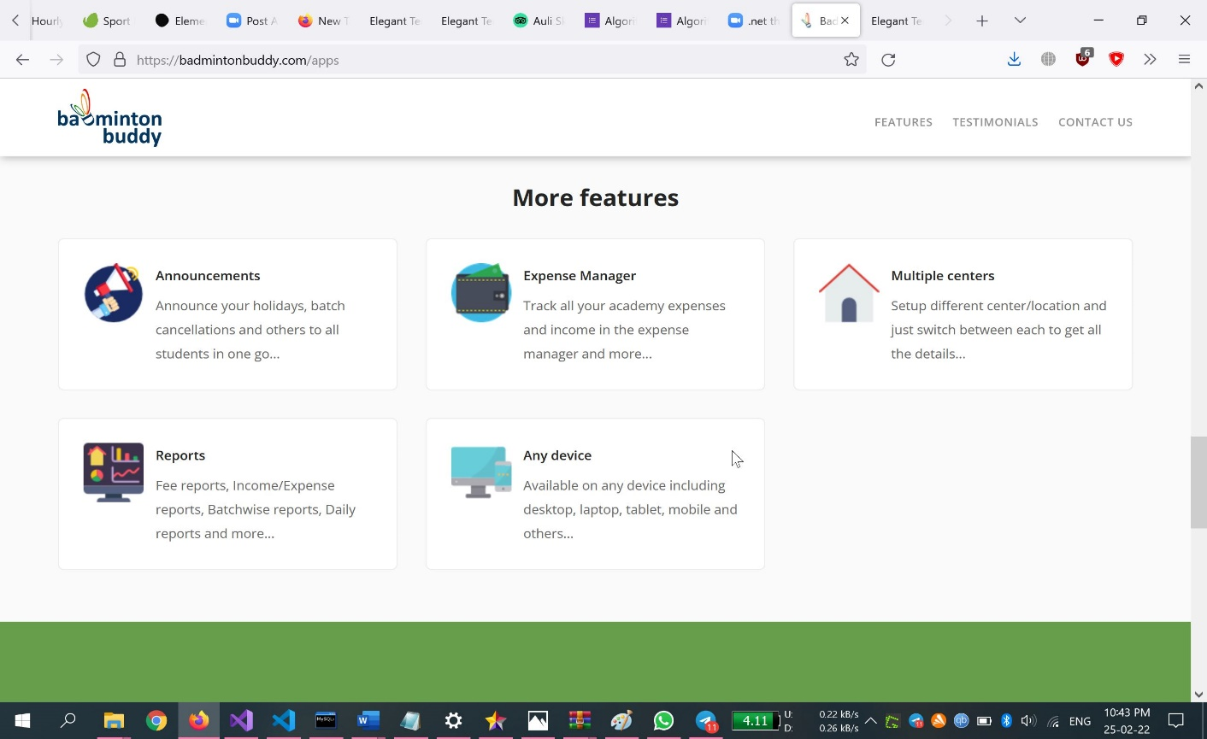

<https://badmintonbuddy.com/apps> ---------------------refer for reviews by owner also