**Practical no. 1**

**Aim:** Using, linux-terminal or Windows-cmd, execute following networking commands and note the output: ping, traceroute, netstat, arp, ipconfig, Getmac, hostname, NSLookUp, pathping, SystemInfo.

**Date:** **Roll no.:** 03 **sign:**

**Command of Network Detection**

1. **Ipconfig**

**Output:**

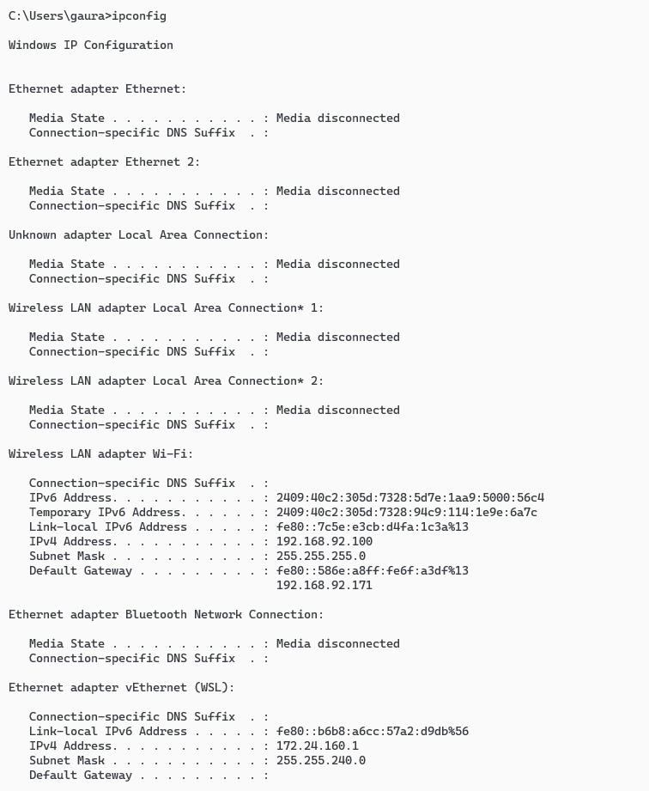

1. **ping**

**Output:**

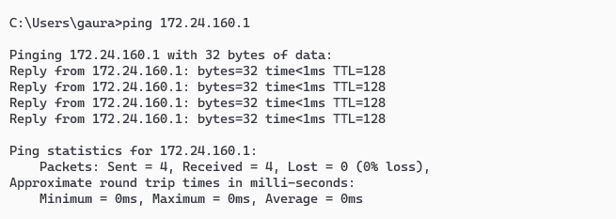

1. **tracert google.com**

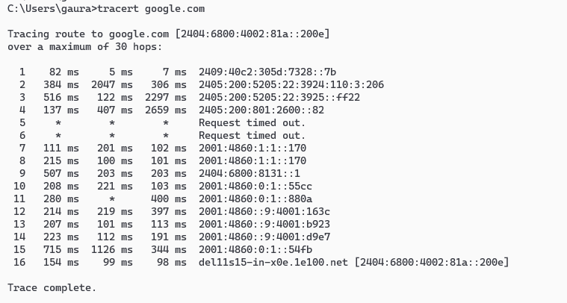**Output:**

1. **pathping google.com**

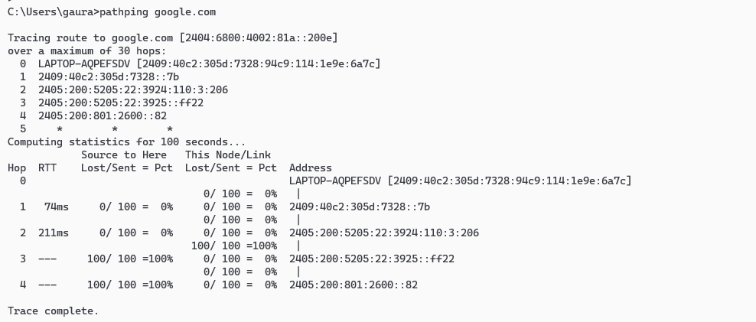**Output:**

1. **ARP -A**

**Output:**

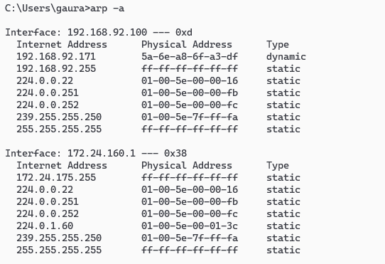

1. **Nslookup youtube.com**

**Output:**

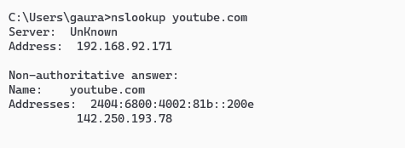

1. **Getmac**

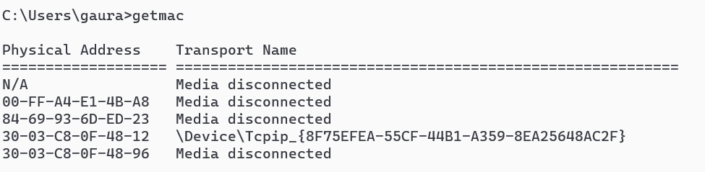**Output:**

1. **Hostname**

**Output:**

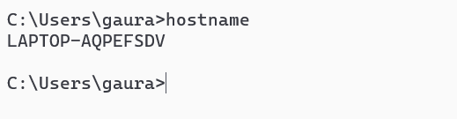

1. **netstat**

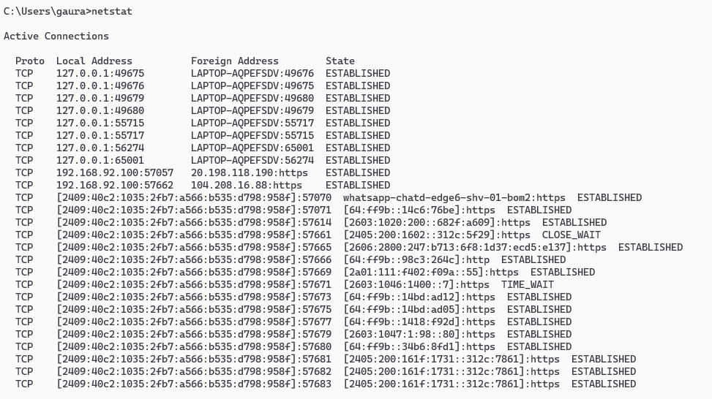**Output:**

**Practical no. 2**

**Aim:** Using Packet Tracer, create a basic network of two computers using appropriate network wire. Use Static IP address allocation and show connectivity

**Date:** **Roll no.:** 03 **sign:**

**Cisco Packet Tracer**

**Output:**

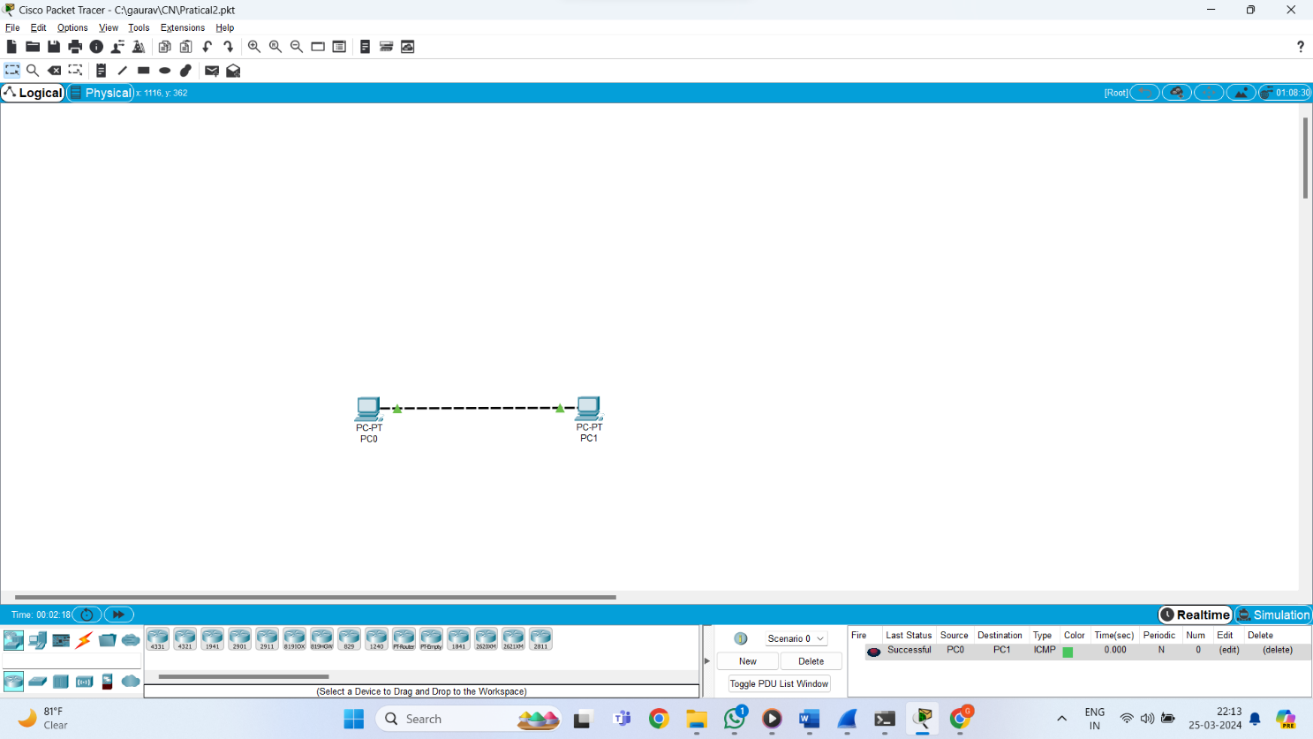

**Practical no. 3**

**Aim:** Using Packet Tracer, create a basic network of One server and two computers using appropriate network wire. Use Dynamic IP address allocation and show connectivity

**Date:** **Roll no.:** 03 **sign:**

**Cisco Packet Tracer**

**Output:**

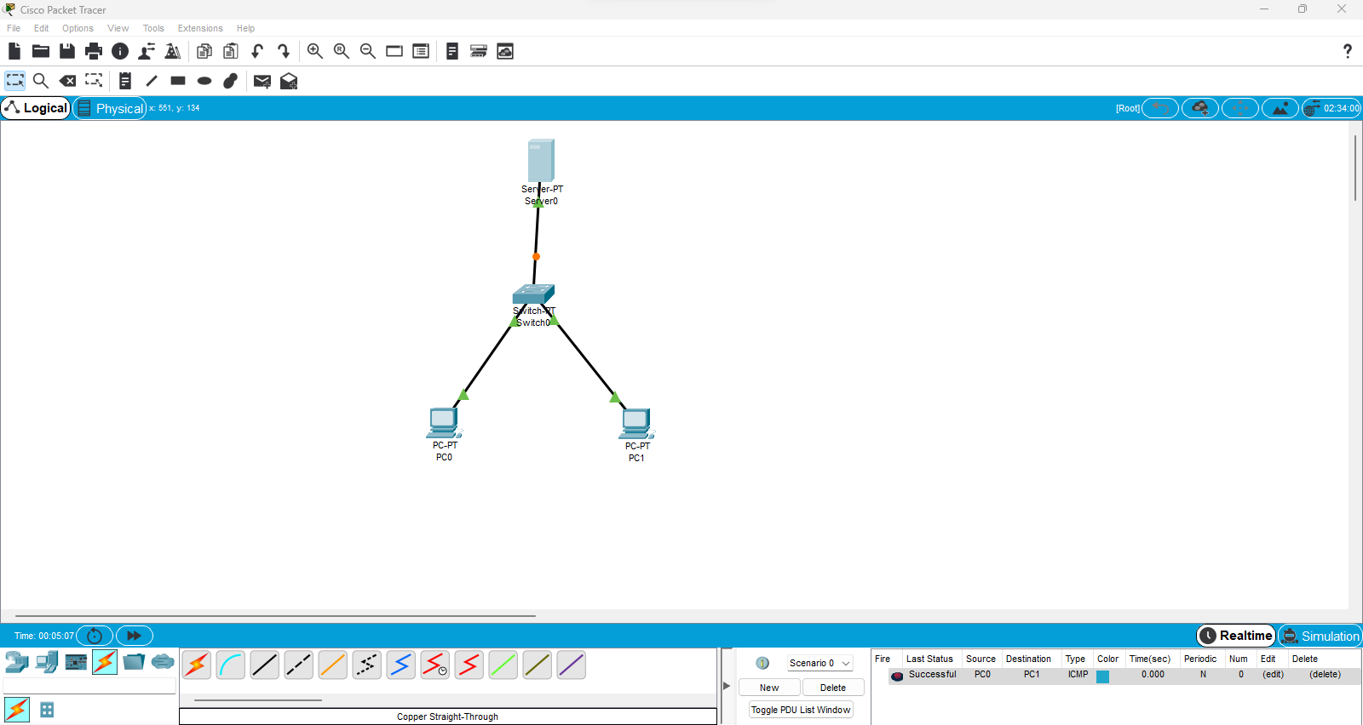

**Practical no. 4**

**Aim:** Using Packet Tracer, create a basic network of One server and two computers and two mobile / movable devices using appropriate network wire. Show connectivity

**Date:** **Roll no.:** 03 **sign:**

**Cisco Packet Tracer**

**Output:**

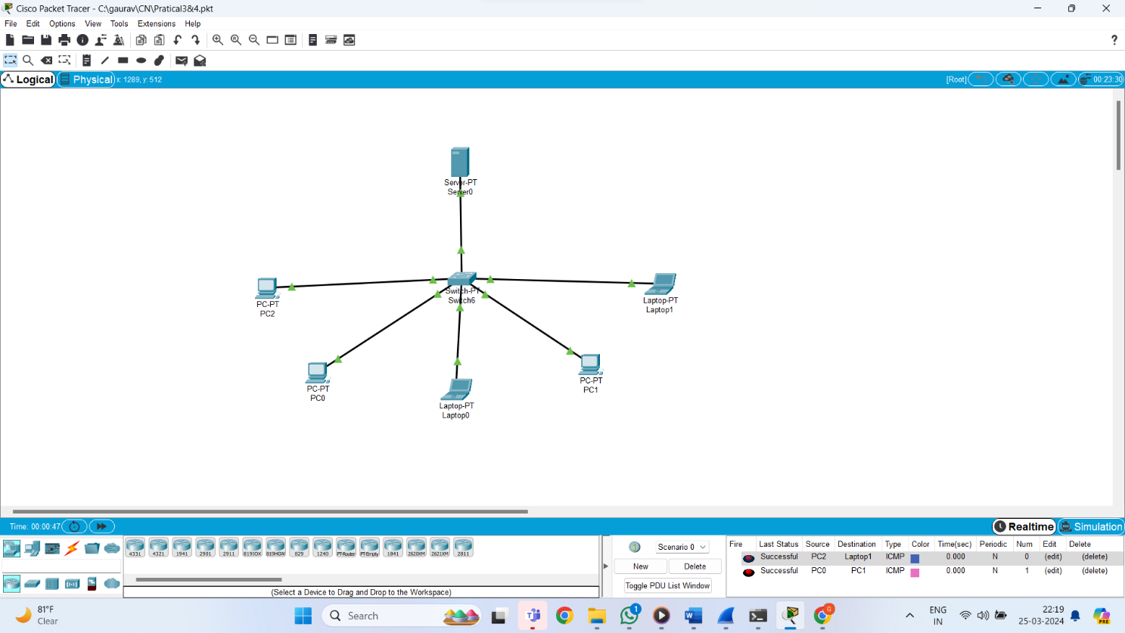

**Practical no. 5**

**Aim:** Using Packet Tracer, create a network with three routers with RIPv1 and each router associated network will have minimum three PC. Show Connectivity

**Date:** **Roll no.:** 03 **sign:**

**Cisco Packet Tracer**

**Output:**

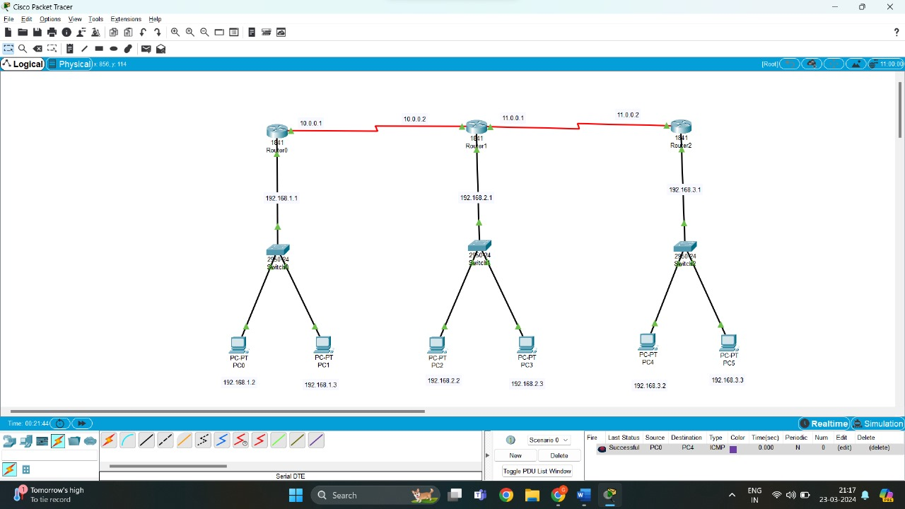

**Practical no. 6**

**Aim:** Using Packet Tracer, create a network with three routers with RIPv2 and each router associated network will have minimum three PC. Show Connectivity

**Date:** **Roll no.:** 03 **sign:**

**Cisco Packet Tracer**

**Output:**

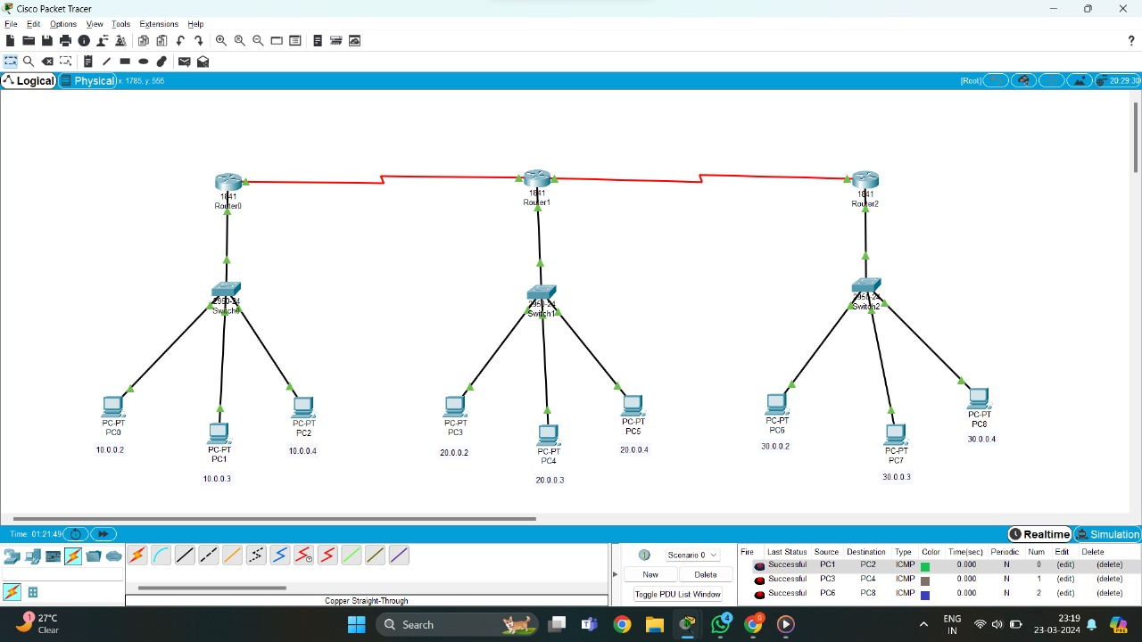

**Practical no. 7**

**Aim:** Using Packet Tracer, create a network with three routers with OSPF and each router

associated network will have minimum three PC. Show Connectivity.

**Date:** **Roll no.:** 03 **sign:**

**Cisco Packet Tracer**

**Output:**

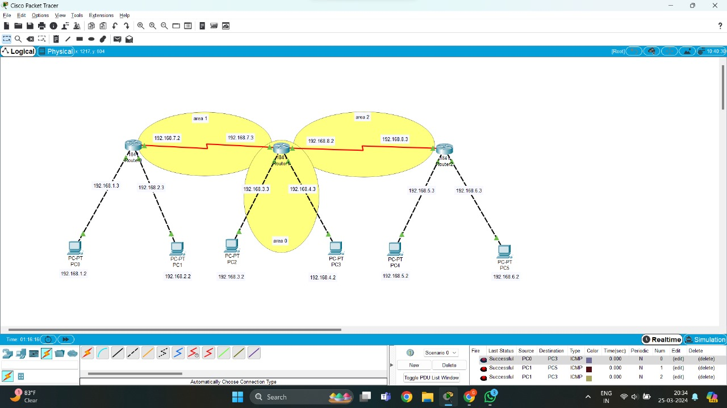

**Practical no. 8**

**Aim:** Using Packet Tracer, create a network with three routers with BGP and each router

associated network will have minimum three PC. Show Connectivity

**Date:** **Roll no.:** 03 **sign:**

**Cisco Packet Tracer**

**Output:**

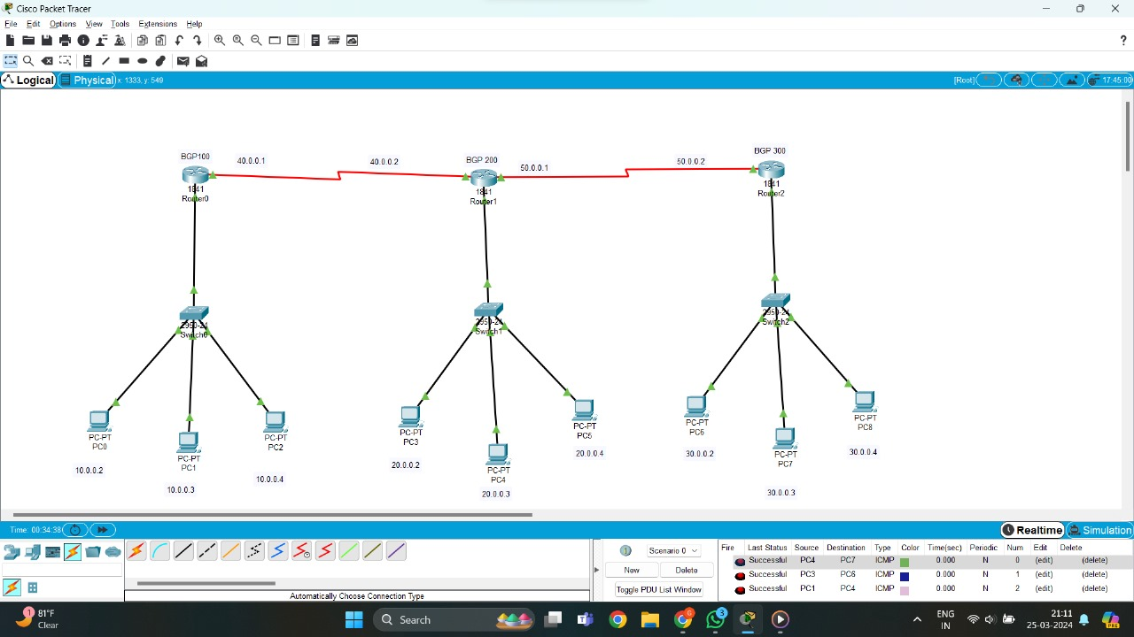

**Practical no. 9**

**Aim:** Using Packet Tracer, create a wireless network of multiple PCs using appropriate access point.

**Date:** **Roll no.:** 03 **sign:**

**Cisco Packet Tracer**

**Output:**

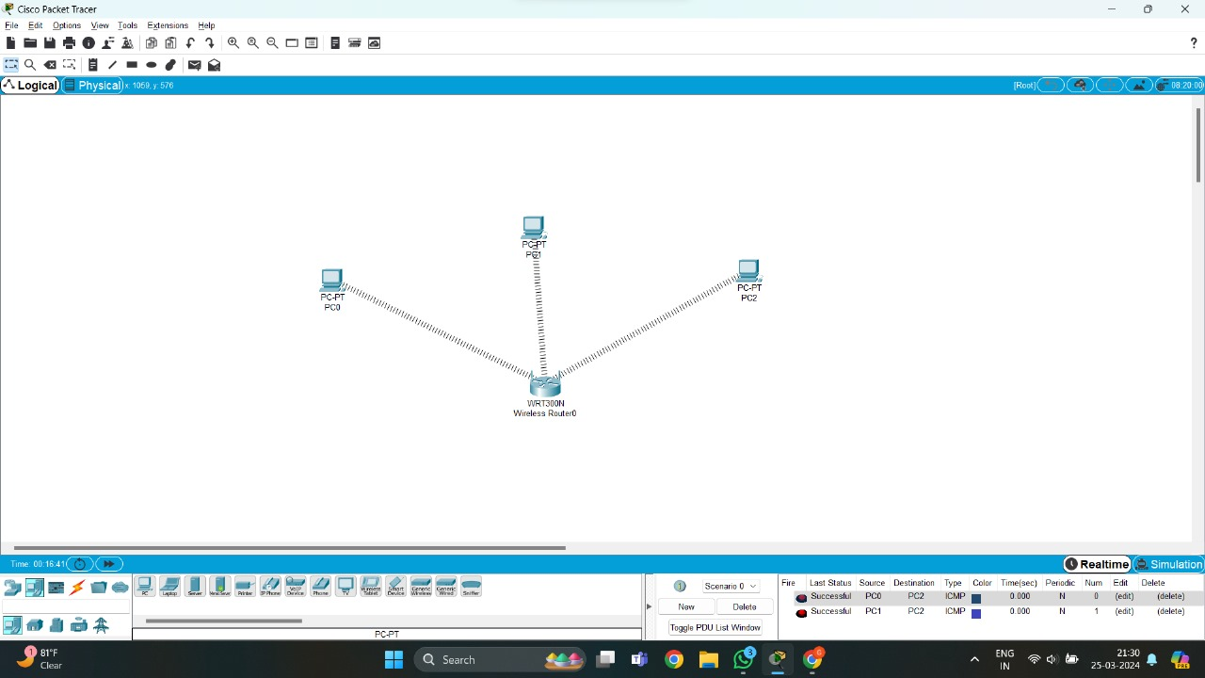

**Practical no. 10**

**Aim:** Using Wireshark, network analyzer, set the filter for ICMP, TCP, HTTP, UDP, FTP and perform respective protocol transactions to show/prove that the network analyzer is working

**Date:** **Roll no.:** 03 **sign:**

**TCP:**

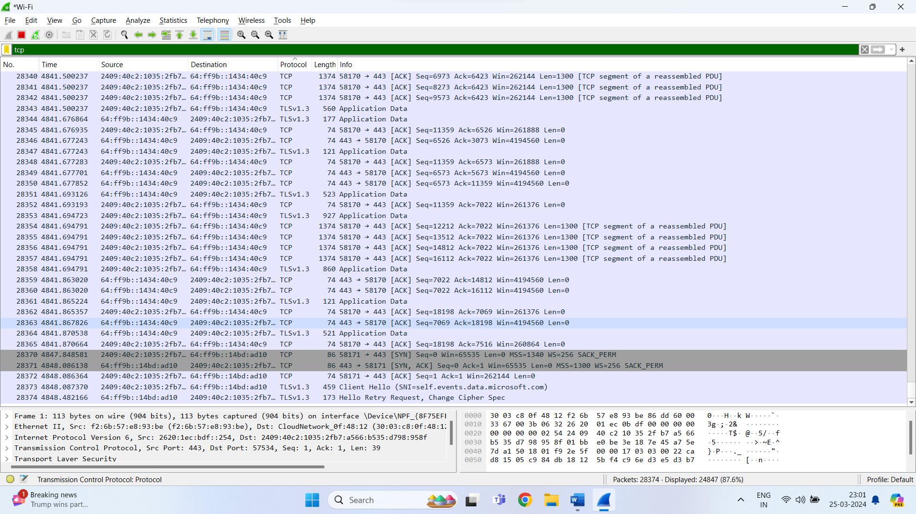

**HTTP:**

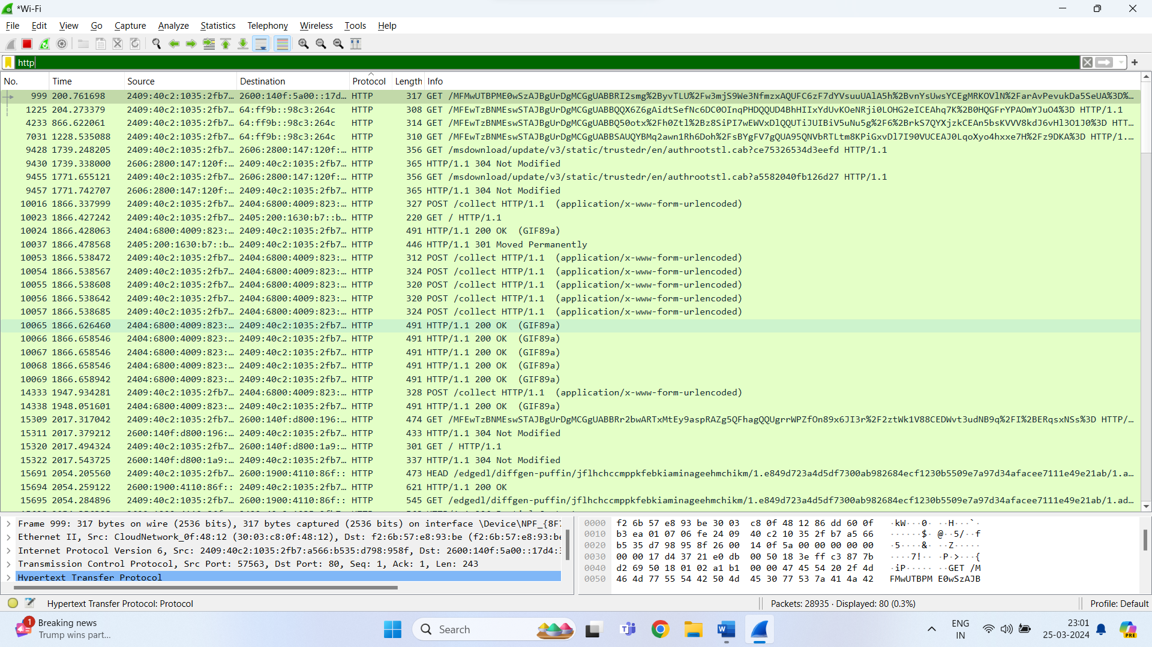

**UDP:**

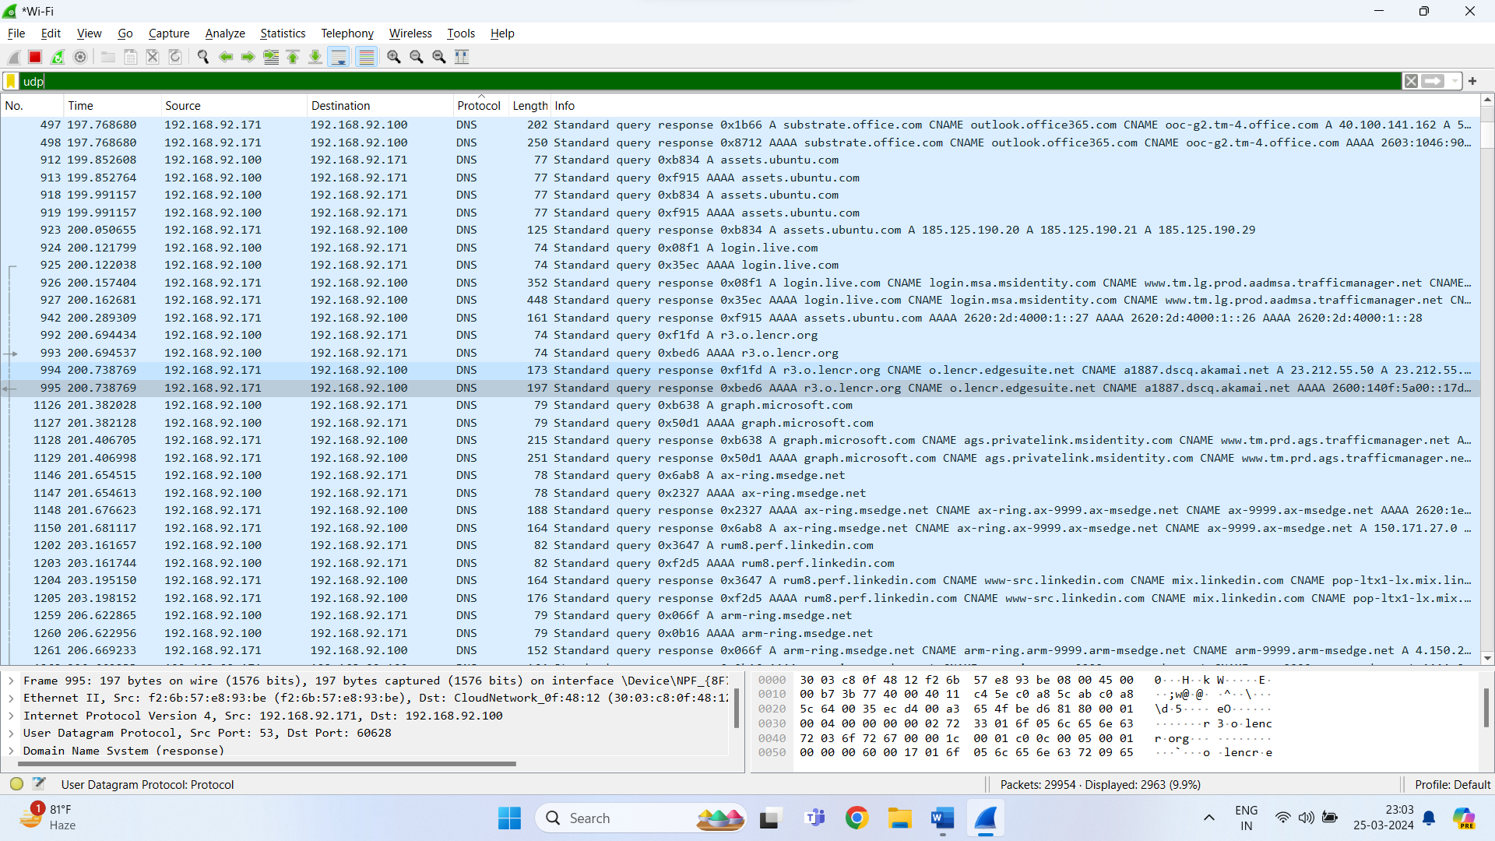

**ARP:**

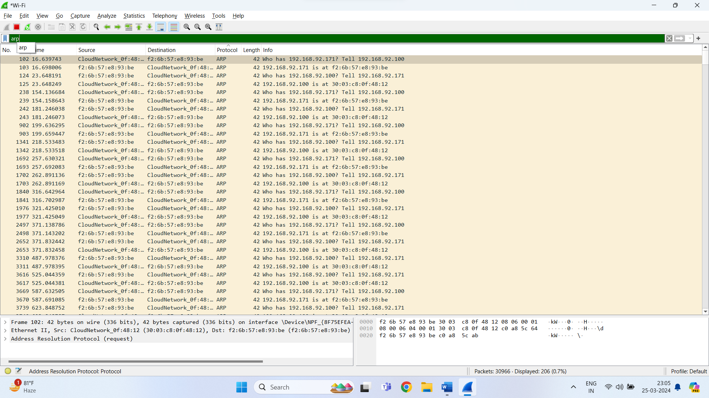

**FTP:**

