ONLINE FOOD ORDERING &
DELIVERY DATABASE SYSTEM
Mini Project Documentation
Course: Database Management Systems
Database: MySQL
Frontend: HTML/CSS (proposed) | Backend: PHP (proposed)
ER Modeling: Chen Notation
Prepared according to the project structure in the course handout.

Abstract
The Online Food Ordering & Delivery Database System is a relational database project designed to organize and manage information related to customers, restaurants, menu items, orders, payments, and deliveries. The system addresses the limitations of manual or fragmented record keeping by providing structured storage, integrity constraints, efficient retrieval, and reliable transaction processing.
The proposed implementation uses MySQL for the database. HTML/CSS can provide a simple interface, while PHP can later connect the interface to MySQL. The database is the primary focus and is intended to demonstrate normalization, keys, joins, views, triggers, stored procedures, transactions, and indexing.
Keywords: Online food ordering, relational database, MySQL, ER model, normalization, SQL, transactions, indexing.

1. Title Selection
Online Food Ordering & Delivery Database System
The title clearly identifies the real-world application being modeled: a system for managing restaurant menus, customer orders, payments, and food delivery.

2. Problem Statement
Traditional food ordering methods such as phone calls, handwritten records, or manually maintained spreadsheets make it difficult for restaurants to efficiently manage customers, menus, orders, payments, and deliveries. Manual records can lead to duplicate information, incorrect order records, difficulty tracking delivery status, and delays in retrieving information.
As the number of customers and orders increases, manual management becomes more difficult and can result in data inconsistency and errors. There is also a need to search menu and order information efficiently and to generate useful delivery-status reports.
An automated database system is therefore required to store and manage customer, restaurant, menu, order, payment, and delivery information in a structured manner. The proposed system uses a normalized relational database to reduce redundancy and maintain data integrity, indexing for efficient searching, transactions for reliable order placement and payment, and views for delivery-status reporting.

3. Objectives
- Design a structured relational database for customers, restaurants, menus, orders, payments, and deliveries.
- Model the system using an ER diagram with keys, cardinality, and constraints.
- Normalize the database to reduce redundancy and improve data integrity.
- Implement the database in MySQL using DDL and DML.
- Provide SQL queries for retrieval, reporting, and analysis.
- Use views for delivery-status reporting.
- Use stored procedures and triggers for database-level automation and validation.
- Implement transactions for order placement and payment.
- Add indexes to commonly searched fields and evaluate query performance.
- Test the database using realistic dummy data.

4. Scope
The project covers the database layer and a simple optional interface for demonstrating the system.
- Customer registration and information management.
- Restaurant information management.
- Menu item and availability management.
- Order and order-item management.
- Payment recording and payment-status management.
- Delivery information and delivery-status tracking.
- SQL search and reporting using joins, views, subqueries, and indexes.
- Reliable order and payment processing using transactions.
Real payment gateways, GPS tracking, and production deployment are outside the core scope and are treated as future enhancements.

5. Requirements Gathering

Functional Requirements
- Store and retrieve customer records.
- Store restaurant details.
- Maintain restaurant menu items.
- Allow customers to place orders.
- Store individual items and quantities belonging to each order.
- Record payment information and payment status.
- Store delivery information and delivery status.
- Search and report order and delivery information.
- Process order placement and payment as a database transaction.
- Provide a delivery-status report through a database view.

Non-Functional Requirements
- Data integrity through keys and constraints.
- Efficient retrieval using suitable indexes.
- Reliability through transaction management.
- Controlled access where DCL is demonstrated.
- Maintainability through a normalized design.
- Simple and understandable user interface for the optional frontend.

6. Entity-Relationship Modeling
The ER model represents the main entities and relationships before conversion into relational tables. The project uses Chen notation: rectangles represent entities, ovals represent attributes, double-outlined ovals represent key attributes, and diamonds represent relationships. Cardinalities are shown near the relationships.
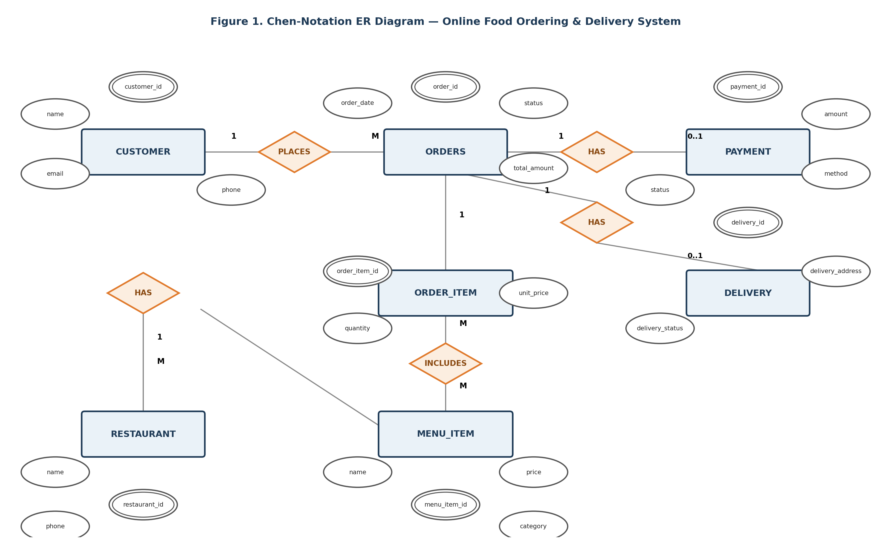
Figure 1. Chen-Notation ER Diagram — Online Food Ordering & Delivery System

7. Relational Schema Design
The following relational schema is derived from the ER model. Primary keys uniquely identify records and foreign keys connect related tables.
Table | Primary Key | Foreign Key(s) | Main Attributes
CUSTOMER | customer_id | — | name, email, phone, address
RESTAURANT | restaurant_id | — | name, phone, address
MENU_ITEM | menu_item_id | restaurant_id | name, category, price, availability
ORDERS | order_id | customer_id, restaurant_id | order_date, total_amount, status
ORDER_ITEM | order_item_id | order_id, menu_item_id | quantity, unit_price
PAYMENT | payment_id | order_id | payment_date, amount, method, status
DELIVERY | delivery_id | order_id | delivery_address, delivery_status, assigned_at, delivered_at

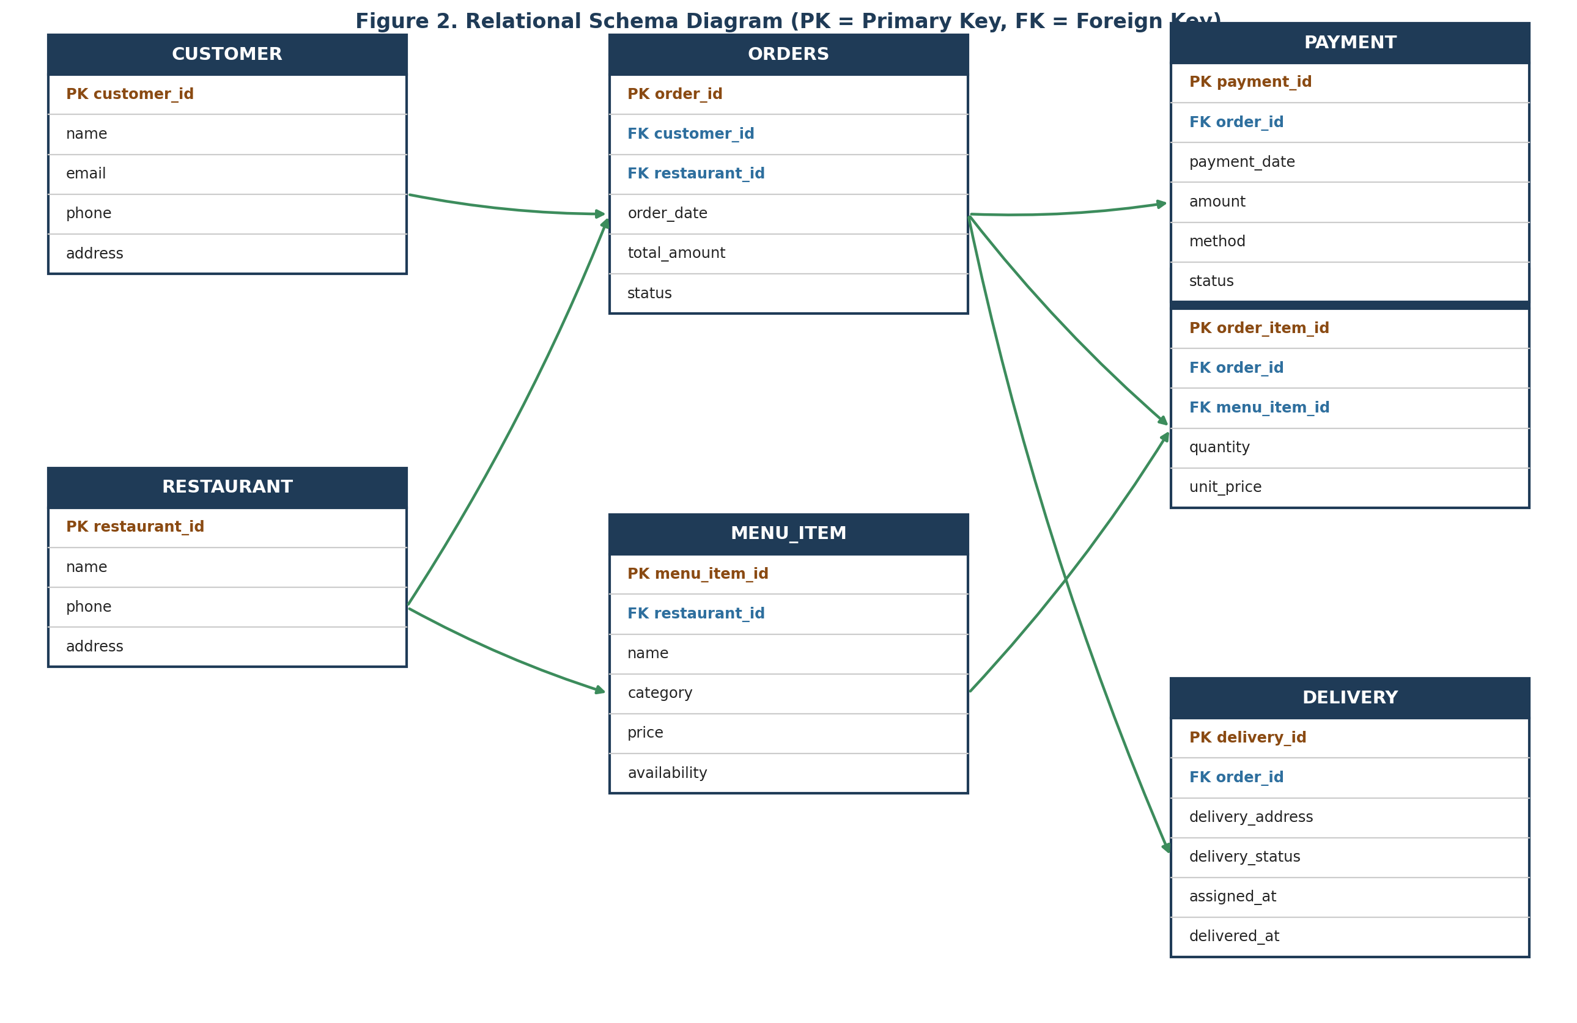
Figure 2. Relational Schema Diagram (PK = Primary Key, FK = Foreign Key)

8. Normalization
The database is checked against 1NF, 2NF, and 3NF to remove repeating groups, partial dependencies, and unnecessary transitive dependencies. Separating customers, restaurants, menu items, orders, order items, payments, and deliveries provides a clear subject for each table and reduces redundant storage.
The final submission should include the functional dependencies and a short explanation showing how the decomposed tables satisfy the selected normal form.

9. SQL Implementation

DDL (Data Definition Language)
DDL creates the database tables and enforces structural constraints such as PRIMARY KEY, FOREIGN KEY, NOT NULL, UNIQUE, CHECK where appropriate, and suitable data types.

DML (Data Manipulation Language)
DML inserts realistic dummy data and demonstrates INSERT, UPDATE, and DELETE operations. Multiple customers, restaurants, menu items, orders, payments, and deliveries are included so that reports produce meaningful results.

DCL (Data Control Language)
Where required, GRANT and REVOKE demonstrate access control. Privileges are kept minimal and appropriate for the roles being demonstrated.

10. Advanced SQL Features
- Views: a delivery-status report joining order, customer, restaurant, and delivery information.
- Stored Procedures: procedures for useful operations such as checking available menu items or processing an order.
- Triggers: validate or automatically update related data where appropriate.
- Joins: combine related tables for order, restaurant, customer, payment, and delivery reports.
- Subqueries: answer analytical questions such as finding items above average price or customers with multiple orders.
The course handout explicitly expects views, stored procedures, triggers, joins, and subqueries as advanced SQL features.

11. Transaction Management
Order placement and payment are treated as a logical unit of work. A transaction creates the order, creates its order items, records payment, and updates relevant statuses. If all required operations succeed, COMMIT is issued. If a required operation fails, ROLLBACK restores the previous consistent state.
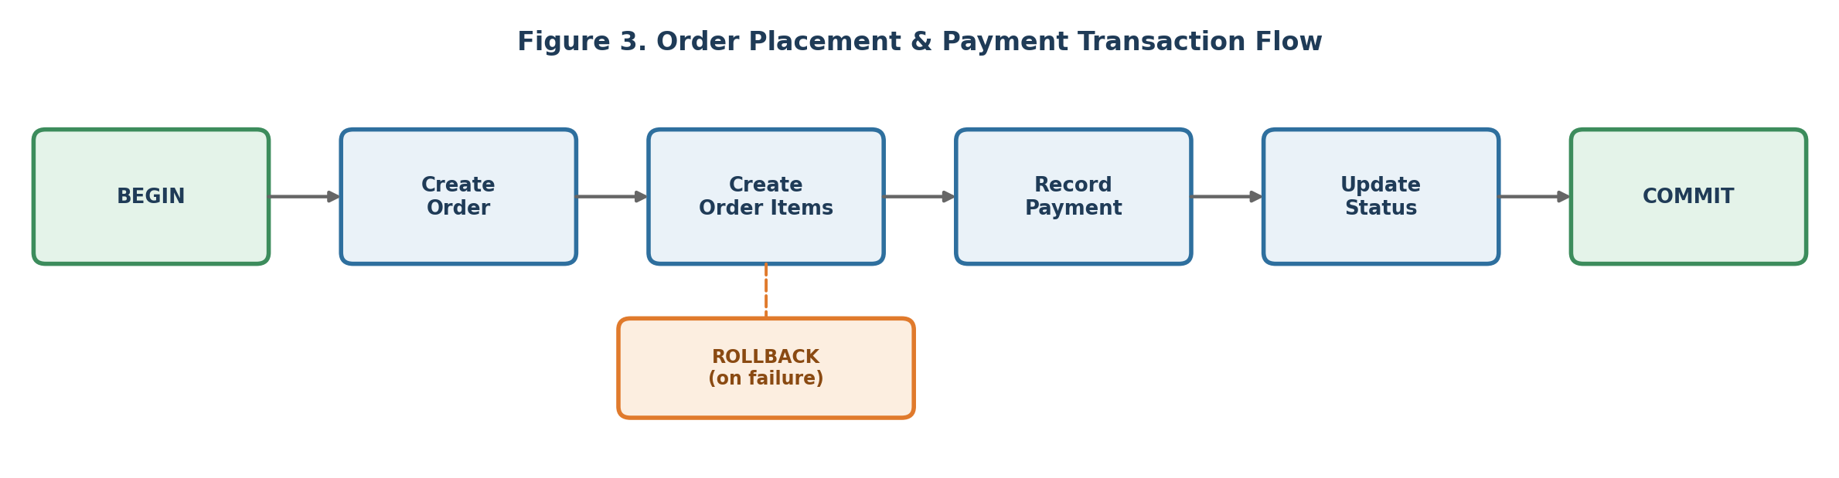
Figure 3. Order Placement & Payment Transaction Flow
Concurrency control is also demonstrated conceptually using appropriate locking or transaction isolation behavior when simultaneous operations could modify the same data.

12. Indexing and Optimization
Indexes are considered for frequently searched or joined fields such as restaurant_id in MENU_ITEM, customer_id and restaurant_id in ORDERS, order_id in ORDER_ITEM / PAYMENT / DELIVERY, and fields used heavily in delivery-status reports.
The effect of indexing can be examined with EXPLAIN before and after adding an index. The final index set is justified using the actual queries used in the project.

13. Testing and Validation
Testing uses dummy data representing realistic food-ordering activity. Each major requirement has at least one test case.
Test Case | Expected Result
Insert valid customer | Customer is stored successfully.
Insert duplicate unique value | Uniqueness rule rejects the duplicate.
Create order for valid customer/restaurant | Order is inserted successfully.
Use invalid customer_id | Foreign-key constraint rejects the record.
Add multiple items to one order | Multiple ORDER_ITEM rows are linked to the order.
Successful order and payment transaction | All changes are committed.
Failure during payment transaction | Related changes are rolled back.
Delivery status view | Correct order and delivery information is returned.
Indexed search | Correct result is returned and query plan can be inspected.
Procedure / trigger test | Expected database-side operation or rule occurs.

14. Documentation and Deliverables
The final documentation contains the cover page, abstract, problem statement, objectives and scope, ER diagram, schema design, SQL snippets, screenshots of query results, testing evidence, and conclusion. The course handout specifies a maximum report length of 15 pages and a 10–12 slide presentation.

Suggested Project Files
- database.sql — schema, constraints, sample data, views, procedures, triggers, indexes, and test queries.
- README.md — setup and execution instructions.
- ER_Diagram.drawio — Chen-style ER model.
- frontend/ — optional HTML/CSS interface.
- screenshots/ — query and result screenshots.

15. Conclusion
The Online Food Ordering & Delivery Database System provides a structured approach to managing the information required for restaurant food ordering and delivery. A normalized relational design reduces redundancy and improves data integrity, while SQL queries, views, stored procedures, triggers, transactions, and indexes demonstrate important database-management concepts.
The project is intentionally focused on the database requirements of the mini project. A simple HTML/CSS frontend and PHP backend can later be added to demonstrate interaction with MySQL, while the core assessment remains centered on the ER model, relational schema, SQL implementation, transaction handling, indexing, testing, and reporting.

16. Future Enhancements
- Real online payment gateway integration.
- Real-time delivery tracking using maps/GPS.
- Restaurant and delivery-agent login roles.
- Customer reviews and ratings.
- Coupon and discount management.
- Restaurant operating hours and availability rules.
- Production deployment with stronger authentication, logging, and security controls.

17. Reference to Course Handout
This documentation follows the uploaded Database Management Systems course handout, especially its Mini Project and Project Structure sections. The handout specifies the progression from title selection and problem statement through requirements, ER modeling, schema design, SQL implementation, advanced SQL, transactions, indexing, testing, documentation, and presentation.
The handout also specifies final deliverables of a report of maximum 15 pages, a 10–12 slide deck, code, README, and results.

