Azure Cloud Fundamentals and Data Pipeline Implementation using Azure Data Factory (ADF)
Assignment Report
Student: Gaurav Gaikwad
Course: CEI Data Engineering - Week 4
Objective: To understand Azure cloud concepts and build an end-to-end data pipeline using Azure Storage Account and Azure Data Factory.

1. Resource Group

Objective of this Step
Created a Resource Group named RG_CEI_Week4 in the Central India region. A Resource Group acts as a logical container that groups related Azure resources together, making deployment, monitoring, access control, and lifecycle management easier.

Work Performed
The required Azure resource or pipeline component was created, configured, validated, and verified successfully according to the assignment requirements.

Learning Outcome
This step strengthened practical understanding of Azure cloud services, data engineering concepts, and enterprise-grade data pipeline implementation.

Screenshot

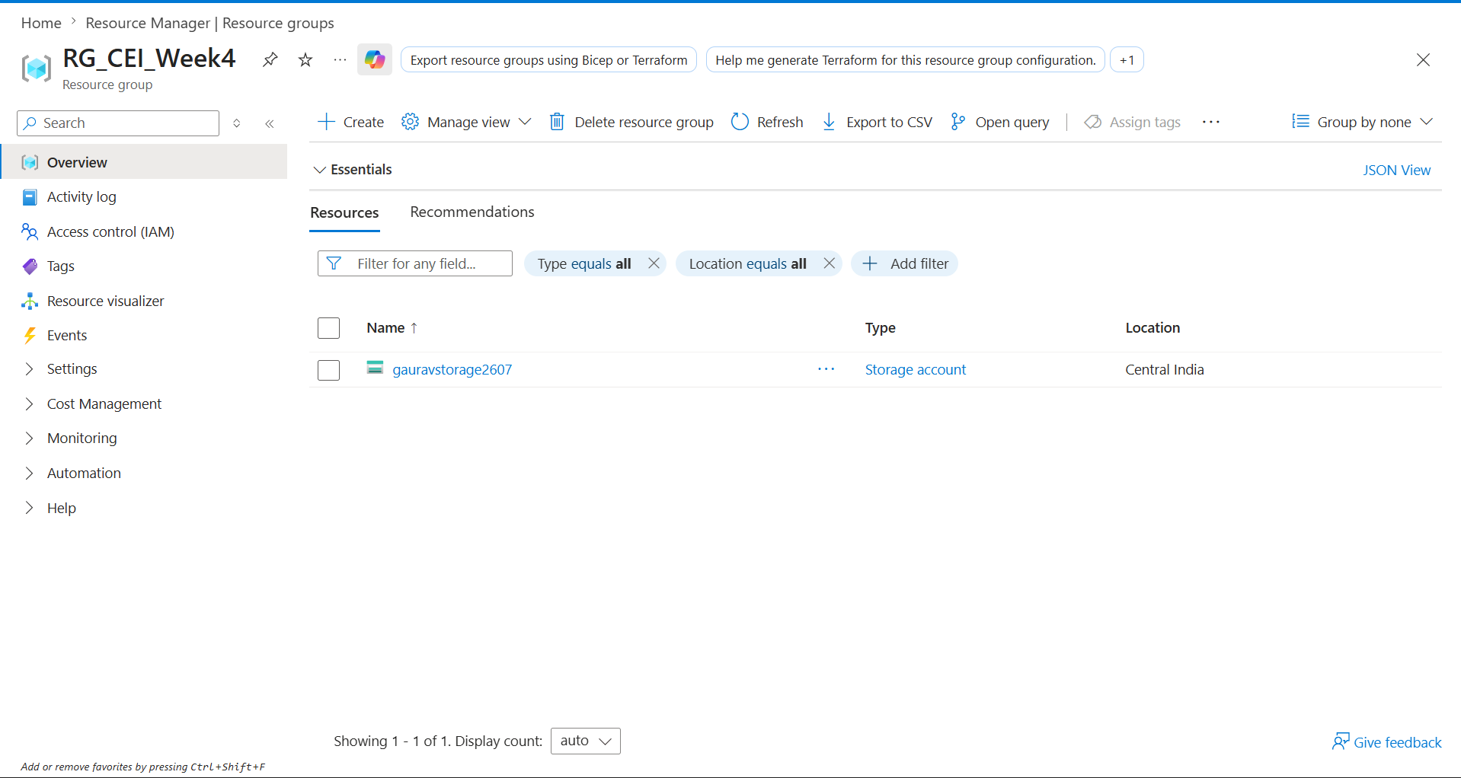

2. Storage Account

Objective of this Step
Created a General Purpose v2 Storage Account named gauravstorage2607. This service provides secure, scalable, and highly available cloud storage for the assignment.

Work Performed
The required Azure resource or pipeline component was created, configured, validated, and verified successfully according to the assignment requirements.

Learning Outcome
This step strengthened practical understanding of Azure cloud services, data engineering concepts, and enterprise-grade data pipeline implementation.

Screenshot

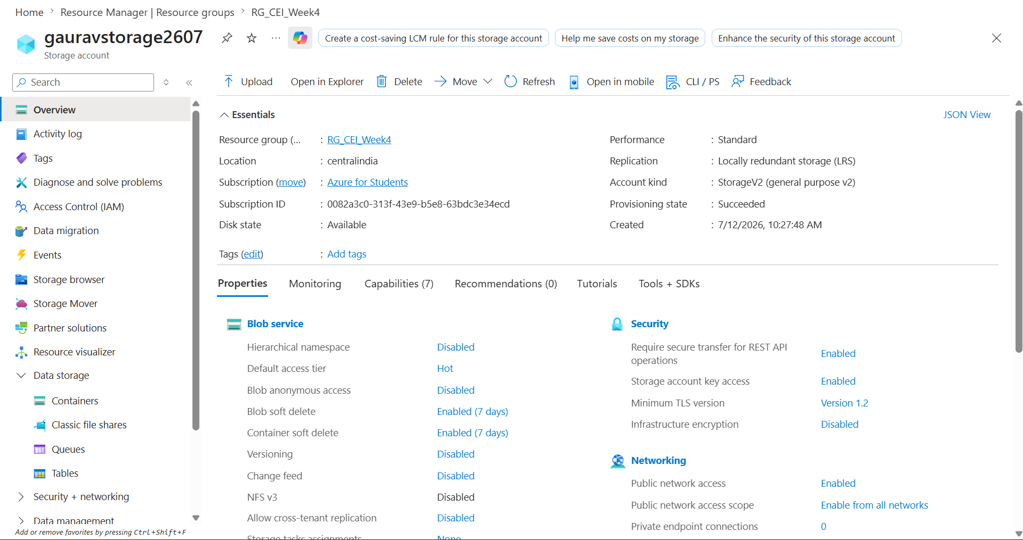

3. Blob Container

Objective of this Step
Created a Blob Container named superstore-data for storing source and destination files. Blob Storage is optimized for unstructured data such as CSV, images, documents, and backups.

Work Performed
The required Azure resource or pipeline component was created, configured, validated, and verified successfully according to the assignment requirements.

Learning Outcome
This step strengthened practical understanding of Azure cloud services, data engineering concepts, and enterprise-grade data pipeline implementation.

Screenshot

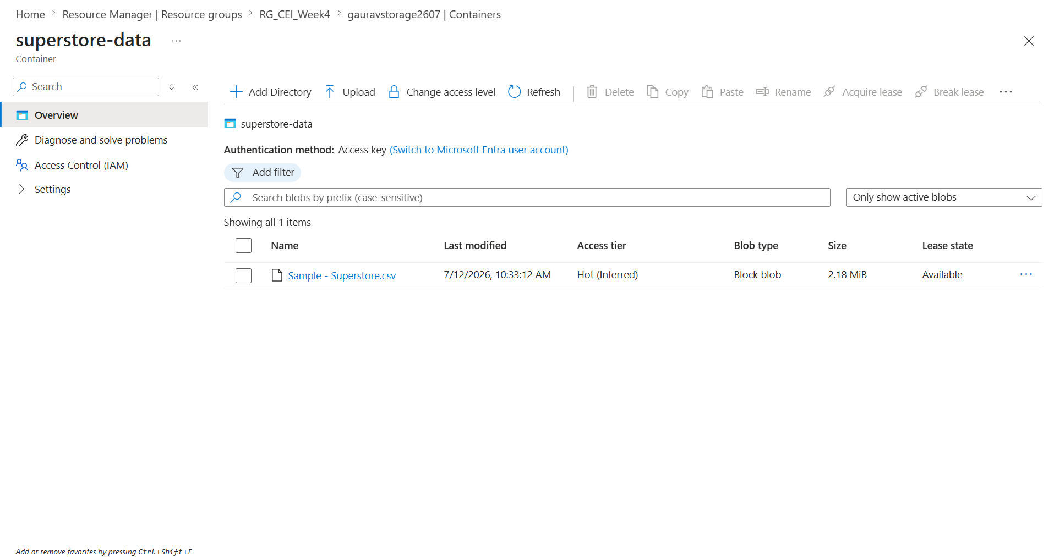

4. Upload Dataset

Objective of this Step
Uploaded the Sample - Superstore.csv dataset into Azure Blob Storage. This file serves as the source dataset for the Azure Data Factory pipeline.

Work Performed
The required Azure resource or pipeline component was created, configured, validated, and verified successfully according to the assignment requirements.

Learning Outcome
This step strengthened practical understanding of Azure cloud services, data engineering concepts, and enterprise-grade data pipeline implementation.

Screenshot

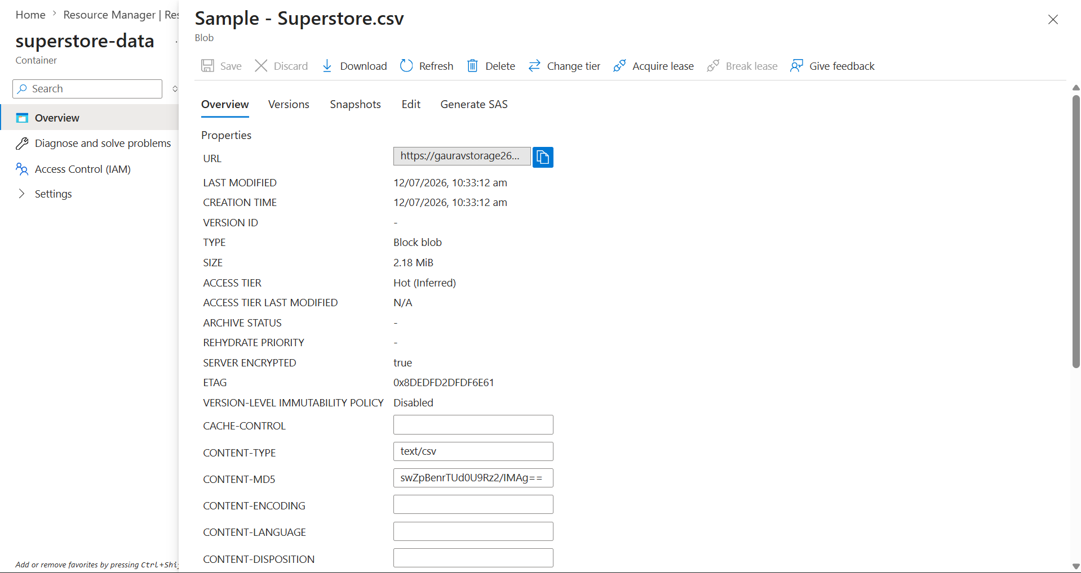

5. Azure Data Factory

Objective of this Step
Created Azure Data Factory (adfgaurav2607) and explored the Author, Monitor, and Manage modules. Azure Data Factory provides a cloud-based ETL and orchestration platform.

Work Performed
The required Azure resource or pipeline component was created, configured, validated, and verified successfully according to the assignment requirements.

Learning Outcome
This step strengthened practical understanding of Azure cloud services, data engineering concepts, and enterprise-grade data pipeline implementation.

Screenshot
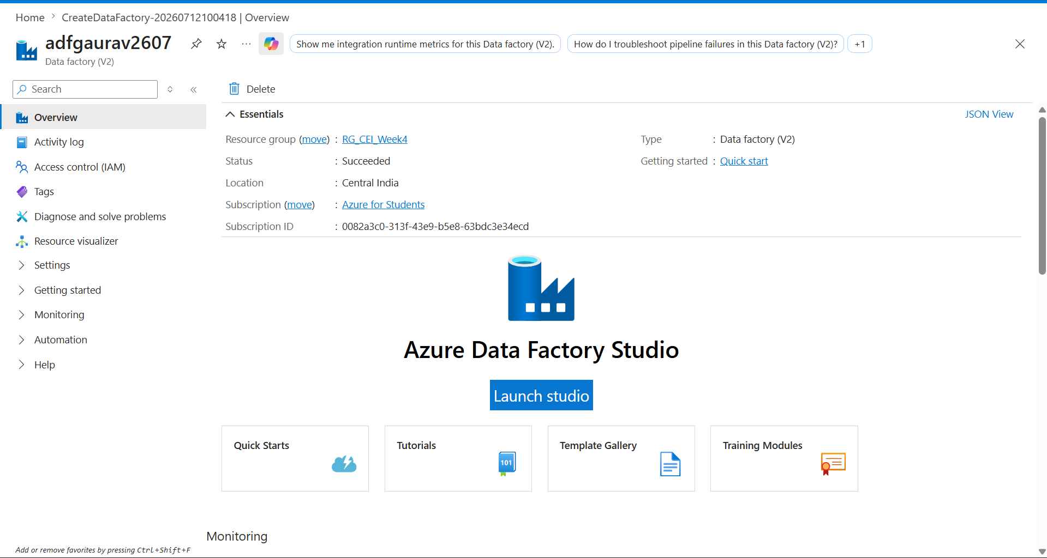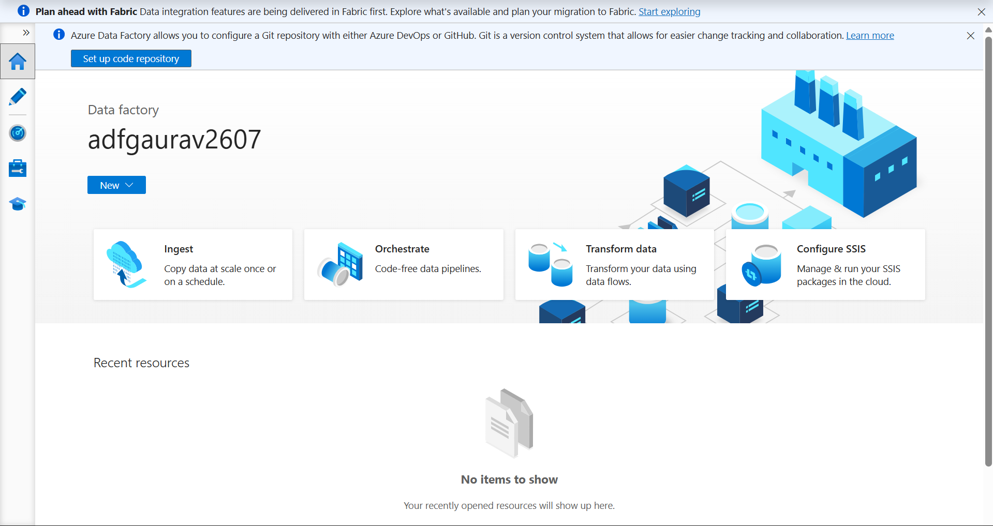

6. Linked Service

Objective of this Step
Configured a Linked Service connecting Azure Data Factory with Azure Blob Storage. This secure connection enables ADF to access datasets stored in Blob Storage.

Work Performed
The required Azure resource or pipeline component was created, configured, validated, and verified successfully according to the assignment requirements.

Learning Outcome
This step strengthened practical understanding of Azure cloud services, data engineering concepts, and enterprise-grade data pipeline implementation.

Screenshot

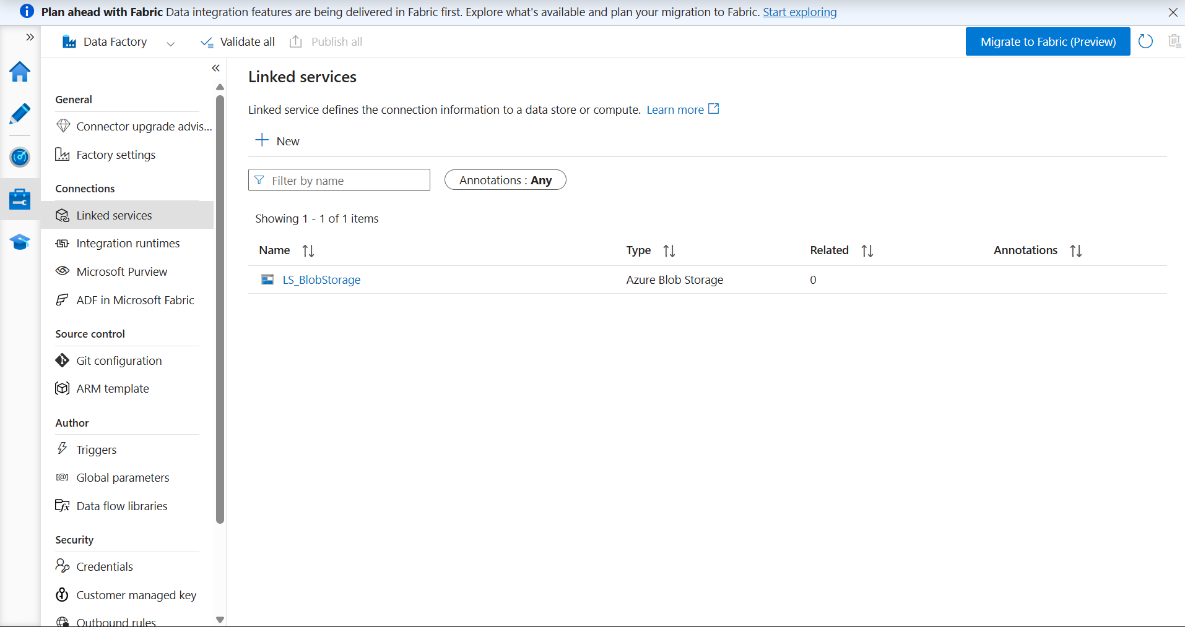

7. Source Dataset

Objective of this Step
Created the source dataset (DS_Source) using Delimited Text format and connected it to the uploaded CSV file.

Work Performed
The required Azure resource or pipeline component was created, configured, validated, and verified successfully according to the assignment requirements.

Learning Outcome
This step strengthened practical understanding of Azure cloud services, data engineering concepts, and enterprise-grade data pipeline implementation.

Screenshot

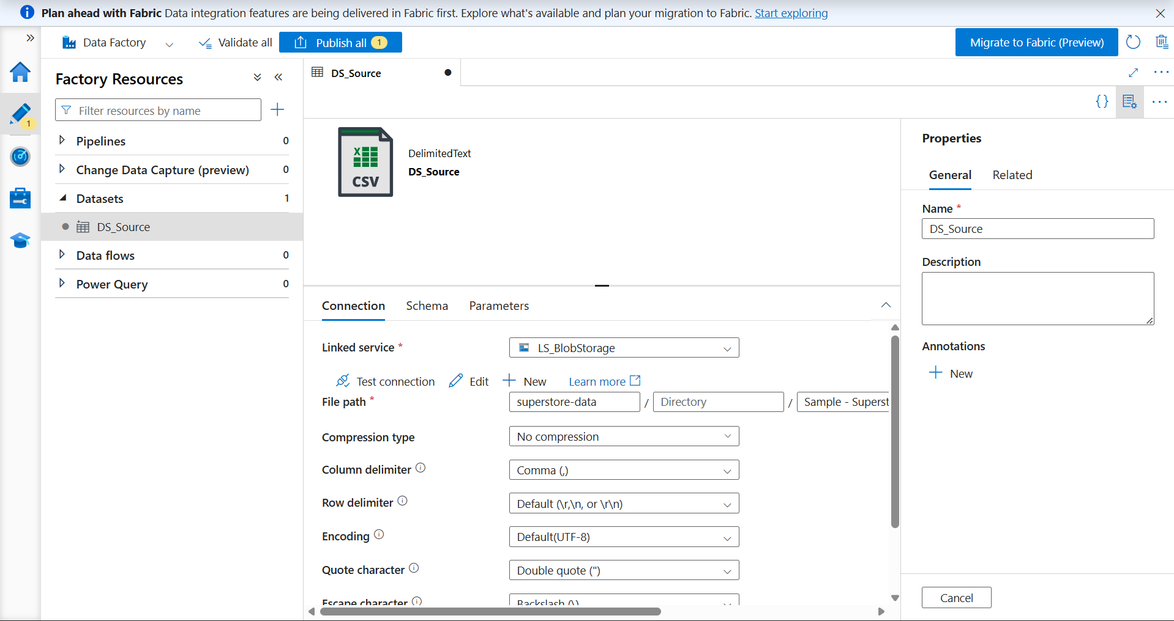

8. Destination Dataset

Objective of this Step
Created the destination dataset (DS_Destination) that stores the copied output file in Azure Blob Storage.

Work Performed
The required Azure resource or pipeline component was created, configured, validated, and verified successfully according to the assignment requirements.

Learning Outcome
This step strengthened practical understanding of Azure cloud services, data engineering concepts, and enterprise-grade data pipeline implementation.

Screenshot

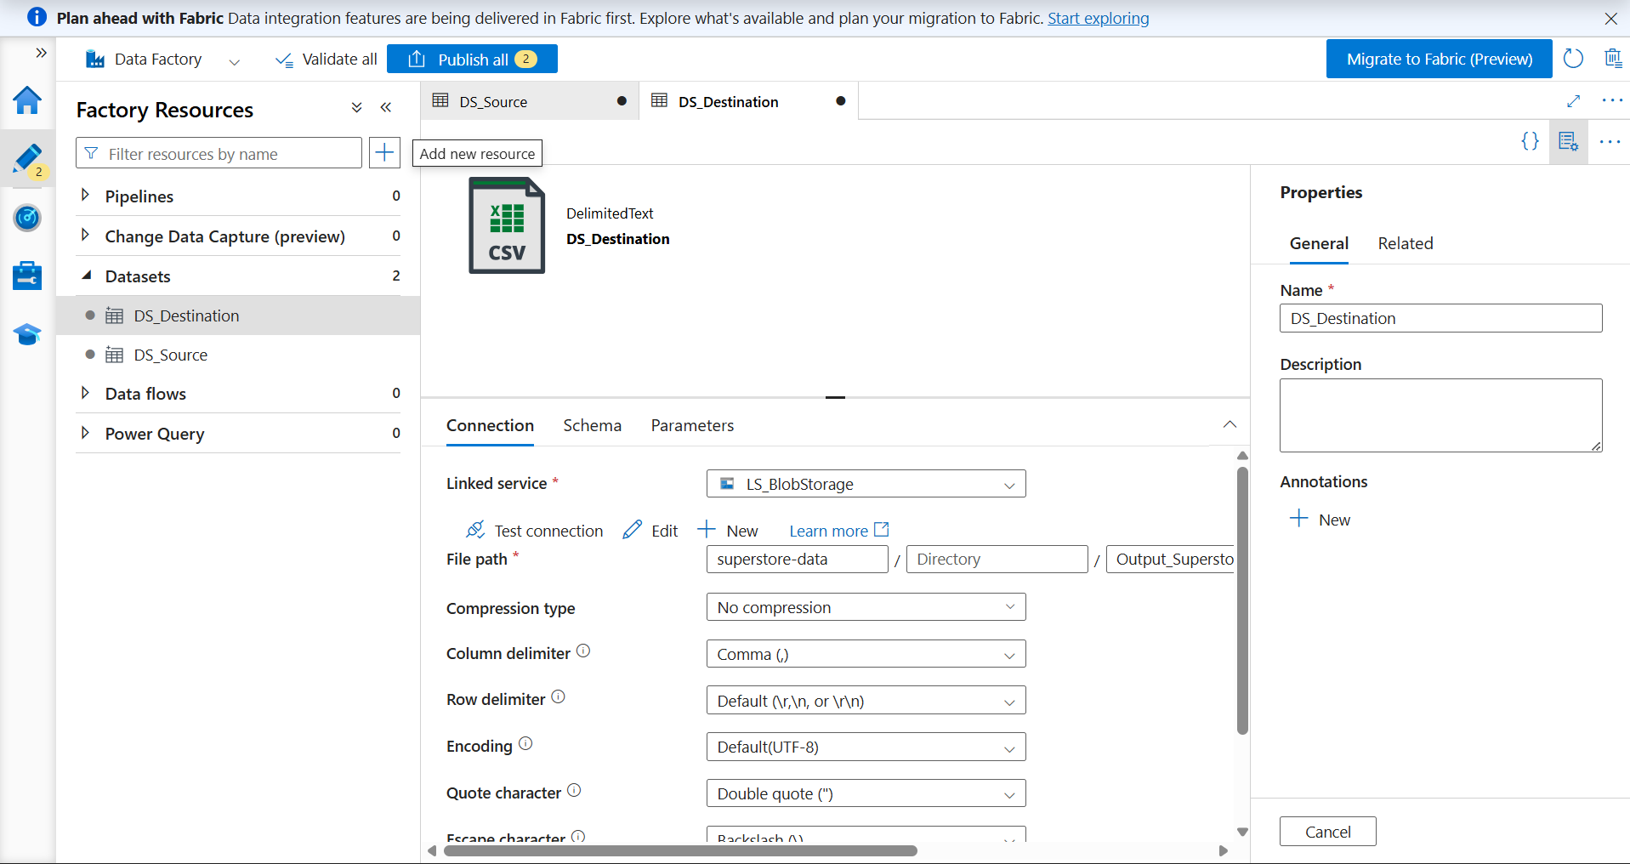

9. Get Metadata

Objective of this Step
Configured the Get Metadata activity to validate the source file before copying. The activity checks file properties such as existence and metadata.

Work Performed
The required Azure resource or pipeline component was created, configured, validated, and verified successfully according to the assignment requirements.

Learning Outcome
This step strengthened practical understanding of Azure cloud services, data engineering concepts, and enterprise-grade data pipeline implementation.

Screenshot

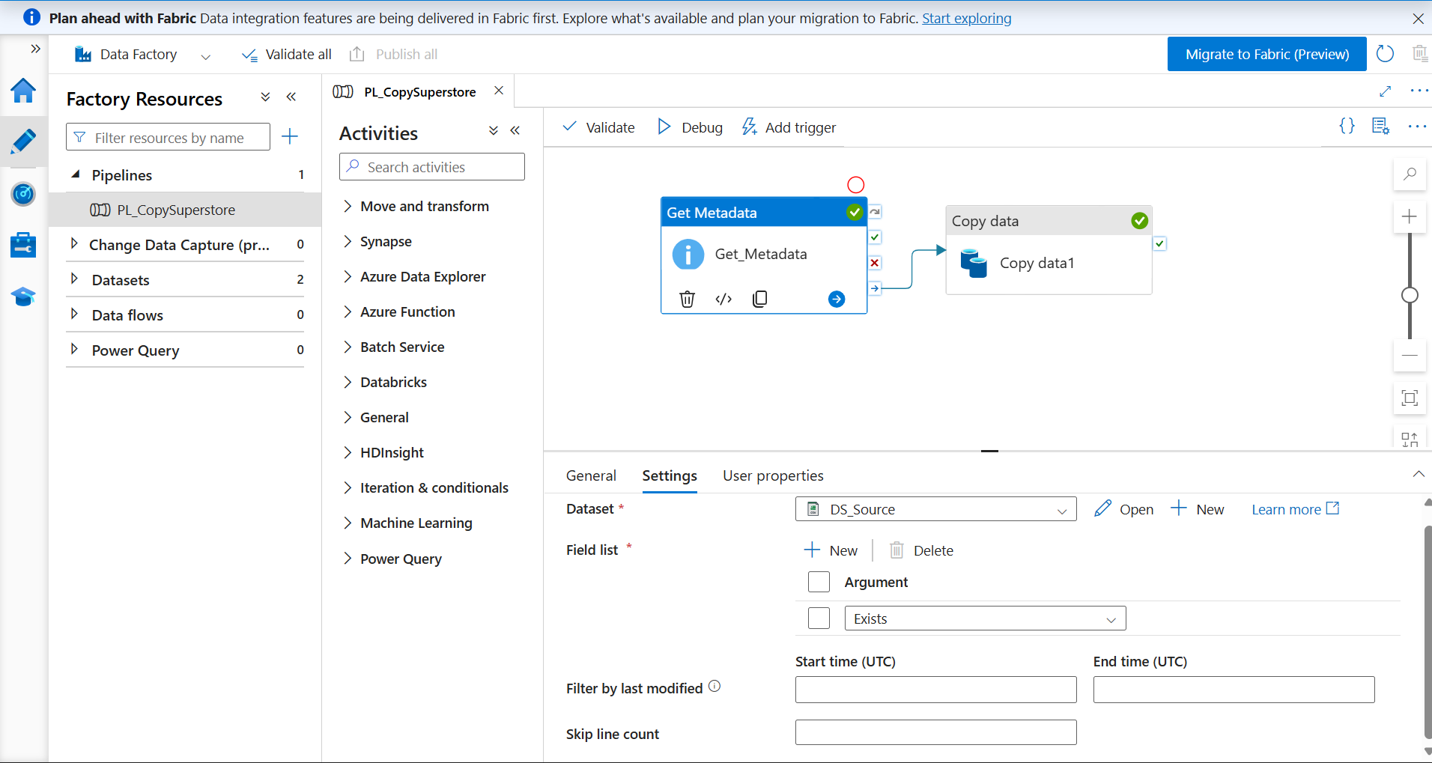

10. Pipeline Design

Objective of this Step
Designed the pipeline by connecting Get Metadata with Copy Data activity. This workflow validates the file before transferring it to the destination.

Work Performed
The required Azure resource or pipeline component was created, configured, validated, and verified successfully according to the assignment requirements.

Learning Outcome
This step strengthened practical understanding of Azure cloud services, data engineering concepts, and enterprise-grade data pipeline implementation.

Screenshot

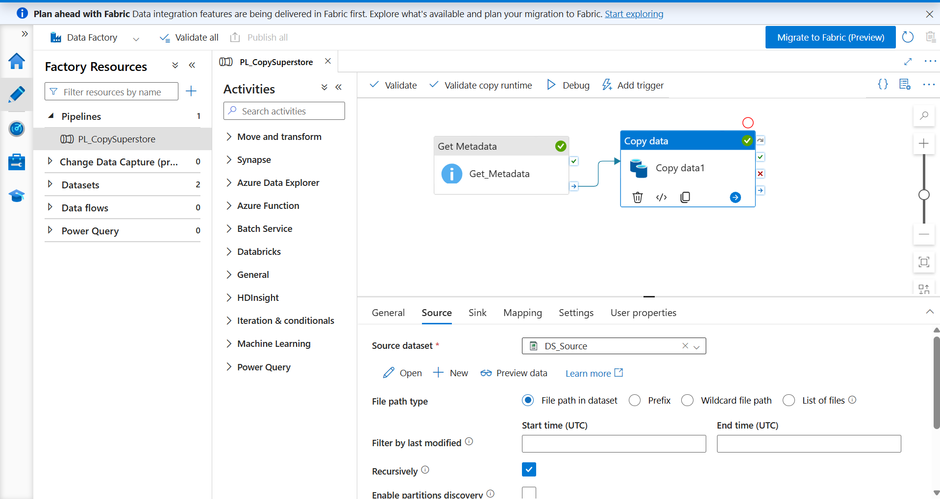

11. Pipeline Execution

Objective of this Step
Executed the pipeline successfully using Debug. Both Get Metadata and Copy Data activities completed successfully, confirming correct pipeline configuration.

Work Performed
The required Azure resource or pipeline component was created, configured, validated, and verified successfully according to the assignment requirements.

Learning Outcome
This step strengthened practical understanding of Azure cloud services, data engineering concepts, and enterprise-grade data pipeline implementation.

Screenshot

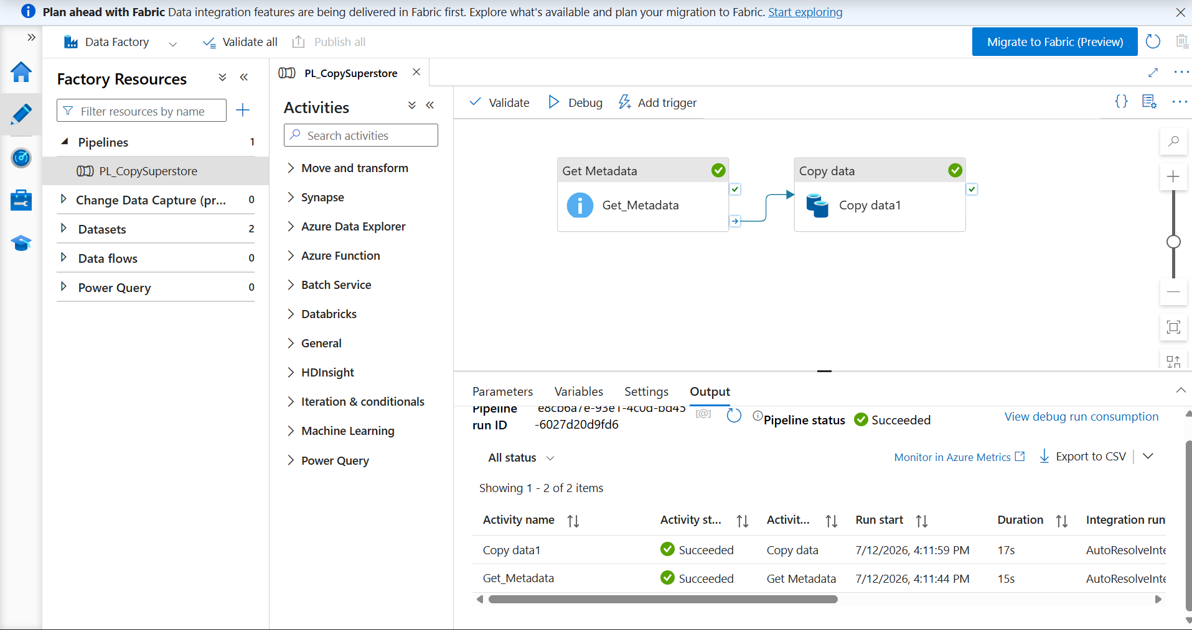

12. Monitoring

Objective of this Step
Verified the successful execution through the Monitor section and reviewed the execution history, duration, and activity status.

Work Performed
The required Azure resource or pipeline component was created, configured, validated, and verified successfully according to the assignment requirements.

Learning Outcome
This step strengthened practical understanding of Azure cloud services, data engineering concepts, and enterprise-grade data pipeline implementation.

Screenshot

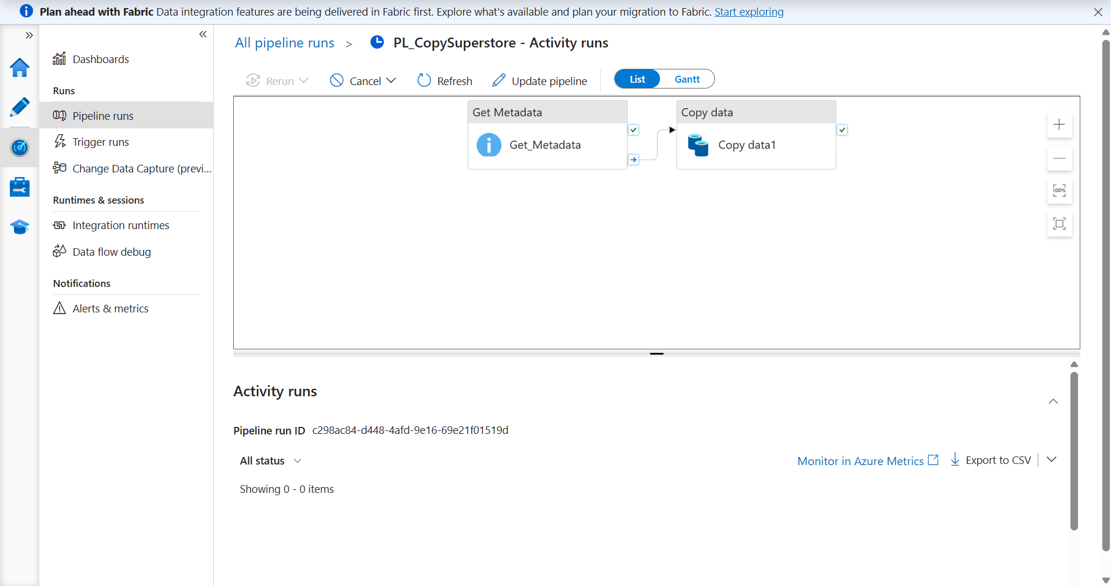

13. IAM Roles

Objective of this Step
Explored Azure Access Control (IAM) and reviewed Azure RBAC concepts such as Owner, Reader, and Contributor roles used to manage permissions securely.

Work Performed
The required Azure resource or pipeline component was created, configured, validated, and verified successfully according to the assignment requirements.

Learning Outcome
This step strengthened practical understanding of Azure cloud services, data engineering concepts, and enterprise-grade data pipeline implementation.

Screenshot

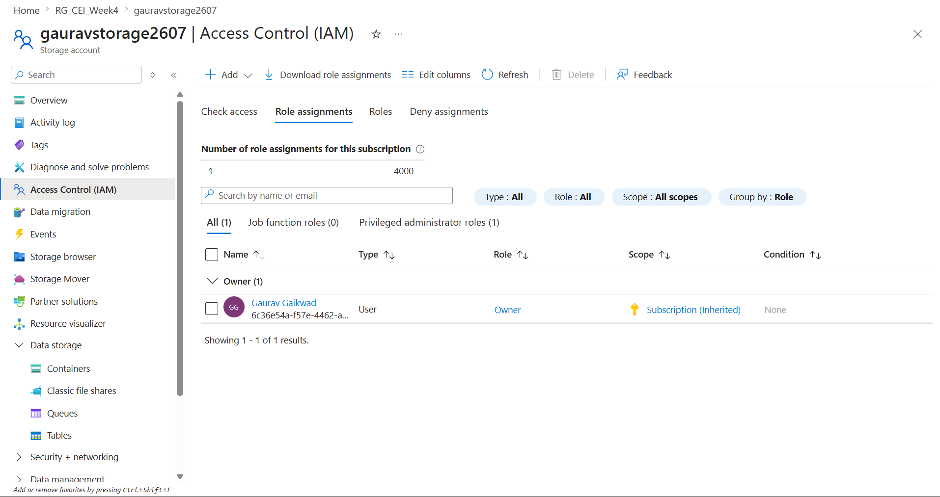

14. Final Resources

Objective of this Step
Verified that the Resource Group contains both the Azure Data Factory instance and the Azure Storage Account, confirming successful deployment.

Work Performed
The required Azure resource or pipeline component was created, configured, validated, and verified successfully according to the assignment requirements.

Learning Outcome
This step strengthened practical understanding of Azure cloud services, data engineering concepts, and enterprise-grade data pipeline implementation.

Screenshot

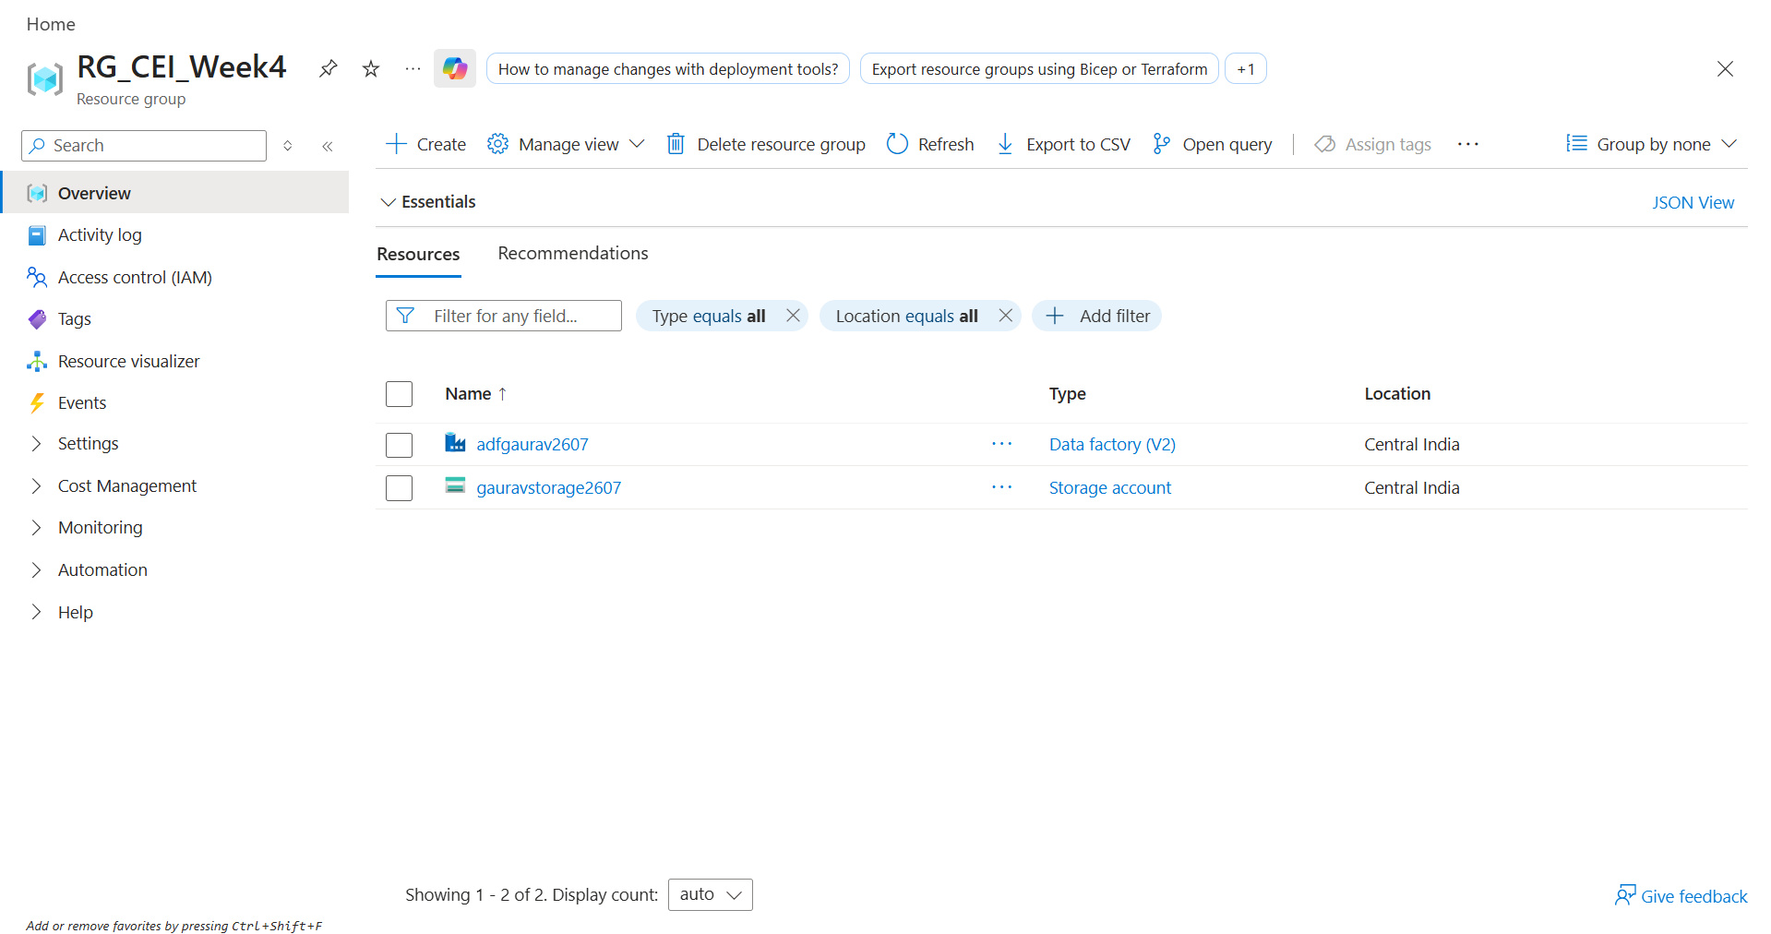

15. Conclusion

Objective of this Step
Successfully implemented an end-to-end Azure cloud data pipeline. The solution validated the source file using Get Metadata, transferred data using Copy Data activity, monitored execution successfully, and demonstrated Azure Storage, Azure Data Factory, monitoring, and role-based access control concepts. This assignment provided practical experience in designing cloud-native data engineering workflows following industry practices.

Work Performed
The required Azure resource or pipeline component was created, configured, validated, and verified successfully according to the assignment requirements.

Learning Outcome
This step strengthened practical understanding of Azure cloud services, data engineering concepts, and enterprise-grade data pipeline implementation.

