# **Parole Violators**

Parole is a temporary release of a prisoner who agrees to certain conditions before the completion of the maximum sentence period. Inmates deemed not to be a threat to society are released from prison under the parole system. Parolees are still considered to be serving their sentences, and may be returned to prison if they violate the conditions of their parole.

Parole boards are charged with identifying which inmates are good candidates for release on parole. They seek to release inmates who will not commit additional crimes after release.

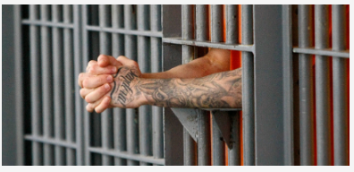

In this problem, we will build and validate a model that predicts if an inmate will violate the terms of his or her parole. Such a model could be useful to a parole board when deciding to approve or deny an application for parole.

We will use data from the United States 2004 National Corrections Reporting Program ([link](https://www.icpsr.umich.edu/icpsrweb/content/NACJD/index.html)), a nationwide census of parole releases that occurred during 2004. We limited our focus to parolees who served no more than 6 months in prison and whose maximum sentence for all charges did not exceed 18 months. The dataset contains all such parolees who either successfully completed their term of parole during 2004 or those who violated the terms of their parole during that year. The dataset contains the following variables:

**violator**: Dependent Variable- 1 if the parolee violated the parole, and 0 if the parolee completed the parole without violation.

**male**: 1 if the parolee is male, 0 if female

**race**: 1 if the parolee is white, 2 otherwise

**age**: the parolee's age (in years) when he or she was released from prison

**state**: a code for the parolee's state. 2 is Kentucky, 3 is Louisiana, 4 is Virginia, and 1 is any other state. The three states were selected due to having a high representation in the dataset.

**time.served**: the number of months the parolee served in prison (limited by the inclusion criteria to not exceed 6 months).

**max.sentence**: the maximum sentence length for all charges, in months (limited by the inclusion criteria to not exceed 18 months).

**multiple.offenses**: 1 if the parolee was incarcerated for multiple offenses, 0 otherwise.

**crime**: a code for the parolee's main crime leading to incarceration. 2 is larceny, 3 is drug-related crime, 4 is driving-related crime, and 1 is any other crime.