CS 506 homework 1

Due: Beginning of week 2

1.

How much more inaccurate is binary integer arithmetic than decimal integer arithmetic? Can the accuracy of binary computers be improved to make them as accurate as decimal computers?

Answer:

1. The same number can be represented in both the forms that is Binary and decimal that’s why I feel none of them is more accurate or inaccurate. Binary computer system requires more space for storage than decimal systems. Binary integer arithmetic is better for performing arithmetic and logical operations whereas decimal system is better for more complex operations on computer. Binary set represents {0,1} and Decimal set is {0,1,2,3,4,5,6,7,8,9}.
2. Also, Binary computers might not be able to represent decimal numbers as accurate as decimal computers. It would also be difficult to calculate and improve accuracy of Binary computers.

2.

What are the decimal equivalents of the following values (assume positional notation and unsigned integer?

formats):

a. (11001100)2

b. (11001100)3

c. (11001100)4

d. (11001100)-2

Answer:

1. 204
2. 2954
3. 20560
4. -68

3.

Convert the following decimal numbers into (a) binary and (b) hexadecimal forms

a. 25

b. 250

c. 2500

d. 25555

Answer:

Binary

1. 011001
2. 011111010
3. 0100111000100
4. 0110001111010011

Hexadecimal

1. 19
2. FA
3. 9C4
4. 63D3

4.

Perform the following calculations in the stated bases

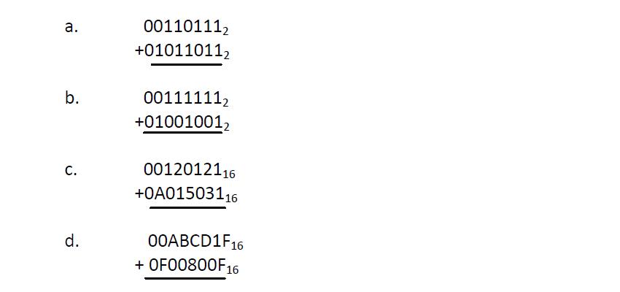

Answer:

1. 010010010
2. 010001000
3. A135152
4. FAC4D2E

5.

Positive and negative numbers can be represented in many ways in a computer. List some of the ways of representing signed numbers. Can you think of any other ways of representing signed values?

Answer:

* 1. Some of the ways of representing signed numbers are:
     1. One’s complement
     2. Two’s complement
     3. Excess-8
     4. Signed bit representation
  2. Other ways that can be used are method like negative base two (Base-2).