Week 2 homework

1. What is arithmetic overflow? When does it occur and how can it be detected?

**Answer:** Arithmetic overflow occurs whenever the result of an arithmetic operation exceeds the storage space allocated to it. Overflow occurs when:

1. Two negative numbers are added, and an answer comes positive
2. Two positive numbers are added, and an answer comes as negative.

overflow can be known by checking Most Significant Bit(MSB) of two operands and output.

2.

Draw a truth table to represent the intermediate values and output of the circuit below.

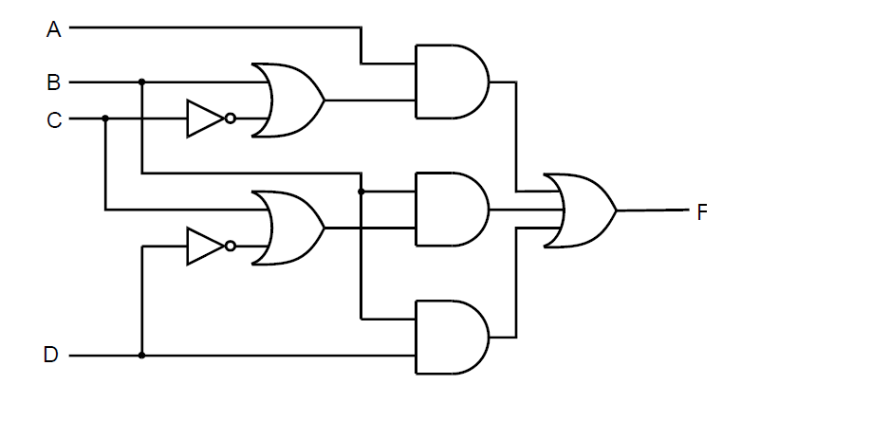

|  |  |  |  |  |
| --- | --- | --- | --- | --- |
| Input A | Input B | Input C | Input D | Output F |
| 0 | 0 | 0 | 0 | 0 |
| 0 | 0 | 0 | 1 | 0 |
| 0 | 0 | 1 | 0 | 0 |
| 0 | 0 | 1 | 1 | 0 |
| 0 | 1 | 0 | 0 | 1 |
| 0 | 1 | 0 | 1 | 0 |
| 0 | 1 | 1 | 0 | 1 |
| 0 | 1 | 1 | 1 | 1 |
| 1 | 0 | 0 | 0 | 1 |
| 1 | 0 | 0 | 1 | 1 |
| 1 | 0 | 1 | 0 | 0 |
| 1 | 0 | 1 | 1 | 0 |
| 1 | 1 | 0 | 0 | 1 |
| 1 | 1 | 0 | 1 | 1 |
| 1 | 1 | 1 | 0 | 1 |
| 1 | 1 | 1 | 1 | 1 |

3.

Draw a truth table for the circuit below and explain what it does.

|  |  |  |
| --- | --- | --- |
| Input A | Input B | Output C |
| 0 | 0 | 0 |
| 0 | 1 | 1 |
| 1 | 0 | 1 |
| 1 | 1 | 0 |

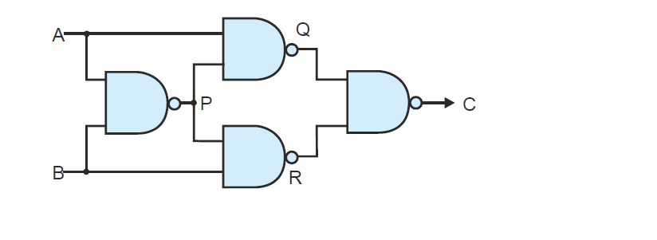

ANSWER:

We can see from the outputs:

1. The output is low when both the Inputs are low.
2. The output is low also when both the inputs are high
3. So basically for the output to be high one input should be low and the other input should be high.