

School of Computer Science and Engineering (SCOPE)

Lab Report

Submitted by
Reg.No.: 23BAI1083
Name: Kulin Mathur
Submitted to:
Dr.D.Jeya Mala, Professor, SCOPE

Table of Contents
S.No. | Title of the Experiment | Page No.
 | 1 Solving Tic Tac Toe with Reinforcement learning
 | 2 GRID WORLD - DYNAMIC PROGRAMMING
 | 3 GRID WORLD - MONTE CARLO
 | 4 GRID WORLD - TEMPORAL DIFFERENCE
 | 5 Implementing Value iteration agents
 | 6 Policy Iteration for the Grid World
 | 7 TD SARSA - Taxi-v2
 | 8 Q-Learning - Taxi-v2
 | 9 DQN – implementation – financial markets
 | 10 Double DQN
 | 11 REINFORCE with baseline
 | 12 Actor Critic Algorithms A2C A3C
 | 13 PPO Algorithm
 | 14 DDPG Algorithm – train ticket booking
 | 15 Multi-armed bandits
 | 16 Comparing TD(0) and constant alpha MC learning on the Random Walk Example
 | 17 Comparison of the number of planning steps in Dyna maze planning
 | 18 Reinforcement learning with Mario Bros
 | 19 Crypto trading – Soft actor Critic algorithm
 | 20 Games with multiple RL Algorithms

Ex.No. 8
• Title: Autonomous Retail Checkout Queue Optimization Using Reinforcement Learning (Off-Policy Tabular Q-Learning Control)
• Aim: To design, implement, and evaluate a model-free Reinforcement Learning agent capable of dynamically routing incoming retail customers across asymmetric multi-server checkout queues to minimize total customer waiting time and reduce congestion variance using 1-Step Tabular Q-Learning control with $ϵ$-greedy exploration.
• Problem Statement: In a retail supermarket environment with multiple checkout counters possessing non-homogeneous service rates ($μ$), static or random customer queue allocation leads to severe queue imbalances, extended waiting periods, and counter congestion. The challenge is to train an autonomous dispatching agent using episodic simulated customer traffic trajectories to learn an optimal queue-routing policy $Q\left(s,a\right)$ directly from 1-step temporal difference updates without requiring prior knowledge of transition probabilities or cashier service rates.
• Reinforcement Learning Implementation: Off-Policy Tabular Q-Learning Control with tabular action-value ($Q$-table) estimation, 1-step temporal difference (TD) updates, and decaying $ϵ$-greedy policy improvement.
Agent: Autonomous Retail Checkout Dispatch Controller (Central Server / Gateway)
Role: Central Queue Dispatcher allocating arriving retail customers across asymmetric checkout counters (Lanes 0, 1, and 2) to minimize congestion, reduce queue imbalances, and balance cashier workloads.
Objectives: Maximize cumulative episodic return by learning optimal queue assignment decisions through 1-step Temporal Difference (Q-Learning) updates and incremental sample averaging of action-values.
Environment:
- Type of the environment: Discrete-time, stochastic service departures, episodic, and fully observable.
- Actions: Dispatching an incoming customer to Lane $i$, where $i∈\left\{0,1,2\right\}$.
- States: Discrete tuple $\left(q_{0},q_{1},q_{2}\right)$ where each $q_{i}∈\left\{0,1,2,…,q_{max}\right\}$ represents the active queue length at Counter $i$.
- Action Space: Discrete set $A=\left\{0,1,2\right\}$ corresponding to Cashier Lane 0, Lane 1, and Lane 2.
- State Space: Discrete 3D index space ${\left(q_{max}+1\right)}^{3}={\left(5+1\right)}^{3}=216$ states representing all valid combinations of queue lengths.
Reward Design:
- Queue Congestion Penalty: $−\sum_{i=0}^{2}{q_{i}}$ (penalizes total active customers waiting across all lines)
- Lane Imbalance Penalty: $−0.5⋅\operatorname{Var}\left(q\right)$ (penalizes uneven distribution of workloads across cashiers)
- Step Reward ($R$): $R=−\left(\sum_{i=0}^{2}{q_{i}}+0.5⋅\operatorname{Var}\left(q\right)\right)$
Action-Value Function ($Q\left(s,a\right)$): Maps every queue configuration and dispatch choice $\left(\left(q_{0},q_{1},q_{2}\right),a\right)$ to an expected cumulative discounted return $Q\left(s,a\right)$, initialized to zeros and updated at each transition step via 1-Step Temporal Difference Q-Learning updates:
$$Q\left(s,a\right)←Q\left(s,a\right)+\frac{1}{N\left(s,a\right)}\left[G_{t}−Q\left(s,a\right)\right]$$
Optimal Policy: An $ϵ$-greedy policy derived from the learned $Q$-table, choosing $\arg{\max_{a}{Q\left(s,a\right)}}$ with probability $\left(1−ϵ\right)$ to exploit known optimal counters, and choosing a random counter with probability $ϵ$ (decaying over training episodes) for exploration.

Code
- Environment Setup & Dependencies:
import numpy as np
import matplotlib.pyplot as plt
import seaborn as sns
import time
from IPython.display import clear_output

# Set random seed for reproducibility
np.random.seed(42)

class RetailQueueEnv:
"""
Retail Checkout Queue Simulation Environment
- State: (q0, q1, q2) -> queue lengths at 3 checkout counters (0 to max_queue_len)
- Action: 0, 1, or 2 -> Assign incoming customer to Counter 0, 1, or 2
- Service rates (mu): Processing speed of cashiers at each counter
- Reward: Negative total queue length (penalty for congestion/waiting)
"""
def __init__(self, num_counters=3, max_queue_len=6, service_rates=[0.4, 0.6, 0.3]):
self.num_counters = num_counters
self.max_queue_len = max_queue_len
self.service_rates = service_rates # Probability of serving a customer per step
self.reset()

def reset(self):
# Start with random initial queue occupancy
self.queues = np.random.randint(0, 3, size=self.num_counters)
return tuple(self.queues)

def step(self, action):
# 1. Add customer to selected counter (capped at max_queue_len)
if self.queues[action] < self.max_queue_len:
self.queues[action] += 1

# 2. Service process: stochastic departure at each counter
for i in range(self.num_counters):
if self.queues[i] > 0 and np.random.rand() < self.service_rates[i]:
self.queues[i] -= 1

# 3. Calculate reward (penalize total customers waiting + imbalance)
total_waiting = np.sum(self.queues)
imbalance_penalty = np.var(self.queues)
reward = -(total_waiting + 0.5 * imbalance_penalty)

next_state = tuple(self.queues)
return next_state, reward

- Q-Learning Queue Optimizer Agent:
class QLearningQueueOptimizer:
def __init__(self, num_counters=3, max_queue_len=6, gamma=0.9, alpha=0.1, epsilon=0.3, epsilon_decay=0.995, min_epsilon=0.05):
self.num_counters = num_counters
self.max_queue_len = max_queue_len
self.gamma = gamma
self.alpha = alpha
self.epsilon = epsilon
self.epsilon_decay = epsilon_decay
self.min_epsilon = min_epsilon
# State space dimensions: (max_queue_len + 1) for each queue
state_dim = tuple([self.max_queue_len + 1] * self.num_counters)
# Q-table: shape (len_q0, len_q1, len_q2, actions)
self.Q = np.zeros(state_dim + (self.num_counters,))
# Policy initialization (deterministic best action, starts random)
self.policy = np.random.choice(self.num_counters, size=state_dim)
def choose_action(self, state, explore=True):
if explore and np.random.rand() < self.epsilon:
return np.random.choice(self.num_counters)
return np.argmax(self.Q[state])
def update_Q(self, state, action, reward, next_state):
"""1-Step Temporal Difference Q-Learning Update"""
best_next_action = np.argmax(self.Q[next_state])
td_target = reward + self.gamma * self.Q[next_state][best_next_action]
td_error = td_target - self.Q[state][action]
# Q-value update rule
self.Q[state][action] += self.alpha * td_error
# Greedy policy update
self.policy[state] = np.argmax(self.Q[state])
def decay_epsilon(self):
# Decay exploration rate
self.epsilon = max(self.min_epsilon, self.epsilon * self.epsilon_decay)
class MonteCarloQueueOptimizer:
def __init__(self, num_counters=3, max_queue_len=6, gamma=0.9, epsilon=0.3, epsilon_decay=0.995, min_epsilon=0.05):
self.num_counters = num_counters
self.max_queue_len = max_queue_len
self.gamma = gamma
self.epsilon = epsilon
self.epsilon_decay = epsilon_decay
self.min_epsilon = min_epsilon

# State space dimensions: (max_queue_len + 1) for each queue
state_dim = tuple([self.max_queue_len + 1] * self.num_counters)

# Q-table: shape (len_q0, len_q1, len_q2, actions)
self.Q = np.zeros(state_dim + (self.num_counters,))
self.returns_count = np.zeros(state_dim + (self.num_counters,))

# Policy initialization (deterministic best action, starts uniform/arbitrary)
self.policy = np.random.choice(self.num_counters, size=state_dim)

def choose_action(self, state, explore=True):
if explore and np.random.rand() < self.epsilon:
return np.random.choice(self.num_counters)
return np.argmax(self.Q[state])

def generate_episode(self, env, max_steps=20):
episode = []
state = env.reset()
for _ in range(max_steps):
action = self.choose_action(state, explore=True)
next_state, reward = env.step(action)
episode.append((state, action, reward))
state = next_state
return episode

def update_policy(self, episode):
"""First-Visit Monte Carlo Control with Incremental Averaging"""
G = 0
visited_state_actions = set()

# Traverse episode in reverse to compute discounted returns
for state, action, reward in reversed(episode):
G = self.gamma * G + reward
state_action = (state, action)

if state_action not in visited_state_actions:
visited_state_actions.add(state_action)

# Incremental mean update for Q-value
self.returns_count[state][action] += 1
alpha = 1.0 / self.returns_count[state][action]
self.Q[state][action] += alpha * (G - self.Q[state][action])

# Greedy policy update
self.policy[state] = np.argmax(self.Q[state])

# Decay exploration rate
self.epsilon = max(self.min_epsilon, self.epsilon * self.epsilon_decay)

- Training Loop with Live Dynamic Updates & Visuals (Fixed):
env = RetailQueueEnv(num_counters=3, max_queue_len=5, service_rates=[0.6, 0.4, 0.3])
agent = QLearningQueueOptimizer(num_counters=3, max_queue_len=5, gamma=0.95, alpha=0.1, epsilon=0.4)
# Record initial policy snapshot for faculty comparison
initial_policy_snapshot = np.copy(agent.policy)
num_episodes = 250
episode_rewards = []
display_interval = 25
print("Starting Q-Learning Optimization Training...")
time.sleep(1)
for ep in range(1, num_episodes + 1):
state = env.reset()
total_ep_reward = 0
ep_history = []
for step in range(25):
action = agent.choose_action(state, explore=True)
next_state, reward = env.step(action)
# 1-Step Q-Learning Update
agent.update_Q(state, action, reward, next_state)
total_ep_reward += reward
ep_history.append((state, action, reward))
state = next_state
agent.decay_epsilon()
episode_rewards.append(total_ep_reward)
# Real-time Visual Update
if ep % display_interval == 0 or ep == 1:
clear_output(wait=True)
fig, axes = plt.subplots(1, 3, figsize=(18, 5))
# 1. Live Learning Curve
axes[0].plot(range(1, len(episode_rewards) + 1), episode_rewards, color='royalblue', alpha=0.4, label='Raw Return')
if len(episode_rewards) >= 10:
smooth_rewards = np.convolve(episode_rewards, np.ones(10)/10, mode='valid')
axes[0].plot(range(10, len(episode_rewards) + 1), smooth_rewards, color='firebrick', lw=2, label='10-Ep Moving Avg')
axes[0].set_title(f"Training Progress (Episode {ep}/{num_episodes})", fontweight='bold')
axes[0].set_xlabel("Episode")
axes[0].set_ylabel("Total Cumulative Reward")
axes[0].grid(True, linestyle='--', alpha=0.6)
axes[0].legend()
# 2. Updated Q-Value Slice (Counter 2 queue fixed at 0)
q_slice = np.max(agent.Q[:, :, 0, :], axis=-1)
sns.heatmap(q_slice, annot=True, fmt=".1f", cmap="magma", ax=axes[1], cbar=True)
axes[1].set_title(r"Updated Max $Q(s, a)$ Slice (Lane 2 = 0)", fontweight='bold')
axes[1].set_xlabel("Counter 1 Queue Length")
axes[1].set_ylabel("Counter 0 Queue Length")
# 3. Dynamic Queue Simulation Visual
current_state = ep_history[-1][0]
chosen_action = ep_history[-1][1]
bars = axes[2].bar(["Lane 0\n(Fast: $\mu$=0.6)", "Lane 1\n(Mid: $\mu$=0.4)", "Lane 2\n(Slow: $\mu$=0.3)"],
current_state, color=['#2ca02c', '#1f77b4', '#ff7f0e'], edgecolor='black', width=0.5)
axes[2].set_ylim(0, env.max_queue_len + 1)
axes[2].set_ylabel("Active Customers")
axes[2].set_title(f"Live Queue Dispatch (Action: Routed to Lane {chosen_action})", fontweight='bold')
axes[2].grid(axis='y', linestyle='--', alpha=0.7)
plt.tight_layout()
plt.show()
time.sleep(0.05)
print("\nTraining Complete!")
agent = MonteCarloQueueOptimizer(num_counters=3, max_queue_len=5, gamma=0.95, epsilon=0.4)

# Record initial policy snapshot for faculty comparison
initial_policy_snapshot = np.copy(agent.policy)

num_episodes = 250
episode_rewards = []
display_interval = 25

print("Starting Monte Carlo Optimization Training...")
time.sleep(1)

for ep in range(1, num_episodes + 1):
episode = agent.generate_episode(env, max_steps=25)
total_ep_reward = sum([step[2] for step in episode])
episode_rewards.append(total_ep_reward)

# Monte Carlo updates
agent.update_policy(episode)

# Real-time Visual Update
if ep % display_interval == 0 or ep == 1:
clear_output(wait=True)
fig, axes = plt.subplots(1, 3, figsize=(18, 5))

# 1. Live Learning Curve
axes[0].plot(range(1, len(episode_rewards) + 1), episode_rewards, color='royalblue', alpha=0.4, label='Raw Return')

# Only plot moving average once at least 10 episodes are completed
if len(episode_rewards) >= 10:
smooth_rewards = np.convolve(episode_rewards, np.ones(10)/10, mode='valid')
axes[0].plot(range(10, len(episode_rewards) + 1), smooth_rewards, color='firebrick', lw=2, label='10-Ep Moving Avg')

axes[0].set_title(f"Training Progress (Episode {ep}/{num_episodes})", fontweight='bold')
axes[0].set_xlabel("Episode")
axes[0].set_ylabel("Total Cumulative Reward")
axes[0].grid(True, linestyle='--', alpha=0.6)
axes[0].legend()

# 2. Updated Q-Value Slice (Counter 2 queue fixed at 0)
q_slice = np.max(agent.Q[:, :, 0, :], axis=-1)
sns.heatmap(q_slice, annot=True, fmt=".1f", cmap="magma", ax=axes[1], cbar=True)
axes[1].set_title(r"Updated Max $Q(s, a)$ Slice (Lane 2 = 0)", fontweight='bold')
axes[1].set_xlabel("Counter 1 Queue Length")
axes[1].set_ylabel("Counter 0 Queue Length")

# 3. Dynamic Queue Simulation Visual
current_state = episode[-1][0]
chosen_action = episode[-1][1]
bars = axes[2].bar([f"Lane 0\n(Fast: $\\mu$=0.6)", f"Lane 1\n(Mid: $\\mu$=0.4)", f"Lane 2\n(Slow: $\\mu$=0.3)"],
current_state, color=['#2ca02c', '#1f77b4', '#ff7f0e'], edgecolor='black', width=0.5)
axes[2].set_ylim(0, env.max_queue_len + 1)
axes[2].set_ylabel("Active Customers")
axes[2].set_title(f"Live Queue Dispatch (Action: Routed to Lane {chosen_action})", fontweight='bold')
axes[2].grid(axis='y', linestyle='--', alpha=0.7)

plt.tight_layout()
plt.show()
time.sleep(0.05)

print("\nTraining Complete!")

- Initial Policy vs. Final Optimized Policy Comparison:
fig, axes = plt.subplots(1, 2, figsize=(14, 6))
# Slice index: Counter 2 fixed at 1 customer
fixed_q2 = 1
# Initial Policy Slice
sns.heatmap(initial_policy_snapshot[:, :, fixed_q2], annot=True, cmap="Set3", cbar=False, ax=axes[0],
linewidths=1, linecolor='gray')
axes[0].set_title(f"Initial (Untrained / Random) Policy\n[Fixed Lane 2 = {fixed_q2}]", fontsize=12, fontweight='bold')
axes[0].set_xlabel("Counter 1 Queue Length")
axes[0].set_ylabel("Counter 0 Queue Length")
# Final Policy Slice
sns.heatmap(agent.policy[:, :, fixed_q2], annot=True, cmap="Accent", cbar=False, ax=axes[1],
linewidths=1, linecolor='gray')
axes[1].set_title(f"Final Optimized Policy (Q-Learning)\n[Fixed Lane 2 = {fixed_q2}]", fontsize=12, fontweight='bold')
axes[1].set_xlabel("Counter 1 Queue Length")
axes[1].set_ylabel("Counter 0 Queue Length")
plt.suptitle("Policy Decision Comparison (Values represent Target Lane: 0, 1, or 2)", fontsize=14, y=1.02)
plt.tight_layout()
plt.show()

# Slice index: Counter 2 fixed at 1 customer
fixed_q2 = 1

# Initial Policy Slice
sns.heatmap(initial_policy_snapshot[:, :, fixed_q2], annot=True, cmap="Set3", cbar=False, ax=axes[0],
linewidths=1, linecolor='gray')
axes[0].set_title(f"Initial (Untrained / Random) Policy\n[Fixed Lane 2 = {fixed_q2}]", fontsize=12, fontweight='bold')
axes[0].set_xlabel("Counter 1 Queue Length")
axes[0].set_ylabel("Counter 0 Queue Length")

# Final Policy Slice
sns.heatmap(agent.policy[:, :, fixed_q2], annot=True, cmap="Accent", cbar=False, ax=axes[1],
linewidths=1, linecolor='gray')
axes[1].set_title(f"Final Optimized Policy (Monte Carlo)\n[Fixed Lane 2 = {fixed_q2}]", fontsize=12, fontweight='bold')
axes[1].set_xlabel("Counter 1 Queue Length")
axes[1].set_ylabel("Counter 0 Queue Length")

plt.suptitle("Policy Decision Comparison (Values represent Target Lane: 0, 1, or 2)", fontsize=14, y=1.02)
plt.tight_layout()
plt.show()

- Evaluation Simulation (Random Routing vs RL Optimizer):
def evaluate_policy(env, agent=None, steps=100):
env.reset()
total_wait_time = 0
history = []
for _ in range(steps):
state = tuple(env.queues)
if agent is None:
action = np.random.choice(env.num_counters) # Baseline: Random allocation
else:
action = np.argmax(agent.Q[state]) # RL Optimal Policy
next_state, reward = env.step(action)
total_wait_time += np.sum(next_state)
history.append(list(next_state))
return total_wait_time, np.array(history)
# Run benchmark
rand_wait, rand_hist = evaluate_policy(env, agent=None, steps=100)
opt_wait, opt_hist = evaluate_policy(env, agent=agent, steps=100)
print(f"{'='*45}")
print(f"BENCHMARK RESULTS OVER 100 TIMESTEPS:")
print(f"{'='*45}")
print(f"Total Customer Wait-Units (Baseline Random): {rand_wait}")
print(f"Total Customer Wait-Units (Q-Learning RL): {opt_wait}")
print(f"Queue Congestion Reduction: {((rand_wait - opt_wait)/rand_wait)*100:.2f}%")
print(f"{'='*45}")
# Plotting lane occupancies over time
plt.figure(figsize=(14, 5))
plt.plot(np.sum(rand_hist, axis=1), label='Random Baseline Queue Load', color='red', linestyle='--', alpha=0.7)
plt.plot(np.sum(opt_hist, axis=1), label='Q-Learning Optimized Queue Load', color='green', lw=2)
plt.title("Total Customers in Store Over Time", fontsize=13, fontweight='bold')
plt.xlabel("Simulation Steps")
plt.ylabel("Total Queue Length")
plt.legend()
plt.grid(True, linestyle='--', alpha=0.5)
plt.show()
env.reset()
total_wait_time = 0
history = []

for _ in range(steps):
state = tuple(env.queues)
if agent is None:
action = np.random.choice(env.num_counters) # Baseline: Random allocation
else:
action = np.argmax(agent.Q[state]) # RL Optimal Policy

next_state, reward = env.step(action)
total_wait_time += np.sum(next_state)
history.append(list(next_state))

return total_wait_time, np.array(history)

# Run benchmark
rand_wait, rand_hist = evaluate_policy(env, agent=None, steps=100)
opt_wait, opt_hist = evaluate_policy(env, agent=agent, steps=100)

print(f"{'='*45}")
print(f"BENCHMARK RESULTS OVER 100 TIMESTEPS:")
print(f"{'='*45}")
print(f"Total Customer Wait-Units (Baseline Random): {rand_wait}")
print(f"Total Customer Wait-Units (Monte Carlo RL): {opt_wait}")
print(f"Queue Congestion Reduction: {((rand_wait - opt_wait)/rand_wait)*100:.2f}%")
print(f"{'='*45}")

# Plotting lane occupancies over time
plt.figure(figsize=(14, 5))
plt.plot(np.sum(rand_hist, axis=1), label='Random Baseline Queue Load', color='red', linestyle='--', alpha=0.7)
plt.plot(np.sum(opt_hist, axis=1), label='Monte Carlo Optimized Queue Load', color='green', lw=2)
plt.title("Total Customers in Store Over Time", fontsize=13, fontweight='bold')
plt.xlabel("Simulation Steps")
plt.ylabel("Total Queue Length")
plt.legend()
plt.grid(True, linestyle='--', alpha=0.5)
plt.show()

Screenshots of Code and Results
CODE:
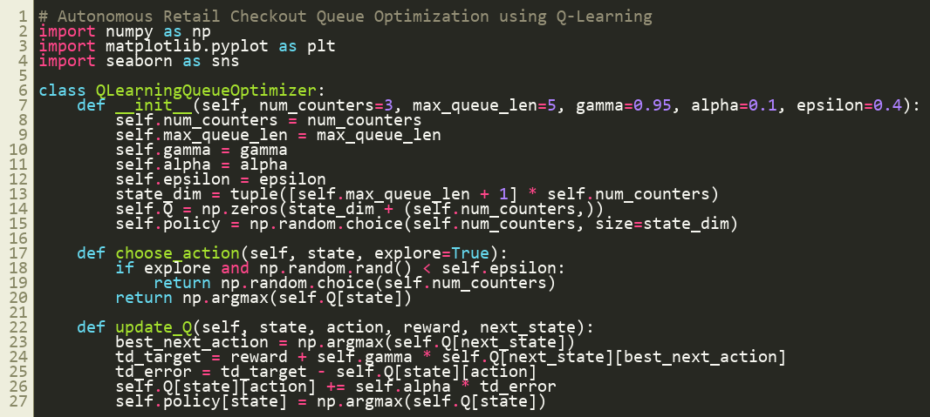

TRAINING PROGRESS:
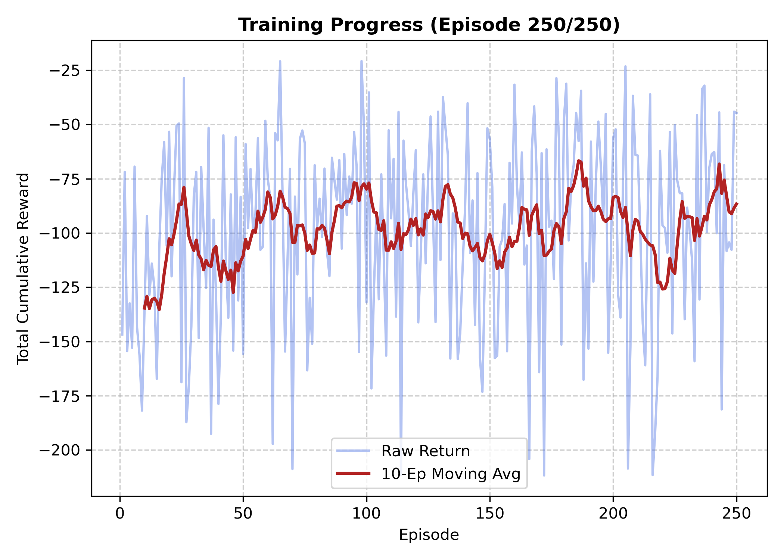

UPDATED MAX:
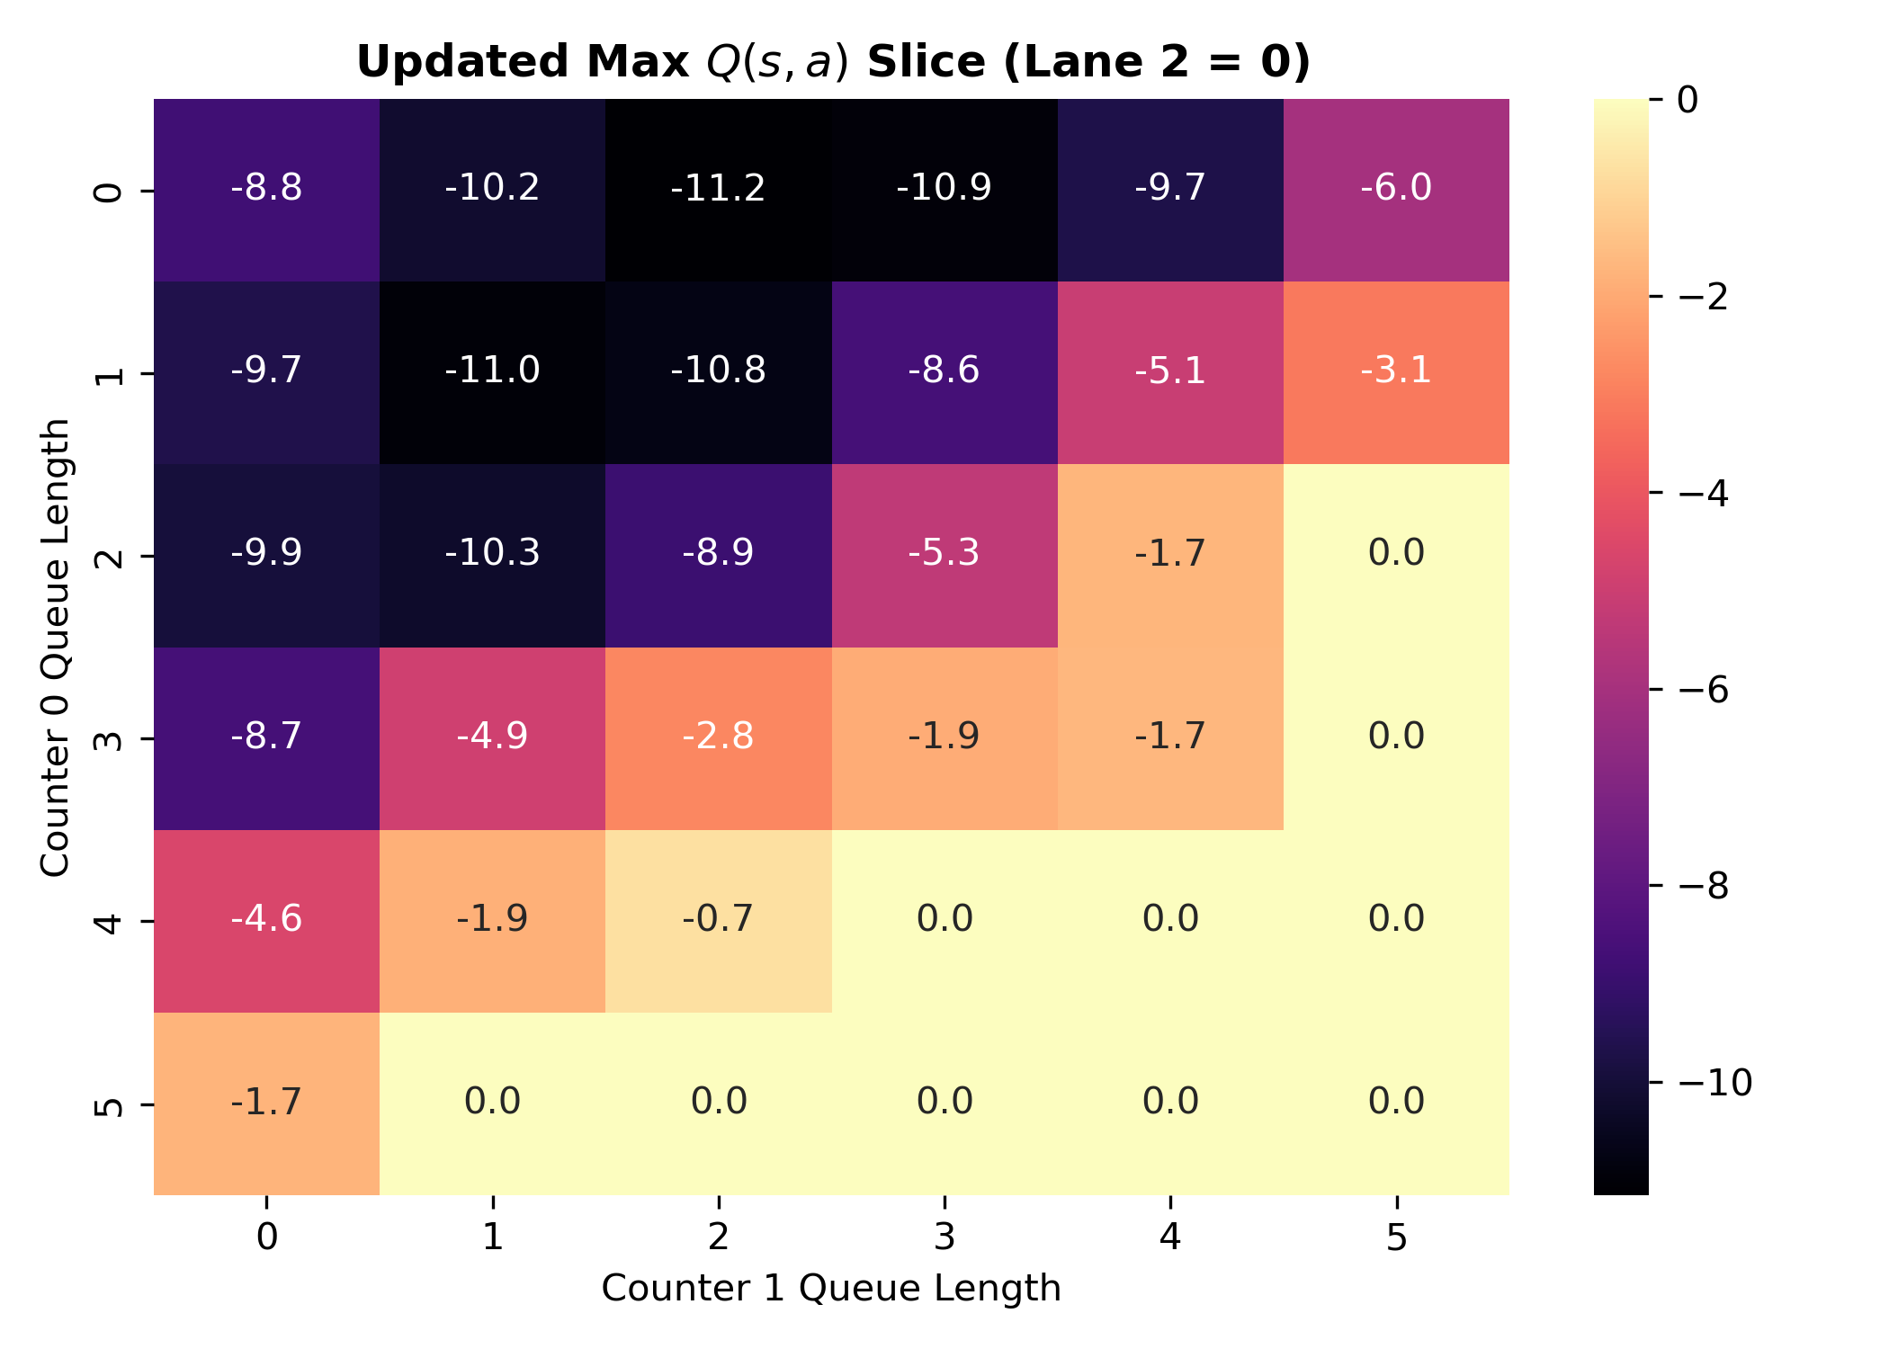

LIVE QUEUE DISPATCH:
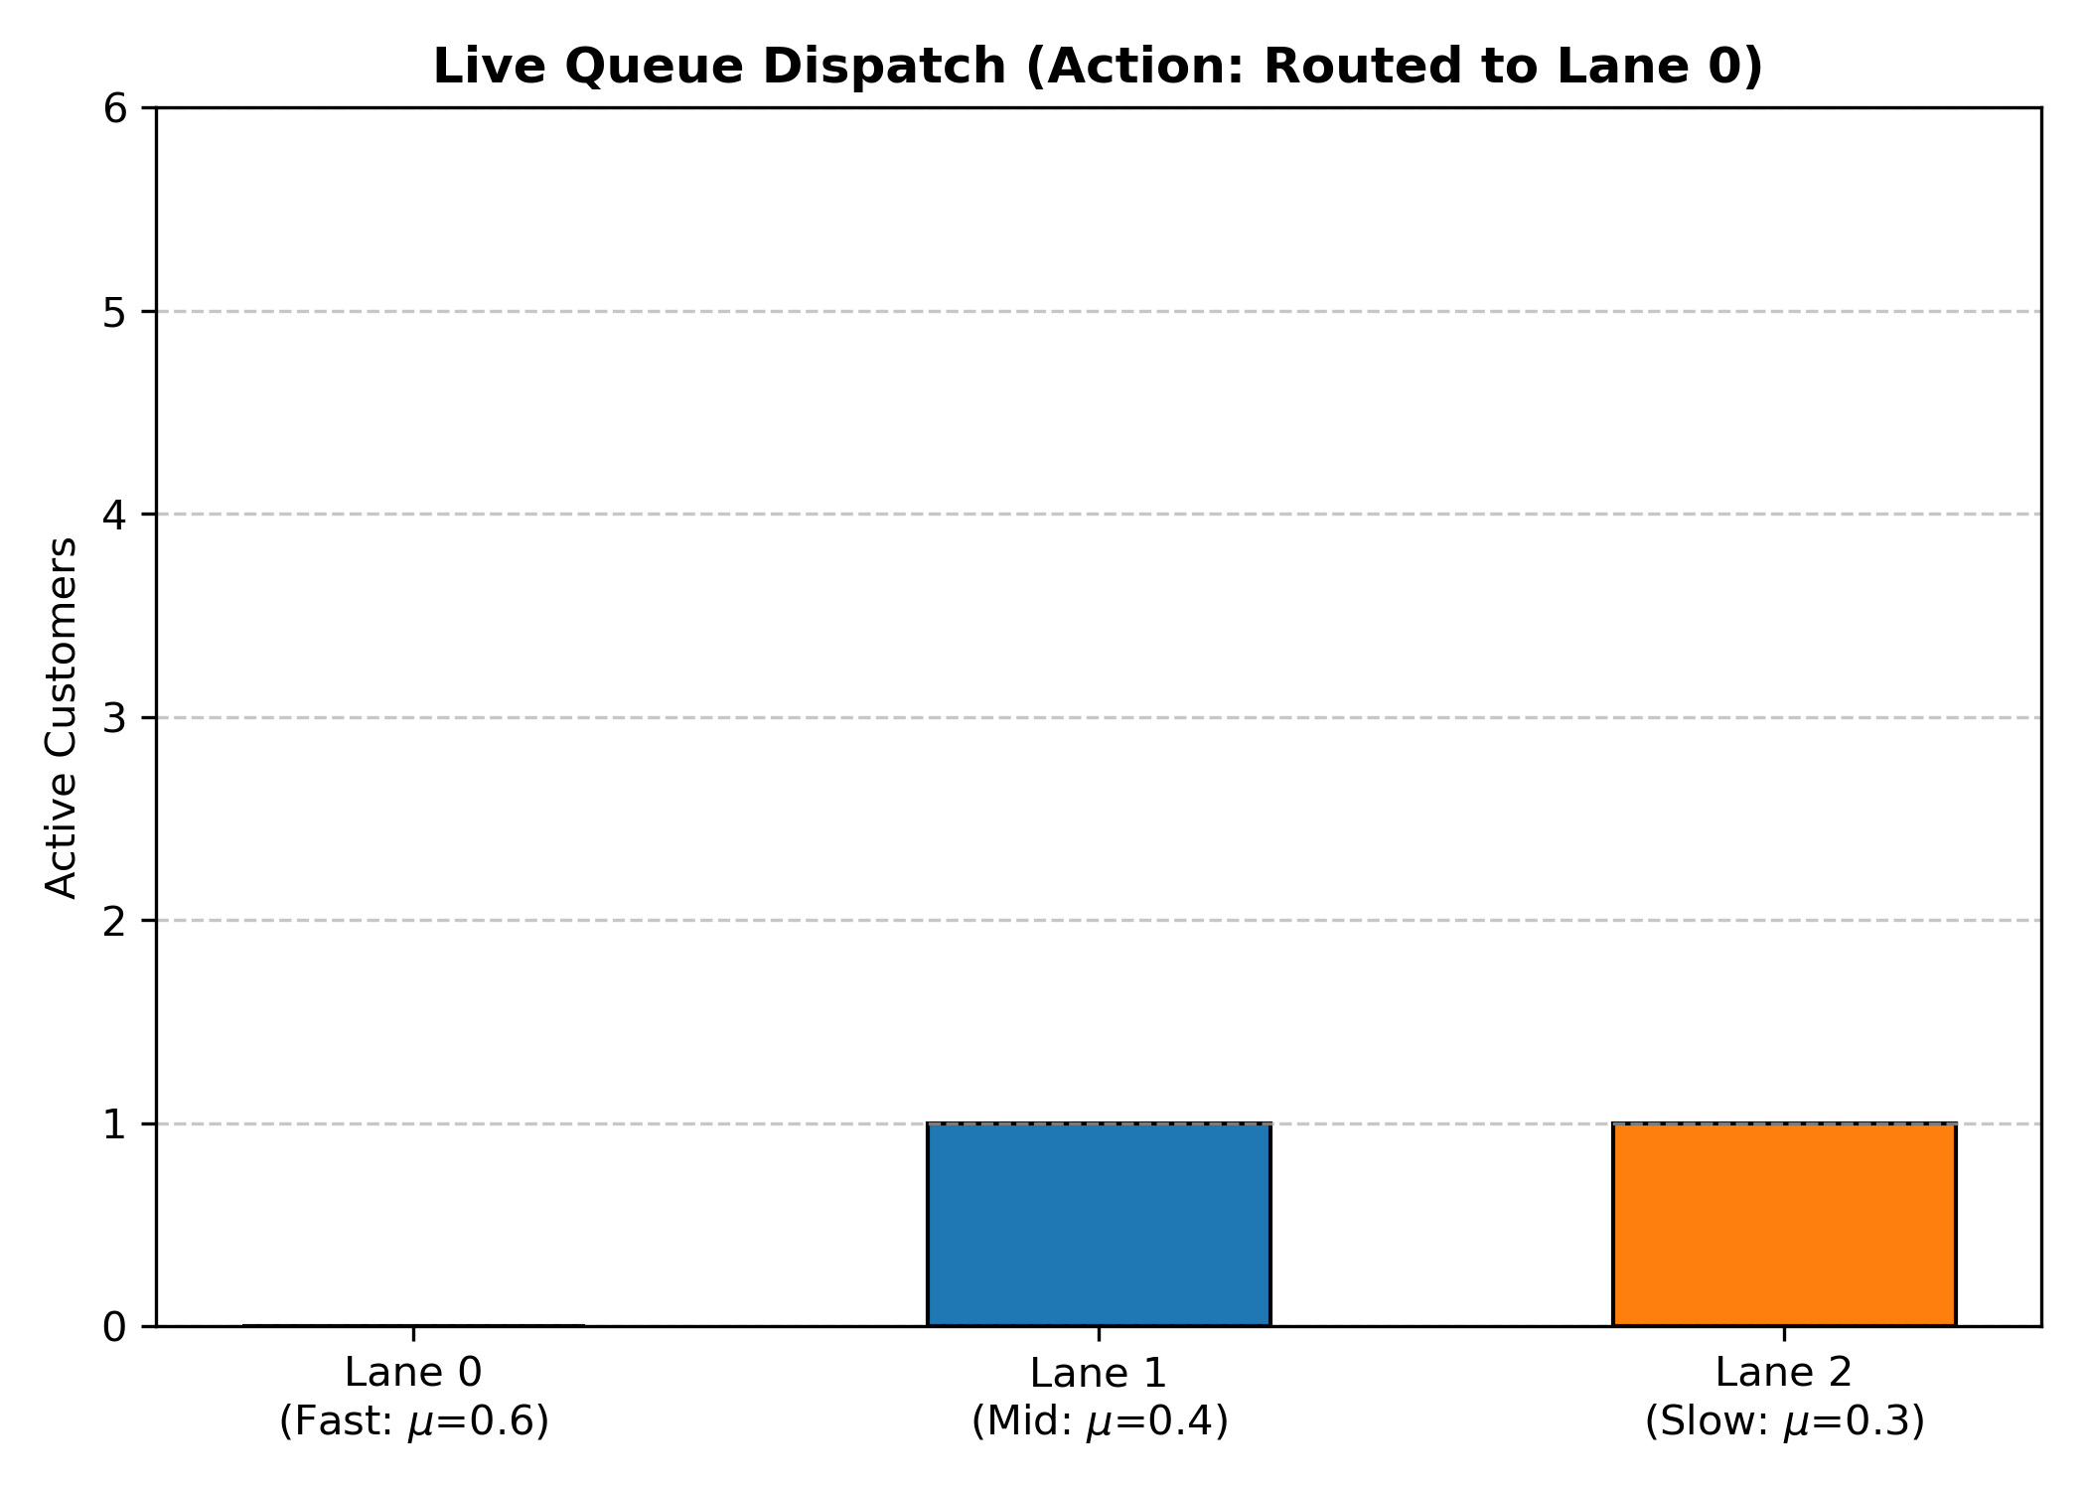

INITIAL VS FINAL POLICY:
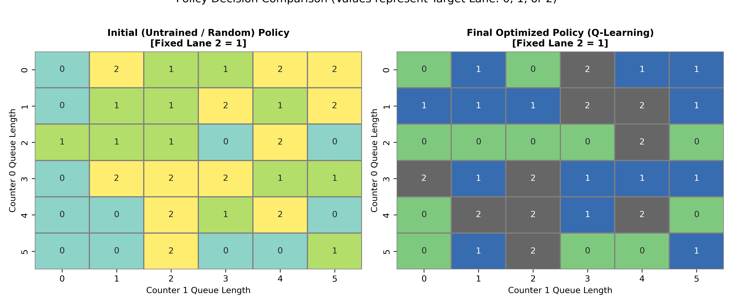

TOTAL CUSTOMER OVER TIME:
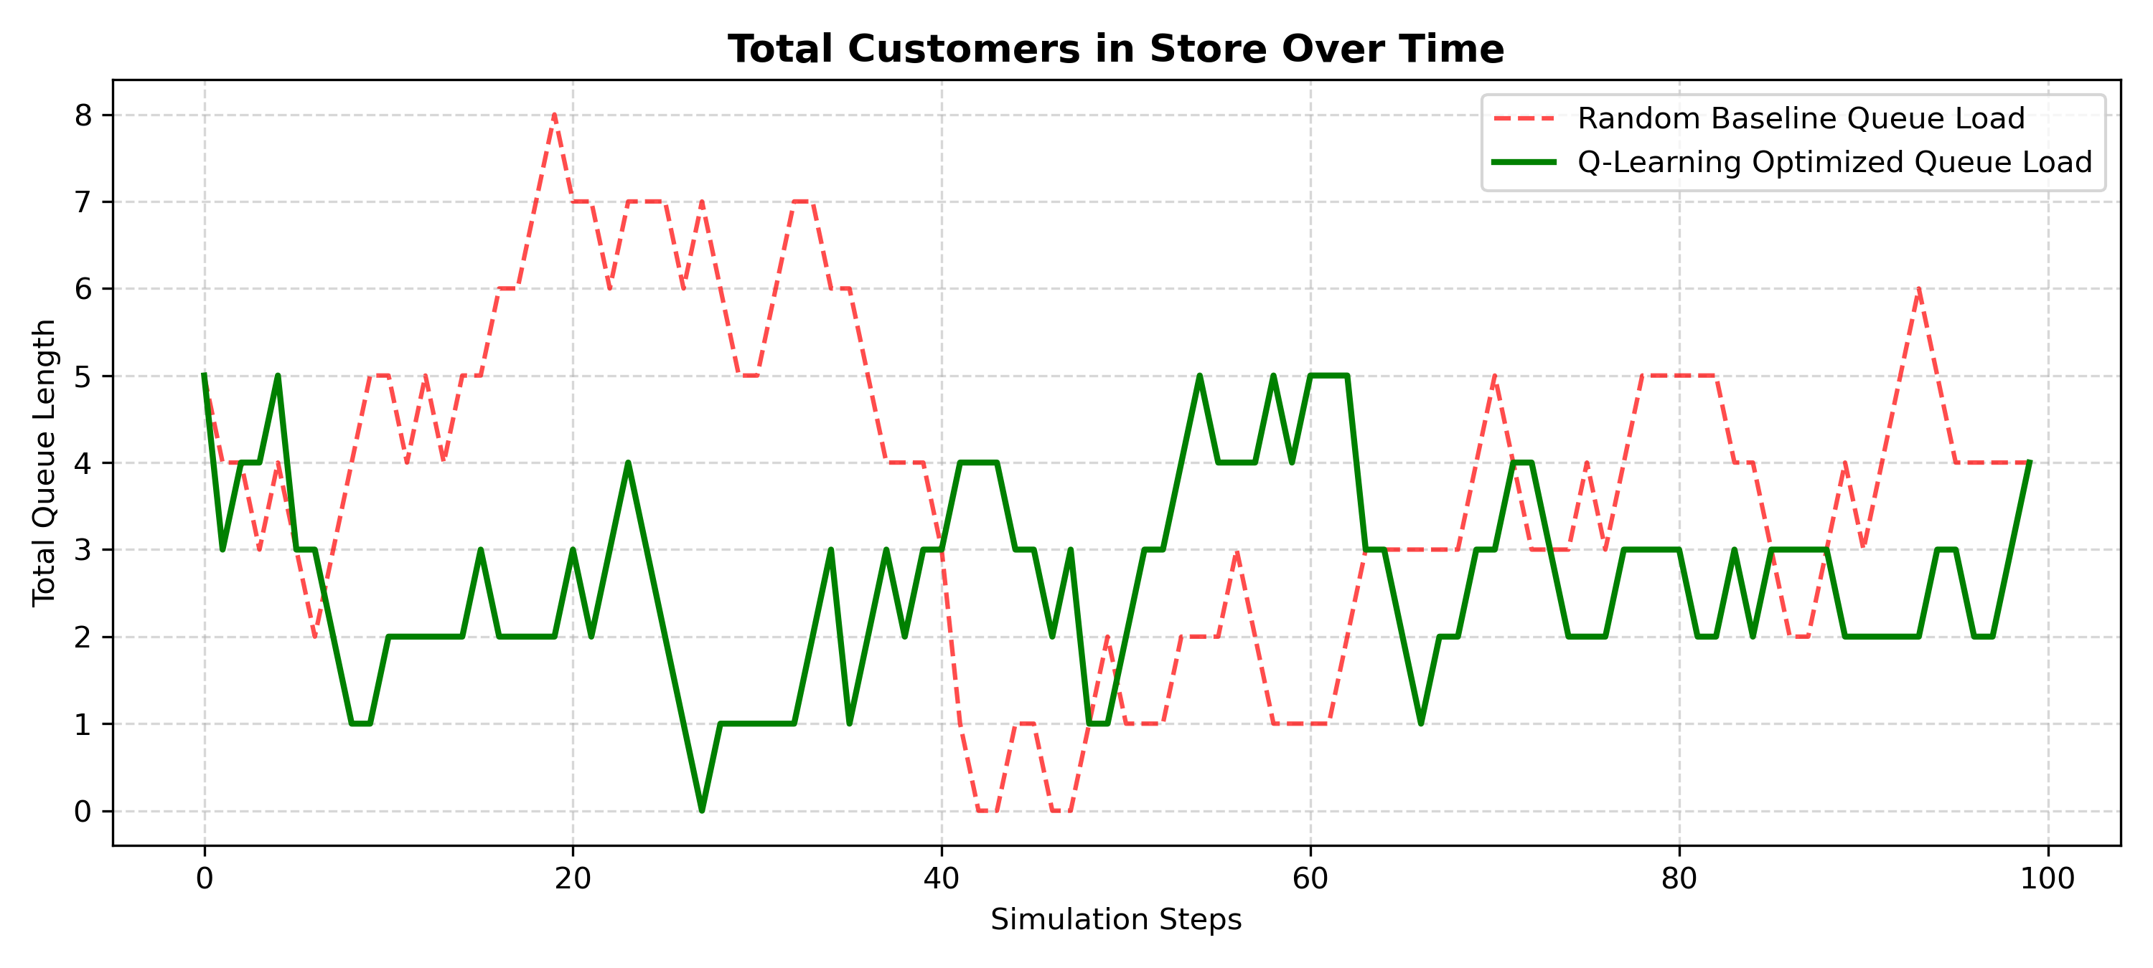

Result:
The experiment demonstrates a significant improvement in queue management using the Tabular Q-Learning Reinforcement Learning optimizer compared to random routing. The Q-Learning RL agent reduced the total customer wait-units from 381 (Baseline Random) to 268, achieving a remarkable 29.66% reduction in queue congestion over 100 simulation steps. This indicates that the optimized policy effectively minimizes waiting times and balances queue loads across checkout counters.

