**Name:** Kaklotar Gaurav Amarshibhai

**Subject:** SDP

**Batch:** A3

**Roll No:** CE053

**ID No:** 20CEUBG084

**Lab07 Tutorial-1**

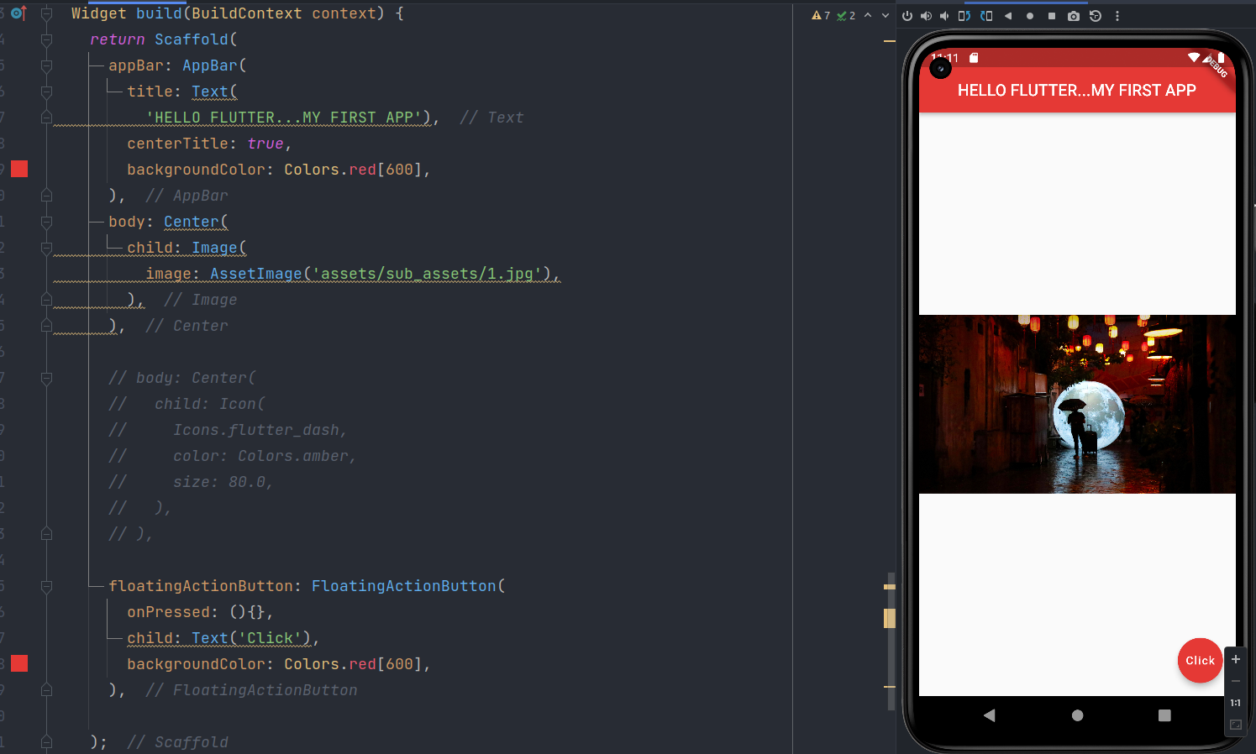

abstract class StatelessWidget extends Widget

A widget that does not require mutable state.

A stateless widget is a widget that describes part of the user interface by building a constellation of other widgets that describe the user interface more concretely.

Containing class: **AssetImage**

Creates an object that fetches an image from an asset bundle.

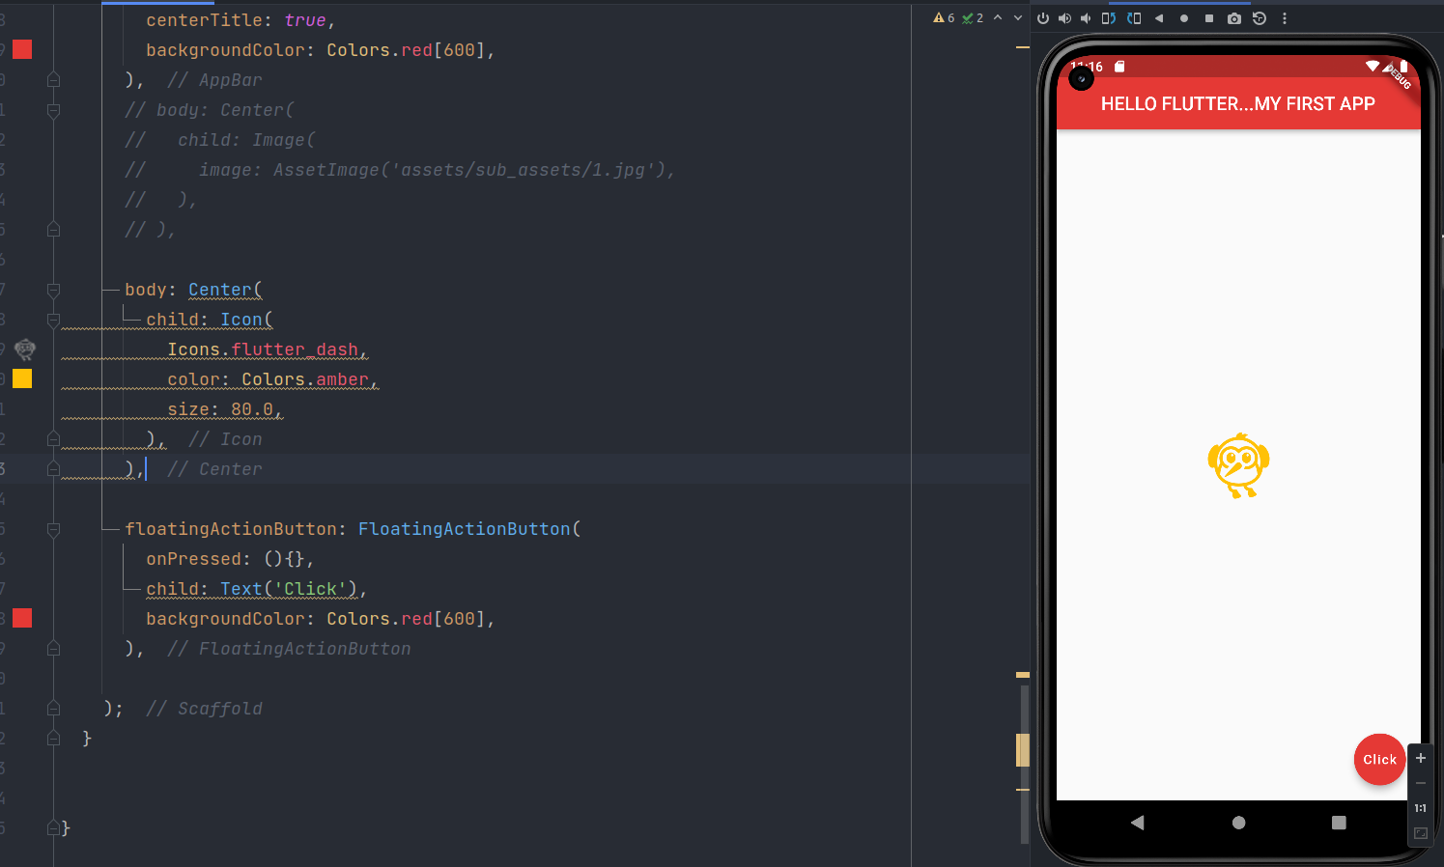

Containing class: Icon

Creates an icon.

The size and color default to the value given by the current IconTheme.

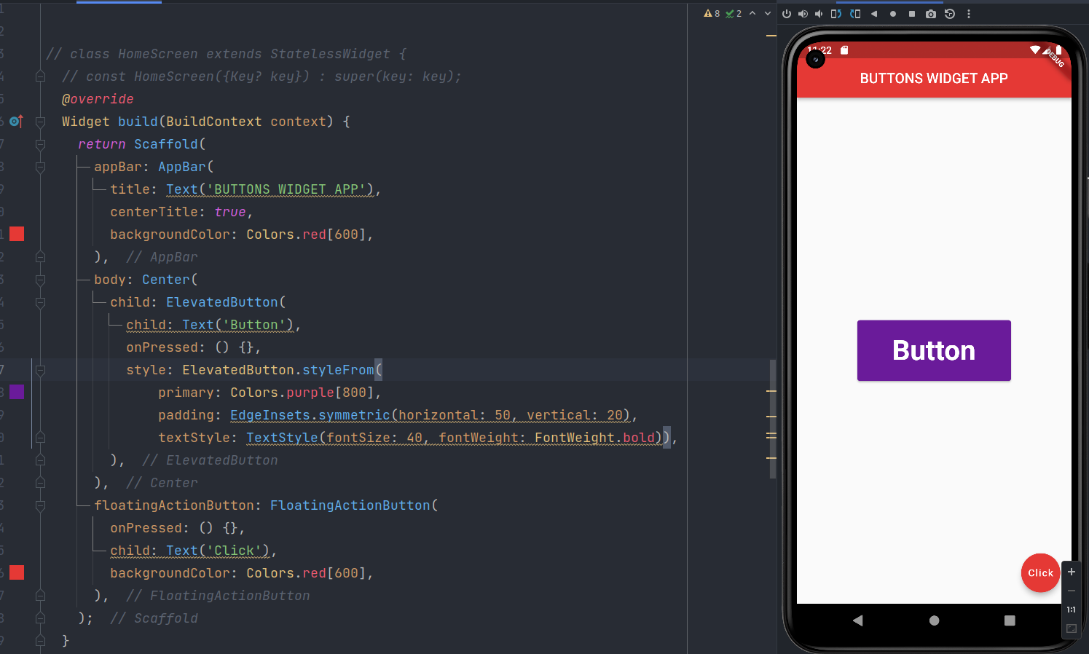

Containing class: ElevatedButton

Create an ElevatedButton.

The autofocus and clipBehavior arguments must not be null.

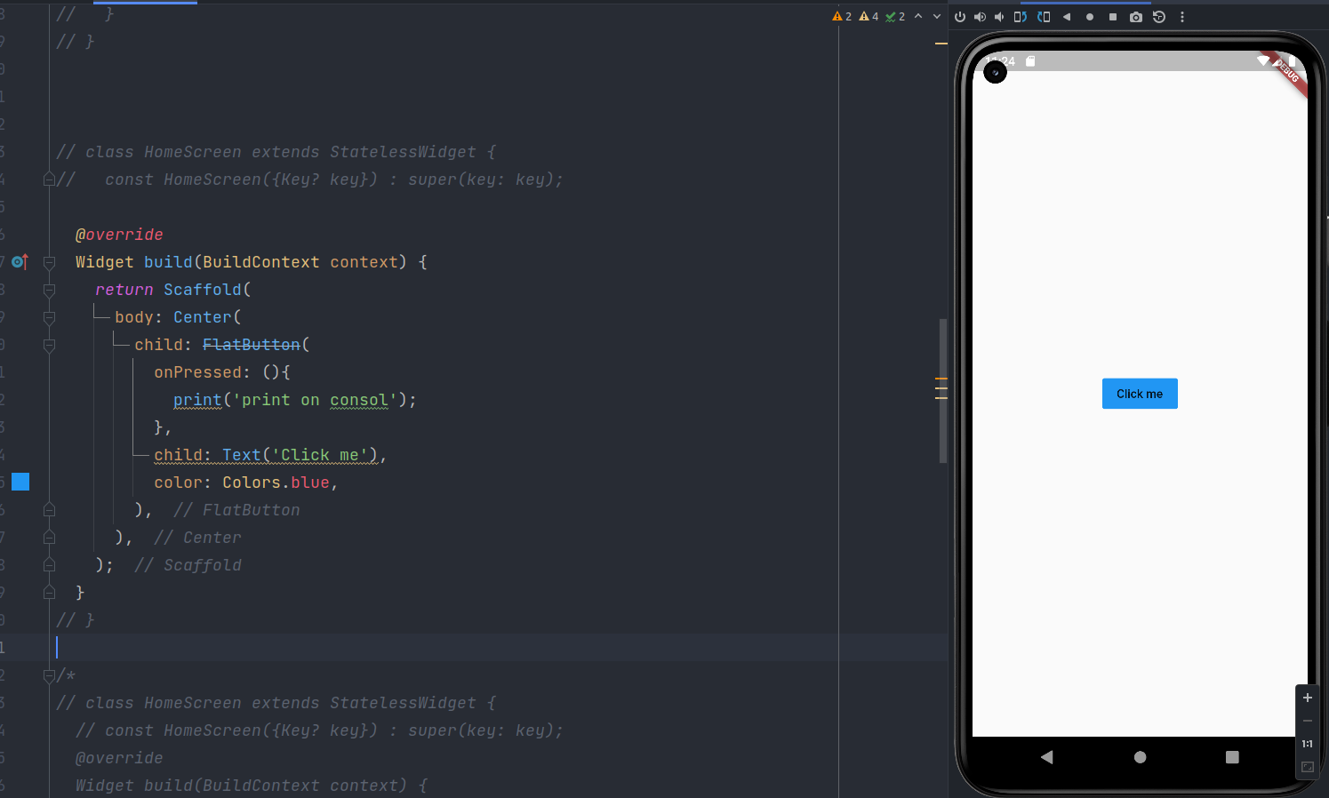

Once we click on “Click me” it will print message on console.

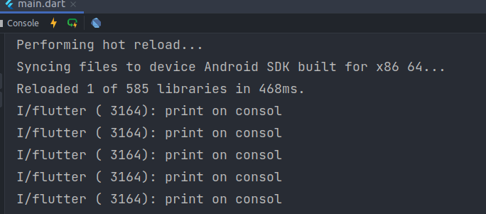

Same thing we can achive using Icons.

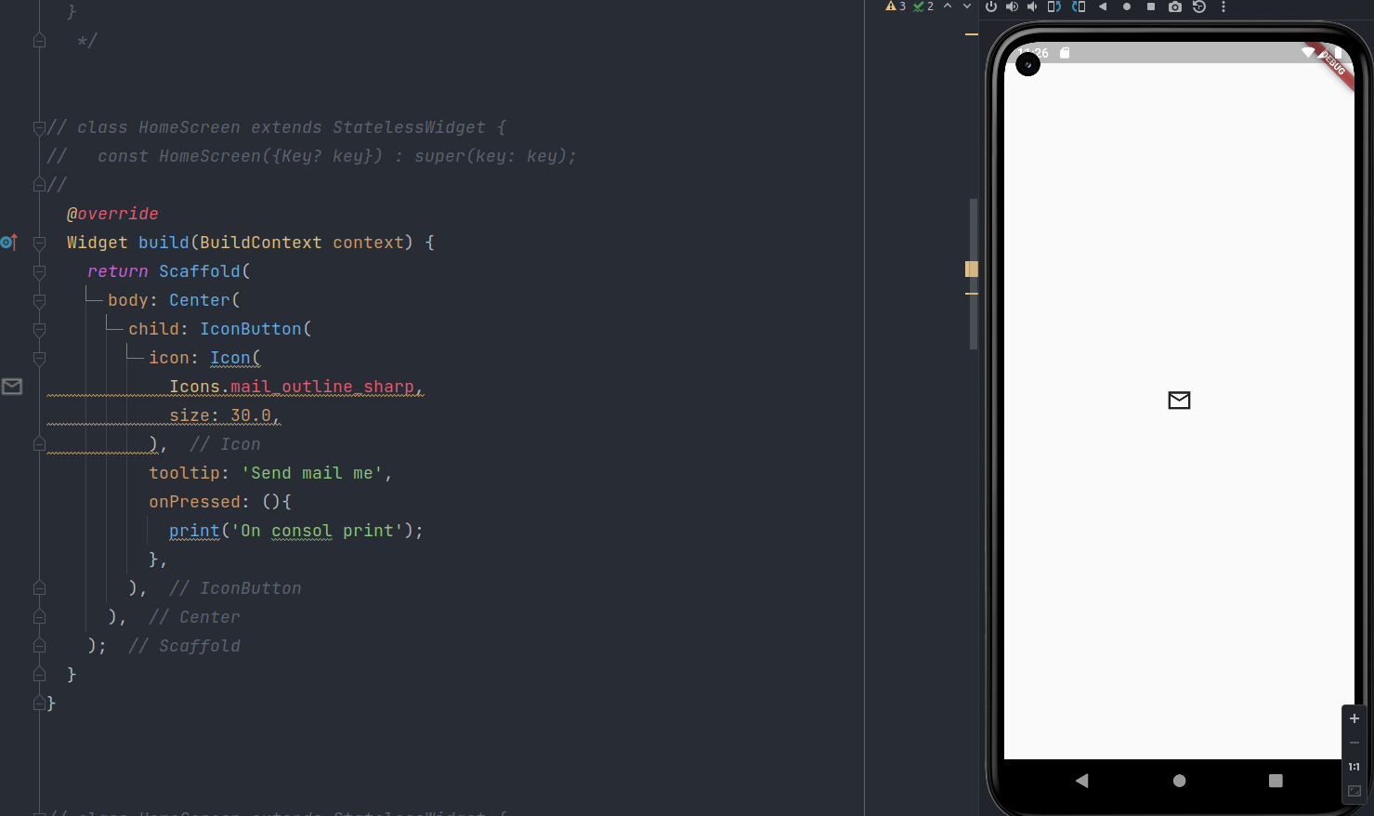

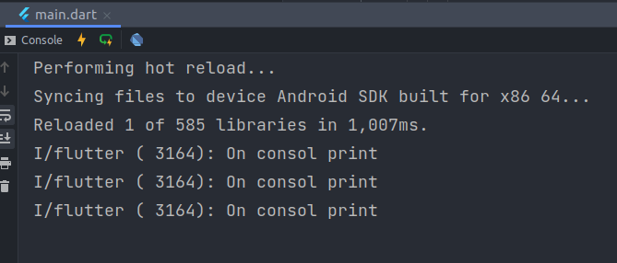

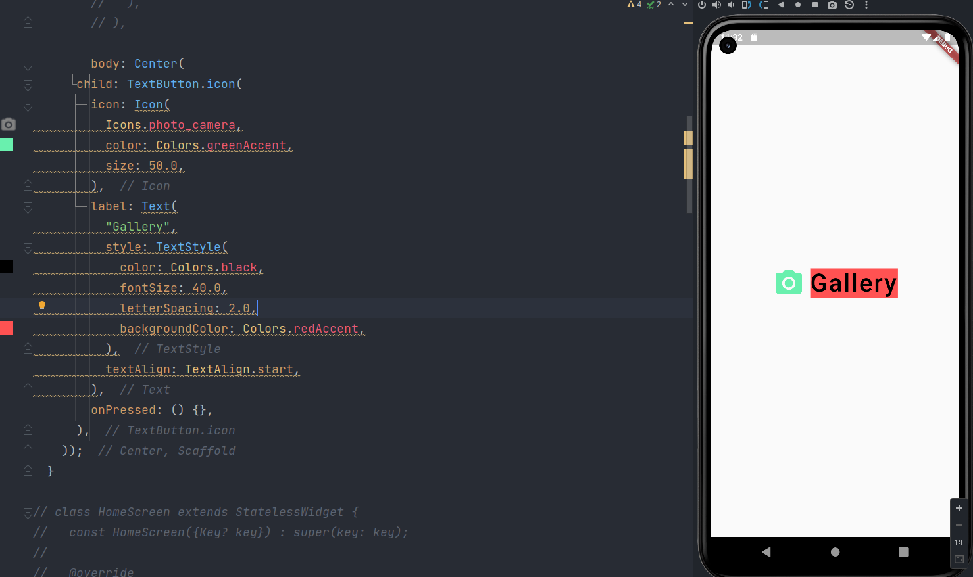

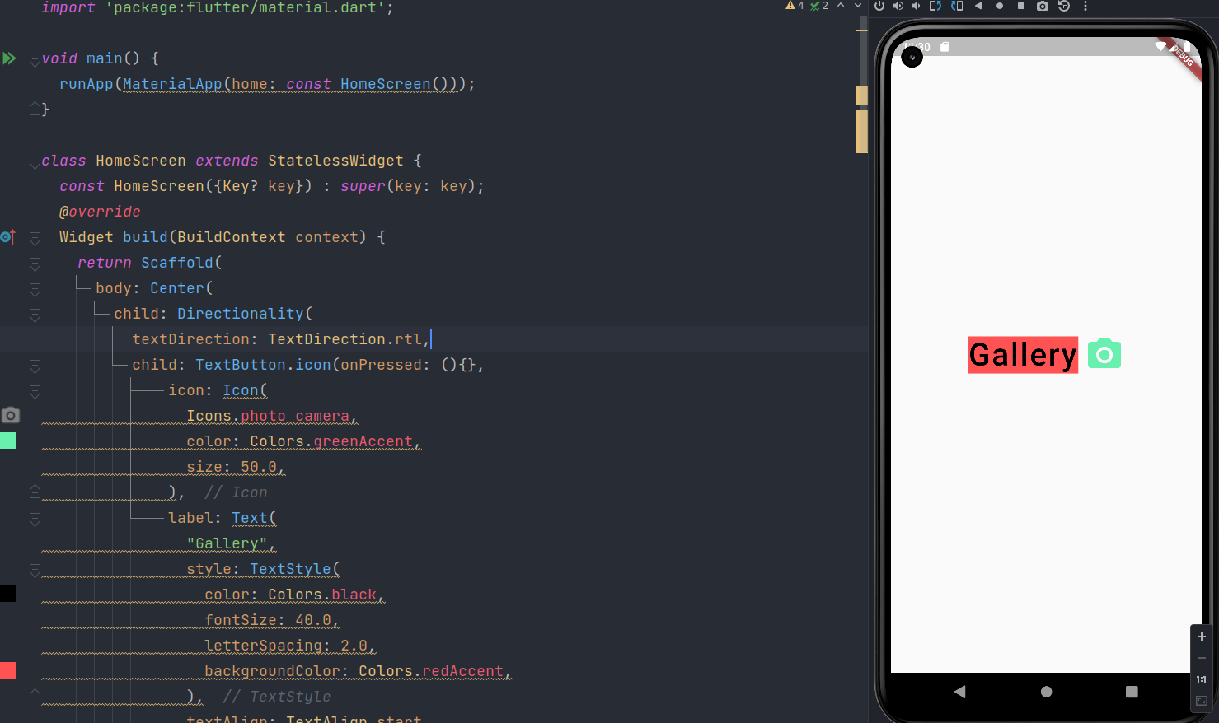

Containing class: **Directionality**

Creates a widget that determines the directionality of text and text-direction-sensitive render objects.

The textDirection and child arguments must not be null.

Containing class: TextDirection

Type: TextDirection

The text flows from right to left (e.g. Arabic, Hebrew).

**Final Code:**

**Main.dart**

*import* 'package:flutter/material.dart';  
  
void main() {  
 runApp(MaterialApp(home: *const* HomeScreen()));  
}  
  
class HomeScreen *extends* StatelessWidget {  
 *const* HomeScreen({Key? key}) : *super*(key: key);  
 *@override*  
Widget build(BuildContext context) {  
 *return* Scaffold(  
 body: Center(  
 child: Directionality(  
 textDirection: TextDirection.rtl,  
 child: TextButton.icon(onPressed: (){},  
 icon: Icon(  
 Icons.photo_camera,  
 color: Colors.greenAccent,  
 size: 50.0,  
 ),  
 label: Text(  
 "Gallery",  
 style: TextStyle(  
 color: Colors.black,  
 fontSize: 40.0,  
 letterSpacing: 2.0,  
 backgroundColor: Colors.redAccent,  
 ),  
 textAlign: TextAlign.start,  
 )),  
 ),  
 ),  
 );  
  
 *// body: Center(*  
 *// child: TextButton.icon(*  
 *// icon: Icon(*  
 *// Icons.photo_camera,*  
 *// color: Colors.greenAccent,*  
 *// size: 50.0,*  
 *// ),*  
 *// label: Text(*  
 *// "Gallery",*  
 *// style: TextStyle(*  
 *// color: Colors.black,*  
 *// fontSize: 40.0,*  
 *// letterSpacing: 2.0,*  
 *// backgroundColor: Colors.redAccent,*  
 *// ),*  
 *// textAlign: TextAlign.start,*  
 *// ),*  
 *// onPressed: () {},*  
 *// ),*  
 *// ));*  
}  
  
// class HomeScreen extends StatelessWidget {  
// const HomeScreen({Key? key}) : super(key: key);  
//  
// @override  
// Widget build(BuildContext context) {  
// return Scaffold(  
// body: Center(  
// child: IconButton(  
// icon: Icon(  
// Icons.mail_outline_sharp,  
// size: 30.0,  
// ),  
// tooltip: 'Send mail me',  
// onPressed: (){  
// print('On consol print');  
// },  
// ),  
// ),  
// );  
// }  
// }  
  
// class HomeScreen extends StatelessWidget {  
// const HomeScreen({Key? key}) : super(key: key);  
//  
// @override  
// Widget build(BuildContext context) {  
// return Scaffold(  
// body: Center(  
// child: FlatButton(  
// onPressed: (){  
// print('print on consol');  
// },  
// child: Text('Click me'),  
// color: Colors.blue,  
// ),  
// ),  
// );  
// }  
// }  
  
/*  
// class HomeScreen extends StatelessWidget {  
 // const HomeScreen({Key? key}) : super(key: key);  
 @override  
 Widget build(BuildContext context) {  
 return Scaffold(  
 appBar: AppBar(  
 title: Text('BUTTONS WIDGET APP'),  
 centerTitle: true,  
 backgroundColor: Colors.red[600],  
 ),  
 body: Center(  
 child: ElevatedButton(  
 child: Text('Button'),  
 onPressed: () {},  
 style: ElevatedButton.styleFrom(  
 primary: Colors.purple[800],  
 padding: EdgeInsets.symmetric(horizontal: 50, vertical: 20),  
 textStyle: TextStyle(fontSize: 40, fontWeight: FontWeight.bold)),  
 ),  
 ),  
 floatingActionButton: FloatingActionButton(  
 onPressed: () {},  
 child: Text('Click'),  
 backgroundColor: Colors.red[600],  
 ),  
 );  
 }  
 */  
  
/*  
 @override  
 Widget build(BuildContext context) {  
 return Scaffold(  
 appBar: AppBar(  
 title: Text(  
 'HELLO FLUTTER...MY FIRST APP'),  
 centerTitle: true,  
 backgroundColor: Colors.red[600],  
 ),  
 // body: Center(  
 // child: Image(  
 // image: AssetImage('assets/sub_assets/1.jpg'),  
 // ),  
 // ),  
  
 // body: Center(  
 // child: Icon(  
 // Icons.flutter_dash,  
 // color: Colors.amber,  
 // size: 80.0,  
 // ),  
 // ),  
  
 floatingActionButton: FloatingActionButton(  
 onPressed: (){},  
 child: Text('Click'),  
 backgroundColor: Colors.red[600],  
 ),  
  
 );  
 }  
 */  
  
}

**Github Link:**

[**https://github.com/GauravKaklotar/SDP/tree/master/Lab07/lab7_t1**](https://github.com/GauravKaklotar/SDP/tree/master/Lab07/lab7_t1)