**Name:** Kaklotar Gaurav Amarshibhai

**Subject:** SDP

**Batch:** A3

**Roll No:** CE053

**ID No:** 20CEUBG084

**Lab8 Tutorial-1**

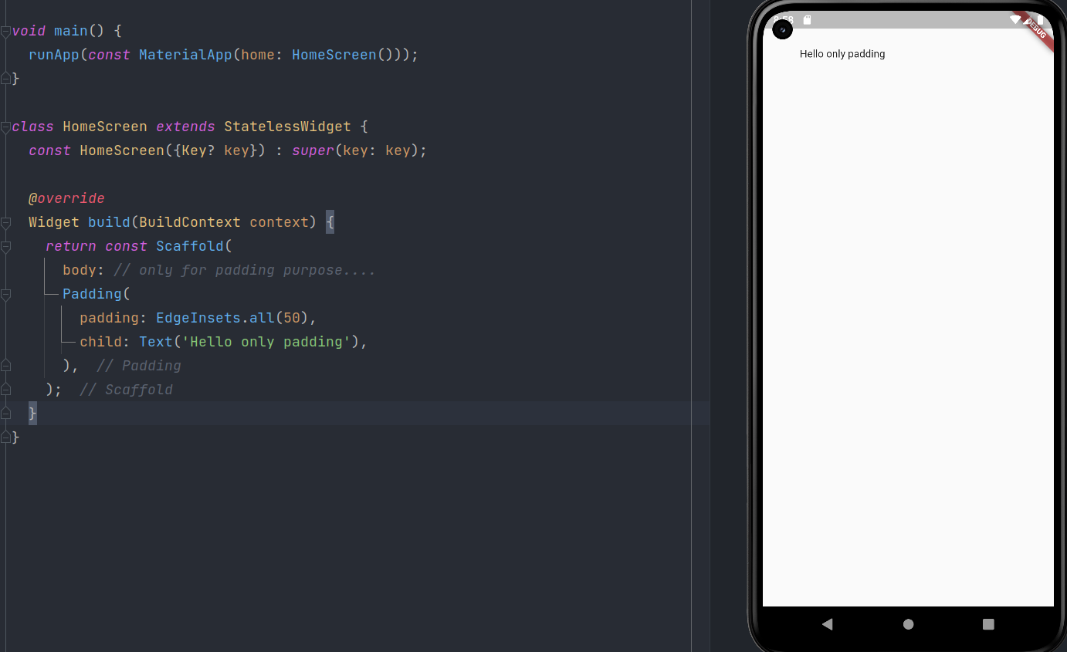

**Description:**

instead of container we can directly used the padding widget.

It can't support marging, color, etc.

If we want to use both and other we can use container widget.

Containing class: Padding

Creates a widget that insets its child.

The padding argument must not be null.

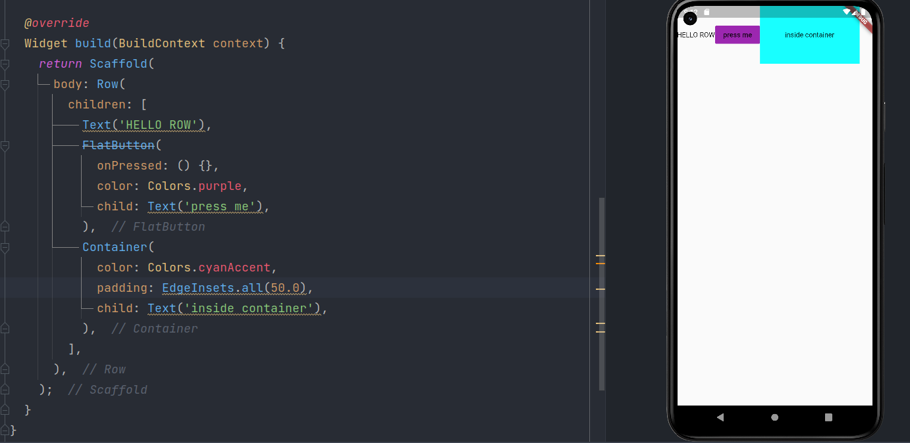

**Description:**

instead of ‘child’ – ‘children : []’ property is used

Type: List<Widget>

Creates a horizontal array of children.

The mainAxisAlignment, mainAxisSize, crossAxisAlignment, and verticalDirection arguments must not be null. If crossAxisAlignment is CrossAxisAlignment.baseline, then textBaseline must not be null.

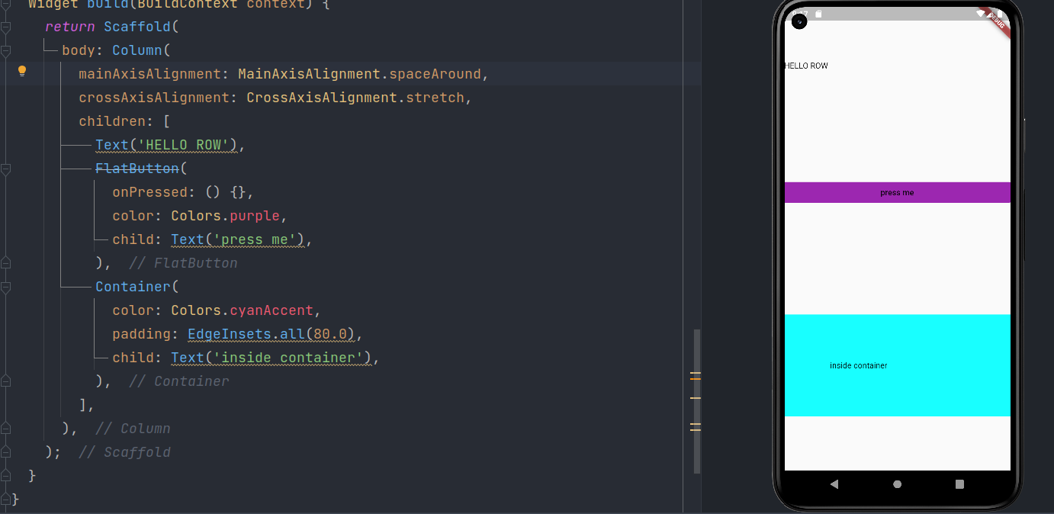

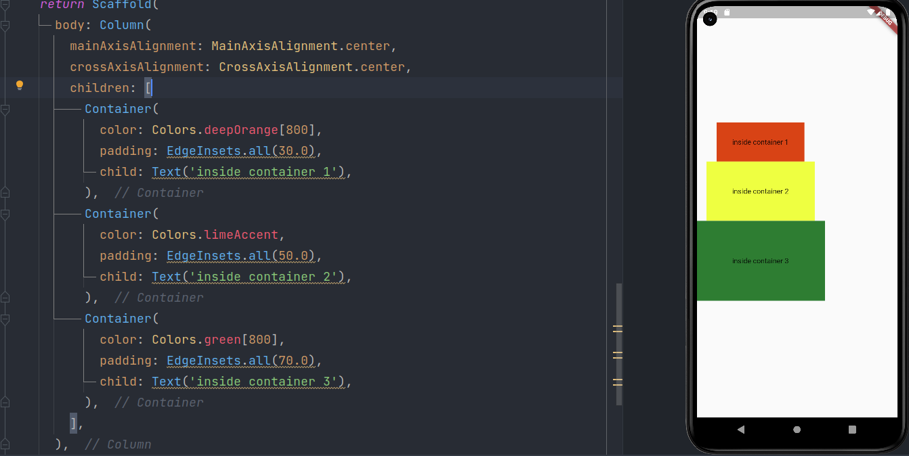

**Description:**

In Column widget It is totally opposites.

Vertical line becomes Main axis for Column and Horizontal line becomes Cross axis.

Containing class: Column

Creates a vertical array of children.

The mainAxisAlignment, mainAxisSize, crossAxisAlignment, and verticalDirection arguments must not be null. If crossAxisAlignment is CrossAxisAlignment.baseline, then textBaseline must not be null.

Test 1:

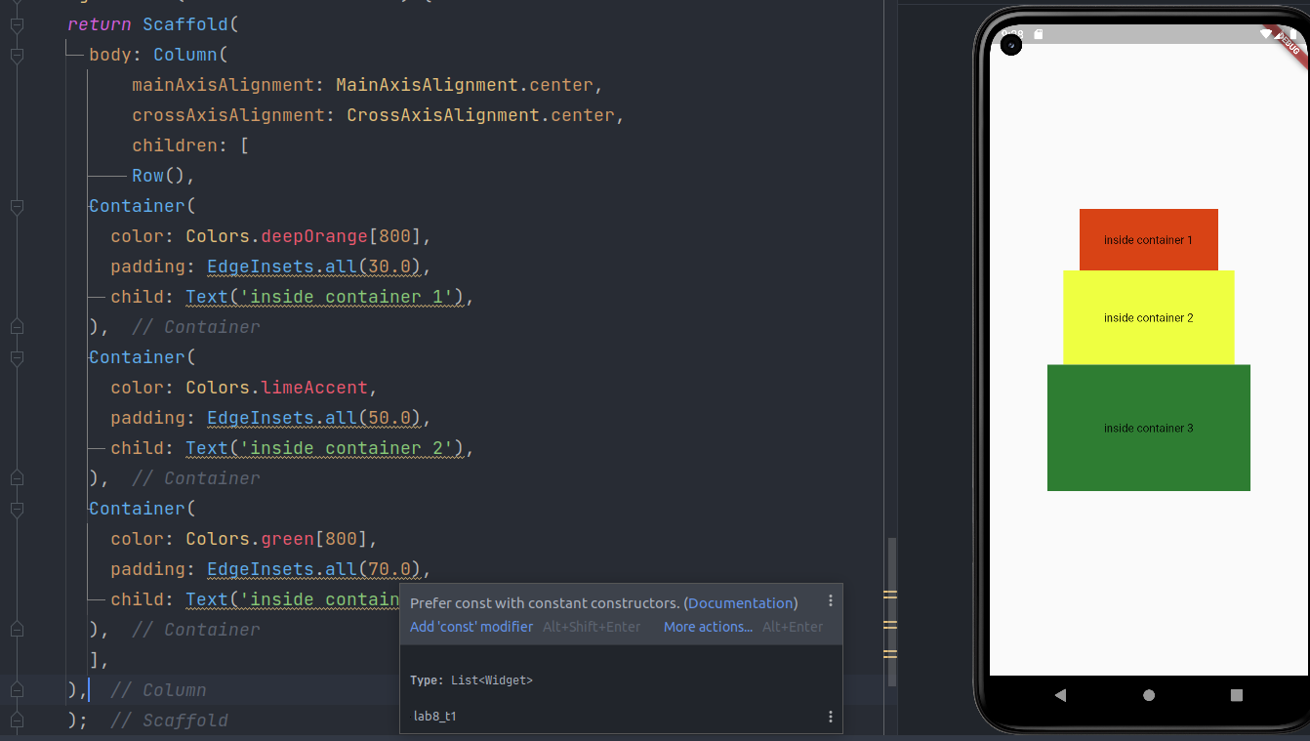

**row and column**

**If we complete Row() in above code:**

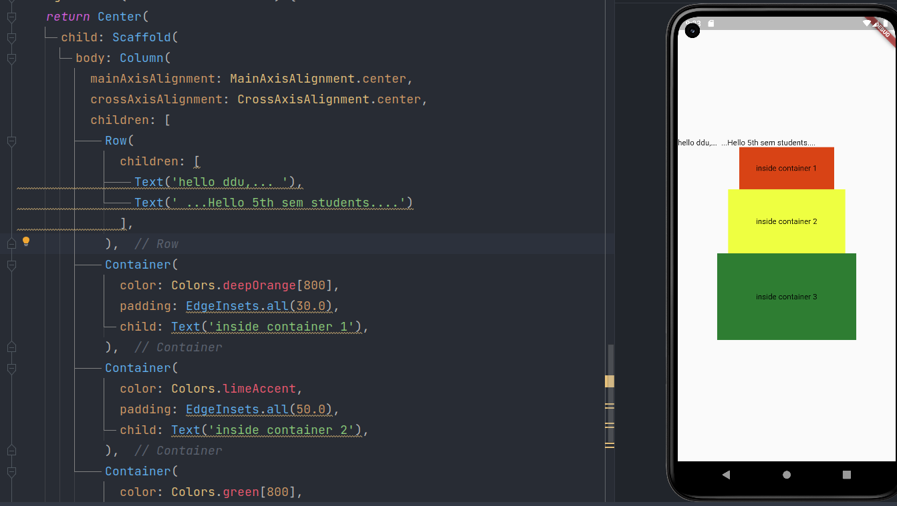

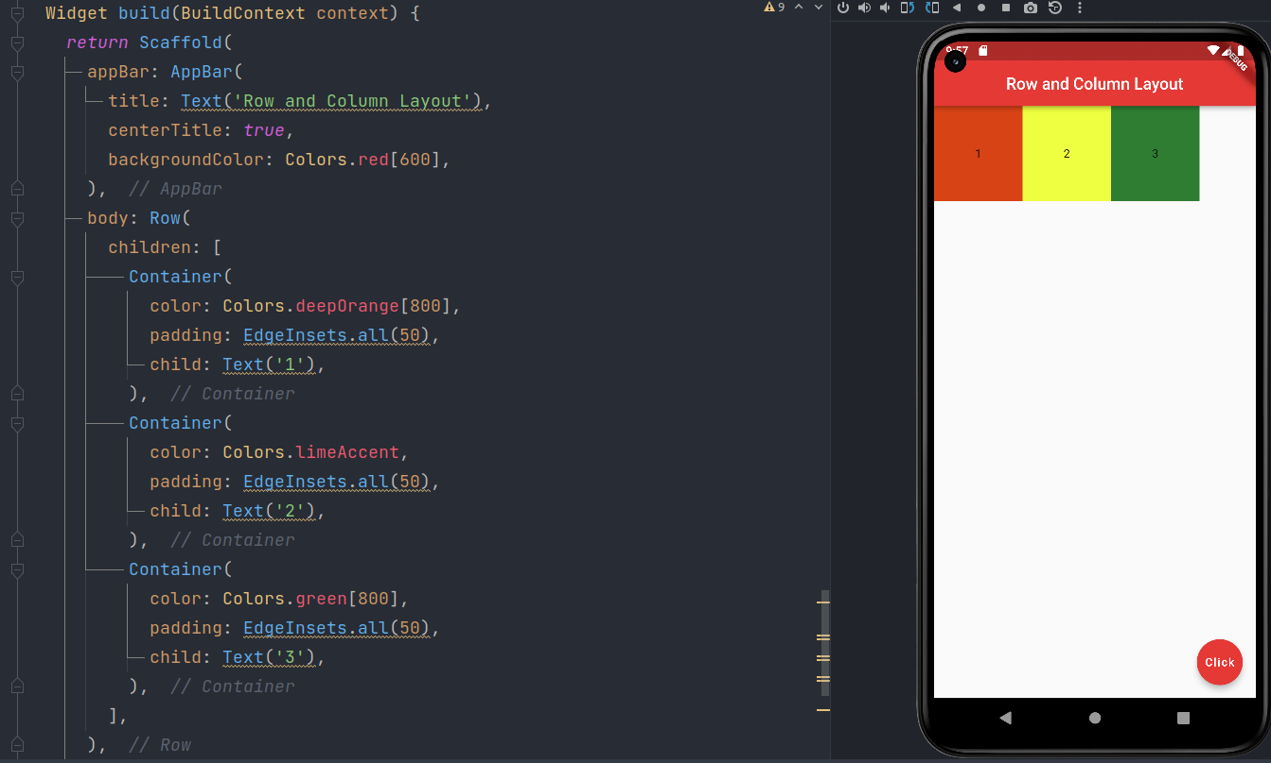

**Description:**

In Above code we are using Expanded and Flex widget.

Containing class: Expanded

Creates a widget that expands a child of a Row, Column, or Flex so that the child fills the available space along the flex widget's main axis.

Creates a flex layout.

The direction is required.

**Final Test:**

Update Pubsec.yaml file

assets:  
 - assets/images/

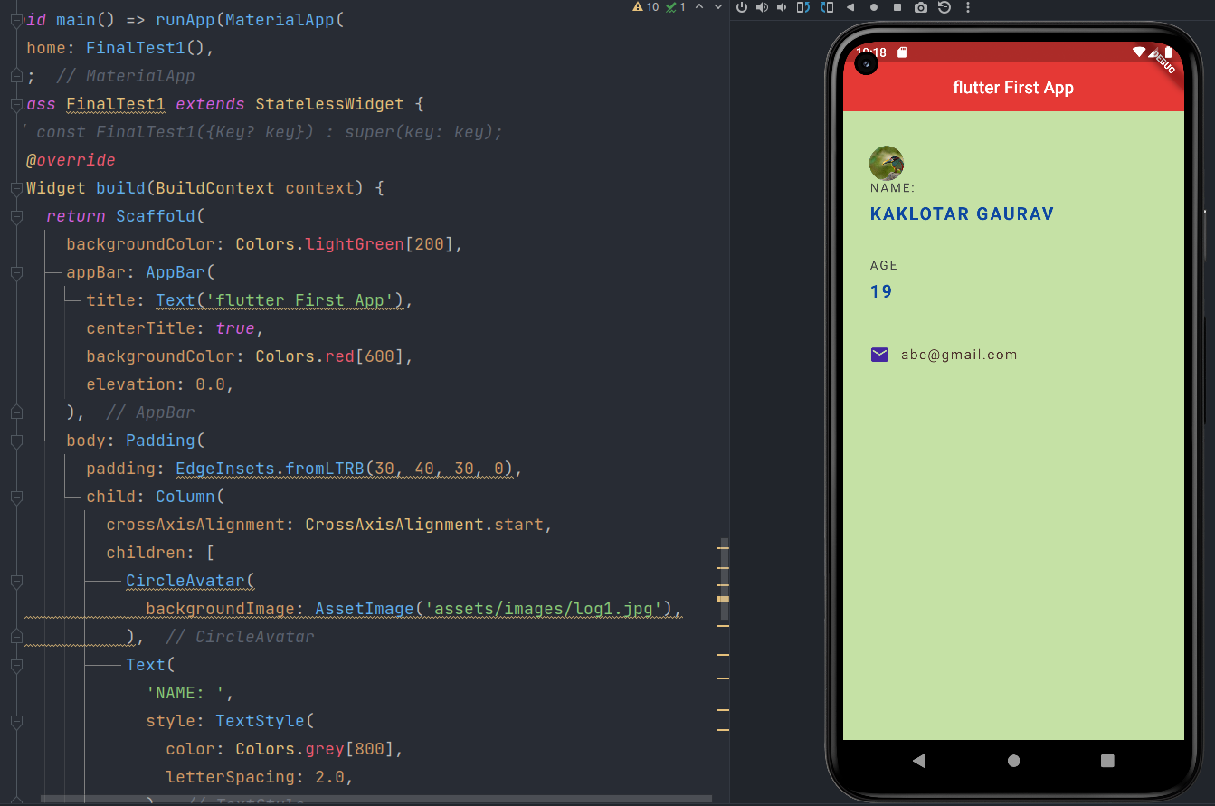

**Final Code:**

*import 'package:flutter/material.dart';*  
  
*// void main() {*  
*// runApp(const MaterialApp(home: HomeScreen()));*  
*// }*  
  
*/\**  
*class HomeScreen extends StatelessWidget {*  
 *const HomeScreen({Key? key}) : super(key: key);*  
  
 *@override*  
 *Widget build(BuildContext context) {*  
 *return const Scaffold(*  
 *body: // only for padding purpose....*  
 *Padding(*  
 *padding: EdgeInsets.all(50),*  
 *child: Text('Hello only padding'),*  
 *),*  
 *);*  
 *}*  
*}*  
*\*/*  
  
*/\**  
*class HomeScreen extends StatelessWidget {*  
 *const HomeScreen({Key? key}) : super(key: key);*  
  
 *@override*  
 *Widget build(BuildContext context) {*  
 *return Scaffold(*  
 *body: Row(*  
 *children: [*  
 *Text('HELLO ROW'),*  
 *FlatButton(*  
 *onPressed: () {},*  
 *color: Colors.purple,*  
 *child: Text('press me'),*  
 *),*  
 *Container(*  
 *color: Colors.cyanAccent,*  
 *padding: EdgeInsets.all(50.0),*  
 *child: Text('inside container'),*  
 *),*  
 *],*  
 *),*  
 *);*  
 *}*  
*}*  
*\*/*  
  
*/\**  
*class HomeScreen extends StatelessWidget {*  
 *const HomeScreen({Key? key}) : super(key: key);*  
  
 *@override*  
 *Widget build(BuildContext context) {*  
 *return Scaffold(*  
 *body: Column(*  
 *mainAxisAlignment: MainAxisAlignment.center,*  
 *crossAxisAlignment: CrossAxisAlignment.center,*  
 *children: [*  
 *Container(*  
 *color: Colors.deepOrange[800],*  
 *padding: EdgeInsets.all(30.0),*  
 *child: Text('inside container 1'),*  
 *),*  
 *Container(*  
 *color: Colors.limeAccent,*  
 *padding: EdgeInsets.all(50.0),*  
 *child: Text('inside container 2'),*  
 *),*  
 *Container(*  
 *color: Colors.green[800],*  
 *padding: EdgeInsets.all(70.0),*  
 *child: Text('inside container 3'),*  
 *),*  
 *],*  
 *),*  
 *);*  
 *}*  
*}*  
*\*/*  
  
  
*/\**  
*class HomeScreen extends StatelessWidget {*  
 *const HomeScreen({Key? key}) : super(key: key);*  
  
 *@override*  
 *Widget build(BuildContext context) {*  
 *return Center(*  
 *child: Scaffold(*  
 *body: Column(*  
 *mainAxisAlignment: MainAxisAlignment.center,*  
 *crossAxisAlignment: CrossAxisAlignment.center,*  
 *children: [*  
 *Row(*  
 *children: [*  
 *Text('hello ddu,... '),*  
 *Text(' ...Hello 5th sem students....')*  
 *],*  
 *),*  
 *Padding(*  
 *padding: const EdgeInsets.all(8.0),*  
 *child: Container(*  
 *color: Colors.deepOrange[800],*  
 *padding: EdgeInsets.all(30.0),*  
 *child: Text('inside container 1'),*  
 *),*  
 *),*  
 *Container(*  
 *color: Colors.limeAccent,*  
 *padding: EdgeInsets.all(50.0),*  
 *child: Text('inside container 2'),*  
 *),*  
 *Container(*  
 *color: Colors.green[800],*  
 *padding: EdgeInsets.all(70.0),*  
 *child: Text('inside container 3'),*  
 *),*  
 *],*  
 *),*  
  
 *floatingActionButton: FloatingActionButton(*  
 *onPressed: (){},*  
 *child: Text('Click'),*  
 *backgroundColor: Colors.red[600],*  
 *),*  
 *),*  
 *);*  
 *}*  
*}*  
 *\*/*  
  
  
*/\**  
*class HomeScreen extends StatelessWidget {*  
 *const HomeScreen({Key? key}) : super(key: key);*  
  
 *@override*  
 *Widget build(BuildContext context) {*  
 *return Scaffold(*  
 *appBar: AppBar(*  
 *title: Text('Row and Column Layout'),*  
 *centerTitle: true,*  
 *backgroundColor: Colors.red[600],*  
 *),*  
 *body: Row(*  
 *children: [*  
 *Expanded(*  
 *child: Container(*  
 *color: Colors.deepOrange[800],*  
 *padding: EdgeInsets.all(50),*  
 *child: Text('1'),*  
 *),*  
 *),*  
 *Container(*  
 *color: Colors.limeAccent,*  
 *padding: EdgeInsets.all(50),*  
 *child: Text('2'),*  
 *),*  
 *Container(*  
 *color: Colors.green[800],*  
 *padding: EdgeInsets.all(50),*  
 *child: Text('3'),*  
 *),*  
 *],*  
 *),*  
  
 *floatingActionButton: FloatingActionButton(*  
 *onPressed: (){},*  
 *child: Text('Click'),*  
 *backgroundColor: Colors.red[600],*  
 *),*  
 *);*  
 *}*  
*}*  
 *\*/*  
  
*// import* 'package:flutter/material.dart';  
void main() => runApp(MaterialApp(  
 home: FinalTest1(),  
));  
class FinalTest1 *extends* StatelessWidget {  
// const FinalTest1({Key? key}) : super(key: key);  
 *@override*  
Widget build(BuildContext context) {  
 *return* Scaffold(  
 backgroundColor: Colors.lightGreen[200],  
 appBar: AppBar(  
 title: Text('flutter First App'),  
 centerTitle: *true*,  
 backgroundColor: Colors.red[600],  
 elevation: 0.0,  
 ),  
 body: Padding(  
 padding: EdgeInsets.fromLTRB(30, 40, 30, 0),  
 child: Column(  
 crossAxisAlignment: CrossAxisAlignment.start,  
 children: [  
 CircleAvatar(  
 backgroundImage: AssetImage('assets/images/log1.jpg'),  
 ),  
 Text(  
 'NAME: ',  
 style: TextStyle(  
 color: Colors.grey[800],  
 letterSpacing: 2.0,  
 ),  
 ),  
 SizedBox(height: 10),  
 Text(  
 'KAKLOTAR GAURAV',  
 style: TextStyle(  
 color: Colors.blue[900],  
 letterSpacing: 2.0,  
 fontWeight: FontWeight.bold,  
 fontSize: 20.0,  
 ),  
 ),  
 SizedBox(height: 40),  
 Text(  
 'AGE',  
 style: TextStyle(  
 color: Colors.grey[800],  
 letterSpacing: 2.0,  
 ),  
 ),  
 SizedBox(height: 10),  
 Text(  
  
 '19',  
 style: TextStyle(  
 color: Colors.blue[900],  
 letterSpacing: 2.0,  
 fontWeight: FontWeight.bold,  
 fontSize: 20.0,  
 ),  
 ),  
 SizedBox(height: 50),  
 Row(  
 children: [  
 Icon(  
 Icons.email_rounded,  
 color: Colors.deepPurple[800],  
 ),  
 SizedBox(width: 12.0),  
 Text(  
 'abc@gmail.com',  
  
 style: TextStyle(  
  
 color: Colors.brown[800],  
 fontSize: 16.0,  
 letterSpacing: 1.5,  
  
 ),  
 )  
 ],  
 )  
 ],  
 ),  
 ),  
 );  
 }  
}

**Github Link:**

[**https://github.com/GauravKaklotar/SDP/tree/master/Lab08**](https://github.com/GauravKaklotar/SDP/tree/master/Lab08)