**Name:** Kaklotar Gaurav Amarshibhai

**Subject:** SDP

**Batch:** A3

**Roll No:** CE053

**ID No:** 20CEUBG084

**Lab8 Tutorial-2**

**From Lab8 Tut1**

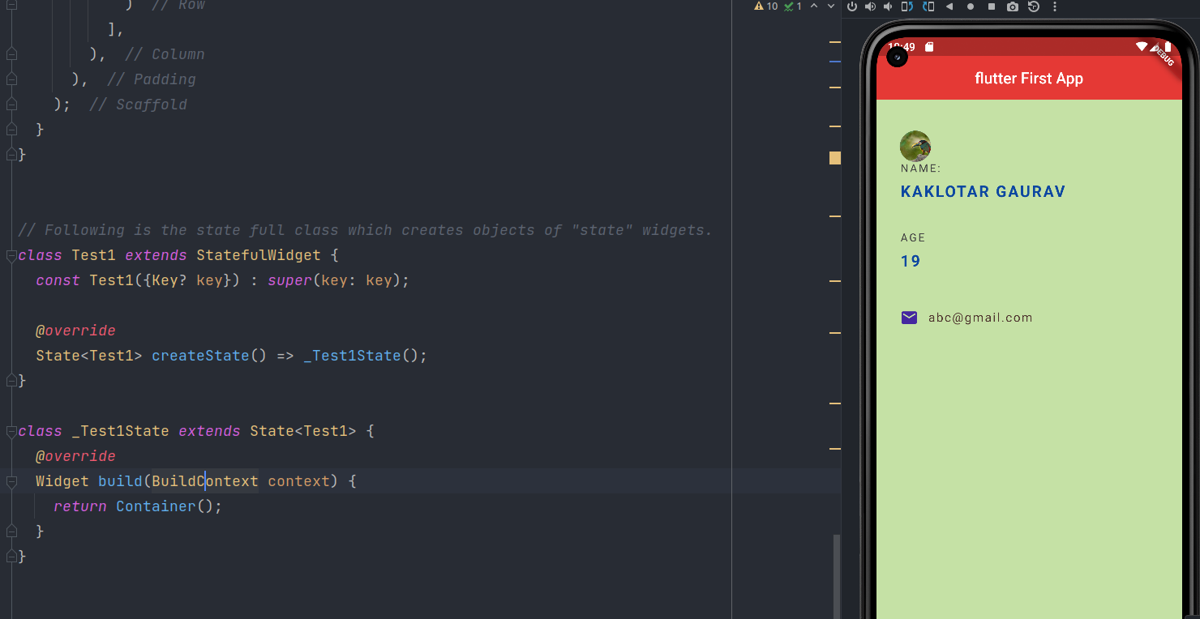

**Description:**

**StatefulWidget**

abstract class StatefulWidget extends Widget

A widget that has mutable state.

StatefulWidget instances themselves are immutable and store their mutable state either in separate State objects that are created by the createState method, or in objects to which that State subscribes, for example Stream or ChangeNotifier objects, to which references are stored in final fields on the StatefulWidget itself.

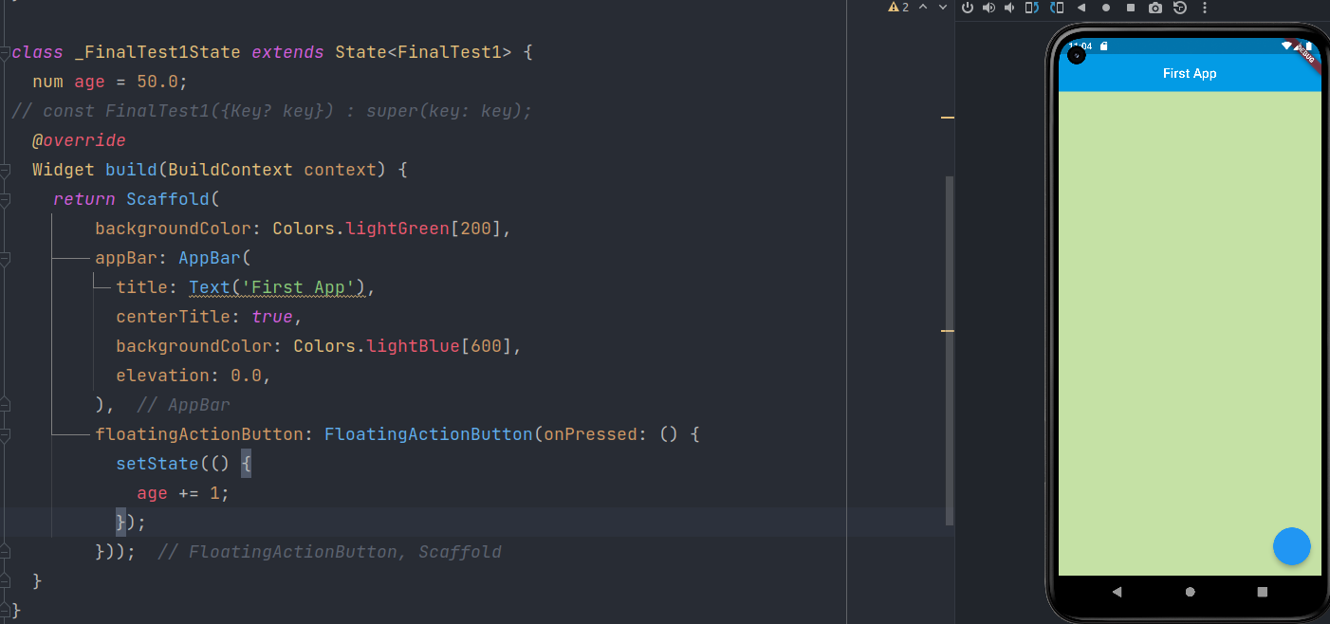

Notify the framework that the internal state of this object has changed.

Whenever you change the internal state of a State object, make the change in a function that you pass to setState:

setState(() { _myState = newValue; });

The provided callback is immediately called synchronously. It must not return a future (the callback cannot be async), since then it would be unclear when the state was actually being set.

Minus Sign can be obtain with Icons.remove.

**Code Test:**

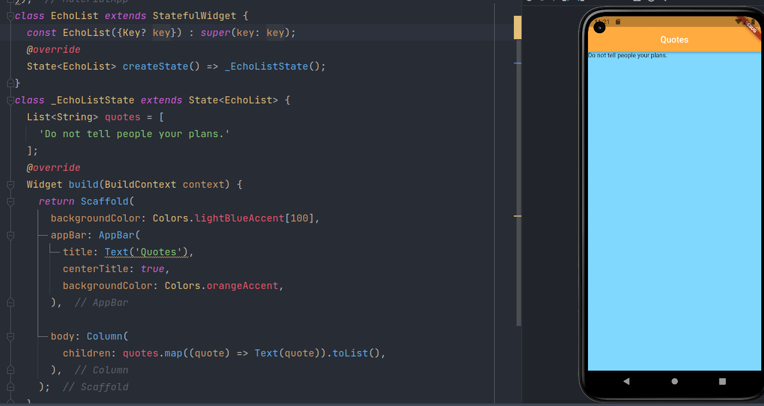

Here we are just creating simple string List name quotes and append one quotes to List.

Let’s Work with some custom class...

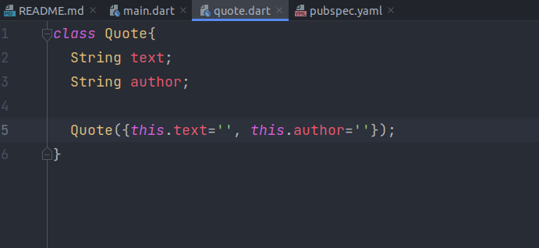

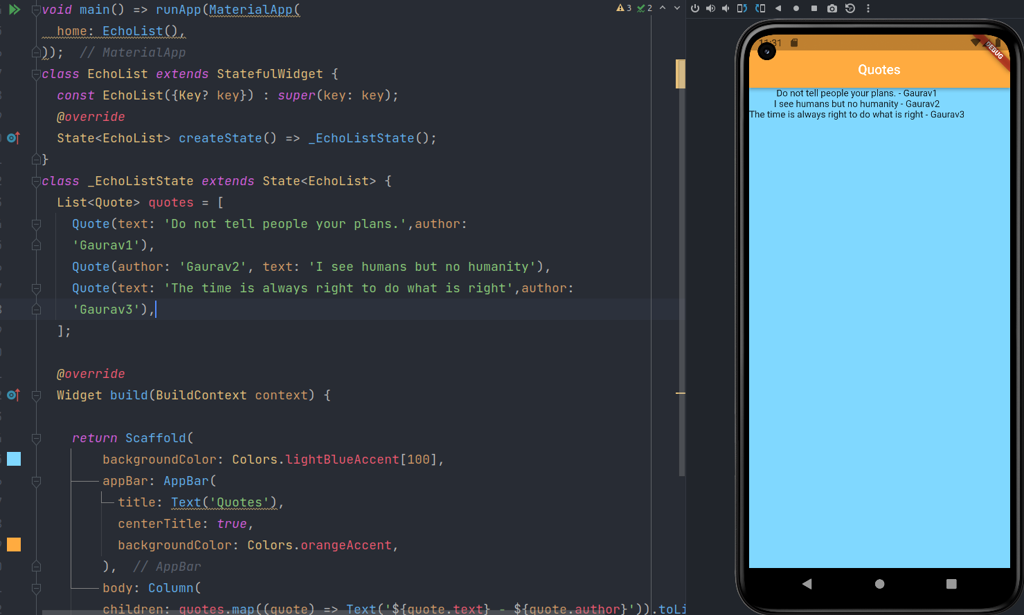

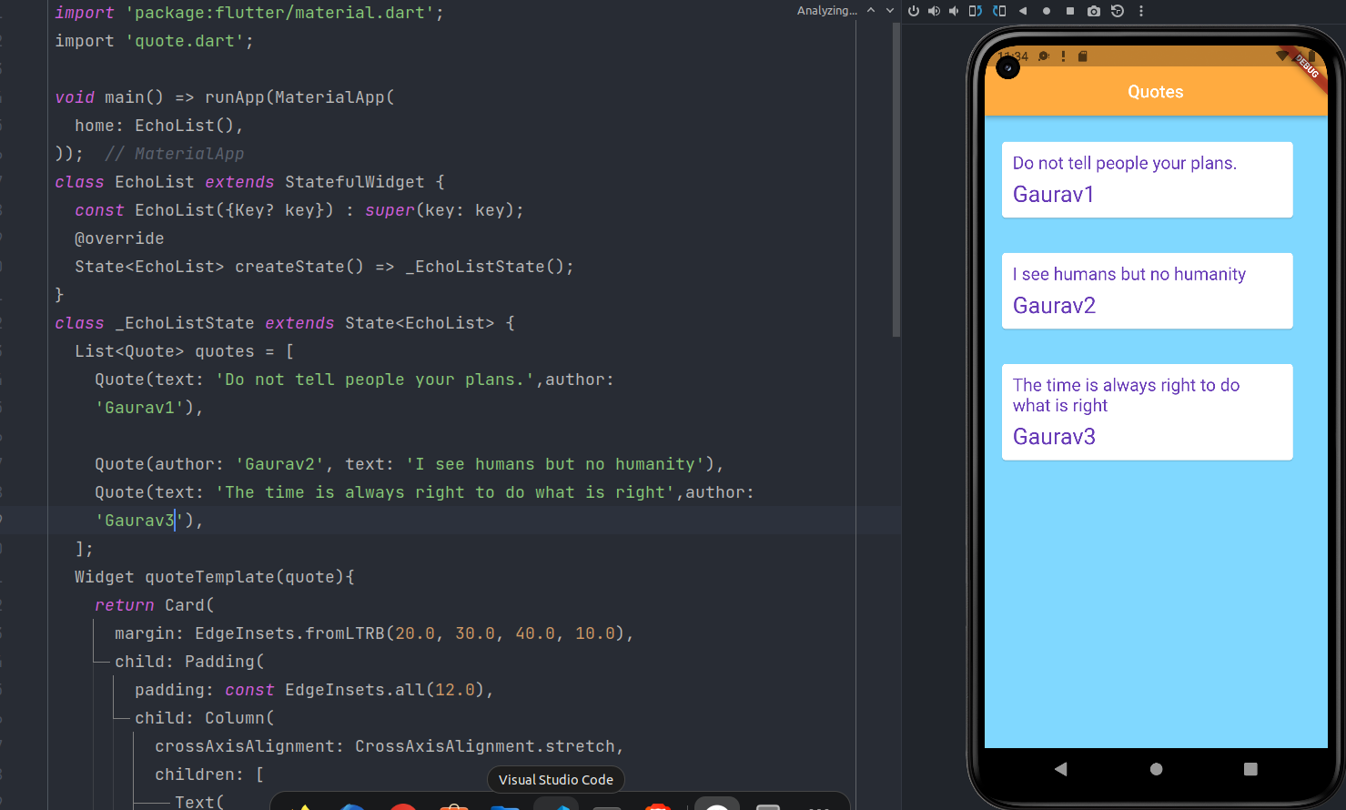

**Description:**

Containing class: Card

Creates a material design card.

The elevation must be null or non-negative. The borderOnForeground must not be null.

Card widget in flutter is a sheet of Material used to represent all the similar information in a single block.

For example, a card can be used to design an album cover as it will represent all the songs that belong to that album. A card will have rounded corners and is elevated by default.

**Final Code:**

*import* 'package:flutter/material.dart';  
import 'quote.dart';  
  
void main() => runApp(MaterialApp(  
 home: EchoList(),  
 ));  
  
class EchoList *extends* StatefulWidget {  
 *const* EchoList({Key? key}) : *super*(key: key);  
 *@override*  
State<EchoList> createState() => _EchoListState();  
}  
  
class _EchoListState *extends* State<EchoList> {  
 List<Quote> quotes = [  
 Quote(text: 'Do not tell people your plans.', author: 'Gaurav1'),  
 Quote(author: 'Gaurav2', text: 'I see humans but no humanity'),  
 Quote(  
 text: 'The time is always right to do what is right',  
 author: 'Gaurav3'),  
 ];  
 Widget quoteTemplate(quote) {  
 *return* Card(  
 margin: EdgeInsets.fromLTRB(20.0, 30.0, 40.0, 10.0),  
 child: Padding(  
 padding: *const* EdgeInsets.all(12.0),  
 child: Column(  
 crossAxisAlignment: CrossAxisAlignment.stretch,  
 children: [  
 Text(  
 quote.text,  
 style: TextStyle(  
 fontSize: 20,  
 color: Colors.deepPurple,  
 ),  
 ),  
 SizedBox(height: 10),  
 Text(  
 quote.author,  
 style: TextStyle(  
 fontSize: 26,  
 color: Colors.deepPurple,  
 ),  
 ),  
 ],  
 ),  
 ),  
 );  
 }  
  
 *@override*  
Widget build(BuildContext context) {  
 *return* Scaffold(  
 backgroundColor: Colors.lightBlueAccent[100],  
 appBar: AppBar(  
 title: Text('Quotes'),  
 centerTitle: *true*,  
 backgroundColor: Colors.orangeAccent,  
 ),  
 body: Column(  
 children: quotes.map((quote) => quoteTemplate(quote)).toList(),  
 ),  
 );  
 }  
}

**Github Link:**  
[**https://github.com/GauravKaklotar/SDP/tree/master/Lab08**](https://github.com/GauravKaklotar/SDP/tree/master/Lab08)