**Name:** Kaklotar Gaurav Amarshibhai

**Subject:** SDP

**Batch:** A3

**Roll No:** CE053

**ID No:** 20CEUBG084

**Lab9 Tutorial-1**

**Extracting Widget card From Previous code:**

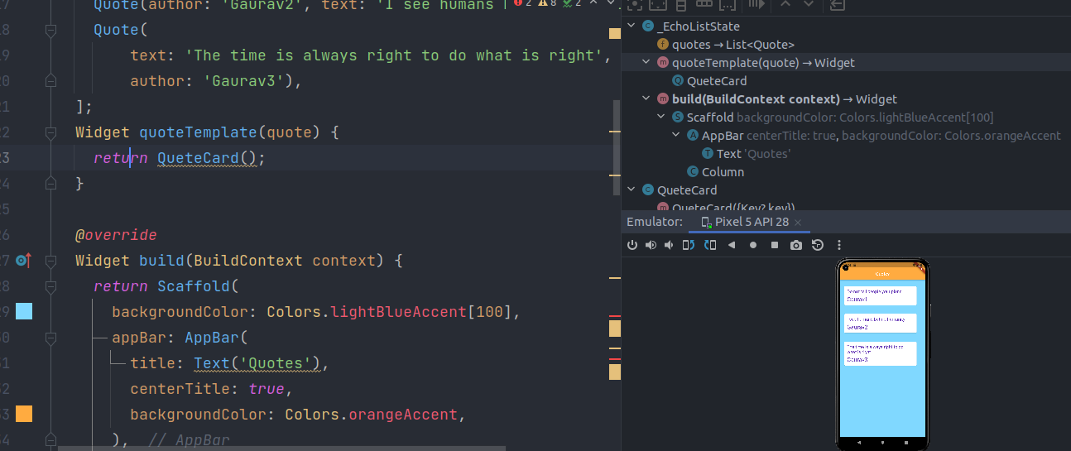

Make changes in “QuoteCard” constructor.

Now no need to call function. Because we can now call object directly.

Output is same as Before.

The FlatButton , RaisedButton and OutlineButton widgets have been replaced

by TextButton , ElevatedButton , and OutlinedButton respectively.

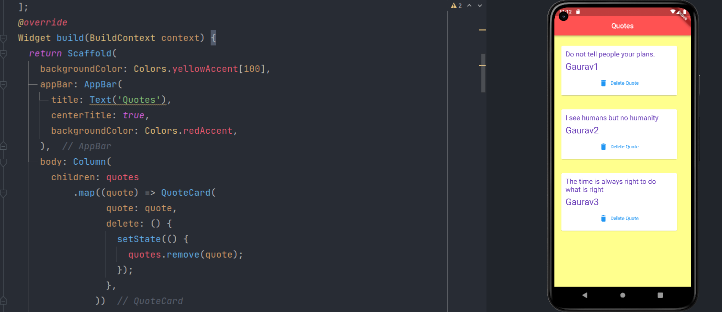

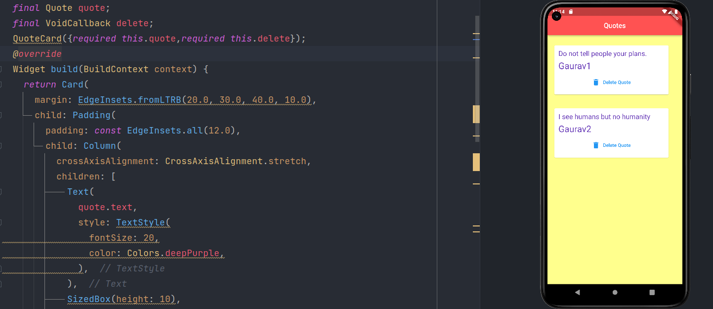

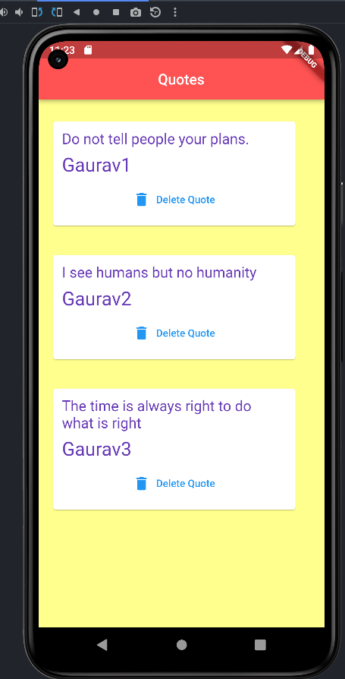

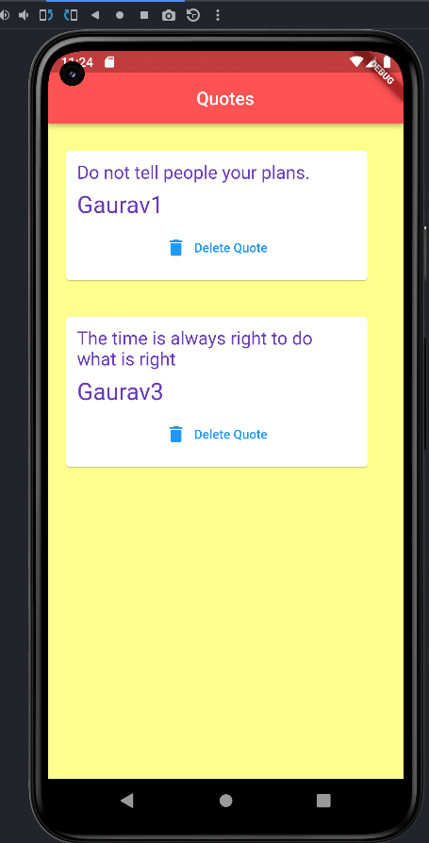

When we are click on Delete quote that particular quote will be deleted.

Here FlateButton widgets is replaced with TextButton on quote_card.dart file.

**FInal Code:**

**main.dart**

*import* 'package:flutter/material.dart';  
// import 'package:lab9_t1/quote.dart';  
import 'quote.dart';  
import 'quote_card.dart';  
  
void main() => runApp(MaterialApp(  
 home: EchoList(),  
 ));  
  
class EchoList *extends* StatefulWidget {  
 *@override*  
State<EchoList> createState() => _EchoListState();  
}  
  
class _EchoListState *extends* State<EchoList> {  
 List<Quote> quotes = [  
 Quote(text: 'Do not tell people your plans.', author: 'Gaurav1'),  
 Quote(author: 'Gaurav2', text: 'I see humans but no humanity'),  
 Quote(  
 text: 'The time is always right to do what is right',  
 author: 'Gaurav3'),  
 ];  
 *@override*  
Widget build(BuildContext context) {  
 *return* Scaffold(  
 backgroundColor: Colors.yellowAccent[100],  
 appBar: AppBar(  
 title: Text('Quotes'),  
 centerTitle: *true*,  
 backgroundColor: Colors.redAccent,  
 ),  
 body: Column(  
 children: quotes  
 .map((quote) => QuoteCard(  
 quote: quote,  
 delete: () {  
 setState(() {  
 quotes.remove(quote);  
 });  
 },  
 ))  
 .toList(),  
 ),  
 );  
 }  
}  
  
// void main() => runApp(MaterialApp(  
// home: EchoList(),  
// ));  
  
/*  
class EchoList extends StatefulWidget {  
 const EchoList({Key? key}) : super(key: key);  
 @override  
 State<EchoList> createState() => _EchoListState();  
}  
  
class _EchoListState extends State<EchoList> {  
 List<Quote> quotes = [  
 Quote(text: 'Do not tell people your plans.', author: 'Gaurav1'),  
 Quote(author: 'Gaurav2', text: 'I see humans but no humanity'),  
 Quote(  
 text: 'The time is always right to do what is right',  
 author: 'Gaurav3'),  
 ];  
 Widget quoteTemplate(quote) {  
 return QuoteCard(quote: quote,);  
 }  
  
 @override  
 Widget build(BuildContext context) {  
 return Scaffold(  
 backgroundColor: Colors.lightBlueAccent[100],  
 appBar: AppBar(  
 title: Text('Quotes'),  
 centerTitle: true,  
 backgroundColor: Colors.orangeAccent,  
 ),  
 body: Column(  
 children: quotes.map((quote) => quoteTemplate(quote)).toList(),  
 ),  
 );  
 }  
}  
 */  
  
/*  
class QuoteCard extends StatelessWidget {  
 // const QuoteCard({  
 // Key? key,  
 // }) : super(key: key);  
  
 @override  
 Widget build(BuildContext context) {  
 return Card(  
 margin: EdgeInsets.fromLTRB(20.0, 30.0, 40.0, 10.0),  
 child: Padding(  
 padding: const EdgeInsets.all(12.0),  
 child: Column(  
 crossAxisAlignment: CrossAxisAlignment.stretch,  
 children: [  
 Text(  
 quote.text,  
 style: TextStyle(  
 fontSize: 20,  
 color: Colors.deepPurple,  
 ),  
 ),  
 SizedBox(height: 10),  
 Text(  
 quote.author,  
 style: TextStyle(  
 fontSize: 26,  
 color: Colors.deepPurple,  
 ),  
 ),  
 ],  
 ),  
 ),  
 );  
 }  
}  
*/  
  
/*  
class QuoteCard extends StatelessWidget {  
 // const QuoteCard({Key? key}) : super(key: key);  
 final Quote quote;  
 QuoteCard({required this.quote});  
  
 @override  
 Widget build(BuildContext context) {  
 return Scaffold(  
 backgroundColor: Colors.lightBlueAccent[100],  
 appBar: AppBar(  
 title: Text('Quotes'),  
 centerTitle: true,  
 backgroundColor: Colors.orangeAccent,  
 ),  
 body: Column(  
 children: quotes.map((quote) => QuoteCard(quote: quote)).toList(),  
 ),  
 );  
 }  
}  
 */

**Quote_card.dart**

*import* 'package:flutter/material.dart';  
import 'package:lab9_t1/quote.dart';  
class QuoteCard *extends* StatelessWidget {  
  
 *final* Quote quote;  
 *final* VoidCallback delete;  
 QuoteCard({*required this*.quote,*required this*.delete});  
 *@override*  
Widget build(BuildContext context) {  
 *return* Card(  
 margin: EdgeInsets.fromLTRB(20.0, 30.0, 40.0, 10.0),  
 child: Padding(  
 padding: *const* EdgeInsets.all(12.0),  
 child: Column(  
 crossAxisAlignment: CrossAxisAlignment.stretch,  
 children: [  
 Text(  
 quote.text,  
 style: TextStyle(  
 fontSize: 20,  
 color: Colors.deepPurple,  
 ),  
 ),  
 SizedBox(height: 10),  
 Text(  
 quote.author,  
 style: TextStyle(  
 fontSize: 26,  
 color: Colors.deepPurple,  
 ),  
 ),  
 SizedBox(height: 8.0,),  
 TextButton.icon(  
/*  
our data doesn't exist inside this stateless widget class..  
data are in 'main.dart' file. ..  
*/  
 onPressed: delete,  
 icon: Icon(Icons.delete),  
 label: Text('Delete Quote'),  
 ),  
 ],  
 ),  
 ),  
 );  
 }  
}

**Quote.dart**

*class* Quote{  
 String text;  
 String author;  
  
 Quote({*this*.text='', *this*.author=''});  
}

**Github LInk:**

[**https://github.com/GauravKaklotar/SDP/tree/master/Lab09**](https://github.com/GauravKaklotar/SDP/tree/master/Lab09)