**Name:** Kaklotar Gaurav Amarshibhai

**Subject:** SDP

**Batch:** A3

**Roll No:** CE053

**ID No:** 20CEUBG084

**Lab9 Tutorial-2**

In home.dart file we are using StatefulWidget.

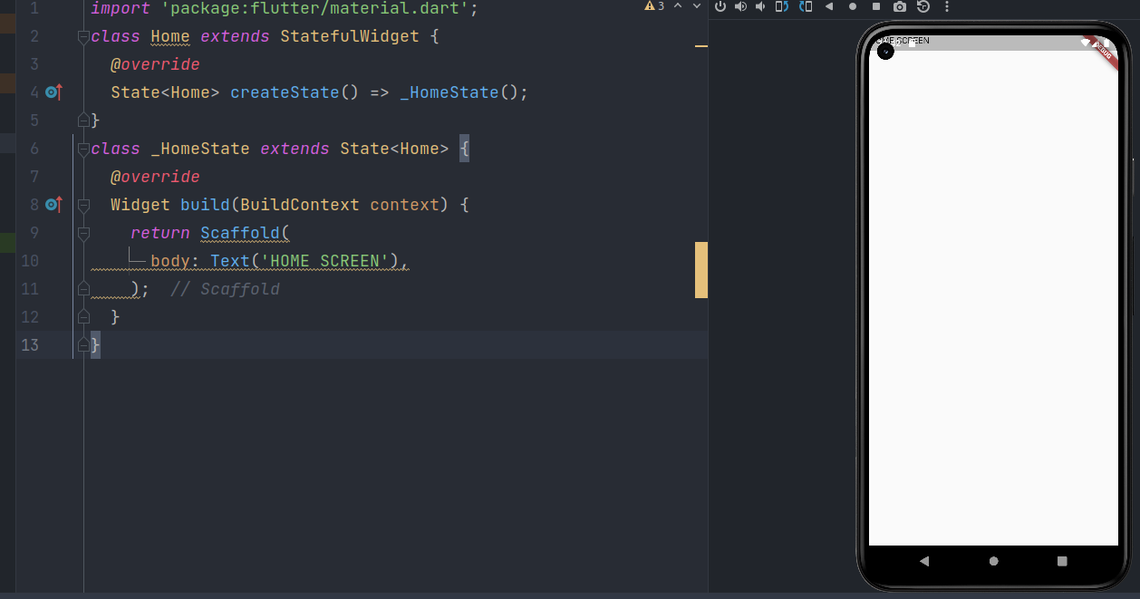

body: SafeArea(child: Text('HOME SCREEN')),

Using SafeArea HOME SCREEN text get some padding.

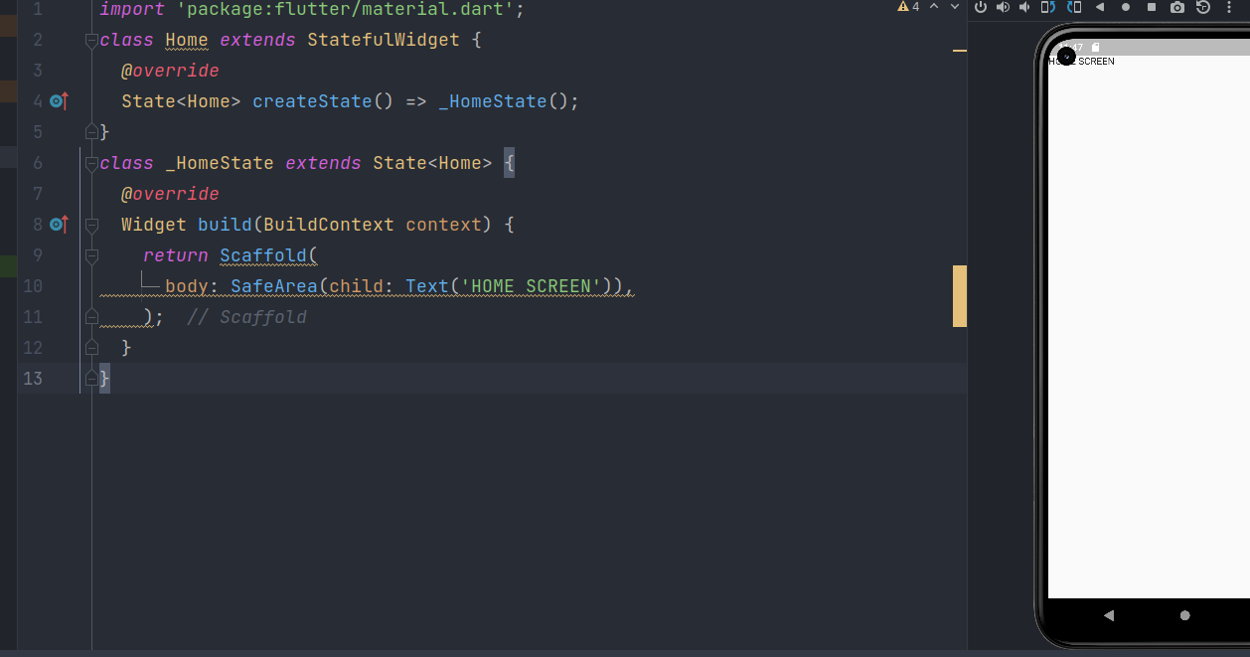

**Choose_location.dart**

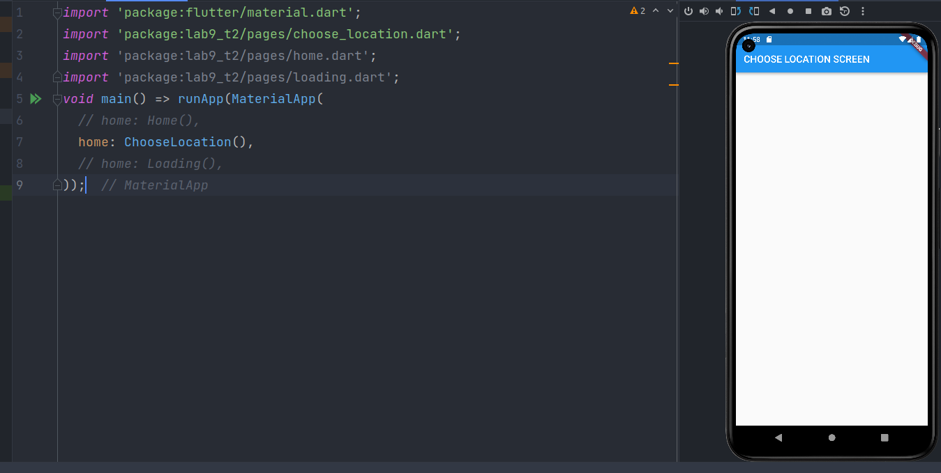

**Loading.dart**

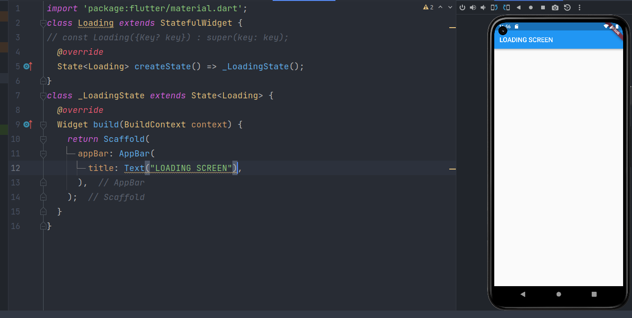

If the app only has one page, then you can specify it using home instead.

If home is specified, then it implies an entry in this table for the

Navigator.defaultRouteName route (/), and it is an error to redundantly provide such a

route in the routes table.

If a route is requested that is not specified in this table (or by home), then the

onGenerateRoute callback is called to build the page instead.

The Navigator is only built if routes are provided (either via home, routes,

onGenerateRoute, or onUnknownRoute); if they are not, builder must not be null.

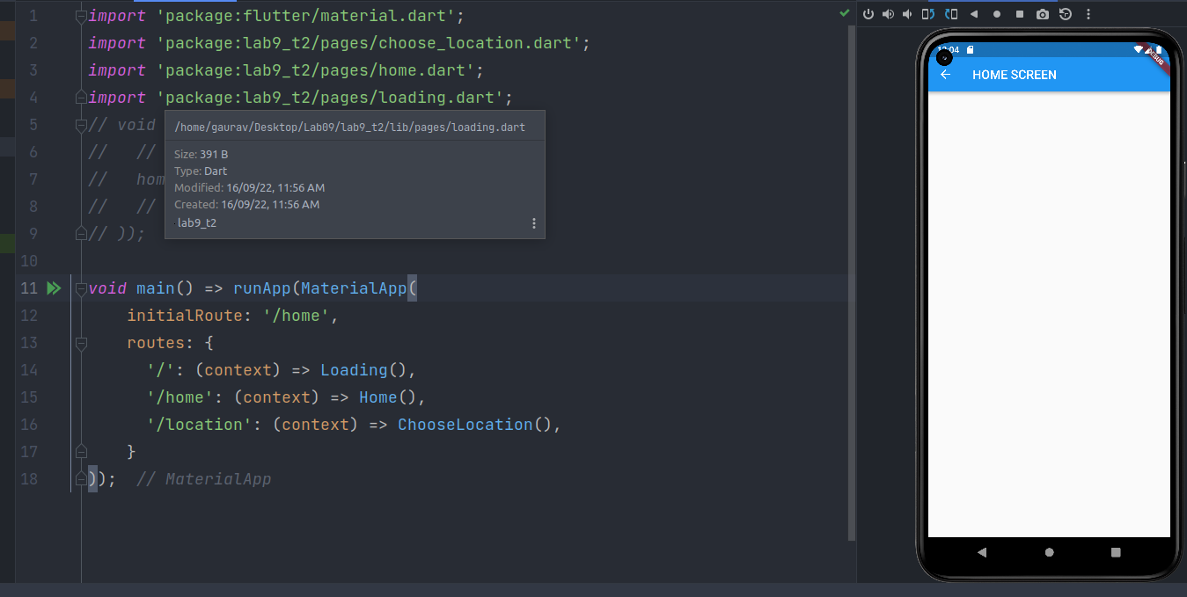

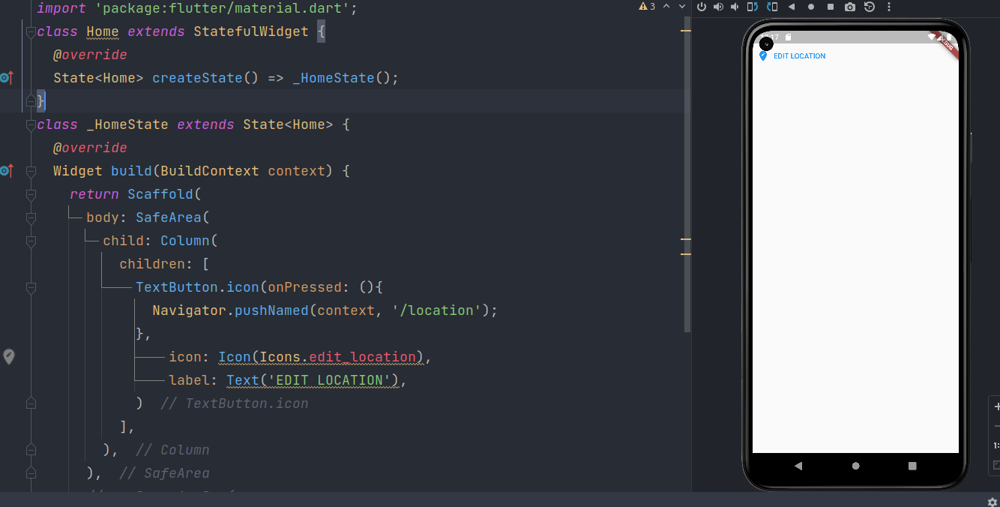

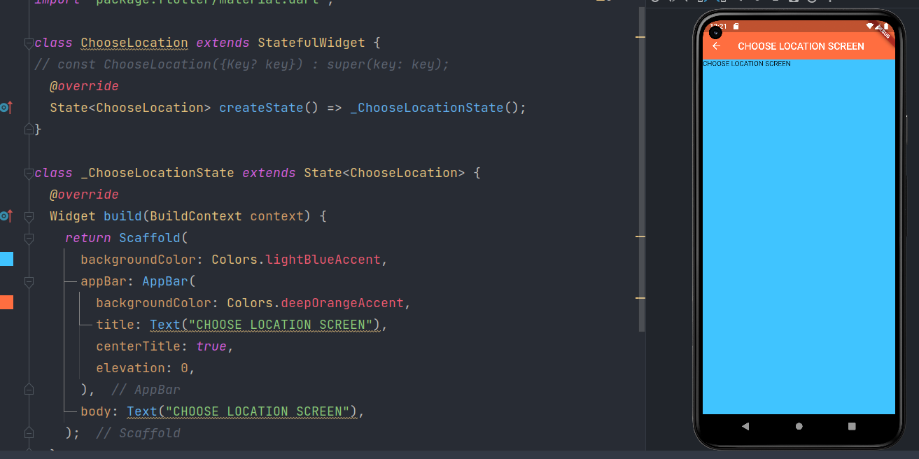

**Final Code:**

**Main.dart**

*import* 'package:flutter/material.dart';  
import 'package:lab9_t2/pages/choose_location.dart';  
import 'package:lab9_t2/pages/home.dart';  
import 'package:lab9_t2/pages/loading.dart';  
// void main() => runApp(MaterialApp(  
// // home: Home(),  
// home: ChooseLocation(),  
// // home: Loading(),  
// ));  
  
void main() => runApp(MaterialApp(  
 initialRoute: '/home',  
 routes: {  
 '/': (context) => Loading(),  
 '/home': (context) => Home(),  
 '/location': (context) => ChooseLocation(),  
 }  
));

**Home.dart**

*import* 'package:flutter/material.dart';  
class Home *extends* StatefulWidget {  
 *@override*  
State<Home> createState() => _HomeState();  
}  
class _HomeState *extends* State<Home> {  
 *@override*  
Widget build(BuildContext context) {  
 *return* Scaffold(  
 body: SafeArea(  
 child: Column(  
 children: [  
 TextButton.icon(onPressed: (){  
 Navigator.pushNamed(context, '/location');  
 },  
 icon: Icon(Icons.edit_location),  
 label: Text('EDIT LOCATION'),  
 )  
 ],  
 ),  
 ),  
 *// appBar: AppBar(*  
 *// title: Text("HOME SCREEN"),*  
  
);  
 }  
}

**Choose_location.dart**

*import* 'package:flutter/material.dart';  
  
class ChooseLocation *extends* StatefulWidget {  
// const ChooseLocation({Key? key}) : super(key: key);  
 *@override*  
State<ChooseLocation> createState() => _ChooseLocationState();  
}  
  
class _ChooseLocationState *extends* State<ChooseLocation> {  
 *@override*  
Widget build(BuildContext context) {  
 *return* Scaffold(  
 backgroundColor: Colors.lightBlueAccent,  
 appBar: AppBar(  
 backgroundColor: Colors.deepOrangeAccent,  
 title: Text("CHOOSE LOCATION SCREEN"),  
 centerTitle: *true*,  
 elevation: 0,  
 ),  
 body: Text("CHOOSE LOCATION SCREEN"),  
 );  
 }  
}

**Loading.dart**

*import* 'package:flutter/material.dart';  
class Loading *extends* StatefulWidget {  
// const Loading({Key? key}) : super(key: key);  
 *@override*  
State<Loading> createState() => _LoadingState();  
}  
class _LoadingState *extends* State<Loading> {  
 *@override*  
Widget build(BuildContext context) {  
 *return* Scaffold(  
 appBar: AppBar(  
 title: Text("LOADING SCREEN"),  
 ),  
 );  
 }  
}

**Github Link:**

[**https://github.com/GauravKaklotar/SDP/tree/master/Lab09**](https://github.com/GauravKaklotar/SDP/tree/master/Lab09)