**Name:** Kaklotar Gaurav Amarshibhai

**Subject:** SDP

**Batch:** A3

**Roll No:** CE053

**ID No:** 20CEUBG084

**Lab10 Tutorial-1**

**Stateless widget:**

State doesn’t change over time

Build function only runs once.

**Stateful widget:**

State can change over time

setState() trigger the build functon

**LIFE CYCLE OF STATEFUL WIDGET:**

initState()

Build()

Dispose()

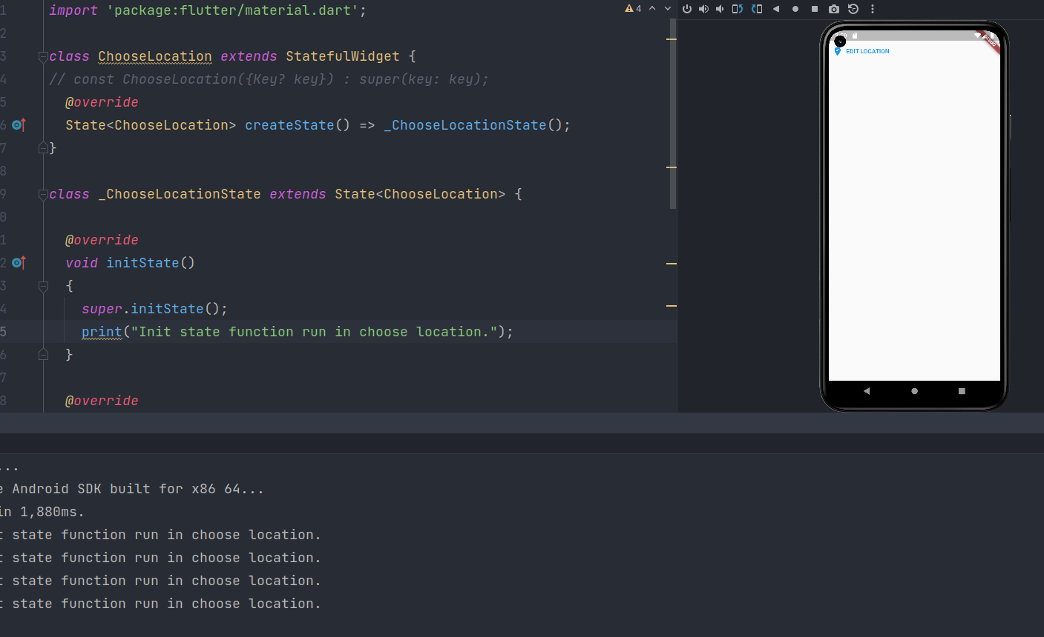

**Description:**

Containing class: _ChooseLocationState

Called when this object is inserted into the tree.

The framework will call this method exactly once for each State object it create.

You cannot use BuildContext.dependOnInheritedWidgetOfExactType from this method. However, didChangeDependencies will be called immediately following this method, and BuildContext.dependOnInheritedWidgetOfExactType can be used there.

Implementations of this method should start with a call to the inherited method, as in super.initState().

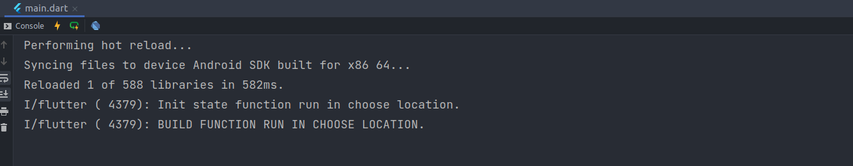

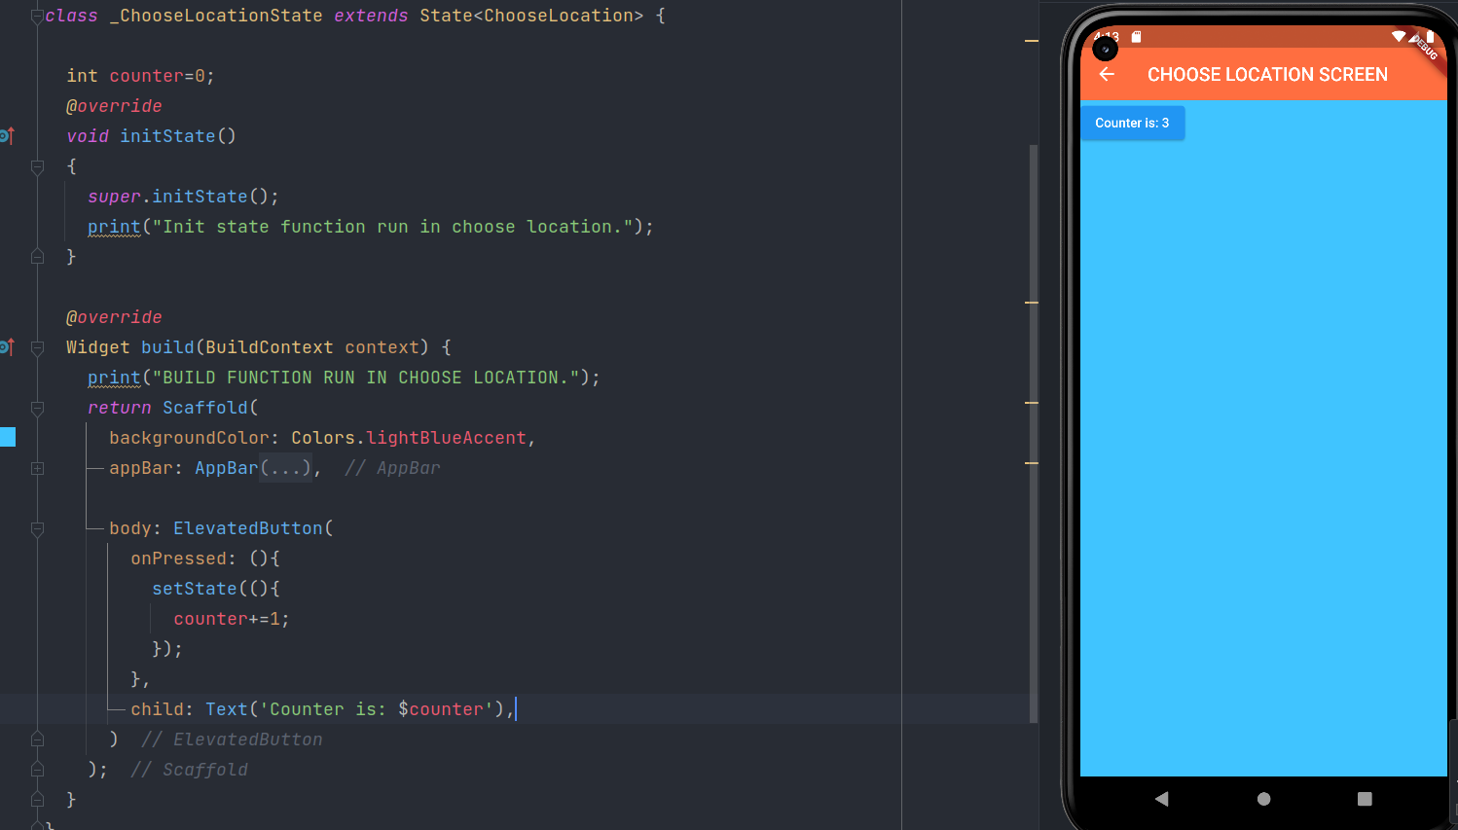  
**Every Time we click on Counter In terminal Build will print message and setState() function will increment the counter value by 1.**

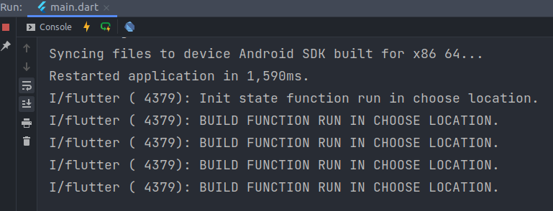

**Async:-** Starts now and finishes in some time in future.

Its non blocking code part

If we request any api to execute/update some data...so we start the request but it doesn’t finish at same time because it might required some time to complete request. In the meantime, our code should not stop until the request is complete..

Once the request is made, the rest of the code from file could carry on..

‘Async function’, ‘wait’ keyword and ‘future’ are the tools to work with async code .

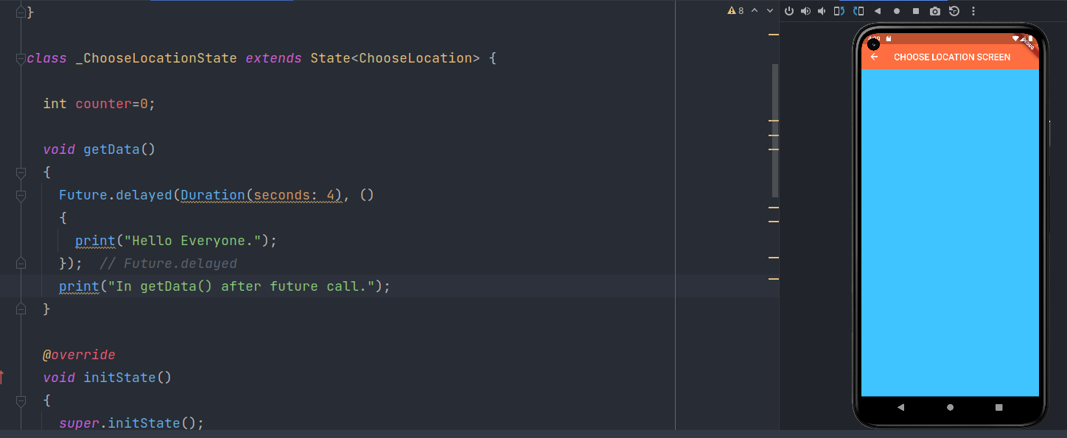

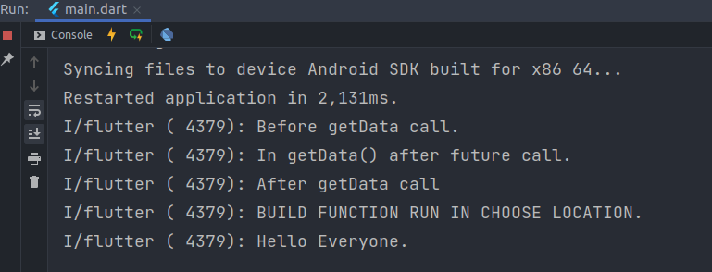

Some times we need to wait for response of request.

Some times new request depends on the data of the first request. So in such situation second request must have to wait until first one not completed.

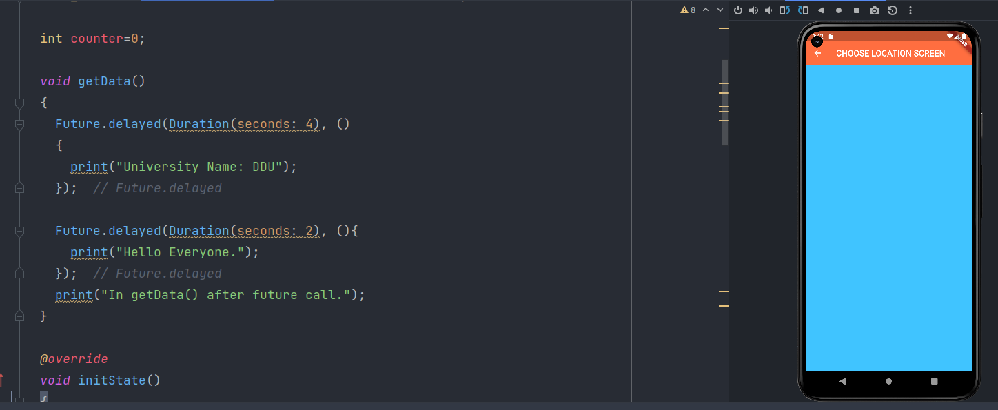

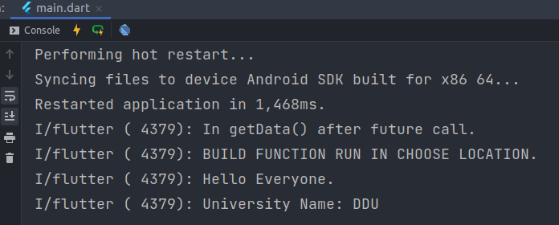

Here First It will print Hello Everyone because it’s delay duration is 2 Sec and then it’ll print another print statement.

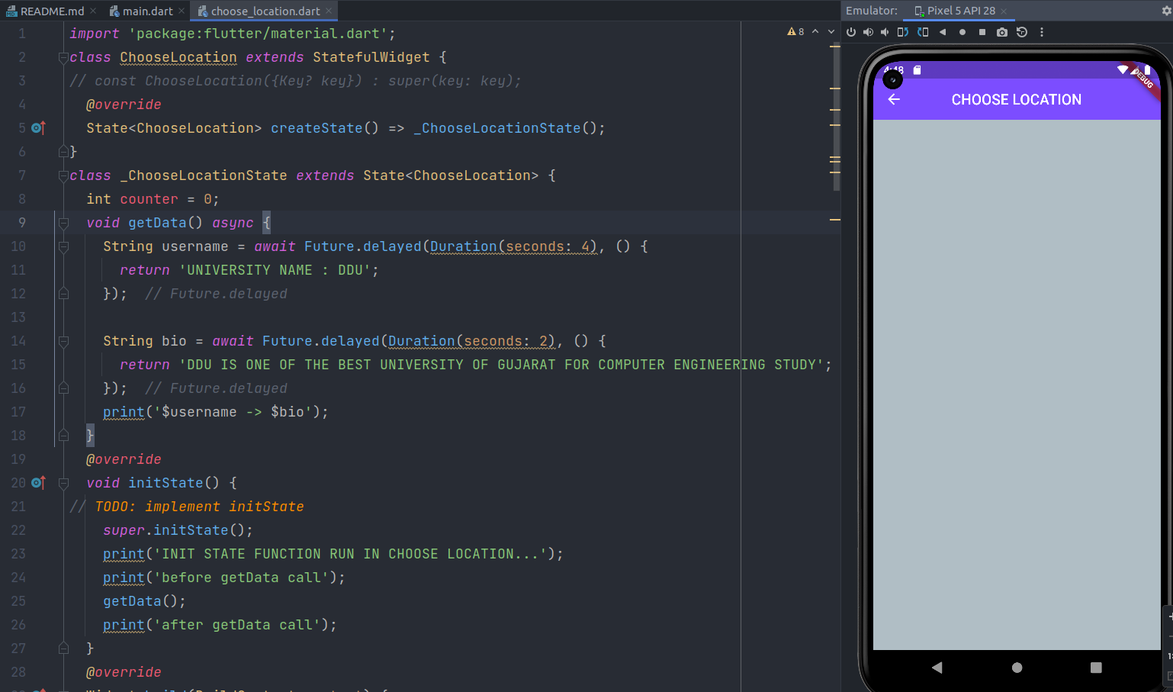

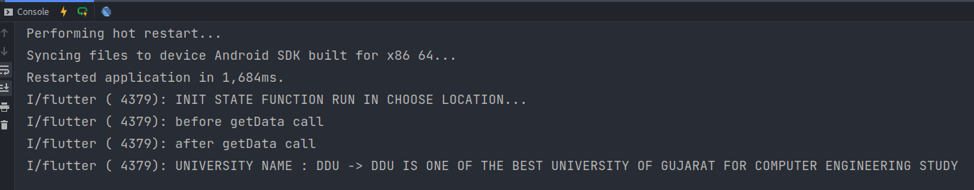

lib/src/*: It contains private Dart code files.

lib/*: It is a directory, which contains the public code in the package.

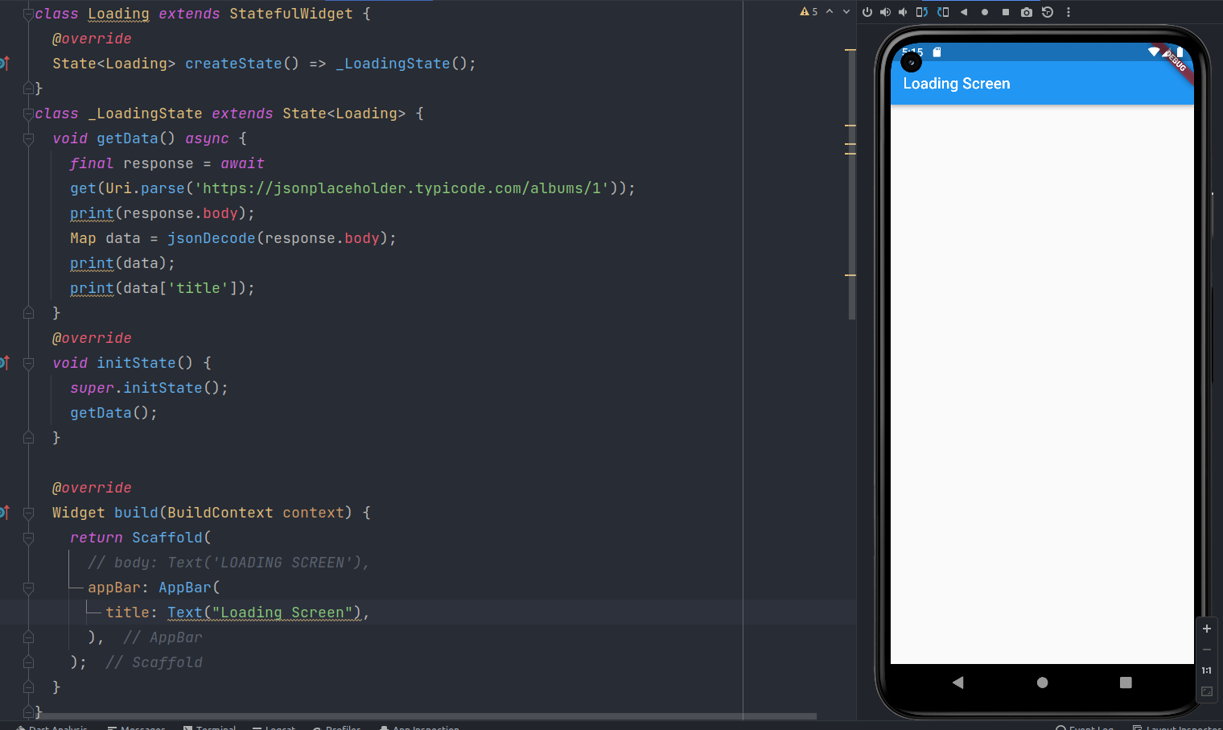

dart:core abstract class Uri

A parsed URI, such as a URL.

To create a URI with specific components, use new Uri.

Uri parse(

String uri, [ int start = 0, int? end, ])

Containing class: Uri Type: Uri Function(String, [int, int?]

)

Creates a new Uri object by parsing a URI string.

If start and end are provided, they must specify a valid substring of uri, and only the substring from start to end is parsed as a URI.

If the uri string is not valid as a URI or URI reference, a FormatException is thrown.

**FInal Code:**

**Main.dart**

*import* 'package:flutter/material.dart';  
import 'package:lab10_t1/pages/choose_location.dart';  
import 'package:lab10_t1/pages/home.dart';  
import 'package:lab10_t1/pages/loading.dart';  
// void main() => runApp(MaterialApp(  
// // home: Home(),  
// home: ChooseLocation(),  
// // home: Loading(),  
// ));  
  
void main() => runApp(MaterialApp(  
 initialRoute: '/',  
 routes: {  
 '/': (context) => Loading(),  
 '/home': (context) => Home(),  
 '/location': (context) => ChooseLocation(),  
 }  
));  
  
/*  
void main() => runApp(MaterialApp(  
 initialRoute: '/home',  
 routes: {  
 '/': (context) => Loading(),  
 '/home': (context) => Home(),  
 '/location': (context) => ChooseLocation(),  
 }  
));  
 */

**Choose_location.dart**

*import* 'package:flutter/material.dart';  
  
class ChooseLocation *extends* StatefulWidget {  
// const ChooseLocation({Key? key}) : super(key: key);  
 *@override*  
State<ChooseLocation> createState() => _ChooseLocationState();  
}  
class _ChooseLocationState *extends* State<ChooseLocation> {  
 int counter = 0;  
  
 *@override*  
Widget build(BuildContext context) {  
// print('BUILD FUNCTION RUN IN CHOOSE LOCATION...');  
 *return* Scaffold(  
 backgroundColor: Colors.blueGrey[200],  
 appBar: AppBar(  
 backgroundColor: Colors.deepPurpleAccent,  
 title: Text('CHOOSE LOCATION'),  
 centerTitle: *true*,  
 elevation: 0,  
 ),  
 );  
 }  
}  
/*  
import 'package:flutter/material.dart';  
  
class ChooseLocation extends StatefulWidget {  
// const ChooseLocation({Key? key}) : super(key: key);  
 @override  
 State<ChooseLocation> createState() => _ChooseLocationState();  
}  
class _ChooseLocationState extends State<ChooseLocation> {  
 int counter = 0;  
 void getData() async {  
 String username = await Future.delayed(Duration(seconds: 4), () {  
 return 'UNIVERSITY NAME : DDU';  
 });  
  
 String bio = await Future.delayed(Duration(seconds: 2), () {  
 return 'DDU IS ONE OF THE BEST UNIVERSITY OF GUJARAT FOR COMPUTER ENGINEERING STUDY';  
 });  
 print('$username -> $bio');  
 }  
 @override  
 void initState() {  
// *TODO: implement initState*  
 *super.initState();*  
 *print('INIT STATE FUNCTION RUN IN CHOOSE LOCATION...');*  
 *print('before getData call');*  
 *getData();*  
 *print('after getData call');*  
 *}*  
 *@override*  
 *Widget build(BuildContext context) {*  
*// print('BUILD FUNCTION RUN IN CHOOSE LOCATION...');*  
 *return Scaffold(*  
 *backgroundColor: Colors.blueGrey[200],*  
 *appBar: AppBar(*  
 *backgroundColor: Colors.deepPurpleAccent,*  
 *title: Text('CHOOSE LOCATION'),*  
 *centerTitle: true,*  
 *elevation: 0,*  
 *),*  
 *);*  
 *}*  
*}*  
  
 *\*/*  
  
*/\**  
*import 'package:flutter/material.dart';*  
  
*class ChooseLocation extends StatefulWidget {*  
*// const ChooseLocation({Key? key}) : super(key: key);*  
 *@override*  
 *State<ChooseLocation> createState() => _ChooseLocationState();*  
*}*  
  
*class _ChooseLocationState extends State<ChooseLocation> {*  
  
 *int counter=0;*  
  
 *void getData()*  
 *{*  
 *Future.delayed(Duration(seconds: 4), ()*  
 *{*  
 *print("University Name: DDU");*  
 *});*  
  
 *Future.delayed(Duration(seconds: 2), (){*  
 *print("Hello Everyone.");*  
 *});*  
 *print("In getData() after future call.");*  
 *}*  
  
 *@override*  
 *void initState()*  
 *{*  
 *super.initState();*  
 *// print("Init state function run in choose location.");*  
 *// print("Before getData call.");*  
 *getData();*  
 *// print("After getData call");*  
 *}*  
 */\**  
 *int counter=0;*  
  
 *void getData()*  
 *{*  
 *Future.delayed(Duration(seconds: 4), ()*  
 *{*  
 *print("Hello Everyone.");*  
 *});*  
 *print("In getData() after future call.");*  
 *}*  
  
 *@override*  
 *void initState()*  
 *{*  
 *super.initState();*  
 *// print("Init state function run in choose location.");*  
 *print("Before getData call.");*  
 *getData();*  
 *print("After getData call");*  
 *}*  
 *\*/*  
  
 *@override*  
 *Widget build(BuildContext context) {*  
 *print("BUILD FUNCTION RUN IN CHOOSE LOCATION.");*  
 *return Scaffold(*  
 *backgroundColor: Colors.lightBlueAccent,*  
 *appBar: AppBar(*  
 *backgroundColor: Colors.deepOrangeAccent,*  
 *title: Text("CHOOSE LOCATION SCREEN"),*  
 *centerTitle: true,*  
 *elevation: 0,*  
 *),*  
  
 *// body: ElevatedButton(*  
 *// onPressed: (){*  
 *// setState((){*  
 *// counter+=1;*  
 *// });*  
 *// },*  
 *// child: Text('Counter is: $counter'),*  
 *// )*  
  
  
 *);*  
 *}*  
*}*  
 *\*/*

**Home.dart**

*import* 'package:flutter/material.dart';  
class Home *extends* StatefulWidget {  
 *@override*  
State<Home> createState() => _HomeState();  
}  
class _HomeState *extends* State<Home> {  
 *@override*  
Widget build(BuildContext context) {  
 *return* Scaffold(  
 body: SafeArea(  
 child: Column(  
 children: [  
 TextButton.icon(onPressed: (){  
 Navigator.pushNamed(context, '/location');  
 },  
 icon: Icon(Icons.edit_location),  
 label: Text('EDIT LOCATION'),  
 )  
 ],  
 ),  
 ),  
 *// appBar: AppBar(*  
 *// title: Text("HOME SCREEN"),*  
  
);  
 }  
}

**Loading.dart**

*import* 'package:flutter/material.dart';  
import 'package:http/http.dart';  
import 'dart:convert';  
class Loading *extends* StatefulWidget {  
 *@override*  
State<Loading> createState() => _LoadingState();  
}  
class _LoadingState *extends* State<Loading> {  
 *void* getData() *async* {  
 *final* response = *await*  
get(Uri.parse('https://jsonplaceholder.typicode.com/albums/1'));  
 print(response.body);  
 Map data = jsonDecode(response.body);  
 print(data);  
 print(data['title']);  
 }  
 *@override*  
 *void* initState() {  
 *super*.initState();  
 getData();  
 }  
  
 *@override*  
Widget build(BuildContext context) {  
 *return* Scaffold(  
 *// body: Text('LOADING SCREEN'),*  
appBar: AppBar(  
 title: Text("Loading Screen"),  
 ),  
 );  
 }  
}  
/*  
import 'package:flutter/material.dart';  
class Loading extends StatefulWidget {  
// const Loading({Key? key}) : super(key: key);  
 @override  
 State<Loading> createState() => _LoadingState();  
}  
class _LoadingState extends State<Loading> {  
 void getData() async {  
 String username = await Future.delayed(Duration(seconds: 4), () {  
 return 'UNIVERSITY NAME : DDU';  
 });  
  
 String bio = await Future.delayed(Duration(seconds: 2), () {  
 return 'DDU IS ONE OF THE BEST UNIVERSITY OF GUJARAT FOR COMPUTER ENGINEERING STUDY';  
 });  
 print('$username -> $bio');  
 }  
 @override  
 void initState() {  
// *TODO: implement initState*  
 *super.initState();*  
 *print('INIT STATE FUNCTION RUN IN CHOOSE LOCATION...');*  
 *print('before getData call');*  
 *getData();*  
 *print('after getData call');*  
 *}*  
 *@override*  
 *Widget build(BuildContext context) {*  
 *return Scaffold(*  
 *appBar: AppBar(*  
 *title: Text("LOADING SCREEN"),*  
 *),*  
 *);*  
 *}*  
*}*  
 *\*/*

**Github Link:**

[**https://github.com/GauravKaklotar/SDP/tree/master/Lab10**](https://github.com/GauravKaklotar/SDP/tree/master/Lab10)