**Name:** Kaklotar Gaurav Amarshibhai

**Subject:** SDP

**Batch:** A3

**Roll No:** CE053

**ID No:** 20CEUBG084

**Lab10 Tutorial-2**

**In this tutorial we will use World Time API.**

# curl "http://worldtimeapi.org/api/timezone/Asia/Kolkata"

{

"abbreviation": "IST",

"client_ip": "103.26.49.78",

"datetime": "2022-09-12T07:40:37.712499+05:30",

"day_of_week": 1,

2

"day_of_year": 255,

"dst": false,

"dst_from": null,

"dst_offset": 0,

"dst_until": null,

"raw_offset": 19800,

"timezone": "Asia/Kolkata",

"unixtime": 1662948637,

"utc_datetime": "2022-09-12T02:10:37.712499+00:00",

"utc_offset": "+05:30",

"week_number": 37

}

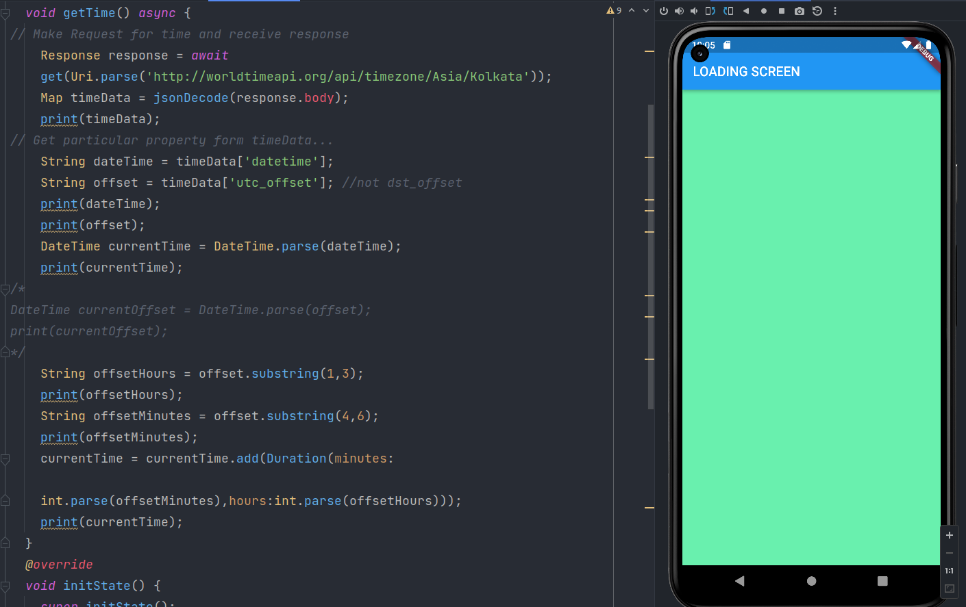

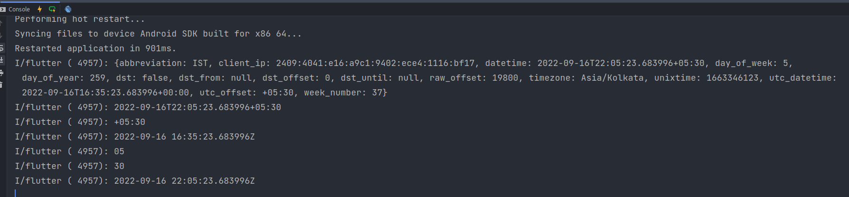

In above code we are using WorldTime API and check details for kolkata.

For London use this link...

<https://www.worldtimeapi.org/api/timezone/Europe/London>

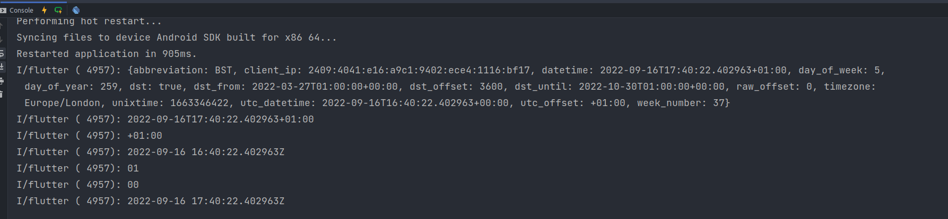

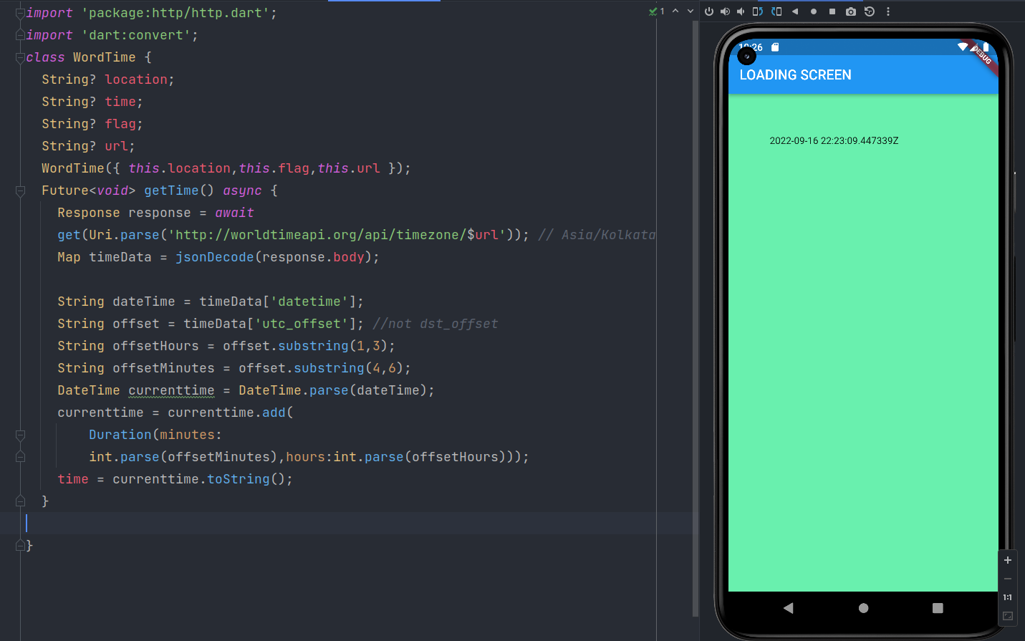

dart:convert

**jsonDecode**

Parses the string and returns the resulting Json object.

The optional reviver function is called once for each object or list property that has been parsed during decoding. The key argument is either the integer list index for a list property, the string map key for object properties, or null for the final result.

The default reviver (when not provided) is the identity function.

Shorthand for json.decode. Useful if a local variable shadows the global json constant.

Example:

const jsonString =

'{"text": "foo", "value": 1, "status": false, "extra": null}';

**Final Code:**

**Main.dart**

*import* 'package:flutter/material.dart';  
import 'package:lab10_t2/pages/choose_location.dart';  
import 'package:lab10_t2/pages/home.dart';  
import 'package:lab10_t2/pages/loading.dart';  
// void main() => runApp(MaterialApp(  
// // home: Home(),  
// home: ChooseLocation(),  
// // home: Loading(),  
// ));  
  
void main() => runApp(MaterialApp(  
 initialRoute: '/',  
 routes: {  
 '/': (context) => Loading(),  
 '/home': (context) => Home(),  
 '/location': (context) => ChooseLocation(),  
 }  
));  
  
/*  
void main() => runApp(MaterialApp(  
 initialRoute: '/home',  
 routes: {  
 '/': (context) => Loading(),  
 '/home': (context) => Home(),  
 '/location': (context) => ChooseLocation(),  
 }  
));  
 */

**Loading.dart**

*import* 'package:flutter/material.dart';  
import 'package:lab10_t2/services/word_time.dart';  
  
class Loading *extends* StatefulWidget {  
 *@override*  
State<Loading> createState() => _LoadingState();  
}  
class _LoadingState *extends* State<Loading> {  
 String? time = 'LOADING..........';  
 *void* setWorldTime() *async* {  
 WordTime timeinstance =  
 WordTime(location: 'kolkata',flag: 'india.png',url: 'Asia/Kolkata');  
 *await* timeinstance.getTime();  
// print(timeinstance.time);  
 setState(() {  
 time = timeinstance.time;  
 });  
 }  
 *@override*  
 *void* initState() {  
 *super*.initState();  
 setWorldTime();  
 }  
  
 *@override*  
Widget build(BuildContext context) {  
 *return* Scaffold(  
 backgroundColor: Colors.greenAccent,  
 appBar: AppBar(  
 title: Text("LOADING SCREEN"),  
 ),  
 body: Padding(  
 padding: EdgeInsets.all(60.0),  
 child: Text(time.toString()),  
 )  
 );  
 }  
}  
/*  
import 'package:flutter/material.dart';  
import 'package:http/http.dart';  
import 'dart:convert';  
class Loading extends StatefulWidget {  
 @override  
 State<Loading> createState() => _LoadingState();  
}  
class _LoadingState extends State<Loading> {  
 void getTime() async {  
// Make Request for time and receive response  
 Response response = await  
 // get(Uri.parse('http://worldtimeapi.org/api/timezone/Asia/London'));  
 get(Uri.parse('https://www.worldtimeapi.org/api/timezone/Europe/London'));  
 Map timeData = jsonDecode(response.body);  
 print(timeData);  
// Get particular property form timeData...  
 String dateTime = timeData['datetime'];  
 String offset = timeData['utc_offset']; //not dst_offset  
 print(dateTime);  
 print(offset);  
 DateTime currentTime = DateTime.parse(dateTime);  
 print(currentTime);  
/*  
DateTime currentOffset = DateTime.parse(offset);  
print(currentOffset);  
*/  
 String offsetHours = offset.substring(1,3);  
 print(offsetHours);  
 String offsetMinutes = offset.substring(4,6);  
 print(offsetMinutes);  
 currentTime = currentTime.add(Duration(minutes:  
  
 int.parse(offsetMinutes),hours:int.parse(offsetHours)));  
 print(currentTime);  
 }  
 @override  
 void initState() {  
 super.initState();  
 getTime();  
 }  
  
 @override  
 Widget build(BuildContext context) {  
 return Scaffold(  
 backgroundColor: Colors.greenAccent,  
 // body: Text('LOADING SCREEN'),  
 appBar: AppBar(  
 title: Text("LOADING SCREEN"),  
 ),  
 );  
 }  
}  
 */

**Home.dart**

*import* 'package:flutter/material.dart';  
class Home *extends* StatefulWidget {  
 *@override*  
State<Home> createState() => _HomeState();  
}  
class _HomeState *extends* State<Home> {  
 *@override*  
Widget build(BuildContext context) {  
 *return* Scaffold(  
 body: SafeArea(  
 child: Column(  
 children: [  
 TextButton.icon(onPressed: (){  
 Navigator.pushNamed(context, '/location');  
 },  
 icon: Icon(Icons.edit_location),  
 label: Text('EDIT LOCATION'),  
 )  
 ],  
 ),  
 ),  
 *// appBar: AppBar(*  
 *// title: Text("HOME SCREEN"),*  
  
);  
 }  
}

**Choose_location.dart**

*import* 'package:flutter/material.dart';  
  
class ChooseLocation *extends* StatefulWidget {  
// const ChooseLocation({Key? key}) : super(key: key);  
 *@override*  
State<ChooseLocation> createState() => _ChooseLocationState();  
}  
class _ChooseLocationState *extends* State<ChooseLocation> {  
 int counter = 0;  
  
 *@override*  
Widget build(BuildContext context) {  
// print('BUILD FUNCTION RUN IN CHOOSE LOCATION...');  
 *return* Scaffold(  
 backgroundColor: Colors.blueGrey[200],  
 appBar: AppBar(  
 backgroundColor: Colors.deepPurpleAccent,  
 title: Text('CHOOSE LOCATION'),  
 centerTitle: *true*,  
 elevation: 0,  
 ),  
 );  
 }  
}  
/*  
import 'package:flutter/material.dart';  
  
class ChooseLocation extends StatefulWidget {  
// const ChooseLocation({Key? key}) : super(key: key);  
 @override  
 State<ChooseLocation> createState() => _ChooseLocationState();  
}  
class _ChooseLocationState extends State<ChooseLocation> {  
 int counter = 0;  
 void getData() async {  
 String username = await Future.delayed(Duration(seconds: 4), () {  
 return 'UNIVERSITY NAME : DDU';  
 });  
  
 String bio = await Future.delayed(Duration(seconds: 2), () {  
 return 'DDU IS ONE OF THE BEST UNIVERSITY OF GUJARAT FOR COMPUTER ENGINEERING STUDY';  
 });  
 print('$username -> $bio');  
 }  
 @override  
 void initState() {  
// *TODO: implement initState*  
 *super.initState();*  
 *print('INIT STATE FUNCTION RUN IN CHOOSE LOCATION...');*  
 *print('before getData call');*  
 *getData();*  
 *print('after getData call');*  
 *}*  
 *@override*  
 *Widget build(BuildContext context) {*  
*// print('BUILD FUNCTION RUN IN CHOOSE LOCATION...');*  
 *return Scaffold(*  
 *backgroundColor: Colors.blueGrey[200],*  
 *appBar: AppBar(*  
 *backgroundColor: Colors.deepPurpleAccent,*  
 *title: Text('CHOOSE LOCATION'),*  
 *centerTitle: true,*  
 *elevation: 0,*  
 *),*  
 *);*  
 *}*  
*}*  
  
 *\*/*  
  
*/\**  
*import 'package:flutter/material.dart';*  
  
*class ChooseLocation extends StatefulWidget {*  
*// const ChooseLocation({Key? key}) : super(key: key);*  
 *@override*  
 *State<ChooseLocation> createState() => _ChooseLocationState();*  
*}*  
  
*class _ChooseLocationState extends State<ChooseLocation> {*  
  
 *int counter=0;*  
  
 *void getData()*  
 *{*  
 *Future.delayed(Duration(seconds: 4), ()*  
 *{*  
 *print("University Name: DDU");*  
 *});*  
  
 *Future.delayed(Duration(seconds: 2), (){*  
 *print("Hello Everyone.");*  
 *});*  
 *print("In getData() after future call.");*  
 *}*  
  
 *@override*  
 *void initState()*  
 *{*  
 *super.initState();*  
 *// print("Init state function run in choose location.");*  
 *// print("Before getData call.");*  
 *getData();*  
 *// print("After getData call");*  
 *}*  
 */\**  
 *int counter=0;*  
  
 *void getData()*  
 *{*  
 *Future.delayed(Duration(seconds: 4), ()*  
 *{*  
 *print("Hello Everyone.");*  
 *});*  
 *print("In getData() after future call.");*  
 *}*  
  
 *@override*  
 *void initState()*  
 *{*  
 *super.initState();*  
 *// print("Init state function run in choose location.");*  
 *print("Before getData call.");*  
 *getData();*  
 *print("After getData call");*  
 *}*  
 *\*/*  
  
 *@override*  
 *Widget build(BuildContext context) {*  
 *print("BUILD FUNCTION RUN IN CHOOSE LOCATION.");*  
 *return Scaffold(*  
 *backgroundColor: Colors.lightBlueAccent,*  
 *appBar: AppBar(*  
 *backgroundColor: Colors.deepOrangeAccent,*  
 *title: Text("CHOOSE LOCATION SCREEN"),*  
 *centerTitle: true,*  
 *elevation: 0,*  
 *),*  
  
 *// body: ElevatedButton(*  
 *// onPressed: (){*  
 *// setState((){*  
 *// counter+=1;*  
 *// });*  
 *// },*  
 *// child: Text('Counter is: $counter'),*  
 *// )*  
  
  
 *);*  
 *}*  
*}*  
 *\*/*

**World_time.dart**

*import* 'package:http/http.dart';  
import 'dart:convert';  
class WordTime {  
 String? location;  
 String? time;  
 String? flag;  
 String? url;  
 WordTime({ *this*.location,*this*.flag,*this*.url });  
 Future<*void*> getTime() *async* {  
 Response response = *await*  
get(Uri.parse('http://worldtimeapi.org/api/timezone/$url')); *// Asia/Kolkata*  
Map timeData = jsonDecode(response.body);  
  
 String dateTime = timeData['datetime'];  
 String offset = timeData['utc_offset']; *//not dst_offset*  
String offsetHours = offset.substring(1,3);  
 String offsetMinutes = offset.substring(4,6);  
 DateTime currenttime = DateTime.parse(dateTime);  
 currenttime = currenttime.add(  
 Duration(minutes:  
 int.parse(offsetMinutes),hours:int.parse(offsetHours)));  
 time = currenttime.toString();  
 }  
  
}

**Github Link:**

[**https://github.com/GauravKaklotar/SDP/tree/master/Lab10**](https://github.com/GauravKaklotar/SDP/tree/master/Lab10)