PROJECT REPORT

ADVANCE JAVA PROGRAMMING
CAN604


Session :2025-27

Topic: Online Job Portal

Submitted to: Submitted by:
Mr. Ravi Kumar Jha Gaurav Singh
Assistant Professor 1000029597
School of Computing MCA-IInd Sem
DIT University

CONTENT

Sr.no | Topic
1. | Certification of completion
2. | Acknowledgement
3. | Introduction
4. | Modules Used
5. | Technologies Used
6. | Working of the Application
7. | Features Implemented
8. | Future Enhancements
9. | Conclusion
10. | Snapshots



Certification of Completion

This is to certify that Sargam Arora, Sap id: 1000026809 of Department of Computer Science, School of Computing has successfully completed a project on developing Online Job Portal under the guidance of Dr. Ravi Kumar Jha for the academic year and session 2024-25 in partial fulfilment of the requirement for the award of the Degree Master of Computer Application.

Mr. Ravi Kumar Jha
Assistant Professor
DIT University

Acknowledgement

I would like to express my sincere gratitude to Mr. Ravi Kumar Jha and DIT University for their invaluable guidance, support, and mentorship throughout the completion of this mini project. Their expertise, insights, and encouragement were instrumental in navigating the complexities of Advance Java Programming, providing me with a comprehensive understanding of advanced concepts. I also extend my thanks to my fellow classmates for their collaborative spirit and to my family and friends for their unwavering motivation, which played a vital role in the successful completion of this project. This accomplishment reflects the supportive academic environment fostered at DIT University, which has been pivotal in refining my skills and preparing me for future professional challenges. Thank you to everyone who contributed to making this project a meaningful and enriching learning experience.

Introduction

The Online Job Portal is a Java-based desktop application that provides a centralized platform for job seekers and employers. It simplifies the traditional job-seeking and recruitment process by allowing employers to post job opportunities and manage applications, while enabling job seekers to search and apply for jobs based on their qualifications.
This project aims to streamline the hiring process by offering a user-friendly interface built with Java Swing, database integration using JDBC, and MySQL as the backend. The portal ensures secure access through authentication features and maintains data integrity through efficient database management.
The key objectives of this project are:
- To provide a digital platform for job seekers and employers.
- To allow employers to post jobs and manage job applications.
- To enable job seekers to search, view, and apply for jobs.
- To implement a secure login and registration system.
- To manage and store data efficiently using a relational database.

Modules Used

The system is divided into the following modules:

4.1 Login Module
- Provides authentication using username and password
- Ensures secure access to the system

4.2 Employee Management Module
- Add employee details (name, department, salary)
- View all employee records in table format
- Delete employee records
- Update employee information

4.3 Search Module
- Allows searching employees by name
- Uses SQL queries with pattern matching

4.4 Dashboard Module
- Displays total number of employees
- Shows average salary
- Provides quick insights

4.5 Export Module
- Exports employee data into CSV file
- File can be opened in Excel

4.6 Theme Module
- Allows switching between Dark and Light mode
- Enhances UI experience

Technologies Used

Component | Tool/Technology
Programming | Java
GUI | Java Swing
Database | PostgreSQL
Database Access | JDBC
IDE | Eclipse

Working of the Application

The application works in the following flow:

1. Login
- User enters username and password
- System validates credentials
- If valid → main dashboard opens

2. Employee Operations
- User can:
  - Add employee
  - View employees
  - Update employee
  - Delete employee

3. Search Functionality
- User enters name
- System queries database using:
SELECT * FROM employee WHERE name ILIKE '%keyword%';

4. Dashboard
- Displays:
  - Total employees
  - Average salary

5. Export Data
- Data is written into CSV file
- Can be opened in Excel

6. Database Interaction
- JDBC connects Java with PostgreSQL
- SQL queries handle CRUD operations

Features Implemented
The Employee Management System incorporates a wide range of features designed to ensure efficient management of employee data while maintaining a user-friendly experience.

🔐 Login Authentication
The system provides a secure login mechanism where users must enter valid credentials (username and password) to access the application. This ensures that only authorized users can interact with the system, thereby maintaining data security and preventing unauthorized access.

➕ Add Employee
Users can add new employee records by entering details such as name, department, and salary. The entered data is validated and then stored in the PostgreSQL database using JDBC. This feature allows easy and structured insertion of employee information.

📋 View Employee
All employee records are displayed in a tabular format using JTable. This provides a clear and organized view of stored data, allowing users to quickly analyze and review employee information.

✏️ Update Employee
The system allows modification of existing employee details. Users can select a record from the table, edit the information in the input fields, and update it in the database. This ensures data accuracy and flexibility in maintaining records.

❌ Delete Employee
Users can delete employee records directly from the system. Upon selecting a row in the table, the corresponding record can be removed from the database. This feature helps in maintaining up-to-date data by removing obsolete entries.

🔍 Search Employee
The application provides a search functionality that allows users to find employees based on their names. It uses SQL queries with pattern matching (ILIKE) to perform case-insensitive searches, improving usability and efficiency.

📊 Dashboard Analytics
A dashboard panel is included to display key insights such as:
- Total number of employees
- Average salary of employees
This helps users quickly understand important statistics without manually analyzing the data.

📁 Export to Excel (CSV)
The system includes an export feature that allows users to save employee data into a CSV file. This file can be opened in Microsoft Excel for further analysis, reporting, or sharing.

🌙 Dark/Light Theme
The application supports both dark and light themes. Users can toggle between themes dynamically, improving accessibility and user comfort, especially during prolonged usage.

🎨 Clean GUI using Swing
The user interface is developed using Java Swing components such as JFrame, JPanel, JTable, JButton, and JTextField. The layout is structured and responsive, ensuring ease of navigation and a smooth user experience.

Future Enhancements
Although the current system is functional and efficient, several enhancements can be implemented to further improve its capabilities:

🔐 Database-based Login System
Instead of hardcoded credentials, user authentication can be integrated with the database. This would allow multiple users to register and log in securely.

📊 Graphical Charts
Data visualization can be added using bar charts, pie charts, or line graphs to represent employee statistics such as department distribution or salary trends.

📱 Mobile Application Version
A mobile version of the application can be developed using Android or cross-platform frameworks, enabling users to access the system on smartphones.

🌐 Web-based Version
The application can be converted into a web-based system using technologies like Spring Boot or JSP, allowing access from any browser without installation.

📧 Email Notifications
Email functionality can be added to notify users about updates such as:
- New employee added
- Salary updates
- Important alerts

👥 Role-based Access (Admin/User)
Different roles can be introduced:
- Admin: Full control over data
- User: Limited access (view/search only)
This improves security and system management.

🔒 Password Encryption
User passwords can be encrypted using hashing techniques (e.g., SHA-256 or BCrypt) to enhance security and protect sensitive data.

Conclusion

The Employee Management System is a robust and user-friendly application designed to simplify the management of employee data. It provides an efficient solution for performing essential operations such as adding, updating, deleting, and searching employee records.
The development of this project has contributed significantly to understanding key concepts, including:
- Java Swing GUI development for creating interactive user interfaces
- JDBC for establishing communication between application and database
- PostgreSQL for efficient data storage and management
- CRUD operations for handling real-world data manipulation
- UI/UX improvements for better user experience
Overall, the project demonstrates a practical implementation of core programming and database concepts. It serves as a scalable and extensible solution that can be further enhanced to meet real-world enterprise requirements.

Snapshots

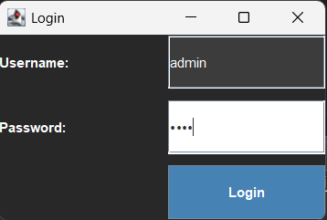

Login Screen
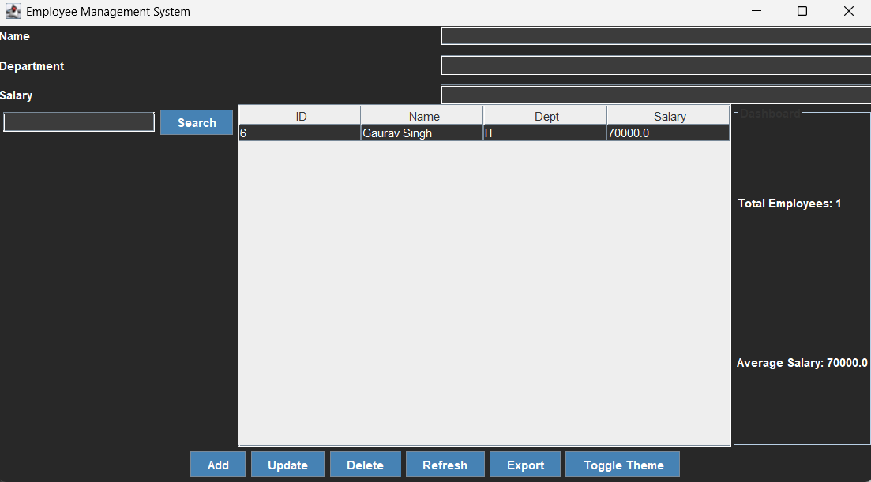

Dashboard

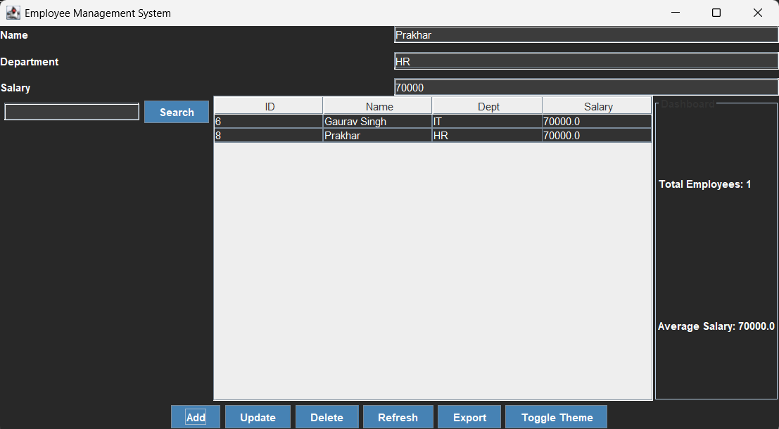

Data inserted
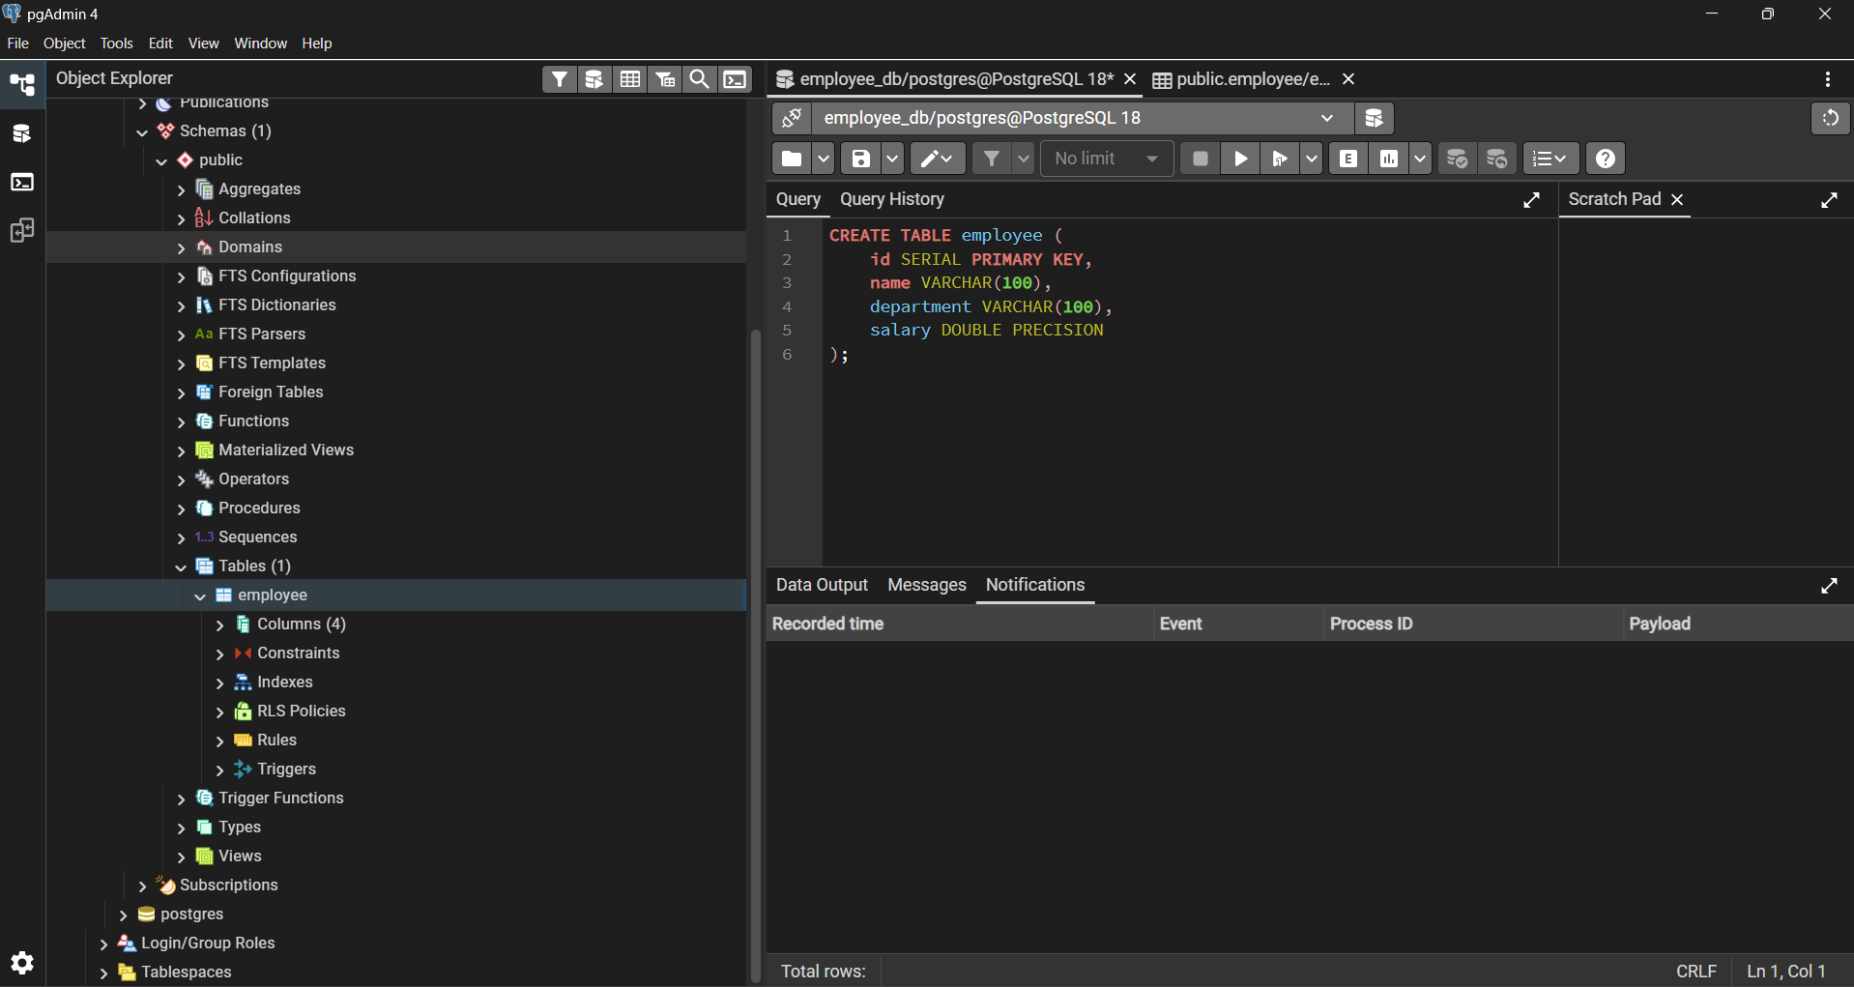

Backend

