MediAid
Voice-Driven Medication Adherence System
Technical Architecture & Engineering Report
Platform  Telegram Bot | Tech Stack  TypeScript + Groq + Drizzle ORM

1. Abstract / Executive Summary
MediAid is a voice-driven medication adherence assistant engineered to reduce one of the most pervasive challenges in modern healthcare: patient non-compliance with prescribed medication regimens. Delivered through an intelligent conversational interface on Telegram. MediAid enables users to register medications, receive timely reminders, and report adherence data through natural language voice inputs, lowering the barrier to engagement for diverse demographics including elderly and low-literacy populations.

The system is designed around a unified codebase and a single database source of truth, enabling seamless multi-platform expansion without architectural duplication. Built on a modern TypeScript backend, powered by Groq for high-throughput AI inference, and structured through Drizzle ORM for type-safe schema management, MediAid represents a production-grade approach to digital health tooling. This report provides a comprehensive overview of its architecture, technology decisions, interaction mechanics, and planned evolution.

2. Problem Statement
Medication non-adherence is a critical and costly global health problem. Studies consistently estimate that nearly 50% of patients with chronic conditions do not take their medications as prescribed, contributing to preventable hospitalizations, disease progression, and significant economic burden on healthcare systems. The causes are multifactorial: forgetfulness, complex multi-drug regimens, lack of accessible reminders, and the friction of traditional adherence tools.

Existing approaches present significant limitations:
- Paper-based pill organizers and manual logs are prone to error and do not provide proactive reminders.
- Dedicated mobile applications demand installation, account creation, and sustained user engagement, creating high drop-off rates.
- Hospital reminder services are often non-interactive, delivering one-way SMS notifications without conversational follow-up.
- Voice assistant integrations on smart devices are inaccessible to populations with limited device ownership.
MediAid addresses these gaps by embedding medication management within messaging platforms that users already trust and use daily. By accepting voice notes as primary input, transcribed and interpreted via AI, MediAid achieves an interaction model that is intuitive, asynchronous, and platform-agnostic. The strategic decision to begin with Telegram ensures coverage across the platforms with the largest global combined messaging footprints.

3. System Architecture
MediAid is architected around the principle of platform-agnostic service delivery: a single backend system that handles all core logic, data persistence, and AI inference, while modular platform adapters manage protocol-level communication with individual messaging APIs. This design ensures that the business logic for medication scheduling, reminder dispatch, and adherence tracking is written exactly once and shared across all deployment targets.

3.1 Unified Codebase Strategy
MediAid employs a layered architecture that decouples the core domain from the transport layer. At the center lies a shared services layer responsible for user management, medication registry, scheduling, and AI orchestration. Platform adapters, currently a single Telegram adapter, translate incoming messages into a normalized internal event format and dispatch outgoing responses through the appropriate API.
Architectural Principle: All medication logic, AI processing, and database interactions reside in a platform-neutral core. Platform adapters are thin translation wrappers, not feature hosts.

3.2 Data Layer & Single Source of Truth
A unified PostgreSQL-compatible relational database serves as the single source of truth for all platform interactions. The schema is defined and managed through Drizzle ORM, providing full type inference from schema definitions to query results. Key entities include:
- Users - storing cross-platform identity, contact references, and timezone metadata.
- Medications - representing drug names, dosage information, frequency patterns, and active status.
- Schedules - encoding cron-compatible timing rules linked to specific medication records.
- AdherenceLog - recording each reminder event, the user's response, and the outcome (confirmed, missed, snoozed).
Because the data model is platform-neutral by design, a user's medication history and adherence record remain fully portable. Existing users can transition channels without data migration, as their profile is already stored in the shared schema.

3.3 User Journey Architecture
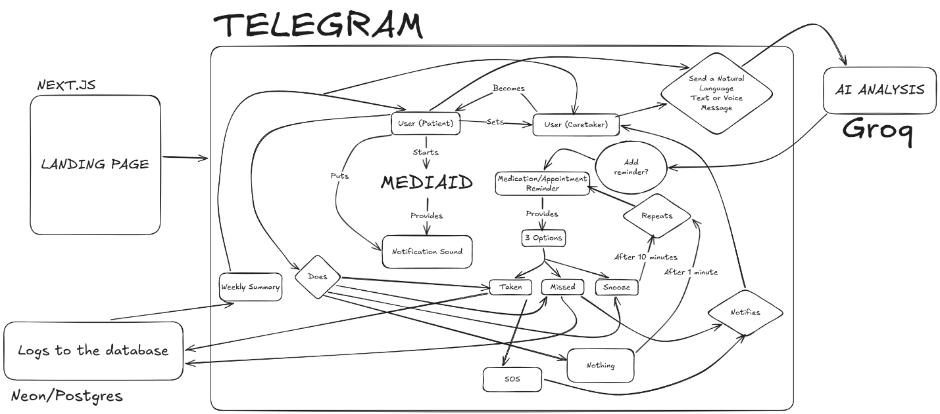

4. Core Technologies
The following technology stack underpins MediAid's architecture:
Layer | Technology | Purpose
Bot Logic & Backend | TypeScript | Type-safe, scalable server-side development
AI Inference Engine | Groq API | Ultra-low-latency large language model inference
Database ORM | Drizzle ORM | Schema definition, migrations, and type-safe queries
Frontend (Landing) | Next.js + Tailwind CSS | Static site generation with utility-first styling
Messaging Platform | Telegram Bot API | Primary voice/text interaction channel

