**Introduction**

1. SDD Application Firmware use for measure distance between devices, and upload to company database via WIFI.
2. All the distance data will store into MicroSD Card first before upload to company database, delete the database when successful upload into company database
3. When two devices are close as less than 200cm, and the total time exceed 5s. It will record a close contact event and
4. When a new close contact event is created, it will store into MicroSD Card first before upload it.
5. When both devices are close as less than 200cm, both devices will display yellow color first then change to red color after reached the 5s, and activate the buzzer by another 5s.

**Distance Measurement method**

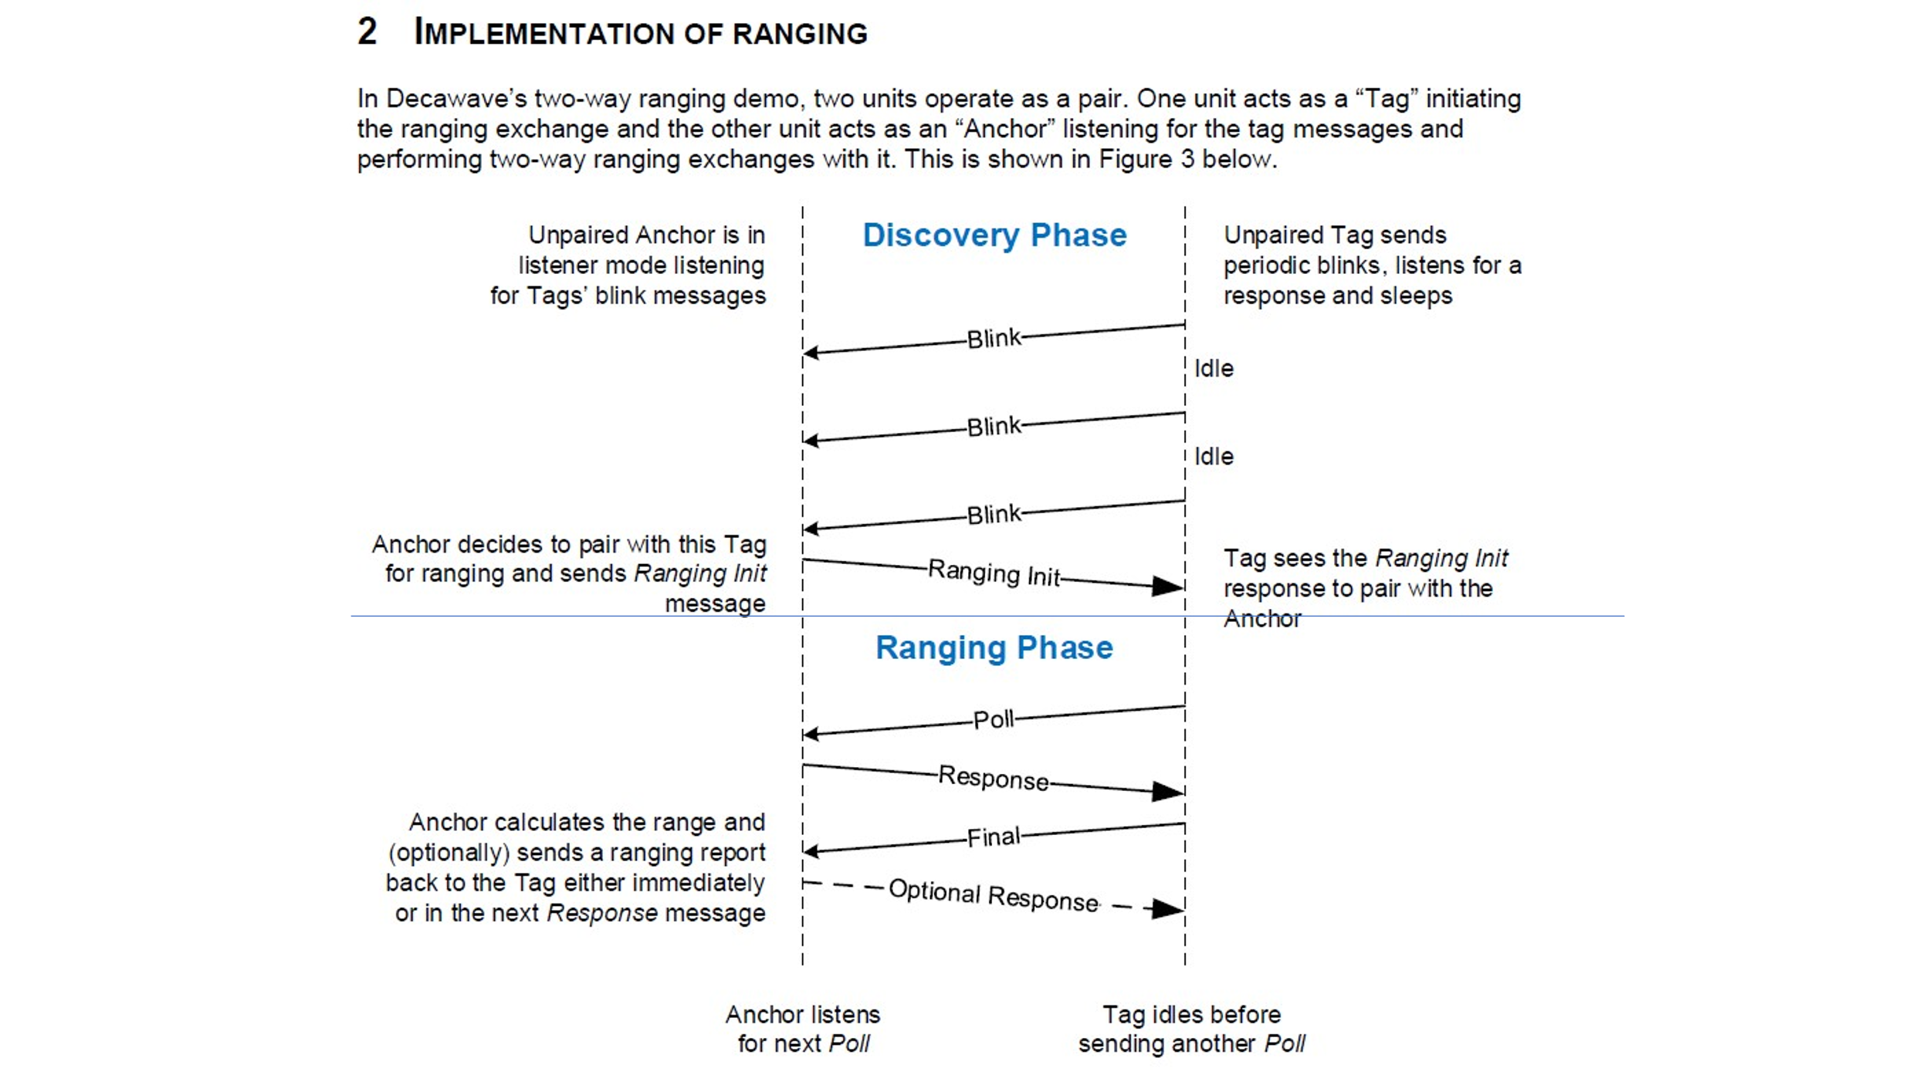

1. Using Two Way Ranging method but skip discovery phase and using Ranging phase only
2. Using TWR to measurement distance between two or more device locations.
3. Devices will not stand at static location, moving device
4. Distance Measurement update frequency about 1Hz, or 1 seconds
5. TWR method timing
   1. Device will send poll message every 100ms, if no response from another device, then immediately enter IDLE mode, except for first 3 poll message.
   2. Around 10ms for poll message timeout for waiting response from another device
   3. First 3 poll messages, the device will switch from IDLE mode to Reception mode to listen poll message from another device and reply it after successful listen the poll message.
   4. ~ 300ms Reception mode ON, ~ 70ms for Tx mode, 630ms for IDLE mode
6. Once the distance measurement is completed, it will block the same device to exchange the message again, refresh rate is about 1 second

**Problem when failed distance measurement**

1. There is two major reason that cause distance measurement failed
   * Distance message drop – quality of transmission of UWB signal is the key factor to affect the message drop issue. Based on experiment result, change the transmission channel to 5 will help to reduce this issue.
   * Distance message collision – due to multiple devices are transmit at the same time, it might have chance to create the message collision issue. Our distance measurement methodology will only allow 100ms buffer to avoid the message collision, the probability of hitting this issue will be increased when more devices.

Note: Need to revise distance measurement method if require to support more and more devices.