**CLOUD**

1. Create a Linux EC2 and access the EC2 through putty on system. Create a html page and make it available on a public IP addres

**Step 1 :** Sign In into your AWS account 🡪 In the search menu Search EC2🡪Select the first option that appears on the screen named EC2**.**

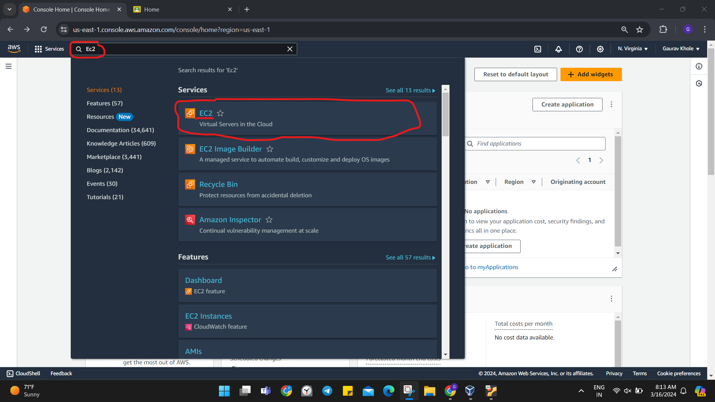

**Step 2:** Then Select the option Lauch Instance highlighted with a yellow background.

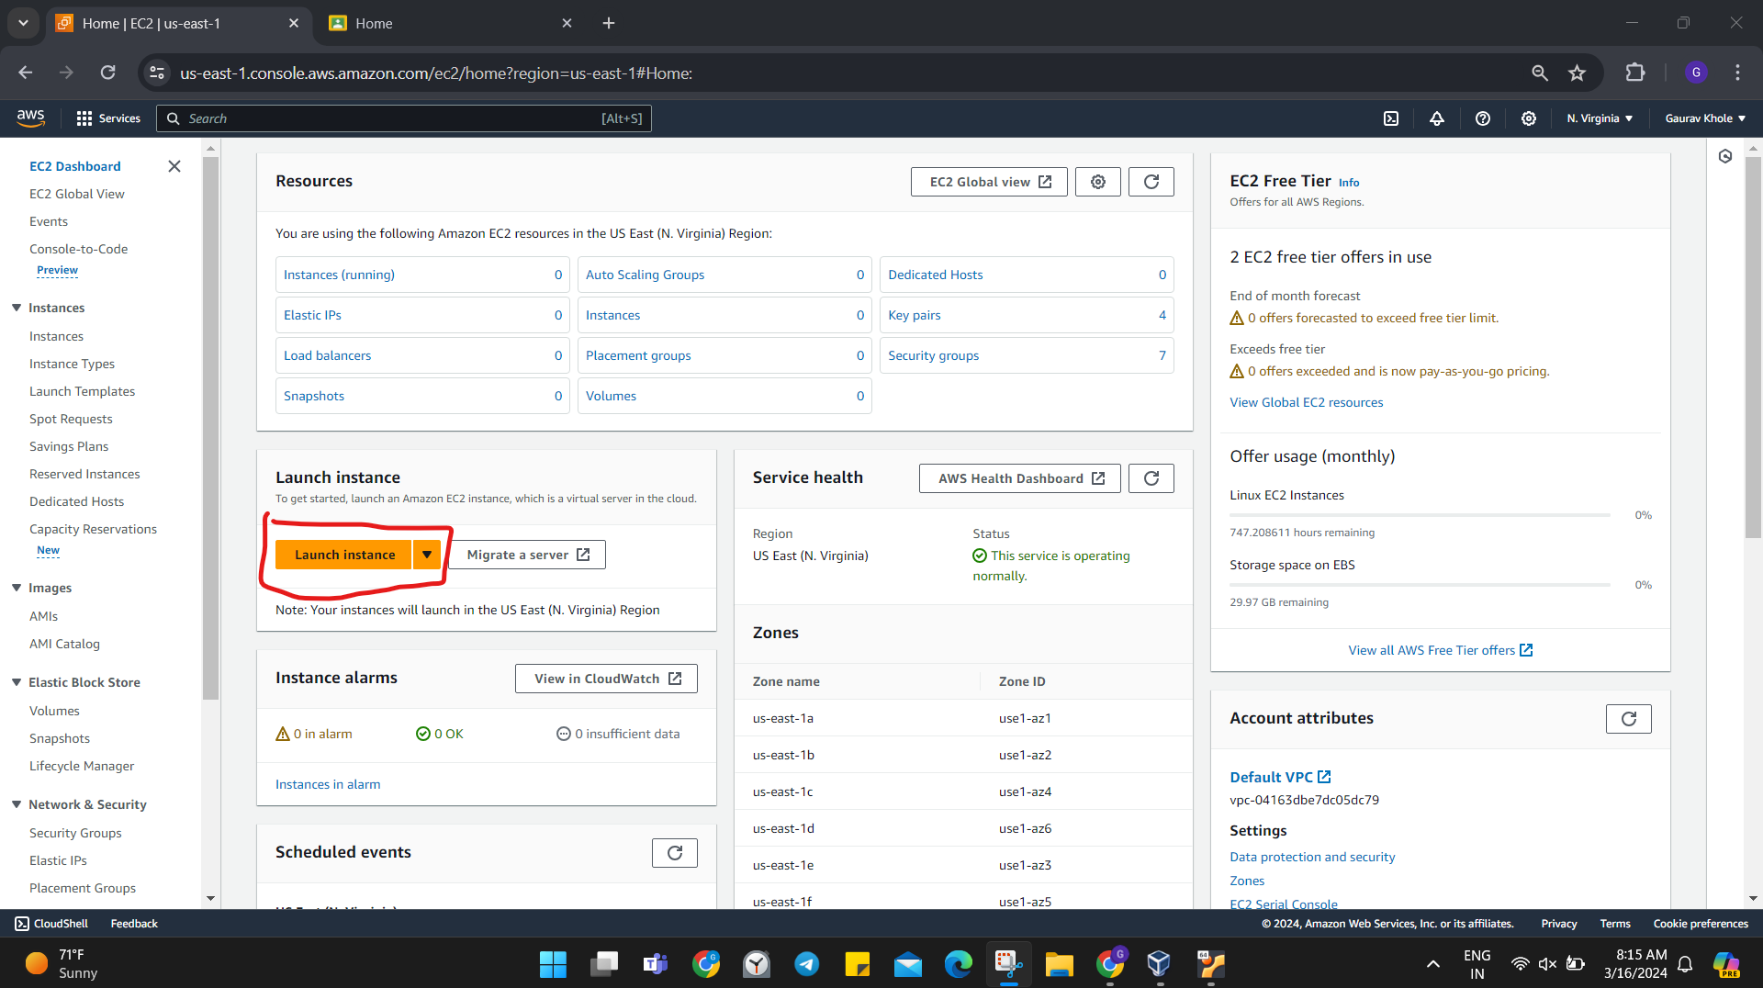

**Step 3:** Then give a name to your instance in the Name and tags section.

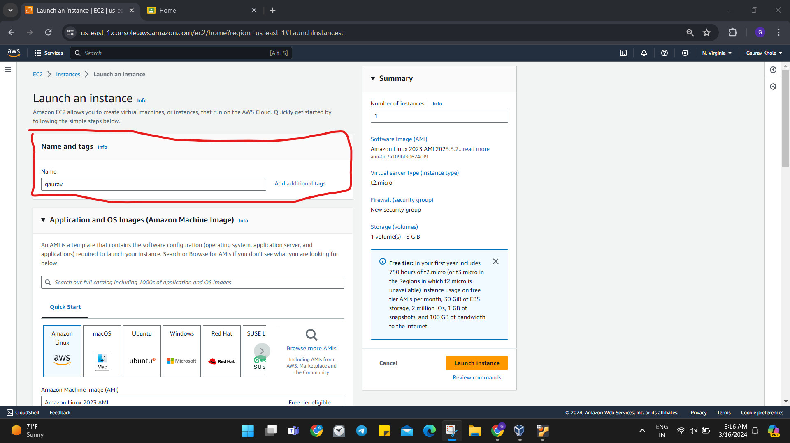

**Step 4:** Generate a Key Pair by selecting the Key Pair option.

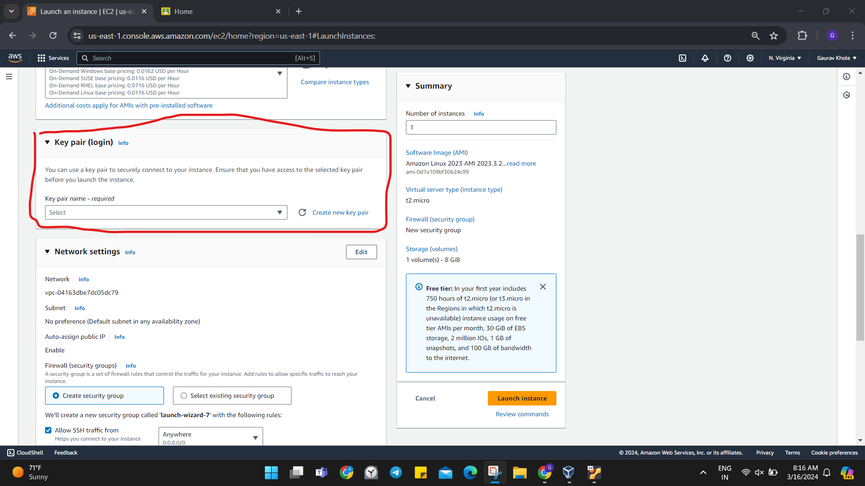

**Step 5:** Give a name to Key Pair 🡪Select .ppk option.

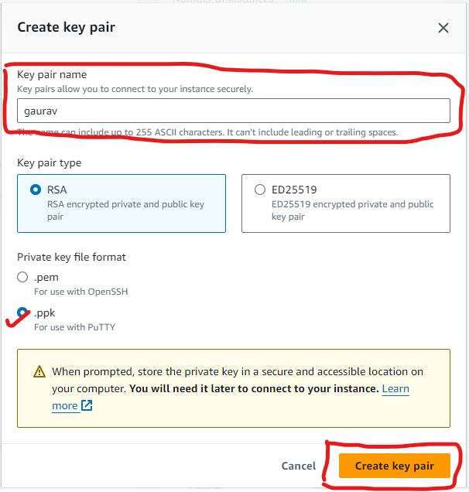

**Step 6:** Then allow to option i.e. Allow HTTPS traffic and Allow HTTP traffic.

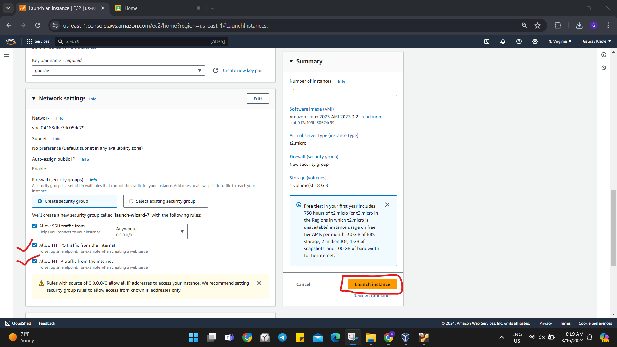

**Step 7:** The instance is Created.

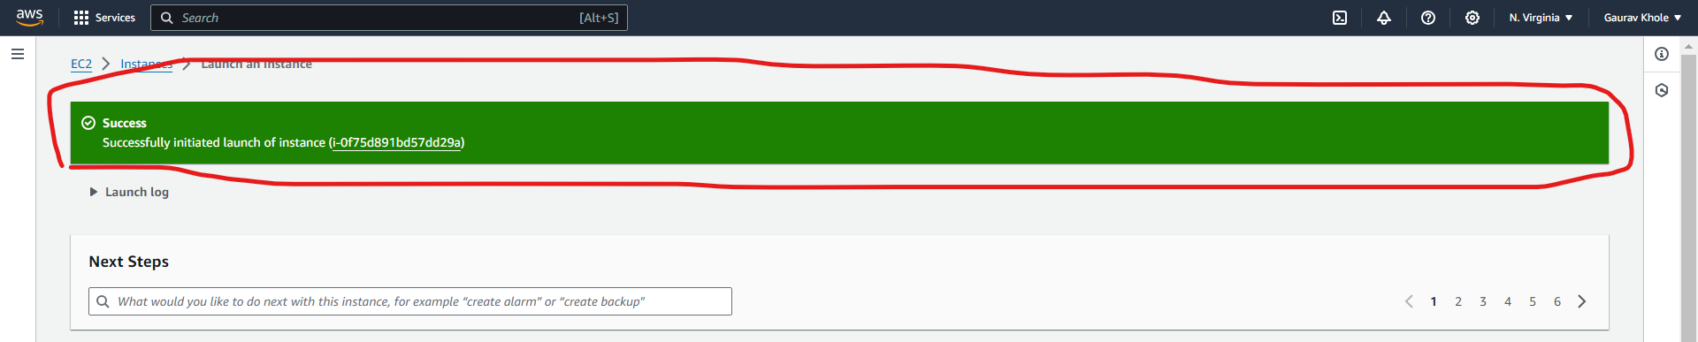

**Step 8: Copy the Public IPv4 address.**

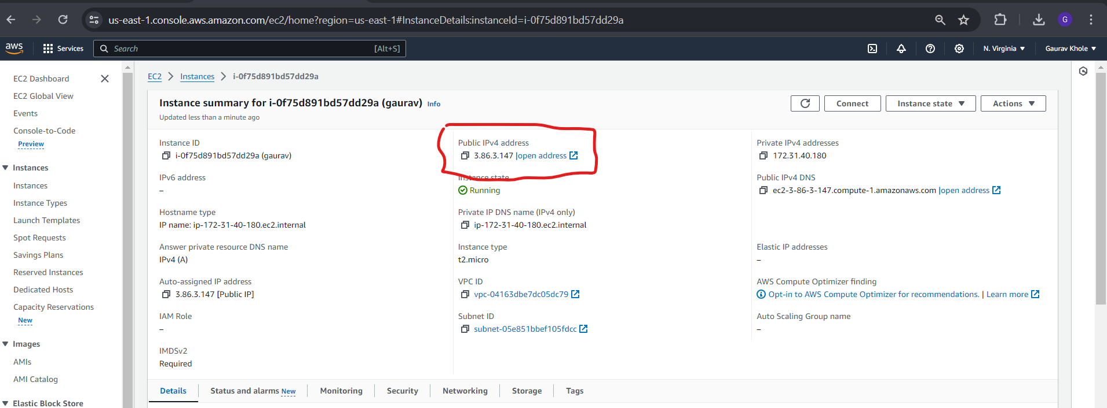

**Step 9: Then open Putty OR we can use connect option in AWS and we can connect Putty in online mode also.**

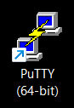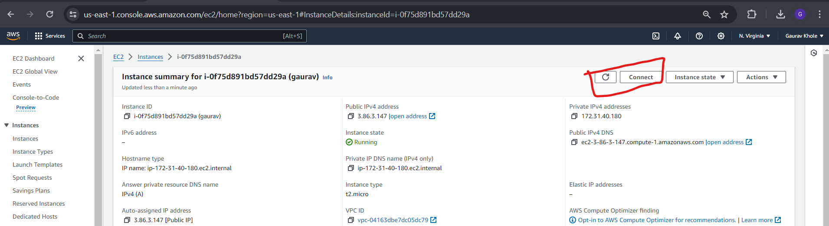

**Step 10: In the Host Name tab Insert a command**

**ec2-user@ipaddress 🡪paste ip address that we copied just now**

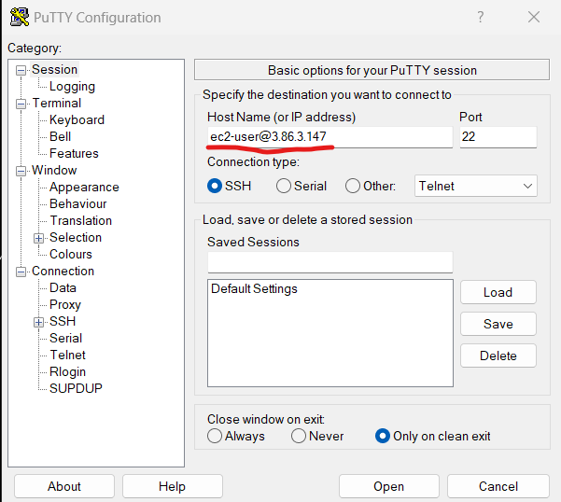

**Step 11: Select SSH🡪Auth🡪Credentials**

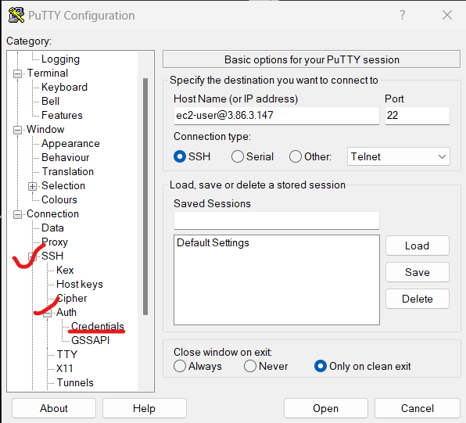

**Step 12: Then Select browse option and paste the Key-Pair that we have generated with step 5.**

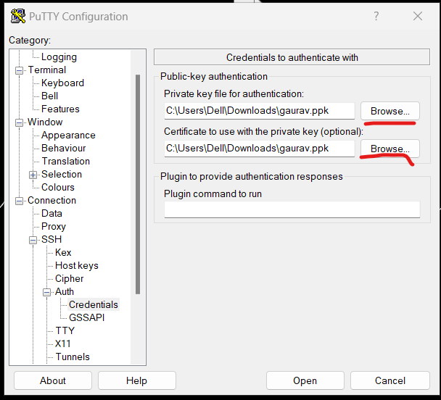

**Step 13: Select Accept.**

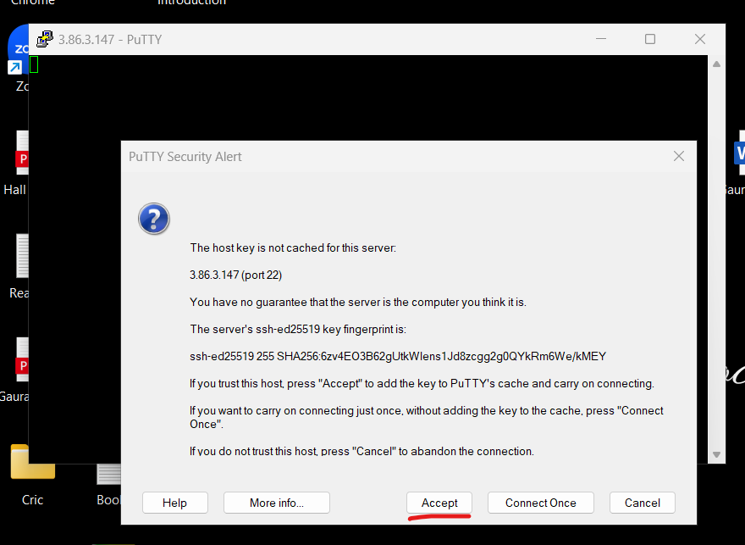

**Step 14 : putty will be opened and we will be logged in.**

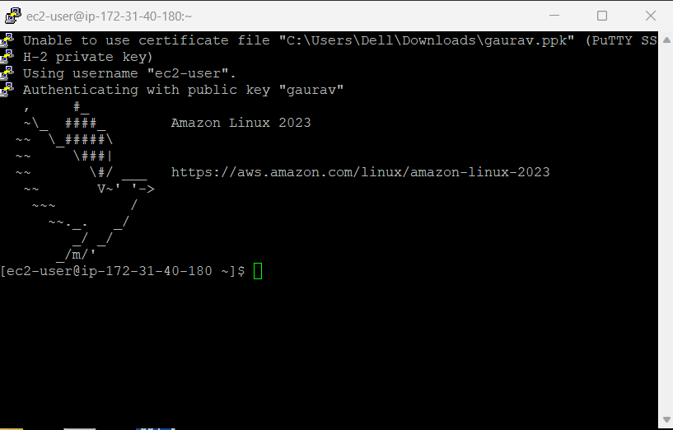

**Step 15 : Now we have to run commands in the below given order**

1. **sudo su**
2. **yum update -y**
3. **yum install httpd -y**
4. **systemctl start httpd**
5. **systemctl status httpd**
6. **system enable httpd**
7. **cd /var/www/html/**
8. **ls**
9. **vi index.html**
10. **cat index.html**

**The results from the given set of command are presented below in a sequential manner.**



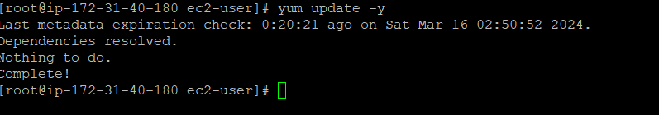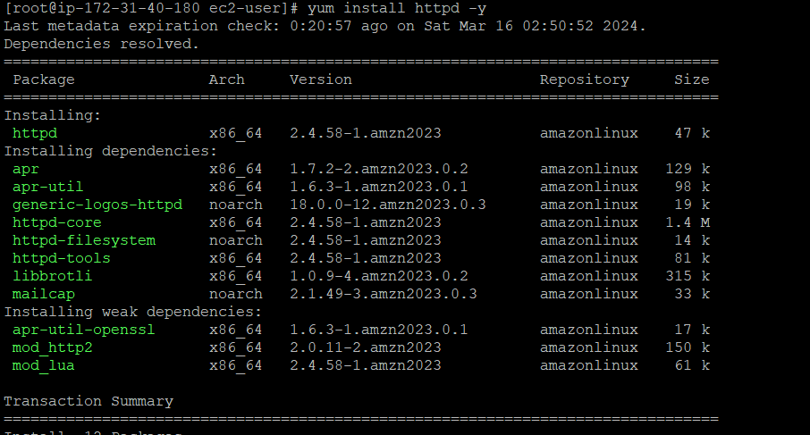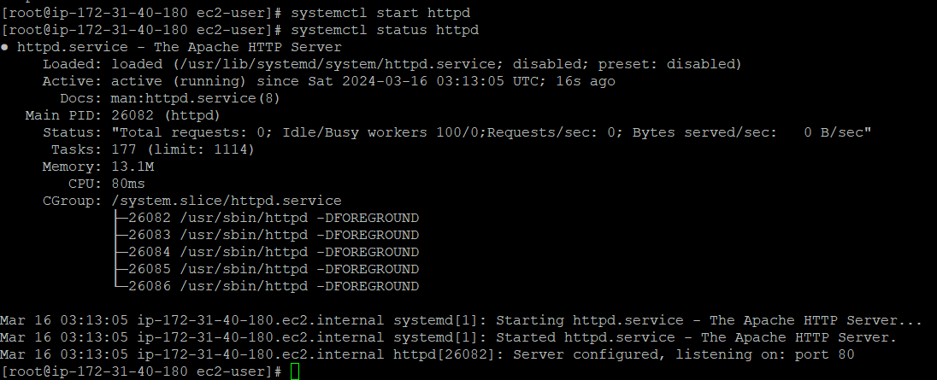

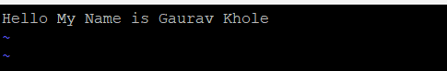

**Step 16 : Then Copy IPv4Public address🡪paste it in the browser🡪The html file will be displayed.**

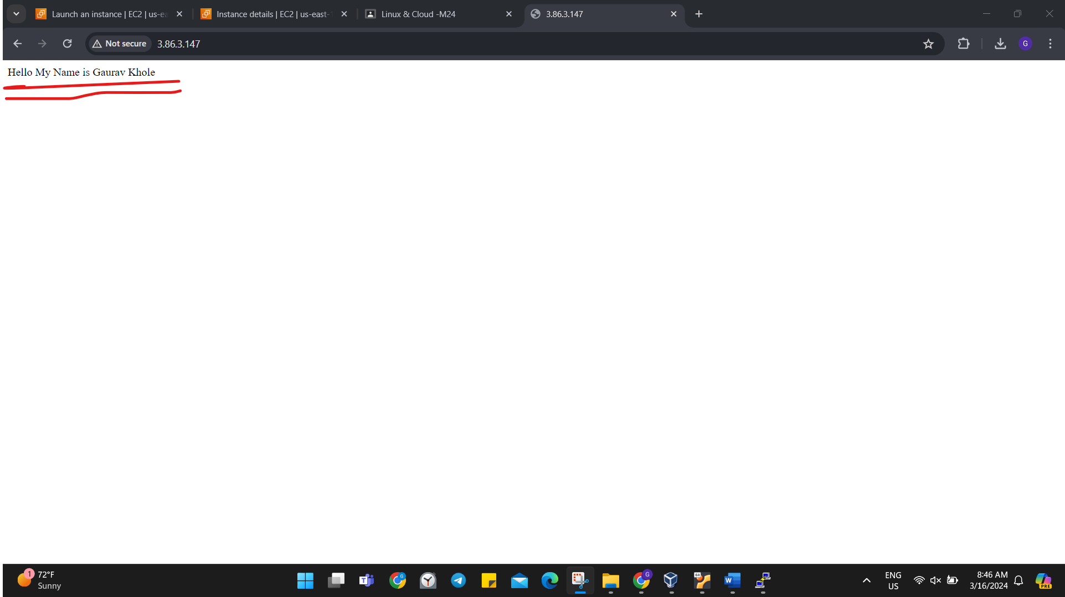

1. **Create a VPC with two subnet and a route table and internet gateway.**

**Step 1:Search VPC in search Menu 🡪 Click VPC**

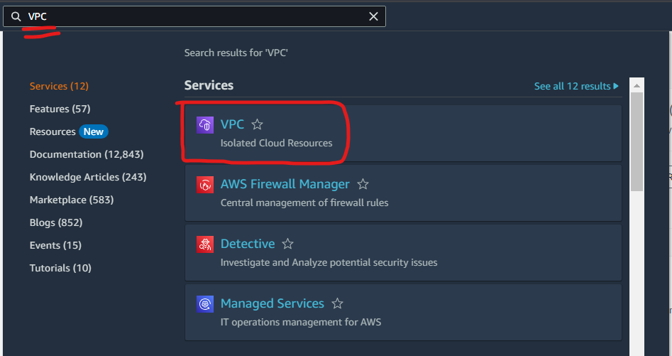

**Step 2: Select Create VPC**

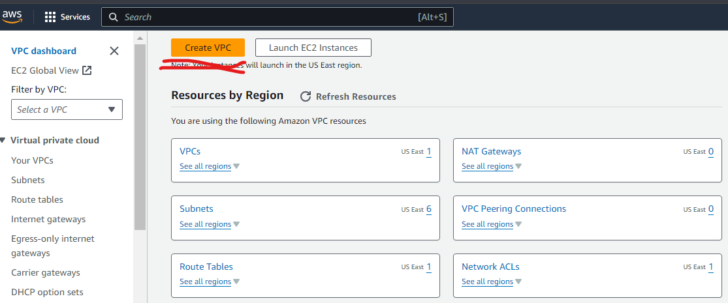

**Step 3 : Select VPC only 🡪Give vpc name 🡪 enter the IPv4 id given as it is 🡪 Create VPC**

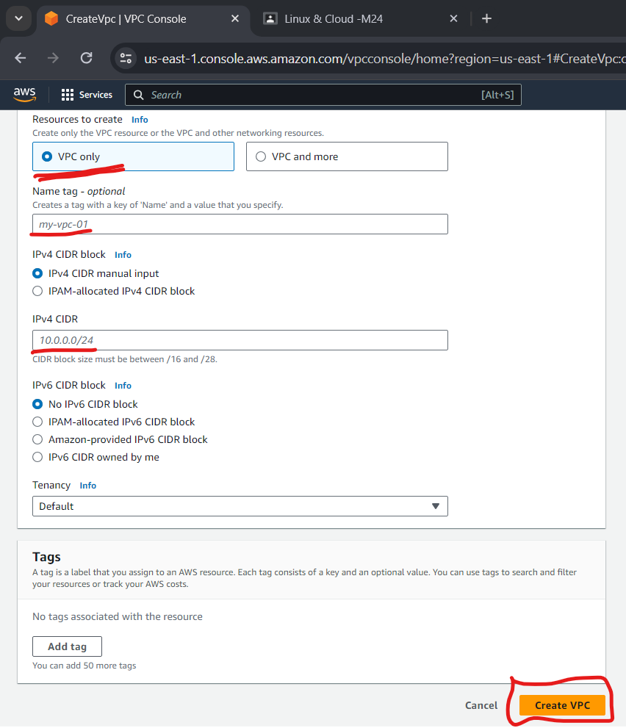

**Step 4 : VPC is Successfully Created**

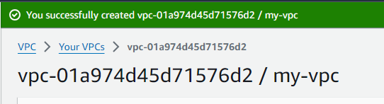

**Step 5 : Select Subnet 🡪 Create Subnet**

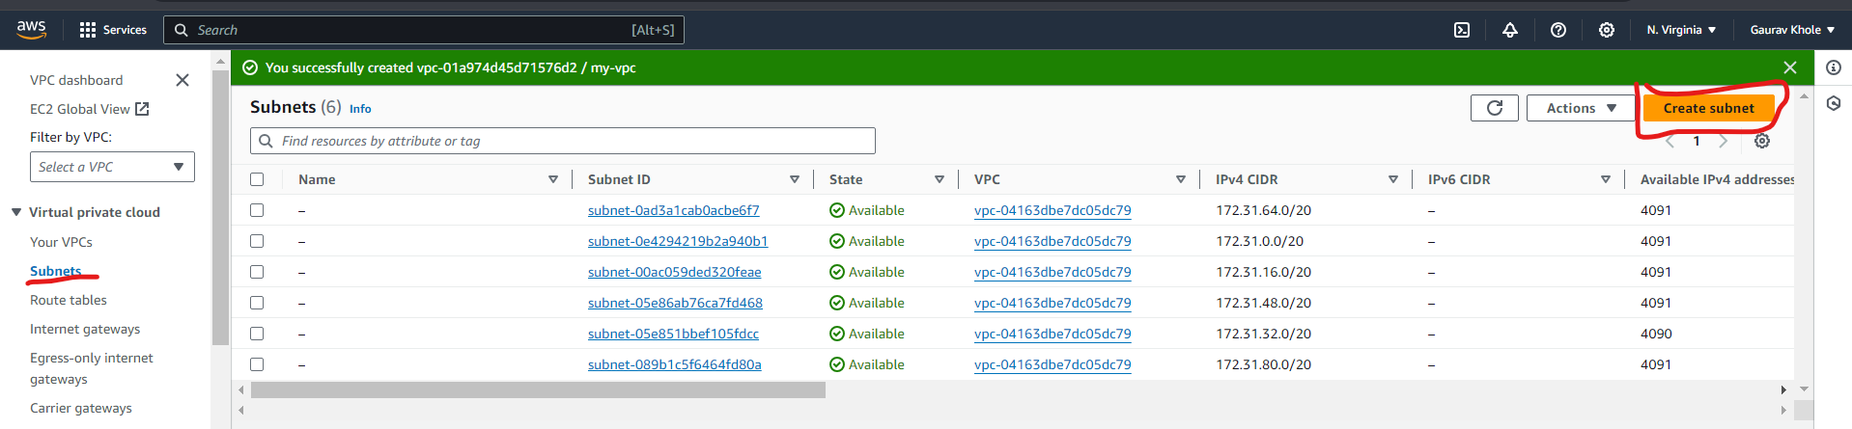

**Step 6: Select VPC that we have created.**

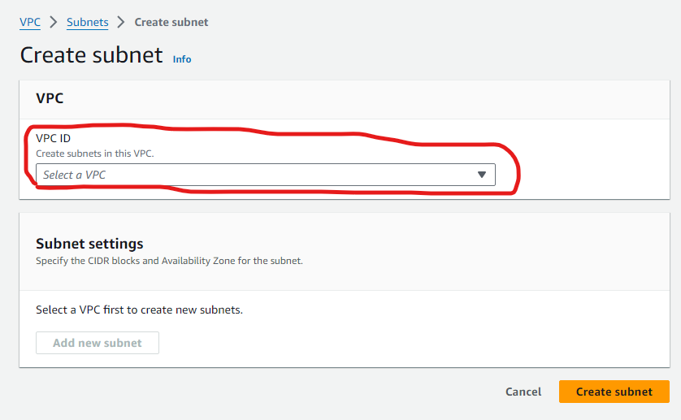

**Step 7: Enter subnet name 🡪 Select zone 🡪 Enter the id as it is**

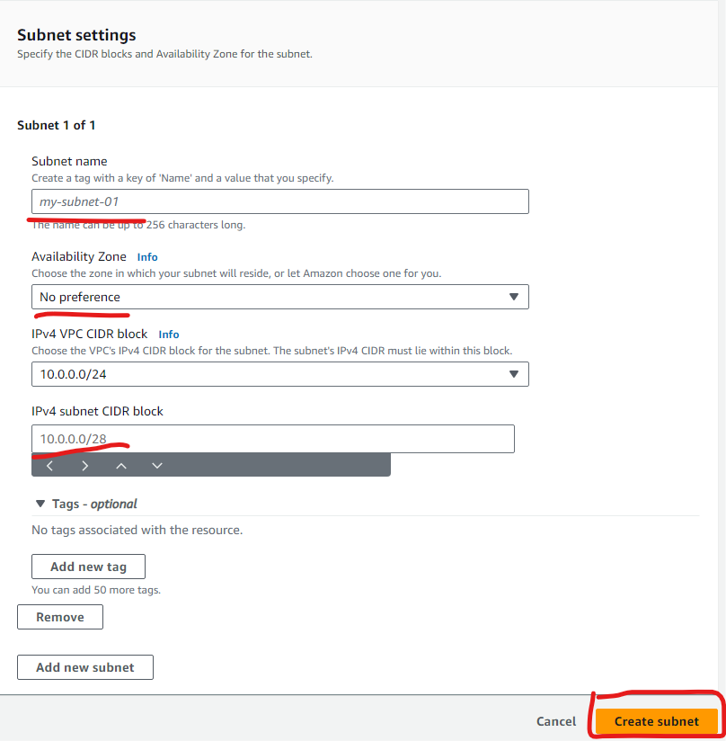

**Step 8: Subnet is created**

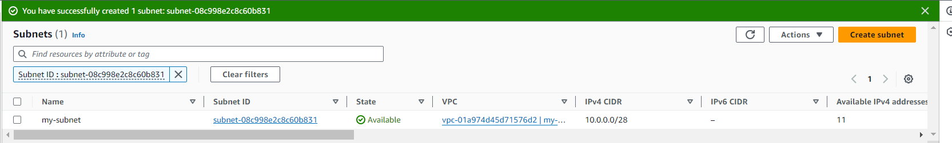

**Step 9: Select route 🡪 Create route table**

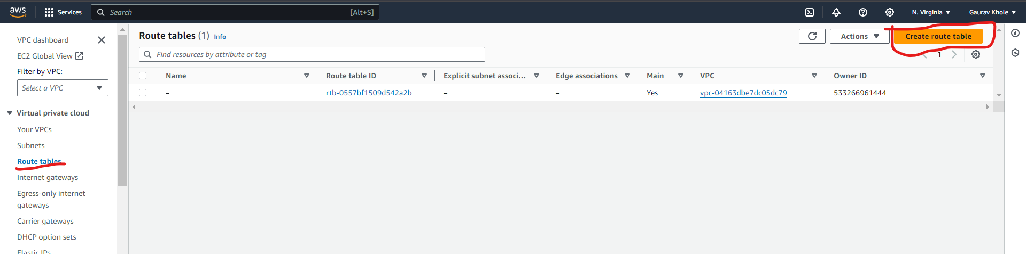

**Step 10: Name route table 🡪 Select VPC 🡪 Create Route table**

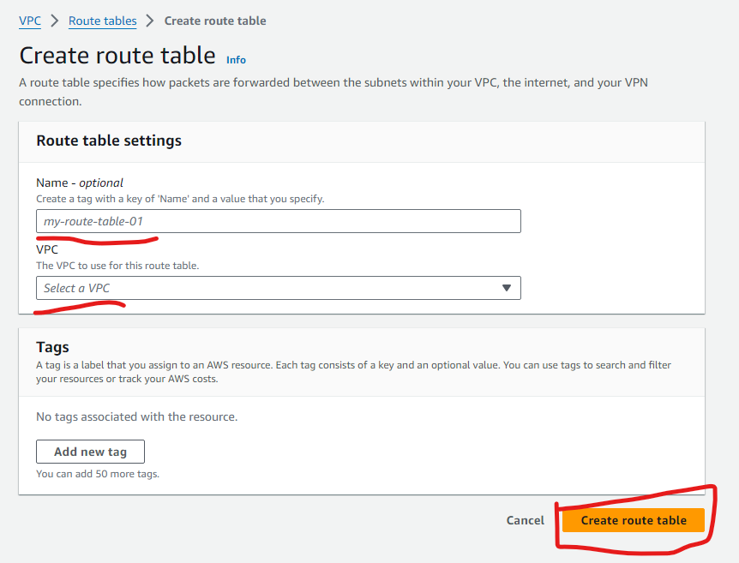

**Step 11 : Select Internet Gateway 🡪 Create Internet Gateway**

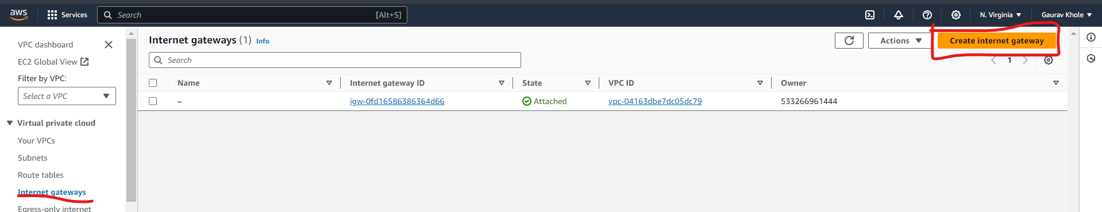

**Step 12 : Name the gateway 🡪 Create Internet Gateway**

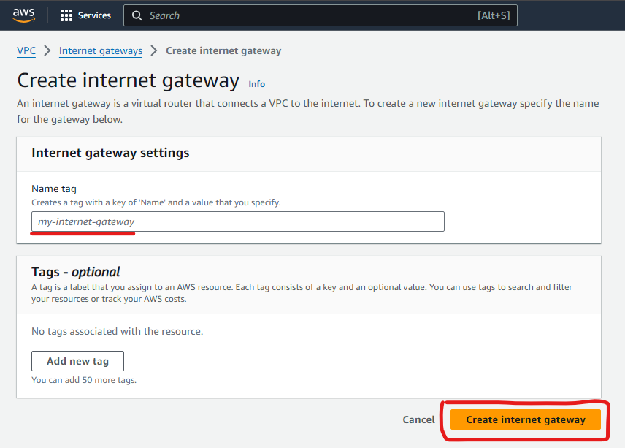

**Step 13 : Gateway is Created 🡪 Attach to VPC**

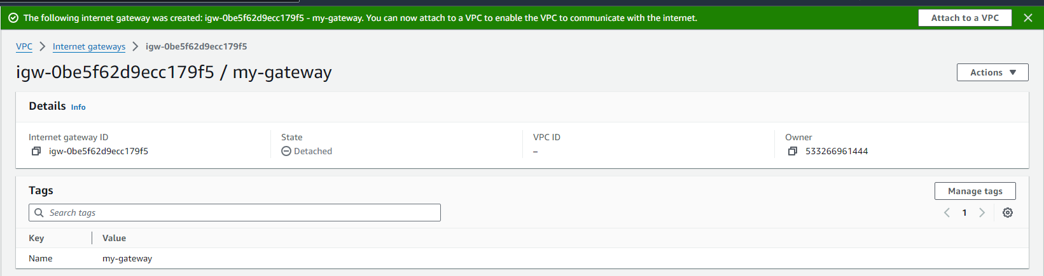

**Step 14 : Select VPC 🡪 Attach internet gateway**

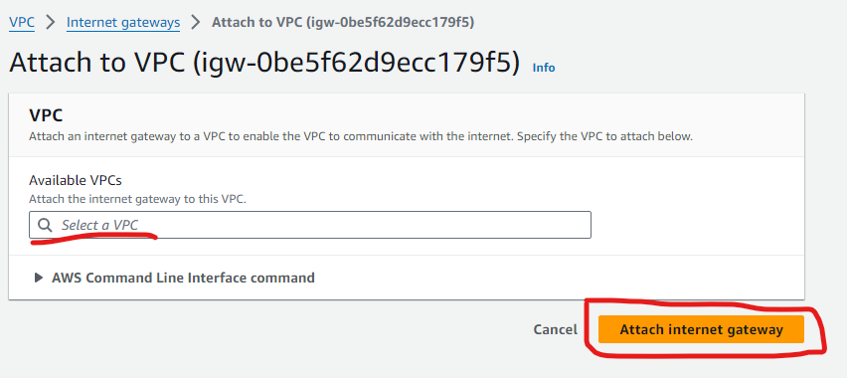

**Step 15 : Then routes 🡪 Edit Routes**

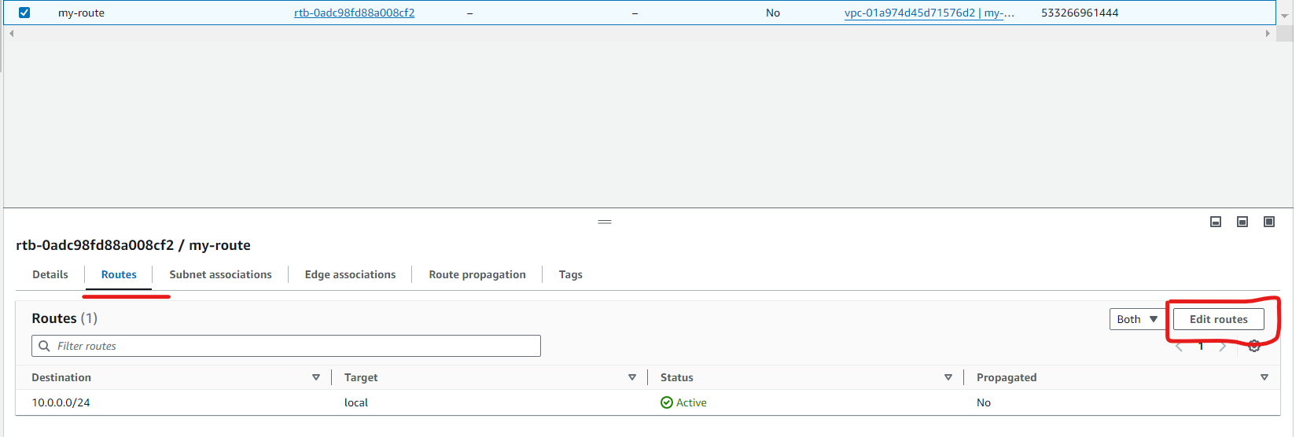

**Step 16 : Then select Add Route 🡪 Then select ipv4 address 🡪 internet gateway 🡪 Save Changes.**

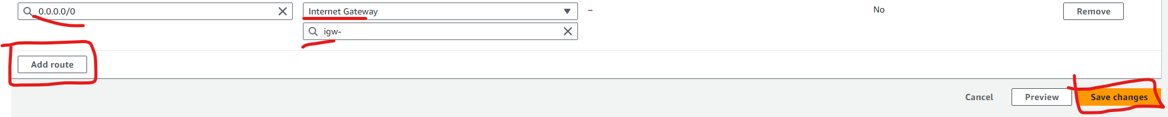

**Step 17 : New route is successfully created**

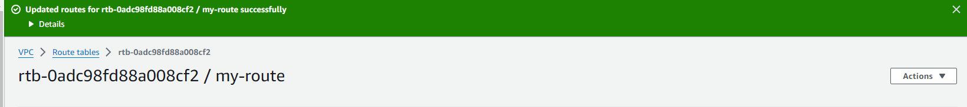

**Step 18 : Select Action 🡪 Edit subnet setting**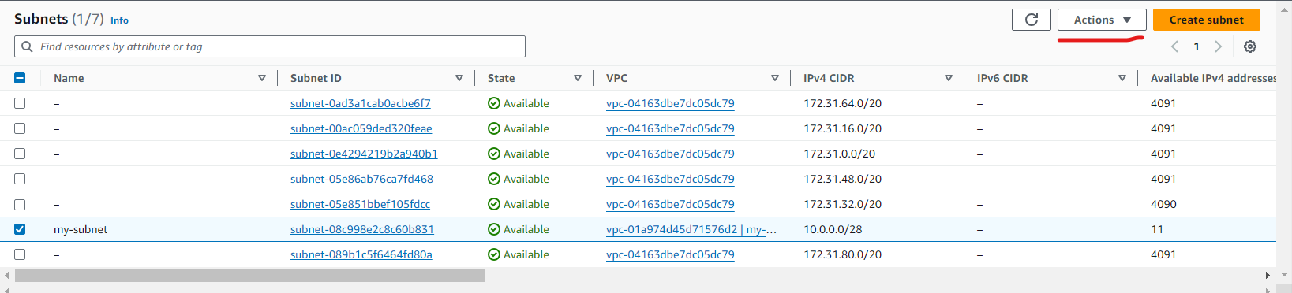

**Step 19 : Enable the auto assign**

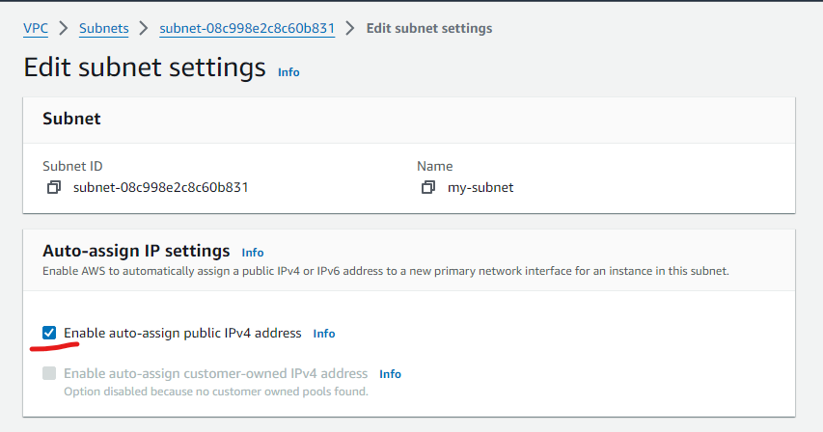

**Step 20 : VPC will ne connected to Subnet Route tables And gateway.**

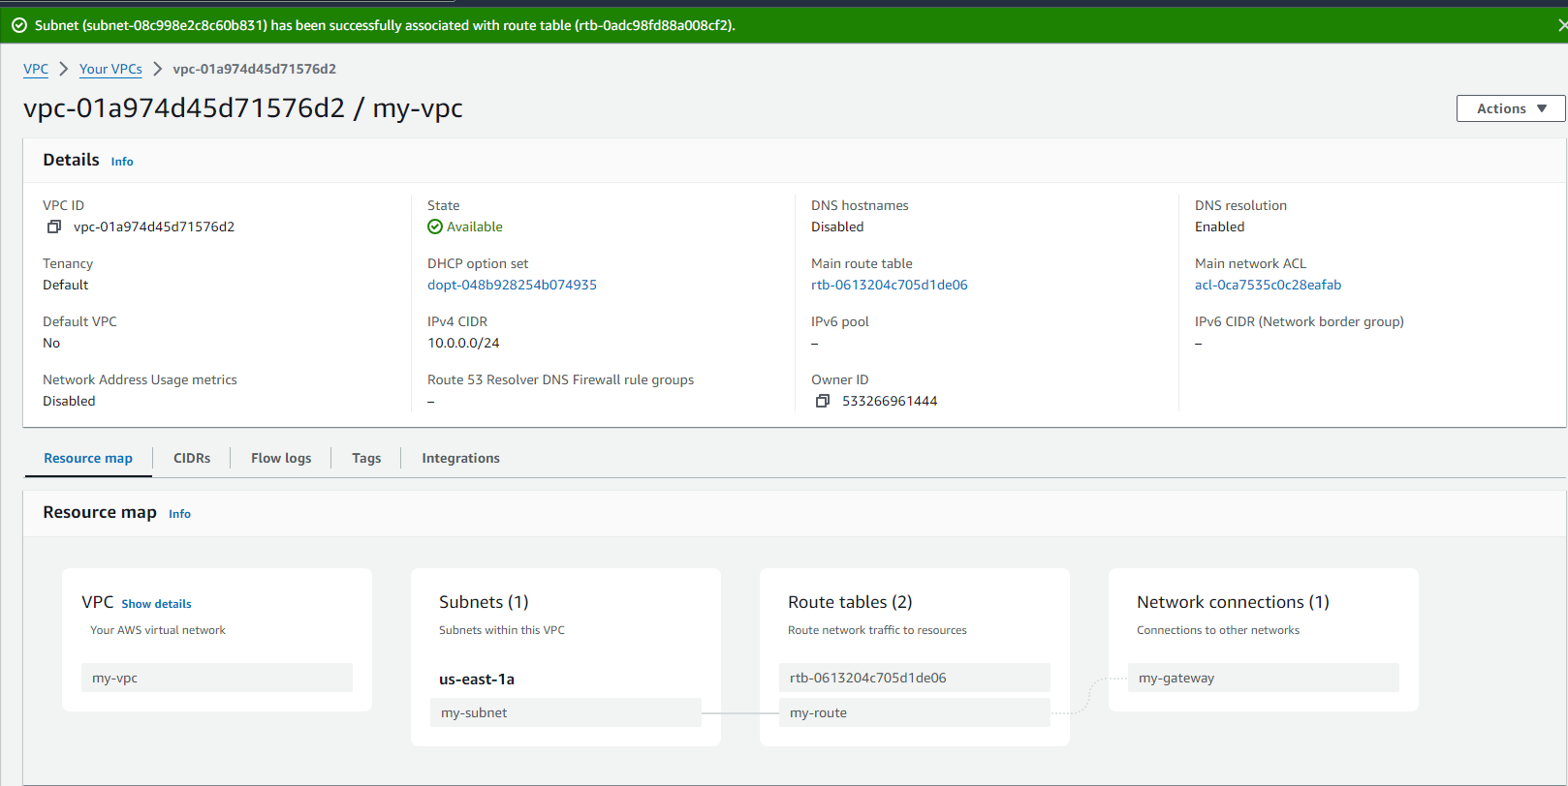

**LINUX**

**Q.3**

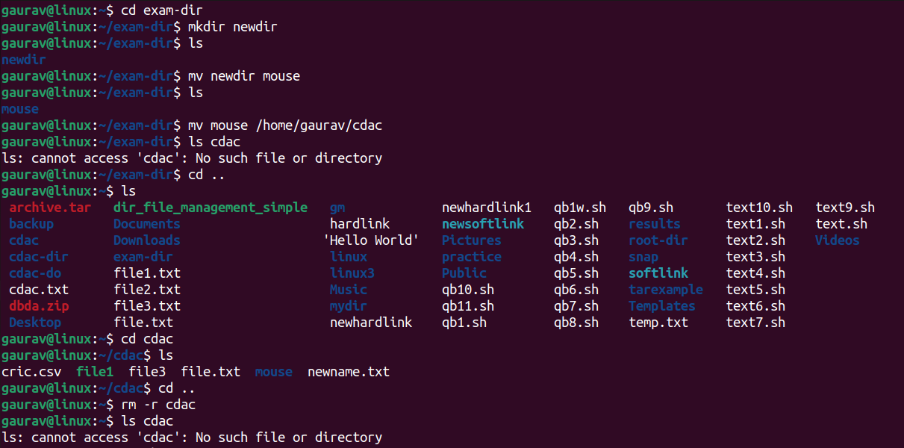

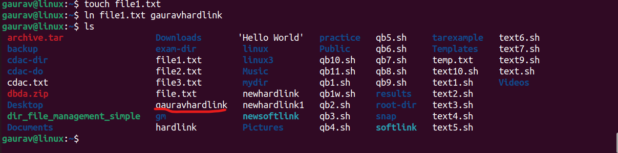

**Q1**

