10 lines content

Logo(png+jpg)

Hero image(company specific)

Website link

* Apple
* Microsoft
* Alphabet
* Oracle
* Adobe

1. Apple: [Apple](https://www.apple.com/)

* Steve Jobs is the founder of apple
* It is the dream company for every software developer.
* Apple is the world's most valuable company and brand
* It provides apple watch, macbook, smart band and many more gadgets to the customer
* The average package apple offers is $50,000.
* It makes more money than any company ever
* It is building the world’s coolest headquarter
* Apple feels more like a startup rather than a giant corporation
* It offers quite good package for many positions.
* It offers great customer service and in-store experience.
* It has mostly solved the phone theft problem
* It has solved the app discovery problem
* 

1. Microsoft: [Microsoft – Cloud, Computers, Apps & Gaming](https://www.microsoft.com/en-us/)

* Bill Gates and Paul Allen founded Microsoft.
* It is a dream job destination for many software developers.
* Work-life balance - even if it provides challenging projects, the company takes care of the work life balance of its employee.
* It offers a higher package of around $122,558 per year.
* The work environment it offers is amazing
* It provides Surface Pro, Microsoft cloud, Microsoft windows, and other features to the user.
* The work environment it provides is amazing
* Microsoft creates a computing economy worth far greater than its own net worth



1. Alphabet(Google): [Alphabet (abc.xyz)](https://abc.xyz/)

* Founded by ergey Mikhailovich Brin
* It is an American MNC
* It was created through a reconstruction of Google in 2015
* It became the parent company of google
* It gives ambitious projects the resources, freedom and focus to make their ideas happen.
* It offers an average package of $149,200
* It allows to keep focus on the extraordinary opportunities we have inside of Google.

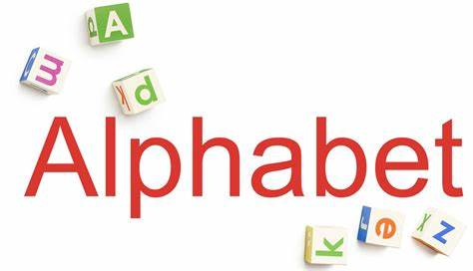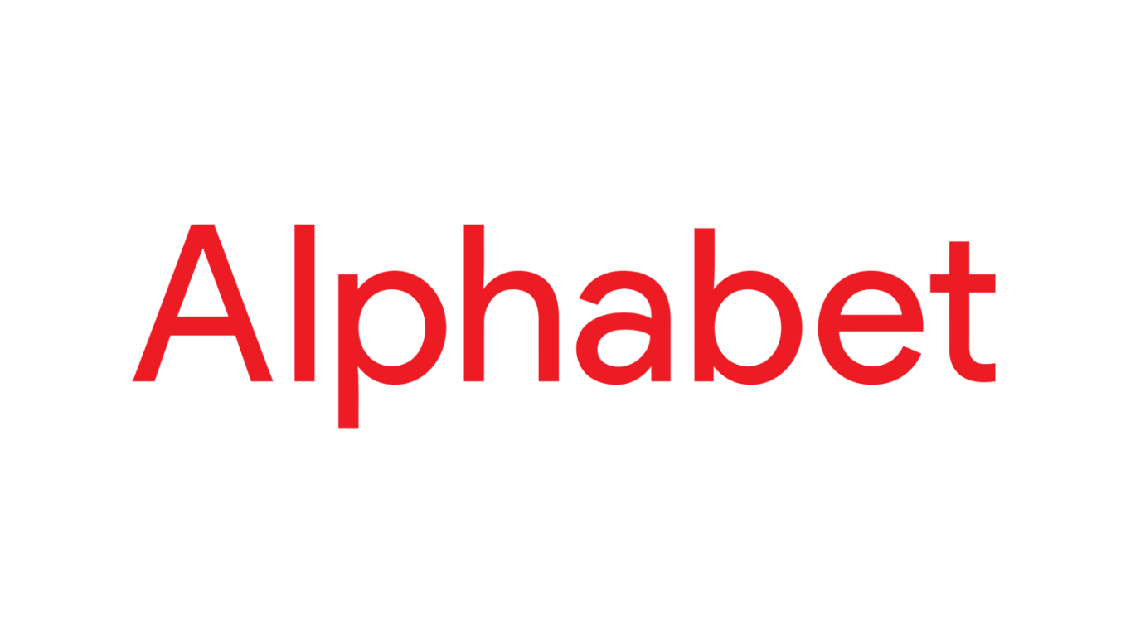

1. Oracle: [Oracle | Cloud Applications and Cloud Platform](https://www.oracle.com/index.html)

* It was founded by Larry Ellison. Bob Miner and Ed Oates.
* Its headquarter is located in Austin, Texas
* It is particularly known for its own brands of database management system.
* In 2020, it was the second largest company in the world by revenue and market capitalization
* The company sells database software and technology, cloud engineered systems and enterprise software products.
* It designs, manufactures and sells both hardware and software products
* It provides Oracle Rdb, MySQL, Oracle NoSQL Databases and many more software.
* It has more than 150,000 employees
* 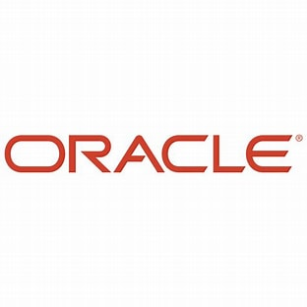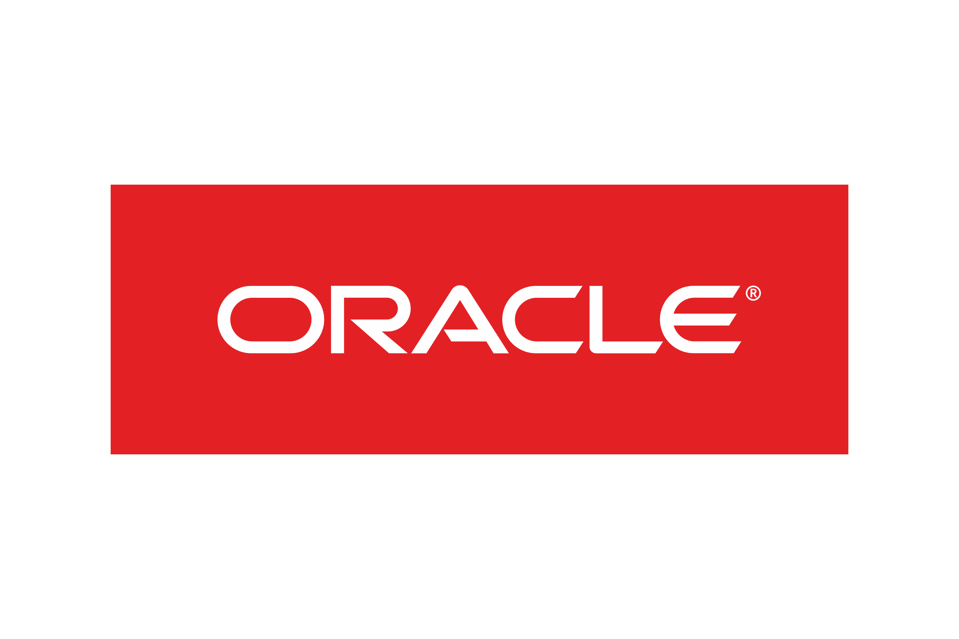

1. Adobe: [Creative business solutions | Adobe Creative Cloud for teams](https://www.adobe.com/creativecloud/business/teams.html?sdid=KKSPR&mv=search&s_kwcid=AL!3085!10!79233684336656!79233954463091&ef_id=d0867e706ce11bc34bef1c29dc81f5ef:G:s&msclkid=d0867e706ce11bc34bef1c29dc81f5ef)

* It was founded by John Warnock and Charles Geschke
* It comes under top 10 Software company
* Its headquarter is located in San Jose, California.
* People can scan, edit, share and sign documents anytime, anywhere.
* It provides with adobe photoshop, adobe illustrator, adobe acrobat pro and adobe InDesign.
* It offers an average package of $90,000
* The best thing about Adobe's benefits are the variety from elder care to maternity leave, to matching contributions, and even financial support for adoptions
* Their response to the 2020 pandemic has been highly praised, with a focus on mental health days off and work-from-home equipment

