Shri Ramdeobaba College of Engineering and Management

Name : Gaurav Kedia

Branch : AIML

Roll No. : E-39

Subject : Computer Networks(Lab)

Topic : Practical 1

1. **Cross :**

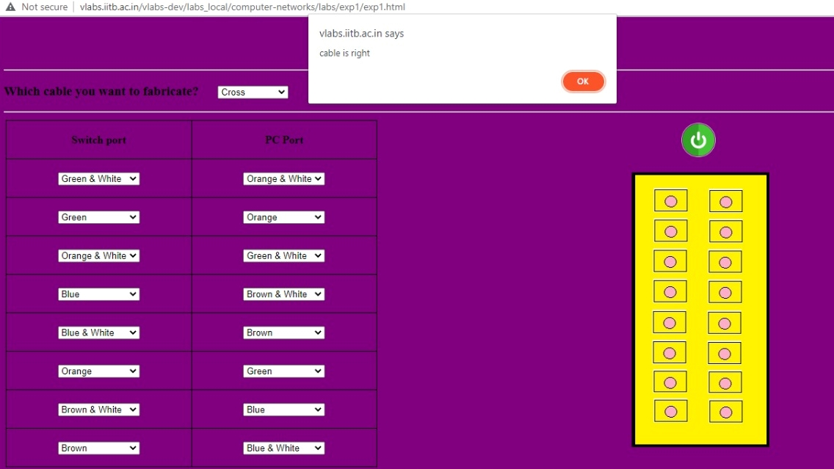

1. **Straight:**

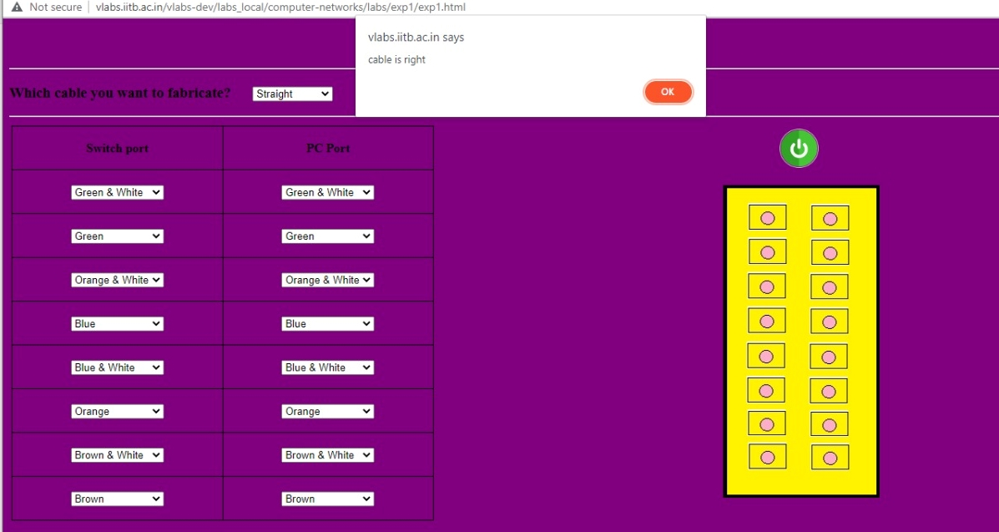

1. **Role Over:**

