Shri Ramdeobaba College of Engineering and Management

Name : Gaurav Kedia

Branch : AIML

Roll No. : E-39

Subject : Computer Networks(Lab)

Topic : Practical 3

Aim : Administrative commands for managing users and devices on the network

**ADDING USER:-**

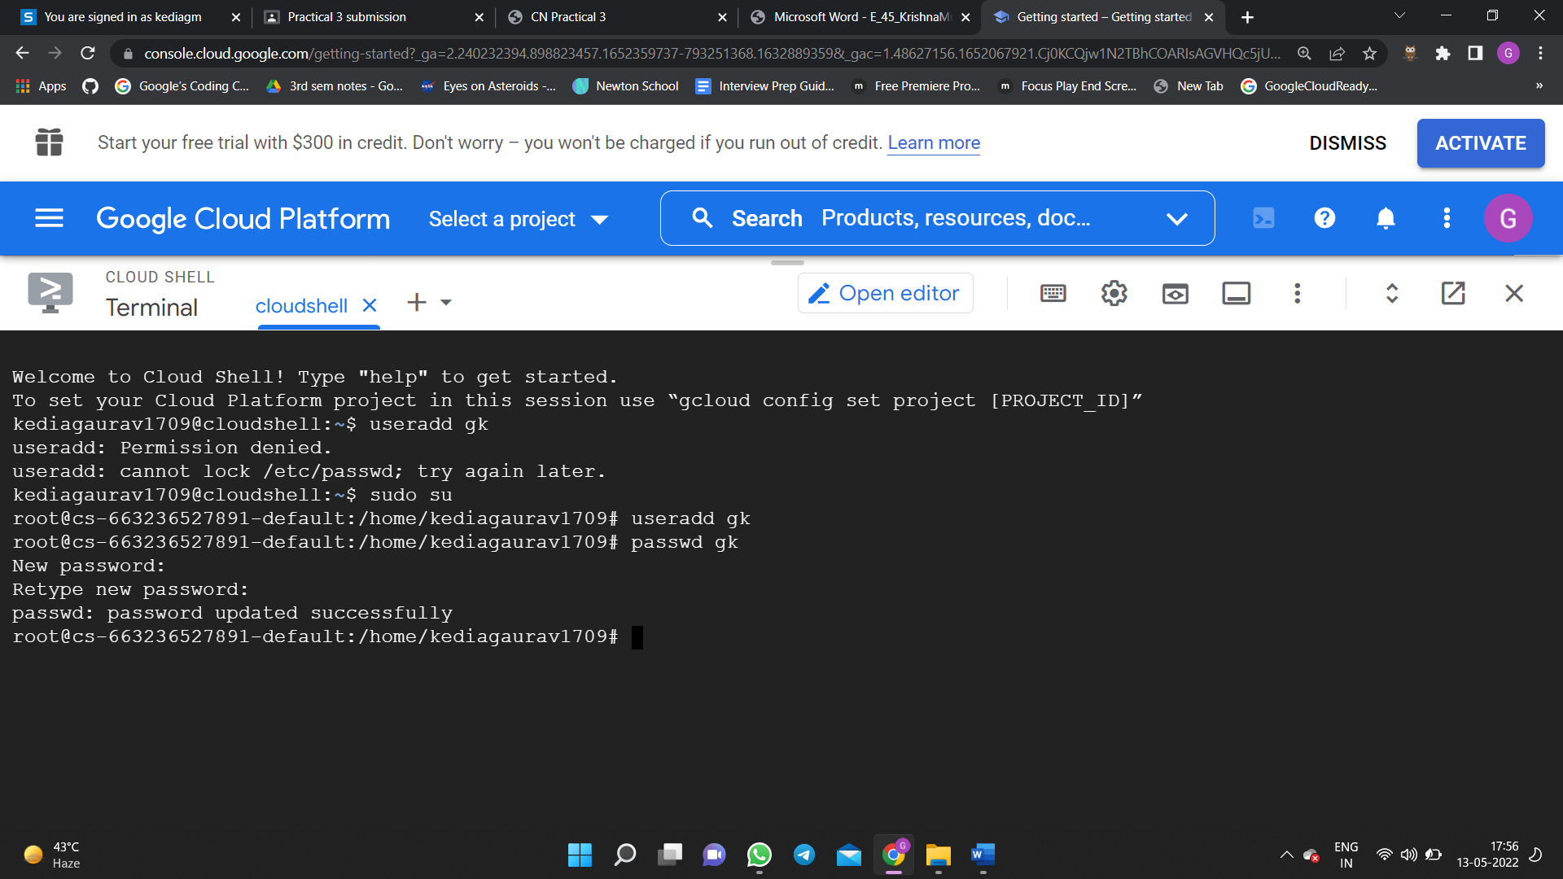

**ADDING GROUP:-**

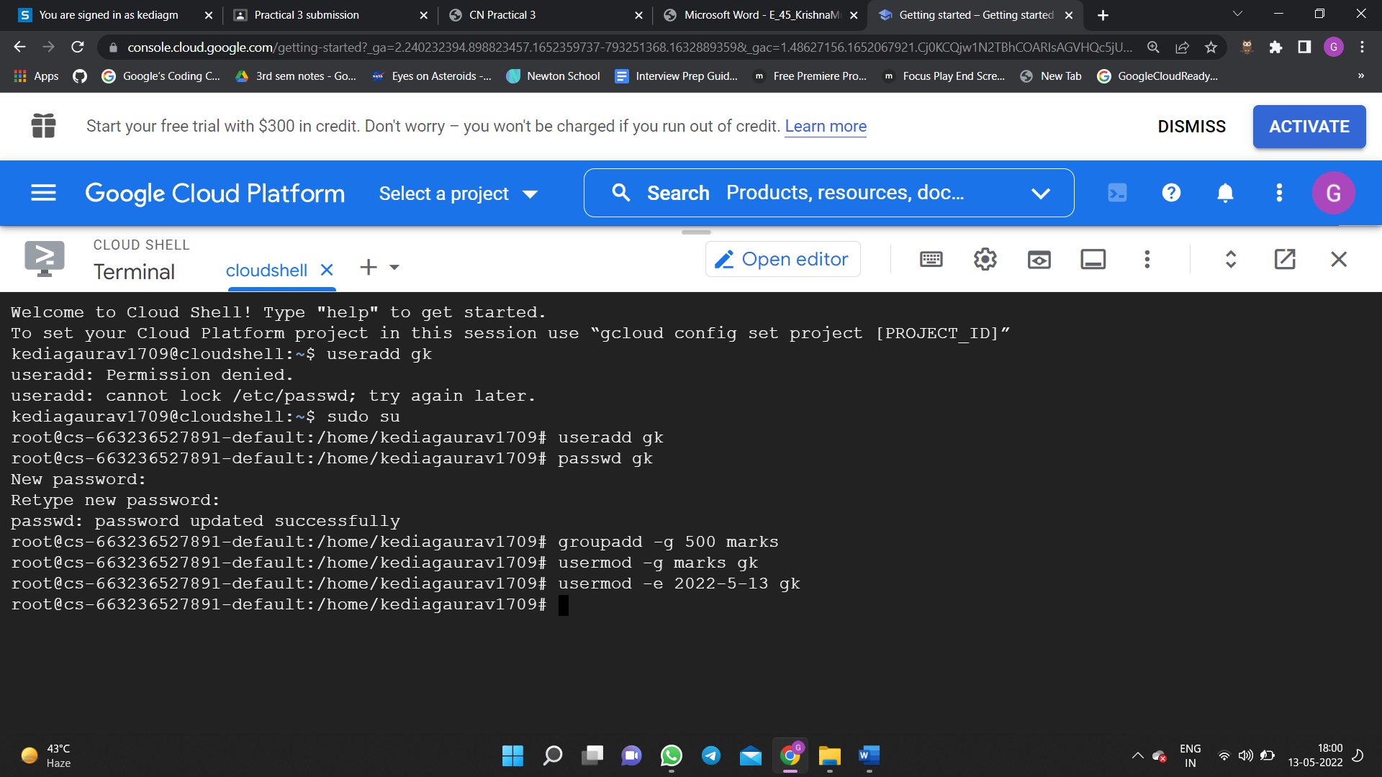

**Complete user Information:-**

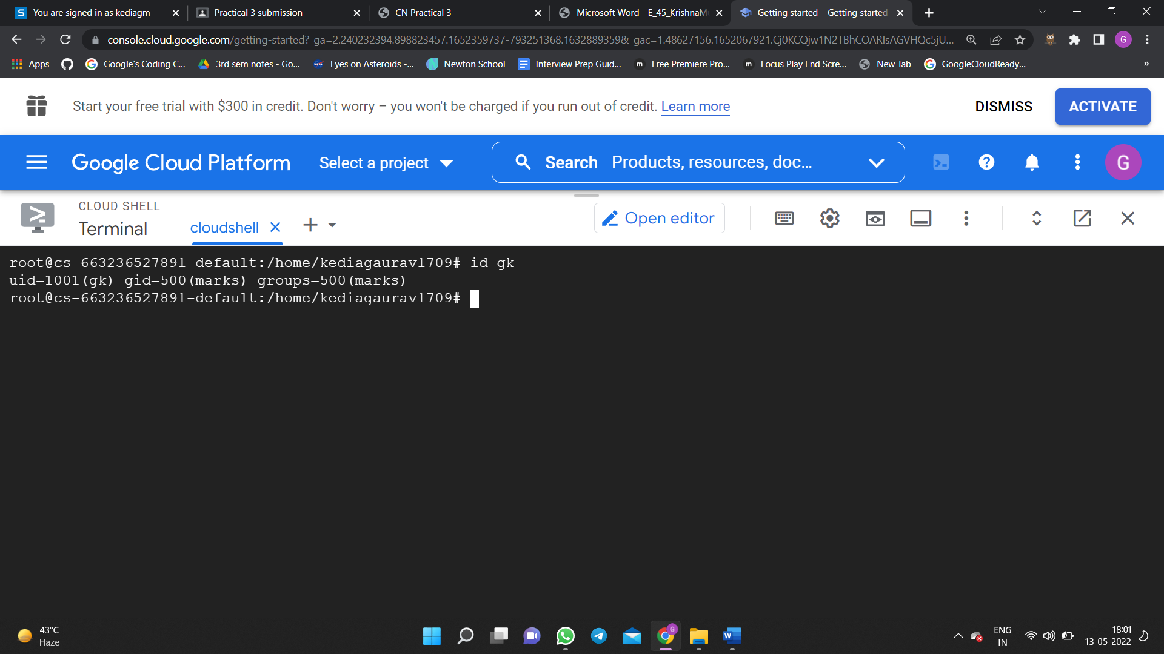

**For all user Login Information:-**

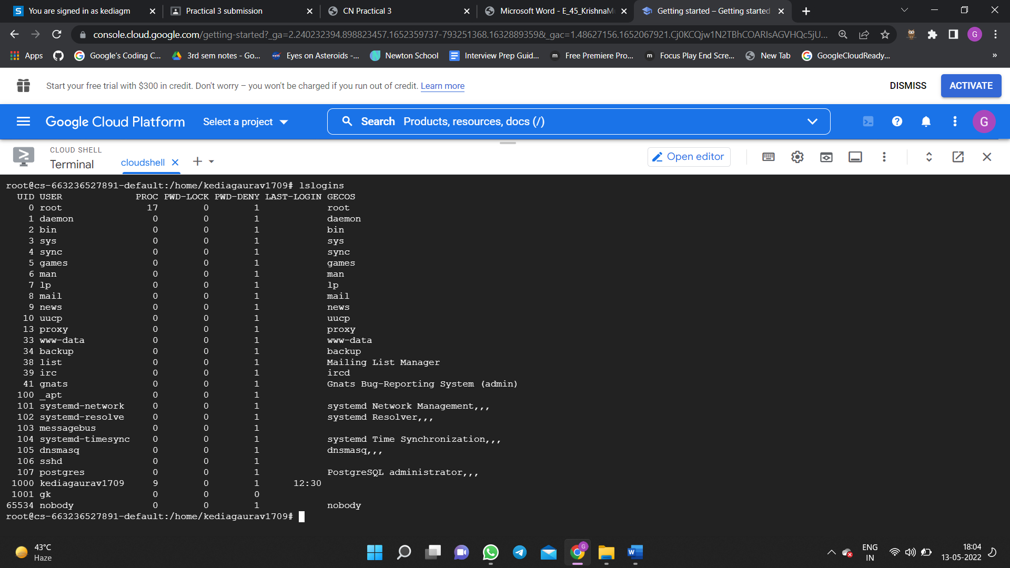

**Deleting a Group:-**

